Project Design Phase-I
Solution Architecture
Project owner: Sendhika Vishwakarma
Project links: Tableau Public dashboard | Google Drive demo video

Date | 01 November 2026
Team ID | Add your SkillWallet Team ID
Project Name | Global Olympic Sports Performance Analysis
Maximum Marks | 4 Marks

Solution Architecture:
Solution architecture is a complex process – with many sub-processes – that bridges the gap between business problems and technology solutions. Its goals are to:
- Find the best tech solution to solve existing business problems.
- Describe the structure, characteristics, behavior, and other aspects of the software to project stakeholders.
- Define features, development phases, and solution requirements.
- Provide specifications according to which the solution is defined, managed, and delivered.

Solution Architecture Diagram (adapted to this project):
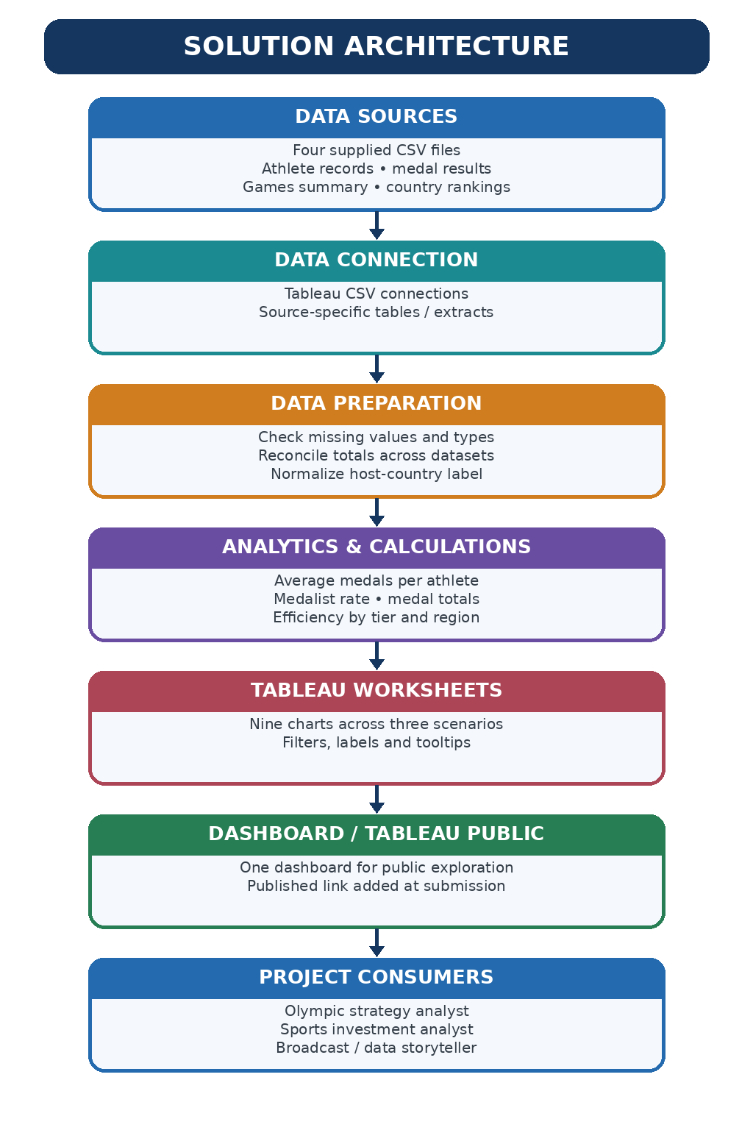

Component Description Table
Component Name | Description / Role in Architecture | Technology Used

Component Description Table
Component | Function in This Project | Technology / Output
Data sources | Four supplied CSV files at separate levels of detail. | CSV files
Data connection | Load each dataset without an unsafe row-level join. | Tableau text-file connections
Validation and preparation | Check columns/types, reconcile medal totals, normalize host label for host-edition analysis. | Tableau calculations and verified prepared tables
Analytics | Calculate averages, rates, country totals, tier/region means, edition trends and host-country medals. | Tableau aggregations / calculations
Visualization | Build nine worksheets grouped into three stakeholder scenarios. | Tableau worksheets and one dashboard
Publication | The published dashboard URL is included in the project proposal and dashboard design template. | Tableau Public
Consumers | Help strategists, analysts and storytellers explore trends and caveats. | Dashboard + project documentation
Data Quality Controls
• The all-time country ranking totals reconcile to 6,025 medals.
• Country-by-Games totals reconcile with the all-time country ranking totals.
• Games totals match medal results by year for the supplied 18 editions.
• Do not combine athlete-level and country-by-Games records without grain-aware aggregation.
• The supplied medal_efficiency_pct field includes values above 100; treat it as exploratory until its formula is confirmed.

