GE HealthCare

AEM AMS to Edge Delivery Services
Migration Analysis Report

Date: April 16, 2026
Source: https://www.gehealthcare.com/
Scope: US English site (gehealthcare.com, no subdomains)
Current Platform: Adobe Experience Manager (AEM as Cloud Service) + Sitecore JSS (legacy /shop)

Table of Contents
- 1. High-Level Summary
- 2. Templates Inventory
- 3. Blocks Catalog
- 4. Page Counts by Template
- 5. Integrations Analysis
- 6. Forms Analysis
- 7. Offers / Personalization Analysis
- 8. Complex Use Cases & Observations
- 9. Outlier Scenarios
- 10. Migration Estimates
- 11. Template Screenshots

1. High-Level Summary

1.1 Site Scale
Metric | Count
Main Sitemap URLs (no locale prefix) | 2,172
US English Pages (/en-us/) | 1,723
Global English Pages (/en/) | 1,667
Total Across All Locales (12 sitemaps) | ~12,950
Estimated Unique Pages (excl. locale duplication) | ~2,500-3,500
Locale Variants | 10+ (US, GB, DE, SG, MY, PH, TH, Middle East, CN, Global)
Max URL Depth | 5 levels (bulk at depth 3)

1.2 Current Tech Stack
Layer | Technology | Evidence
Primary CMS | Adobe Experience Manager (AEM as Cloud Service) | window.CQ, window.Granite, etc.clientlibs, cmp-* components, aem-Grid
Legacy CMS | Sitecore JSS (React SPA) | __JSS_STATE__, -/jssmedia/ paths — serves /shop only
Component Framework | AEM Core Components | cmp-carousel, cmp-container, cmp-button, cmp-link, cmp-experiencefragment
Grid System | AEM Responsive Grid + Material Design Components | aem-Grid--12, mdc-layout-grid
Image Delivery | AEM Dynamic Media / Scene7 | s7d9.scene7.com asset URLs
Search | Algolia | Algolia clientlib, aa-Form search classes
Personalization | Adobe Target (Server-Side) | Console: "Target Server-Side Call Successful"
Analytics | Google Tag Manager (2 containers) | GTM-58LKHLP, GTM-W4V7GZG
Ads/Remarketing | Google Ads + DoubleClick | AW-357630064, AW-435915669, DC-10528130
Cookie Consent | Evidon (Crownpeak) | c.evidon.com scripts
Forms | Marketo | gehc-marketo-form, marketoform classes
Video | Vidyard | play.vidyard.com/embed/v4.js
ABM/Intent | Nrich.ai | j.nrich.ai/tag.js
eCommerce | SAP Hybris (legacy via Sitecore) | gehcstorefront, /shop paths
Payments | Affirm (Buy Now Pay Later) | cdn1.affirm.com/js/v2/affirm.js
Pharma CRM | Veeva | Veeva class prefix on homepage

1.3 Thematic Page Breakdown (2,172 unique URLs)
Category | Pages | % | Type
Products | 906 | 42% | Product Marketing / Catalog
Insights/Articles | 751 | 35% | Content Marketing / Thought Leadership
Courses | 209 | 10% | Education / Training
Education | 84 | 4% | Education Landing Pages
About/Corporate | 54 | 2% | Corporate / Company
Services | 29 | 1% | Service Offerings
Events | 26 | 1% | Events & Conferences
Specialties | 25 | 1% | Medical Specialties
Campaigns | 20 | 1% | Marketing Campaigns
News/Press | 13 | 1% | Press Releases
Shop (eCommerce) | 9 | <1% | eCommerce (Sitecore JSS)
Corporate/Other | ~46 | 2% | Initiatives, Support, etc.

1.4 Pages by Content Type
Type | Est. % | Est. Pages | Description
Static Authored (CMS) | ~80% | ~1,740 | Product pages, about, services, specialties
Dynamic/API-Driven | ~15% | ~325 | Insights/articles feed, courses catalog, events
Hybrid (Static + Personalization) | ~5% | ~107 | Homepage (Adobe Target), campaign landing pages

1.5 Pages by Category
- Pages Integrated with eCommerce:
- Shop pages (/shop) — ~9 pages on Sitecore JSS with SAP Hybris backend
- Product Detail Pages with Affirm pricing — ~20+ PDPs
- Cart icon integration across all pages (header)
- Pages Fed from Other Systems:
- Careers (careers.gehealthcare.com) — external recruitment platform
- Investor Relations (investor.gehealthcare.com) — external IR platform
- Product Security (productsecurity/home) — separate security portal

1.6 Design System Analysis
The site uses AEM Core Components (cmp-* namespace) as its foundation, with custom GE HealthCare components layered on top (ge-feature-card, ge-product-media-carousel, category-hero, etc.). Material Design Components (MDC) grid is used alongside AEM responsive grid. The legacy Sitecore JSS /shop pages use a completely different component system that is being deprecated. Overall: moderately unified design system with AEM Core Components + custom GE overlay. GE brand colors: dark navy (#002B49), white, teal accents.

2. Templates Inventory
# | Template Name | AEM Template | Complexity | Example URL | Description
T1 | Homepage | homepage-template | High | /en-us | Hero carousel (2+ slides, play/pause), category cards carousel, "What's New" editorial cards, stats counter, S-curve cards (3), CTA banner. Adobe Target personalization.
T2 | Product Category | generic-page-template | Medium | /en-us/products/ultrasound | Category hero (image + H1 + CTA), video carousel, product card grid, S-curve feature sections, Marketo form modal, promo cards, CTA banner
T3 | Product Detail (PDP) | generic-page-template | High | /en-us/products/ultrasound/handheld-ultrasound/vscan-air-sl | Sticky sub-nav with tabs, product hero with pricing/Affirm, "At a Glance" icon grid, feature carousels, S-curve features, FAQ accordion, support cards, resource downloads
T4 | Insights Hub | generic-page-template | Medium | /en-us/insights | Text hero, 2-column editorial card grid, section headers with eyebrow text
T5 | Article/Content | generic-page-template | Low-Med | /en-us/insights/article/five-key-trends... | Article hero image, rich text body, author info, related content cards, social sharing
T6 | Contact Us | generic-page-template | Medium | /en-us/about/contact-us | Heading, dynamic form with dropdown routing, reCAPTCHA, phone directory
T7 | Specialties Hub | generic-page-template | Low | /en-us/specialties | Sticky sub-nav, text intro, 3x2 specialty card grids (alphabetical), CTA banner
T8 | Education/Courses | generic-page-template | Medium | /en-us/courses | Category hero, training card grid, resource icon cards, feature cards, CTA banner
T9 | Services | generic-page-template | High | /en-us/services | Sticky sub-nav, hero, anchor nav bar, icon grid, sectioned card groups, tab interface (8 tabs), CTA banner. Most complex template.
T10 | Shop/eCommerce | Sitecore JSS | High | /shop | Different CMS (Sitecore). Hero, category carousel, featured products, Affirm/SAP Hybris integration
T11 | Events | generic-page-template | Low | /en-us/events | Minimal listing page. Content likely loaded dynamically
T12 | Campaigns | generic-page-template | Medium | /en-us/campaigns/* | Marketing landing pages with hero, form capture, feature content
T13 | Newsroom/Press | generic-page-template | Medium | /en-us/about/newsroom | Press release listing, article cards, pagination
T14 | Corporate/About | generic-page-template | Low-Med | /en-us/about, /en-us/about/compliance | Standard content pages with text sections, link lists

3. Blocks Catalog
# | Block | Complexity | Description | Reference | Std EDS? | Backend? | LLM-Ready? | UI Ext?
B1 | Global Header | High | GE logo, mega-nav with multi-level flyout, search (Algolia), sign-in, cart, hamburger mobile menu, country selector | All pages | No - custom build | Yes (Algolia, auth, cart) | No | No
B2 | Global Footer | Medium | Logo, 7-column link grid, compliance links, country selector, social icons, copyright | All pages | No - custom build | No | No | No
B3 | Hero Carousel | High | Multi-slide hero with bg images, H1, CTAs, prev/next/play-pause, slide counter. AEM cmp-carousel | Homepage | Variant of Carousel | No | Yes | No
B4 | Category Hero | Medium | Full-width hero with bg image, H1, body text, CTA button | Product category | Variant of Hero | No | Yes | No
B5 | Product Hero (Pricing) | High | Product image, H1, pricing ($4,999), Affirm financing, dual CTAs (Buy now / Demo) | PDP pages | No - custom build | Yes (pricing, Affirm) | No | No
B6 | Category Cards Carousel | Medium | Horizontal scrollable icon+text cards for product categories, prev/next arrows | Homepage | Variant of Carousel | No | Yes | No
B7 | Feature Cards | Low | Image + H3 + description + "Learn more" CTA. Grid layout (2-col/3-col). Most common component | All templates | Variant of Cards | No | Yes | No
B8 | S-Curve Cards | Medium | Alternating side-by-side image + text. H3 + paragraph + CTA | Homepage, Category | Variant of Columns | No | Yes | No
B9 | Stats Counter | Low | 4-column grid of large numbers + descriptions (~$5.1B, 5M+, 1B+, 110+) | Homepage | No - custom build | No | Yes | No
B10 | Editorial Cards | Low | Image + H3 + link. Horizontal scrollable row with section header | Homepage | Variant of Cards | No | Yes | No
B11 | Product Media Carousel | Medium | Video/image carousel for product demos, with progress bar and indicators | Product pages | Variant of Carousel | No | Yes | No
B12 | Sticky Sub-Navigation | Medium | Fixed top bar with product name, section tabs, CTA buttons | PDP, Services | No - custom build | No | Yes | No
B13 | At a Glance (Icon Grid) | Low | 4-column icon + headline + description grid | PDP pages | Variant of Cards | No | Yes | No
B14 | FAQ Accordion | Low | Expandable Q&A sections with +/- toggle icons | PDP pages | No - custom (Accordion) | No | Yes | No
B15 | Anchor Navigation | Medium | Horizontal scrollable anchor links for in-page section navigation | Services page | No - custom build | No | Yes | No
B16 | Tab Interface | Medium | Tabbed content with 8 selectable tabs displaying different panels | Services page | No - custom build | No | Yes | No
B17 | Marketo Form (Modal) | High | Lead gen form via Marketo, triggered from CTA. Modal overlay | Product, campaigns | No - Marketo integration | Yes (Marketo API) | No | Yes (Medium)
B18 | CTA Banner | Low | "Have a question?" H2 + "Contact us" button. Full-width | Most pages | Yes - standard EDS | No | Yes | No
B19 | Resource Downloads | Low | Cards with download links for brochures, datasheets | PDP pages | Variant of Cards | No | Yes | No
B20 | Cookie Consent Banner | Low | Evidon-powered dialog with Allow/Accept/Customize | All pages | No - Evidon integration | Yes (Evidon) | No | No
B21 | Vidyard Video Player | Medium | Embedded video player for product demos and articles | Product, articles | No - Vidyard embed | Yes (Vidyard) | No | No
B22 | Country Selector | Low | Accordion-style country/locale picker with flag icons | Footer | No - custom build | No | Yes | No
B23 | Disclaimer/References | Low | Small text footnotes and regulatory disclaimers | Product pages | Yes - default content | No | Yes | No
B24 | Separator | Low | Horizontal rule divider between sections | Services, products | Yes - standard EDS | No | Yes | No
B25 | Search (Algolia) | High | Full-featured search with autocomplete, powered by Algolia | All pages (header) | No - Algolia integration | Yes (Algolia API) | No | No
B26 | Sign-in / Auth | Medium | User authentication flow for MyGEHealthCare portal | Header | No - custom build | Yes (auth API) | No | Yes (Medium)
B27 | Shopping Cart | Medium | Cart icon with count badge, links to shop | Header | No - custom build | Yes (cart API) | No | Yes (Medium)
B28 | Transition Banner | Low | Deprecation notice directing users from legacy to new site | Legacy pages | N/A - will be removed | No | No | No

4. Page Counts by Template
Template | Est. Pages | Auto-Migratable? | Notes
T1: Homepage | 1 | No - Manual | Adobe Target personalization, complex carousel
T2: Product Category | ~50 | Partially | Reusable template, Marketo form needs manual setup
T3: Product Detail (PDP) | ~850 | Partially | Pricing/Affirm needs integration; content is structured
T4: Insights Hub | 1 | Yes - Automated | Simple card layout
T5: Article/Content | ~750 | Yes - Automated | Most structured, standardized content
T6: Contact Us | 1 | No - Manual | Complex form routing, reCAPTCHA
T7: Specialties Hub | 1 | Yes - Automated | Simple card grid
T8: Education/Courses | ~290 | Partially | Course catalog may be API-driven
T9: Services | ~30 | Partially | Complex tabs/anchor nav need custom blocks
T10: Shop/eCommerce | ~9 | OUT OF SCOPE | Different CMS (Sitecore JSS), being deprecated
T11: Events | ~26 | Partially | Dynamic listings need feed integration
T12: Campaigns | ~20 | No - Manual | Custom landing pages with unique layouts
T13: Newsroom/Press | ~13 | Partially | Press release feed likely API-driven
T14: Corporate/About | ~130 | Yes - Automated | Standard content pages

Migration Classification Summary
Classification | Pages | %
Automatically Migratable | ~930 | 43%
Semi-Automated (template + adjustments) | ~1,000 | 46%
Manual Migration | ~233 | 11%
Out of Scope (Sitecore shop) | ~9 | <1%

5. Integrations Analysis
# | Integration | Type | Complexity | Client/Server | Active?
I1 | Adobe Target | Personalization API | High | Server | Active
I2 | Google Tag Manager (GTM-58LKHLP) | Tag Manager | Medium | Client | Active
I3 | Google Tag Manager (GTM-W4V7GZG) | Tag Manager | Medium | Client | Active
I4 | Google Ads (AW-357630064, AW-435915669) | Remarketing | Low | Client | Active
I5 | DoubleClick (DC-10528130) | Ad Tracking | Low | Client | Active
I6 | Evidon (Crownpeak) | Cookie Consent | Medium | Client | Active
I7 | Marketo | Marketing Automation / Forms | High | Client + Server | Active
I8 | Algolia | Search-as-a-Service | High | Client + Server | Active
I9 | Vidyard | Video Hosting/Player | Medium | Client | Active
I10 | Nrich.ai | ABM/Intent Data | Low | Client | Active
I11 | AEM Dynamic Media / Scene7 | Image Delivery/DAM | Medium | Server | Active
I12 | Affirm | Buy Now Pay Later | Medium | Client | Active
I13 | SAP Hybris | eCommerce Backend | High | Server | Active (legacy)
I14 | Google reCAPTCHA | Bot Protection | Low | Client | Active
I15 | Veeva | Pharma CRM | Medium | Client + Server | Active
I16 | Sitecore JSS | Legacy CMS (React SPA) | High | Server | Deprecated

6. Forms Analysis
# | Form Type | Complexity | Sample URL | Features | Backend
F1 | Algolia Search Form | Medium | All pages (header) | Autocomplete, category filtering | Algolia API
F2 | Marketo Lead Gen (Modal) | High | /en-us/products/ultrasound | Multi-field, progressive profiling, hidden fields | Marketo API
F3 | Contact Us Routing Form | High | /en-us/about/contact-us | Dropdown routing, conditional fields, reCAPTCHA | Marketo + reCAPTCHA
F4 | Email Preferences | Medium | /en-us/about/email-preferences | Subscription management, opt-in/out | Marketo preference center
F5 | Sign-in Form | High | Header (modal/flyout) | Authentication, MyGEHealthCare portal | Auth API (SSO/OAuth)
F6 | Cookie Preferences | Low | All pages (Evidon dialog) | Consent categories, manage/accept/reject | Evidon
F7 | Cart/Checkout | High | /shop (Sitecore) | Add to cart, quantity, checkout flow | SAP Hybris

7. Offers / Personalization Analysis
# | Offer Type | Complexity | Sample URL | Backend
O1 | Homepage Hero Personalization | High | /en-us — carousel slides via Adobe Target | Adobe Target (server-side)
O2 | Product Recommendations | Medium | Various product pages | Adobe Target mboxes (4 returned per page)
O3 | Geo-based Content | Medium | All pages — country selector + locale routing | GeoIP locator (countrymapping)
O4 | Campaign Landing Pages | Low | /en-us/campaigns/* | Authored content (static)
O5 | Transition Banner | Low | Legacy pages — "outdated site experience" | Static rule-based

8. Complex Use Cases & Observations
# | Use Case | Instances | Where Found | Why Complex
C1 | Dual CMS Architecture | Site-wide | AEM (/en-us/*) + Sitecore JSS (/shop) | Two different tech stacks under same domain
C2 | Adobe Target Server-Side | ~5+ pages | Homepage, product pages | Server-side Target with 4+ mboxes; needs edge worker
C3 | Marketo Form Integration | ~70+ pages | Products, campaigns, contact | Modal forms with progressive profiling, conditional logic
C4 | Affirm Financing on PDP | ~20+ PDPs | Select products | Dynamic pricing + Affirm widget requires JS integration
C5 | Algolia Search | All pages | Header search | Full-text search with autocomplete across catalog
C6 | 10+ Locale Variants | ~12,950 URLs | Entire site | Multi-locale with path-based routing
C7 | Dynamic Media / Scene7 | All pages | Image delivery | Images via Scene7 CDN with dynamic transformations
C8 | Sticky Sub-Navigation | ~100+ pages | PDP, Services, Specialties | Fixed-position nav with scroll-aware active states
C9 | eCommerce Integration | /shop + PDPs | Cart, checkout, pricing | SAP Hybris + Affirm + user auth
C10 | Veeva CRM Integration | Homepage, campaigns | Marketing content | Pharma CRM compliance for content tracking

9. Outlier Scenarios
# | Scenario | Behavior | Implementation | Effort
OS1 | Sitecore JSS Shop Pages | Entire /shop section runs as React SPA with SAP Hybris | Keep separate or rebuild in EDS | Out of scope / 300+ hrs
OS2 | Adobe Target Server-Side | Homepage personalization via server-side Target API (4+ mboxes) | Edge worker for Target orchestration | 40-60 hours
OS3 | Marketo Modal Forms | Forms loaded async via Marketo embed, triggered from CTAs | EDS form block with Marketo API | 30-50 hours
OS4 | Affirm Pricing Widget | Dynamic BNPL pricing on PDP pages | Client-side Affirm.js in EDS block | 15-25 hours
OS5 | Scene7 Dynamic Media | All images with on-the-fly transformations | EDS image optimization or keep Scene7 CDN | 20-40 hours
OS6 | Course Catalog (209 pages) | Education content possibly fed from LMS | API integration or static migration | 20-40 hours

10. Migration Estimates

Scope Definition
In-Scope for EDS Migration: ~2,163 US/EN pages (excluding Sitecore /shop)
Out of Scope: Sitecore JSS shop pages (~9), SAP Hybris eCommerce backend

Effort Breakdown
Phase | Activity | Hours | Days (1 FTE)
Phase 1: Foundation | Design system extraction & EDS CSS custom properties | 40 | 5
 | Global header block (mega-nav + Algolia + auth + cart) | 80 | 10
 | Global footer block | 24 | 3
 | Core EDS block library (25 custom blocks/variants) | 200 | 25
 | Edge worker setup (Adobe Target, APIs) | 40 | 5
Phase 2: Templates | Template T3 (Product Detail) - ~850 pages | 120 | 15
 | Template T5 (Article/Content) - ~750 pages | 80 | 10
 | Template T2 (Product Category) - ~50 pages | 40 | 5
 | Template T8 (Education/Courses) - ~290 pages | 60 | 8
 | Template T9 (Services) - ~30 pages | 40 | 5
 | Templates T1, T4, T6, T7, T11-T14 - ~143 pages | 60 | 8
Phase 3: Integrations | Adobe Target personalization in EDS | 60 | 8
 | Algolia search integration | 40 | 5
 | Marketo form integration | 40 | 5
 | Vidyard video integration | 16 | 2
 | Affirm financing widget | 20 | 3
 | Analytics (GTM) migration | 16 | 2
 | Third-party (Evidon, Nrich, Veeva, reCAPTCHA) | 32 | 4
Phase 4: Content | Automated content import (~930 pages) | 60 | 8
 | Semi-automated content import (~1,000 pages) | 160 | 20
 | Manual content migration (~233 pages) | 120 | 15
Phase 5: QA | Visual regression testing | 60 | 8
 | Functional testing (forms, search, cart, nav) | 40 | 5
 | Performance testing (Lighthouse 100) | 32 | 4
 | Accessibility testing (WCAG 2.1 AA) | 32 | 4
 | UAT & stakeholder review | 40 | 5
Phase 6: Locales | Multi-locale setup & migration (9+ locales) | 240 | 30

Summary
Category | Hours | Days
Foundation (Design + Blocks + Infra) | 384 | 48
Template Migration | 400 | 51
Integrations | 224 | 29
Content Migration | 340 | 43
QA & Testing | 204 | 26
Locale Rollout | 240 | 30
TOTAL (US/EN only) | 1,552 | ~197
TOTAL (All locales) | 1,792 | ~227

Team Recommendation
With a team of 3-4 FTEs (2 frontend developers, 1 integration/content specialist, 1 QA engineer):
- US/EN migration: ~3-4 months
- Full multi-locale migration: ~4-5 months
- Total calendar time with buffer: ~6 months

11. Template Screenshots
The following screenshots capture representative pages for each identified template type.

T1: Homepage
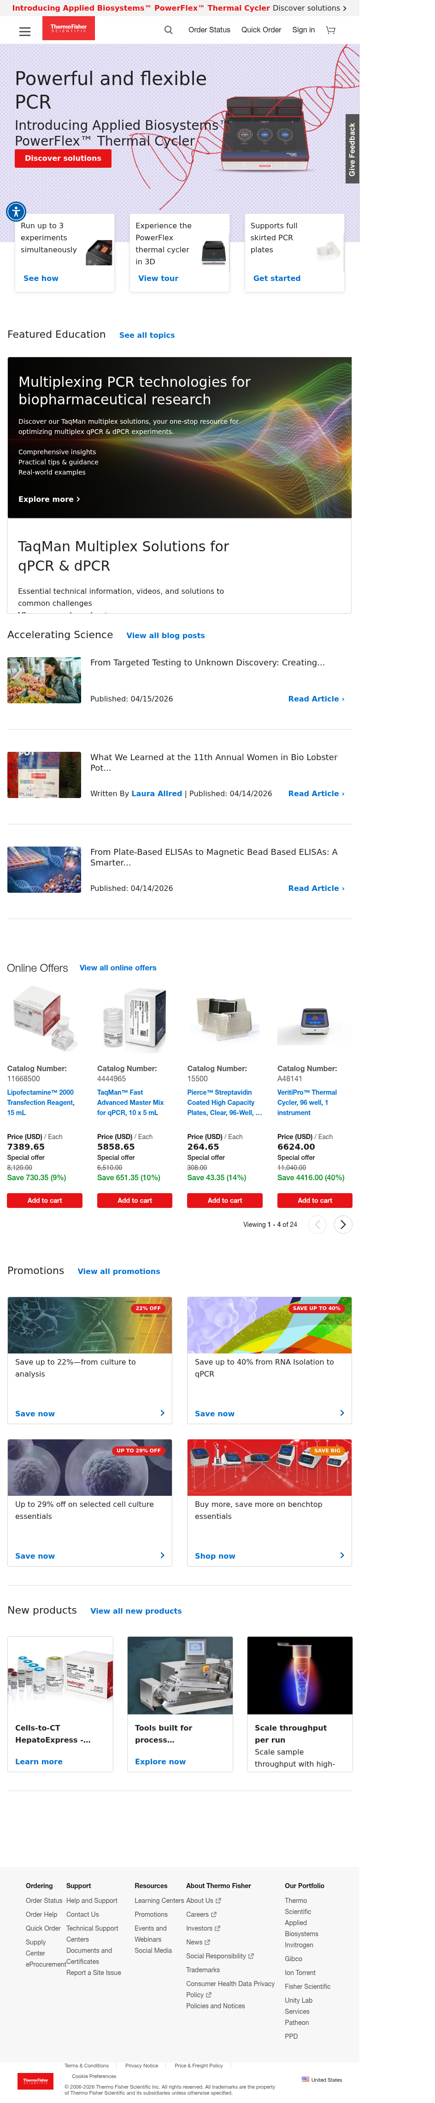
T1: Homepage — gehealthcare.com/en-us

T2: Product Category
T2: Product Category — Ultrasound

T3: Product Detail (PDP)
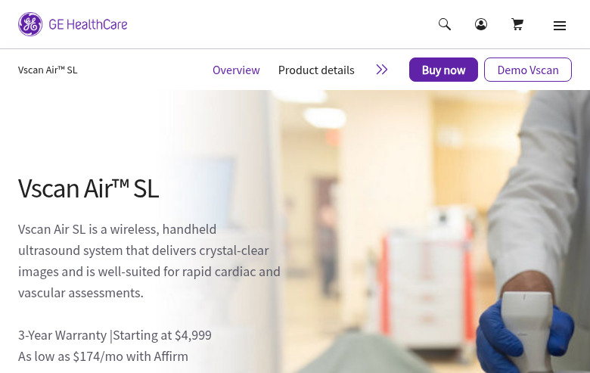
T3: Product Detail (PDP) — Vscan Air SL

T4: Insights Hub
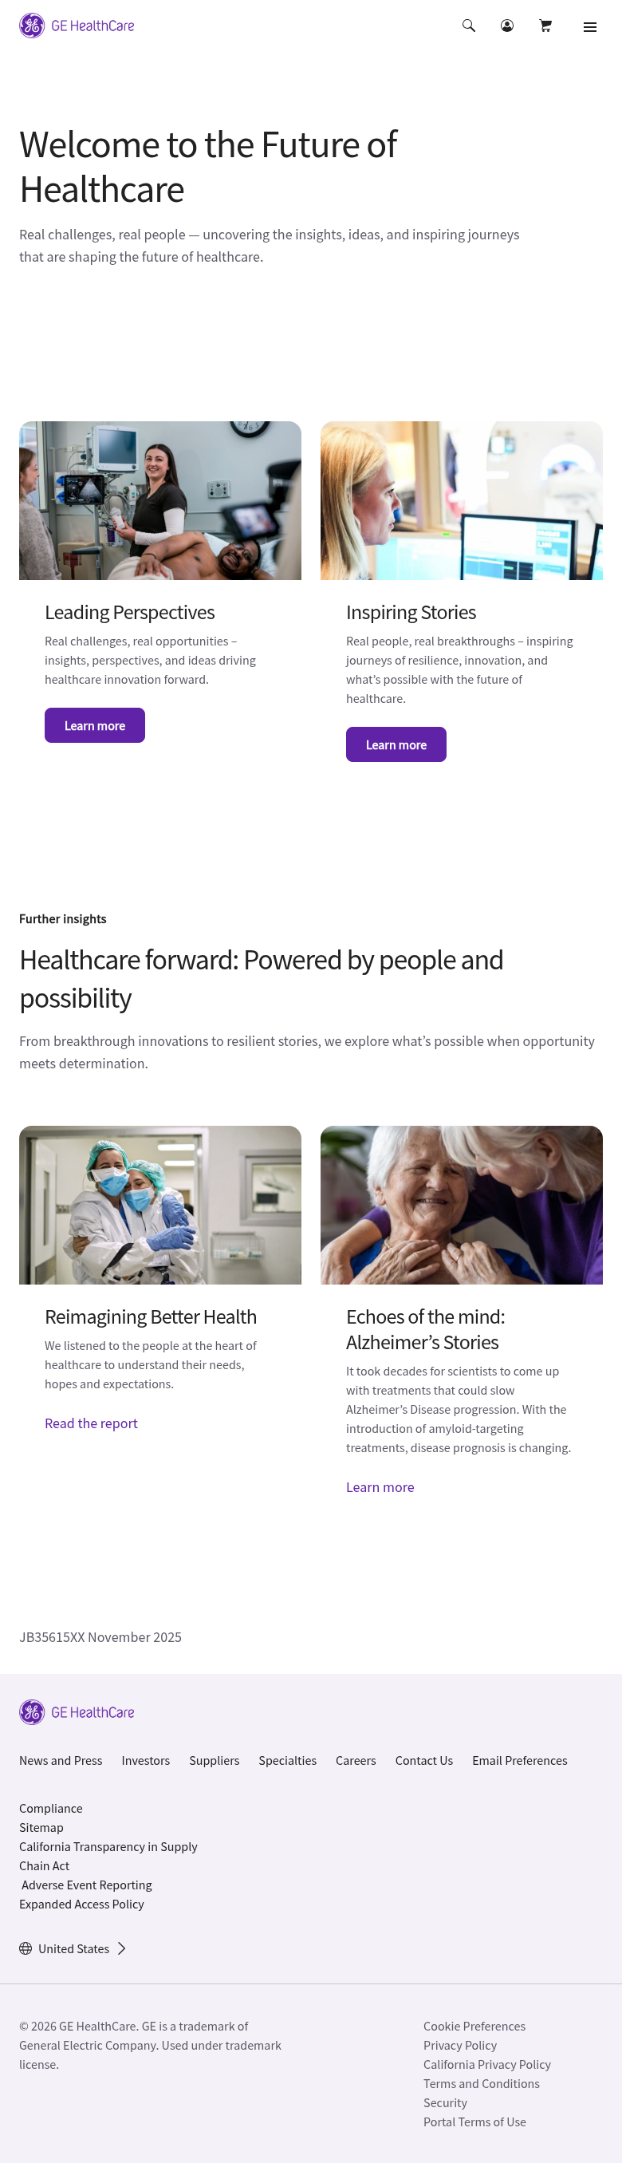
T4: Insights Hub

T5: Article/Content
T5: Article/Content — Five Key Trends

T6: Contact Us
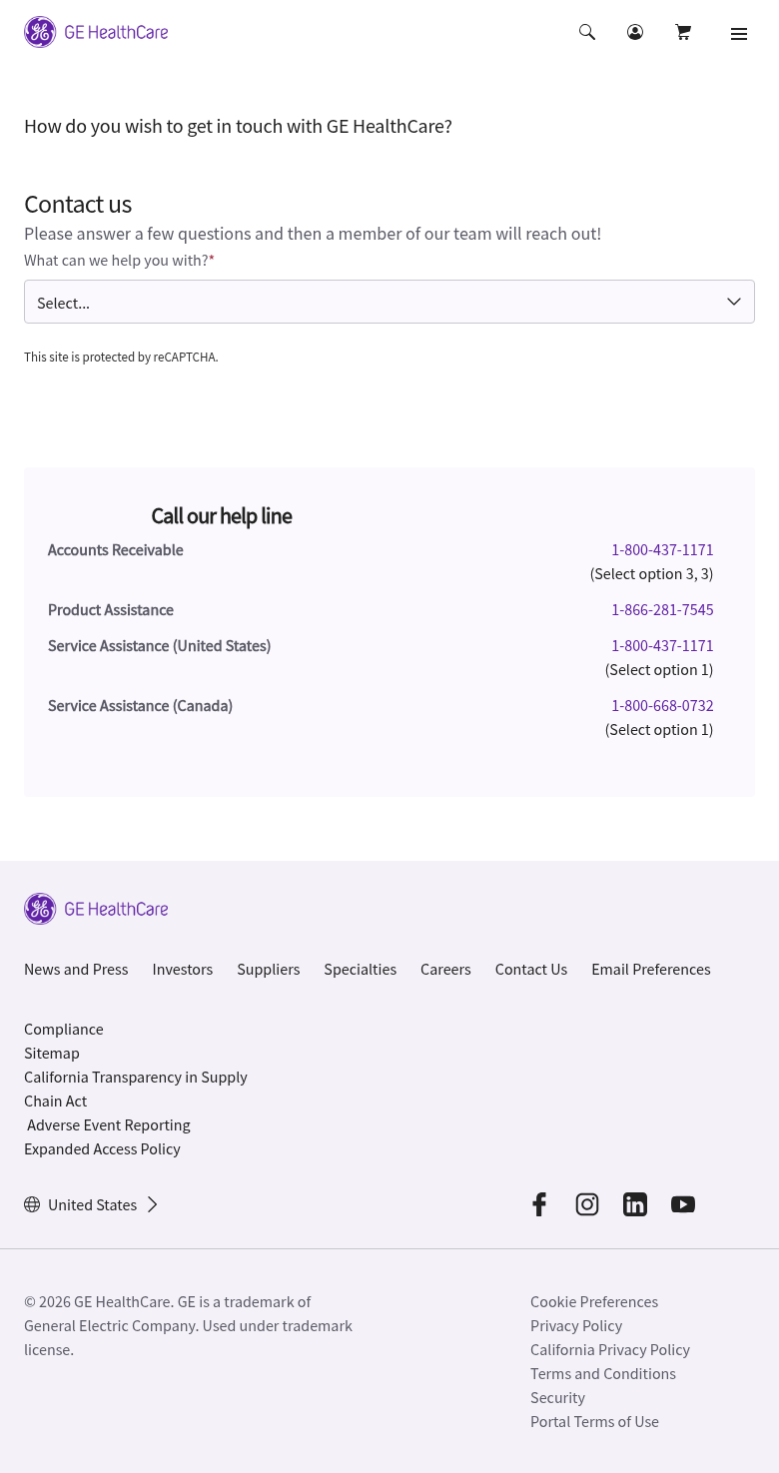
T6: Contact Us

T7: Specialties Hub
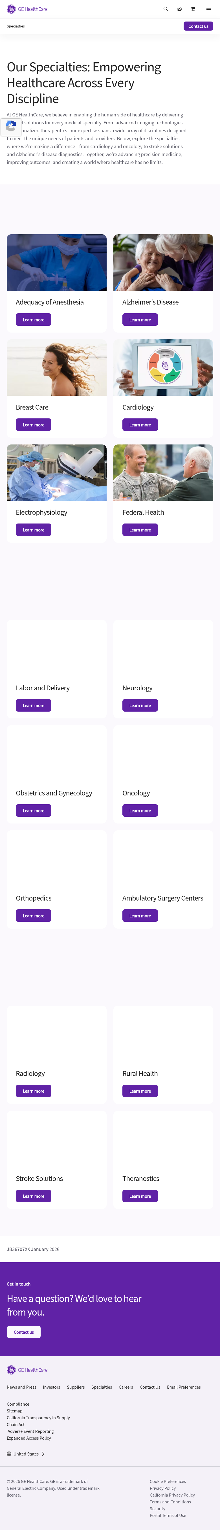
T7: Specialties Hub

T9: Services (most complex template)
T9: Services (most complex template)

T10: Shop/eCommerce (Sitecore JSS
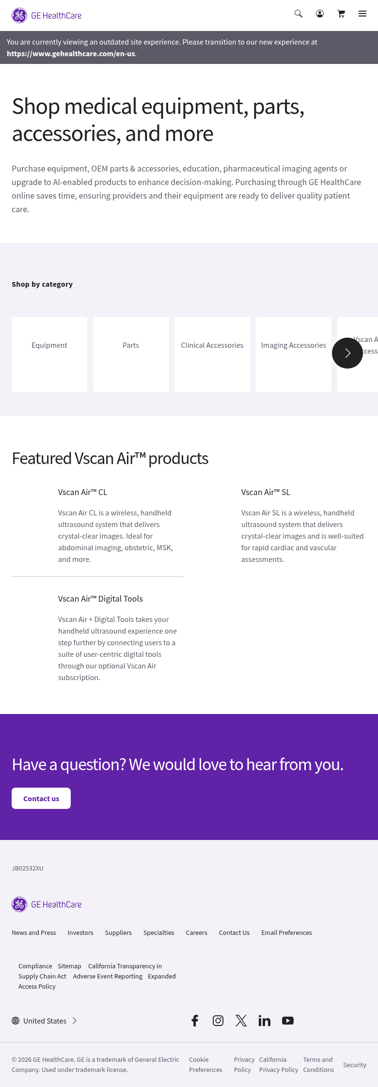
T10: Shop/eCommerce (Sitecore JSS — legacy)

T13: Newsroom/Press
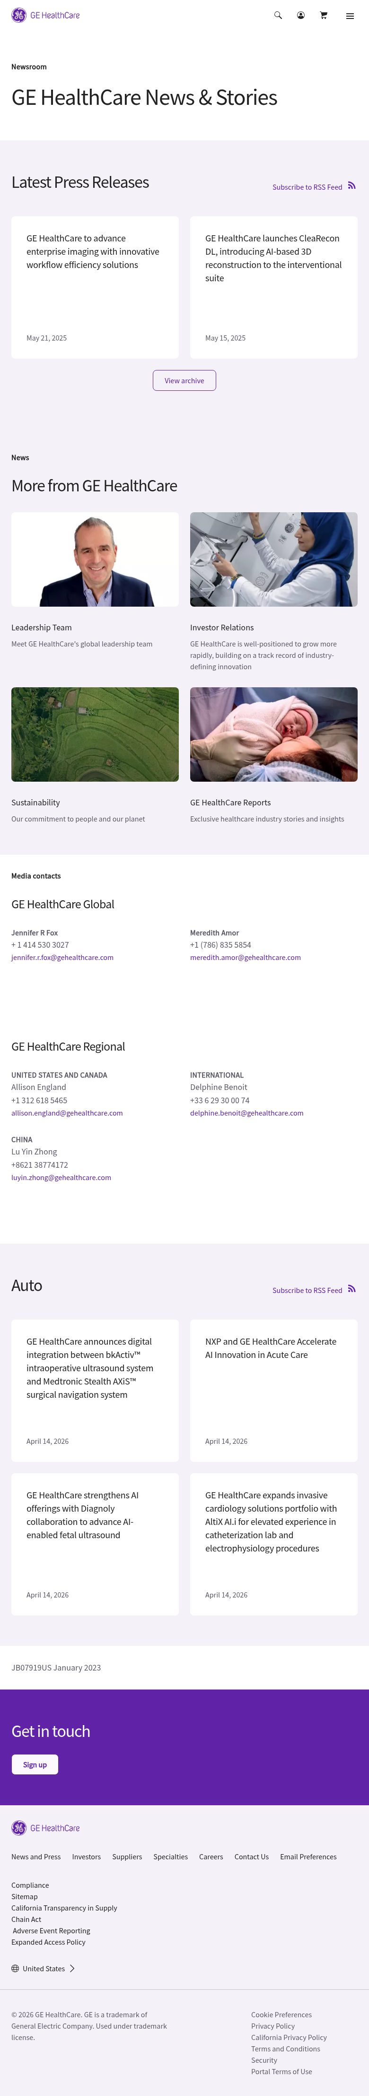
T13: Newsroom/Press

