ThermoFisher.com

AEM AMS to Edge Delivery Services
Migration Analysis Report

Date: April 15, 2026
Source: https://www.thermofisher.com/us/en/home.html
Scope: US English site (do not go into subdomains)
Current Platform: Adobe Experience Manager (AMS)

Table of Contents
- 1. High-Level Summary
- 2. Templates Inventory
- 3. Blocks Catalog
- 4. Page Counts by Template
- 5. Integrations Analysis
- 6. Forms Analysis
- 7. Offers / Personalization Analysis
- 8. Complex Use Cases & Observations
- 9. Outlier Scenarios
- 10. Migration Estimates
- 11. Template Screenshots

1. High-Level Summary

1.1 Site Scale
Metric | Count
US/EN CMS Content Pages (from sitemap) | ~11,595
Product Catalog Pages (/order/catalog/product/) | ~400,000
Antibody Product Pages (/antibody/product/) | ~500,000-800,000
Product FAQ Pages | ~34,000
Product Citation Pages | ~94,000
Total Indexed URLs (entire domain) | ~1.2-1.5 million
Locale Variants (36 country/language sitemaps) | ~200,000-250,000 CMS pages
Max URL Depth | 11 levels (bulk at depth 4-5)

1.2 Thematic Page Breakdown (US/EN CMS pages)
Category | Pages | Type
Life Science | 3,483 | Product/Technology Marketing
Industrial | 1,967 | Product/Technology Marketing
References/Protocols | 1,547 | Technical Resources
Products & Services | 835 | Marketing / eCommerce Hub
Clinical | 639 | Product/Technology Marketing
Technical Resources | 637 | Support & Learning
About Us / Corporate | 567 | Corporate/Company
Electron Microscopy | 418 | Product Marketing
Materials Science | 282 | Product Marketing
Brands | 250 | Brand Marketing
Bioprocessing | 219 | Application Marketing
Chemicals | 163 | Product Marketing
Virtual Tours | 111 | Interactive/3D
Events | 86 | Marketing Events
Other (30+ sections) | ~300 | Mixed

1.3 Pages by Content Type
Type | Estimated % | Estimated Pages
Static Authored (CMS) | ~85% | ~9,850
Dynamic/API-Driven | ~10% | ~1,160
Hybrid (Static + Dynamic) | ~5% | ~585

1.4 Pages Integrated with eCommerce
- Product Detail Pages (PDP): ~400,000+ (separate React SPA, NOT AEM-managed)
- Store pages (/store/v2/): Quick Order, Contact Us, Order Status - separate app, auth-gated
- Homepage has embedded eCommerce carousel with Add-to-Cart functionality

1.5 Pages Fed from Other Systems
- Blog posts (/blog/) - WordPress or similar CMS
- Corporate site (corporate.thermofisher.com) - separate AEM instance
- Careers (jobs.thermofisher.com) - recruitment platform
- Investor Relations (ir.thermofisher.com) - IR platform
- Newsroom (newsroom.thermofisher.com) - news/PR platform

1.6 Current Tech Stack & Design System Analysis
The site runs on multiple coexisting technology stacks:
System | Technology | Scope
CMS | Adobe Experience Manager (AMS) | All /us/en/ content pages
Design System | Komodo (kmd-* classes) | Homepage, modern pages
Component System | AEM Core Components (cmp-*) | Modern content pages
Legacy CMS | AEM Classic (parsys, cq-*) | Older category/brand pages
eCommerce | Custom React SPA (pdp-*, pragma-*) | Product pages, store
Search | Endeca (SearchBar v2) | All pages (header)
JavaScript | jQuery 3.7.1 + jQuery Migrate 3.4.1 | All AEM pages
Analytics | Adobe Experience Platform (Alloy 2.23) | All pages
Tag Manager | Adobe Launch | All pages
Personalization | Adobe Target | Homepage, category pages

Key Observation: No unified design system exists. Multiple coexisting systems (Komodo, AEM Core Components, AEM Classic, Store Platform) indicate organic growth over time. This is a significant consideration for EDS migration as design tokens and patterns must be unified.

2. Templates Inventory
# | Template Name | Complexity | Example URL | Description
T1 | Homepage | High | /us/en/home.html | Hero pods, product carousel (API-driven), blog cards, promotional cards, eCommerce integration. Uses kmd-* Komodo design system + cmp-* AEM components. Hybrid static + dynamic content.
T2 | Category Hub (Full-Width) | Medium | /us/en/home/life-science/antibodies.html | Hero with text overlay, icon link lists, card grids, section dividers. Modern AEM with cmp-* components and aem-Grid responsive layout.
T3 | Category Hub (Sidebar) | Medium | /us/en/home/life-science/pcr.html | Left sidebar navigation + main content area. AEM Classic with parsys containers. Carousel banners, product filmstrips, 3-column link grids.
T4 | Brand Page (Text-Heavy) | Medium | /us/en/home/brands/thermo-scientific.html | Left sidebar with categorized links, anchor navigation, 2-column product link lists. AEM Classic.
T5 | Brand Page (Visual) | Medium | /us/en/home/brands/gibco.html | Full-width, card-grid layout with Brightcove video integration, promotional CTAs. No sidebar.
T6 | Solutions/Application Landing | Medium | /us/en/home/bioprocessing.html | Full-width hero, anchor navigation, alternating image+text content blocks, video embeds. Modern AEM cmp-* components.
T7 | Product Directory | Medium | /us/en/home/order.html | Collapsible table-of-contents, 3-column category link grids, API-loaded promo teasers.
T8 | Promotions Hub | Low | /us/en/home/products-and-services/promotions.html | Minimal static shell, filter buttons, dynamic promotional card grid loaded via API.
T9 | Technical Resource/Support | Low-Med | /us/en/home/support.html | Content-focused pages with link lists, resource cards.
T10 | Events Page | Medium | /us/en/home/events.html | Dynamic event listings, likely API-driven.
T11 | Product Detail Page (PDP) | High | /order/catalog/product/11965092 | NOT AEM - React SPA with web components. Full eCommerce: pricing, stock, add-to-cart, tabs, citations, Q&A.
T12 | Search Results | High | /search/results?query=antibodies | NOT AEM - Standalone JS SPA with faceted search, filters, pagination.
T13 | Store/Commerce App | High | /store/v2/quick-order | NOT AEM - Separate auth-gated application.
T14 | Specialty Subsites | Low-Med | /allergy/, /onelambda/, /bindingsite/ | Smaller microsites with locale variants, simpler layouts.

3. Blocks Catalog
# | Block Name | Complexity | Description | Reference | Standard EDS? | Backend Needed? | LLM-Ready? | UI Extension?
B1 | Global Header | High | Logo, mega-nav with multi-level dropdowns, search bar (SearchBar v2 with Endeca), utility links, promotional offer banner, hamburger mobile menu | All pages | No - custom build | Yes (search API, cart API, auth) | No | No
B2 | Global Footer | Medium | 6-column link grid (Ordering, Support, Resources, About, Portfolio, Brands), legal links, copyright, country selector | All pages | No - custom build | No | No | No
B3 | Hero Pod | Medium | Large hero image + headline + subtitle + CTA button, with 3 sub-hero cards below | Homepage | Variant of Hero | No | Yes | No
B4 | Page Heading Hero | Low | Text overlay hero with H1, subtitle, optional CTA | Category pages | Variant of Hero | No | Yes | No
B5 | Product Offers Carousel | High | Scrollable product cards with images, pricing, "Add to cart" buttons. API-loaded from Adobe Target recommendations | Homepage | No - custom build | Yes (Target, pricing, cart API) | No | No
B6 | Promotional Cards | Medium | Image + headline + CTA + badge label (e.g., "22% OFF"). Grid layout | Homepage, Promotions | Variant of Cards | No | Yes | No
B7 | Education/Featured Cards | Medium | Large featured card with image, description, bullet list + smaller companion cards | Homepage | Variant of Cards | No | Yes | No
B8 | Blog/Article Cards | Low | Image + title + author + date + "Read Article" link. 3-column grid | Homepage | Variant of Cards | Possibly (blog API) | Yes | No
B9 | New Product Cards | Low | Image + headline + CTA link. 3-column grid | Homepage | Variant of Cards | No | Yes | No
B10 | Category Link Grid | Low | 3-column or 2-column lists of category links, sometimes with icons | Category hubs | Variant of Columns | No | Yes | No
B11 | Sidebar Navigation | Medium | Left sidebar with categorized link lists, collapsible sections | Brand/Category pages | No - custom build | No | Yes | No
B12 | Anchor Navigation | Low | In-page scroll navigation with anchor links to sections | Brand/Solutions pages | No - custom build | No | Yes | No
B13 | Image + Text (Alternating) | Low | Side-by-side image and text blocks, alternating left/right | Solutions pages | Variant of Columns | No | Yes | No
B14 | Video Player | Medium | Brightcove/Video.js embedded player for product videos | Brand pages | No - custom (Brightcove) | Yes (Brightcove) | No | No
B15 | Product Filmstrip/Carousel | Medium | Horizontal scrolling product cards with prev/next | Category pages | Variant of Carousel | No | Yes | No
B16 | Promotional Banner Bar | Low | Top-of-page promotional bar with rotating text + link | All pages (header) | No - custom build | Possibly (personalization) | No | No
B17 | Table of Contents (Collapsible) | Low | Expandable/collapsible navigation for long content pages | Product Directory | No - custom build | No | Yes | No
B18 | Filter Buttons | Low | Client-side content filtering (All, Percentage Off, Special Deal) | Promotions page | No - custom build | No | Yes | No
B19 | Contact Department Cards | Medium | 6 clickable department selection cards for customer service routing | Contact page | Variant of Cards | Yes (routing, chat) | No | No
B20 | Dynamic Offer/Teaser | Medium | API-loaded promotional teasers using Adobe Target | Homepage, various | No - custom build | Yes (Adobe Target) | No | No
B21 | Search Bar | High | Full-featured search with category selector, autocomplete, Endeca provider | All pages (header) | No - custom build | Yes (Endeca/search API) | No | No
B22 | Cookie Consent Banner | Low | TrustArc-powered cookie preferences modal | All pages | No - TrustArc integration | Yes (TrustArc) | No | No
B23 | Separator | Low | Horizontal rule divider between sections | Many pages | Yes - standard EDS | No | Yes | No
B24 | CTA List | Low | Grouped call-to-action buttons | Category pages | Variant of Buttons | No | Yes | No
B25 | Section Container | Low | Wrapper component for grouping content sections | Modern AEM pages | Yes - EDS Section | No | Yes | No
B26 | Feedback Button | Low | Kampyle/Medallia feedback widget trigger | All pages | No - Kampyle integration | Yes (Kampyle SDK) | No | No
B27 | Chat Launcher | Medium | Vue.js-based chat widget from chat-api.thermofisher.com | All pages | No - custom build | Yes (chat API) | No | No
B28 | Accessibility Menu | Low | UserWay accessibility widget with skip-to-content, navigation aids | All pages | No - UserWay integration | Yes (UserWay) | No | No
B29 | Country Selector | Low | Country/locale picker with flag icons | Footer | No - custom build | No | Yes | No

4. Page Counts by Template
Template | Est. Pages | Auto-Migratable? | Notes
T1: Homepage | 1 | No - Manual | Complex hybrid layout, API-driven content
T2: Category Hub (Full-Width) | ~2,000 | Partially | Static content migratable; dynamic elements need rebuild
T3: Category Hub (Sidebar) | ~3,000 | Partially | Sidebar nav pattern needs custom EDS block
T4: Brand Page (Text-Heavy) | ~100 | Partially | Individually authored - no single template
T5: Brand Page (Visual) | ~150 | Partially | Video integration needs Brightcove setup
T6: Solutions/Application Landing | ~500 | Partially | Anchor nav and alternating blocks need custom work
T7: Product Directory | ~50 | No - Manual | Collapsible TOC, massive link directories
T8: Promotions Hub | ~50 | No - Manual | Primarily API-driven content
T9: Technical Resource/Support | ~2,500 | Yes - Automated | Mostly static authored content
T10: Events Page | ~100 | No - Manual | Dynamic event listings
T11: PDP (React SPA) | ~400,000 | OUT OF SCOPE | Not AEM content - separate commerce platform
T12: Search Results (SPA) | N/A | OUT OF SCOPE | Standalone application
T13: Store/Commerce App | N/A | OUT OF SCOPE | Separate auth-gated application
T14: Specialty Subsites | ~500 | Yes - Automated | Simpler layouts, static content

Migration Classification Summary
Classification | Pages | % of Total | Description
Automatically Migratable | ~4,000 | 35% | Standardized templates, static data
Semi-Automated Migration | ~5,850 | 50% | Template conversion + manual adjustments
Manual Migration | ~1,745 | 15% | Dynamic, custom, complex logic
Out of Scope | ~400,000+ | N/A | eCommerce PDP, Search, Store - not AEM CMS content

5. Integrations Analysis
# | Integration | Type | Complexity | Client/Server | Active?
I1 | Adobe Experience Platform (AEP) Web SDK / Alloy | Analytics/CDP | High | Client | Active
I2 | Adobe Launch (DTM) | Tag Manager | Medium | Client | Active
I3 | Adobe Target | Personalization | High | Client + Server | Active
I4 | Endeca Search | Search Engine | High | Client + Server | Active
I5 | Kampyle / Medallia | Feedback/Survey | Medium | Client | Active
I6 | TrustArc | Cookie Consent | Low | Client | Active
I7 | UserWay | Accessibility | Low | Client | Active
I8 | Brightcove / Video.js | Video Hosting | Medium | Client | Active
I9 | Chat Widget (Vue.js) | Live Chat | Medium | Client + Server | Active
I10 | eCommerce / Cart API | Commerce | High | Client + Server | Active
I11 | jQuery + jQuery Migrate 3.4.1 | Legacy Framework | Low | Client | Active (deprecated)
I12 | Signals Search Analytics | Search Analytics | Low | Client | Active
I13 | Store Platform (React) | eCommerce SPA | High | Client + Server | Active

6. Forms Analysis
# | Form Type | Complexity | Sample URL | Backend Integration
F1 | Search Form (Header) | High | All pages - #smartsearch | Endeca search API
F2 | Contact Us Form | Medium | /store/v2/contact-us?enableChat=true | Store platform (not AEM)
F3 | Sign In / Account | High | Account dropdown | Auth system (SSO/OAuth)
F4 | Quick Order | High | /store/v2/quick-order | Store/cart API (auth-gated)
F5 | Add to Cart | Medium | Homepage carousel, PDP | Cart API (/api/store/)
F6 | Cookie Preferences | Low | All pages (TrustArc modal) | TrustArc
F7 | Feedback Form | Low | All pages (Kampyle widget) | Kampyle/Medallia

7. Offers / Personalization Analysis
# | Offer Type | Complexity | Sample URL | Backend
O1 | Header Promotional Banner | Medium | All pages - rotating offer bar | Likely Adobe Target or authored
O2 | Online Offers Carousel | High | Homepage - 24 products with pricing | Adobe Target recommendations + Pricing API
O3 | Dynamic Teasers | Medium | Various pages - aem-offer-container | Adobe Target
O4 | Promotional Cards (Curated) | Low | Homepage "Promotions" section | Authored (static)
O5 | Product-Level Promotions | Medium | PDP - promo badges, coupon codes | Store API

8. Complex Use Cases & Observations
# | Use Case | Instances | Where Found | Why It's Complex
C1 | Multi-Platform Architecture | Site-wide | Header, PDP, Search, Store | Three separate tech stacks (AEM Classic, Modern AEM, React Store) must be unified or integrated
C2 | Adobe Target Personalization | ~50+ pages | Homepage, category pages | Dynamic content loaded via Target API requires edge-side personalization in EDS
C3 | Endeca Search Integration | All pages | Header search bar | Deep search integration with category-specific focus areas, autocomplete
C4 | eCommerce Cart on CMS Pages | Homepage + others | "Add to cart" buttons on authored pages | CMS pages embed live commerce functionality (pricing, stock, cart)
C5 | Mega Navigation (Multi-Level) | All pages | Header | Complex mega-nav with dynamic content, popular products, images
C6 | Brand Page Inconsistency | ~250 pages | /us/en/home/brands/* | No consistent template - each brand page is individually authored with different layouts
C7 | Legacy jQuery Dependency | All AEM pages | Global scripts | jQuery Migrate 3.4.1 + deprecated API usage throughout
C8 | 36 Locale Variants | ~250,000 pages | Entire site | Multi-country, multi-language with locale-specific content and redirects
C9 | Aggressive Redirects | Multiple pages | support.html -> order.html | URL-level routing that transforms CMS paths to app endpoints
C10 | Chat Widget (Custom Vue.js) | All pages | Footer/floating | Custom-built chat launcher needs reimplementation or embedding strategy

9. Outlier Scenarios
# | Scenario | Behavior | Implementation | Effort Estimate
OS1 | Product Offers Carousel (Homepage) | Full section rendered via API - Target recommendations -> pricing API -> cart API. No static fallback. | Custom EDS block with edge worker for API orchestration | 40-60 hours
OS2 | Product Detail Pages (400K+ pages) | Entire page is a React SPA with web components (core-tooltip, core-quantityselector, etc.) | Keep as separate app or rebuild as EDS + edge workers | Out of scope / 500+ hrs
OS3 | Search Results SPA | Client-side rendered, anti-bot protections, faceted search with filters | Keep as separate app or integrate EDS-compatible search | Out of scope / 200+ hrs
OS4 | Virtual/3D Tours (111 pages) | Interactive 3D product experiences | Embed strategy in EDS iframe/web component | 20-30 hours
OS5 | Dynamic Offer Containers | aem-offer-container divs filled by Target at runtime | Edge worker or client-side personalization in EDS | 30-40 hours
OS6 | Blog Integration | Blog posts from /blog/ subdirectory (likely WordPress) | RSS/API feed integration or migrate to EDS | 40-80 hours

10. Migration Estimates

Scope Definition
In-Scope for EDS Migration: ~11,595 US/EN CMS content pages
Out of Scope: PDP (React SPA), Search Results (SPA), Store App (auth-gated), external subdomains

Effort Breakdown
Phase | Activity | Hours | Days (1 FTE)
Phase 1: Foundation | Design system extraction & EDS CSS custom properties | 80 | 10
 | Global header block (mega-nav + search + cart integration) | 120 | 15
 | Global footer block | 40 | 5
 | Core EDS block library (23+ custom blocks) | 320 | 40
 | Edge worker setup (personalization, pricing APIs) | 80 | 10
Phase 2: Templates | Template T2 (Category Hub Full-Width) - ~2,000 pages | 160 | 20
 | Template T3 (Category Hub Sidebar) - ~3,000 pages | 200 | 25
 | Template T9 (Technical Resources) - ~2,500 pages | 120 | 15
 | Template T6 (Solutions Landing) - ~500 pages | 80 | 10
 | Template T4/T5 (Brand Pages) - ~250 pages | 80 | 10
 | Templates T1, T7, T8, T10, T14 - ~700 pages | 120 | 15
Phase 3: Integrations | Adobe Target personalization in EDS | 80 | 10
 | Endeca search integration | 60 | 8
 | eCommerce/Cart API integration | 80 | 10
 | Chat widget migration | 40 | 5
 | Analytics (AEP/Launch) migration | 40 | 5
 | Third-party integrations (UserWay, TrustArc, Kampyle, Brightcove) | 60 | 8
Phase 4: Content | Automated content import (~4,000 pages) | 120 | 15
 | Semi-automated content import (~5,850 pages) | 320 | 40
 | Manual content migration (~1,745 pages) | 240 | 30
Phase 5: QA | Visual regression testing | 120 | 15
 | Functional testing (forms, search, cart, navigation) | 80 | 10
 | Performance testing & optimization (Lighthouse 100) | 60 | 8
 | Accessibility testing (WCAG 2.1 AA) | 60 | 8
 | UAT & stakeholder review | 80 | 10
Phase 6: Locales | Multi-locale setup & content migration (35 additional locales) | 400 | 50

Summary
Category | Hours | Days
Foundation (Design + Blocks + Infra) | 640 | 80
Template Migration | 760 | 95
Integrations | 360 | 46
Content Migration | 680 | 85
QA & Testing | 400 | 51
Locale Rollout | 400 | 50
TOTAL (US/EN only) | 2,840 | ~355
TOTAL (All locales) | 3,240 | ~405

Team Recommendation
With a team of 4-5 FTEs (2 frontend developers, 1 integration specialist, 1 content migration specialist, 1 QA engineer):
- US/EN migration: ~4-5 months
- Full multi-locale migration: ~6-7 months
- Total calendar time with buffer: ~8-9 months

11. Template Screenshots
The following screenshots capture representative pages for each identified template type.

T1: Homepage
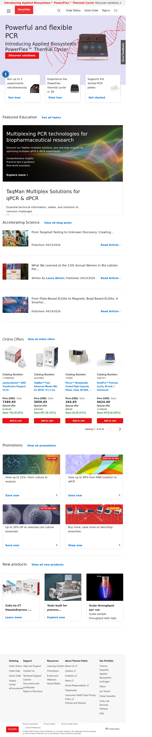
T1: Homepage - thermofisher.com/us/en/home.html

T2: Category Hub (Full-Width)
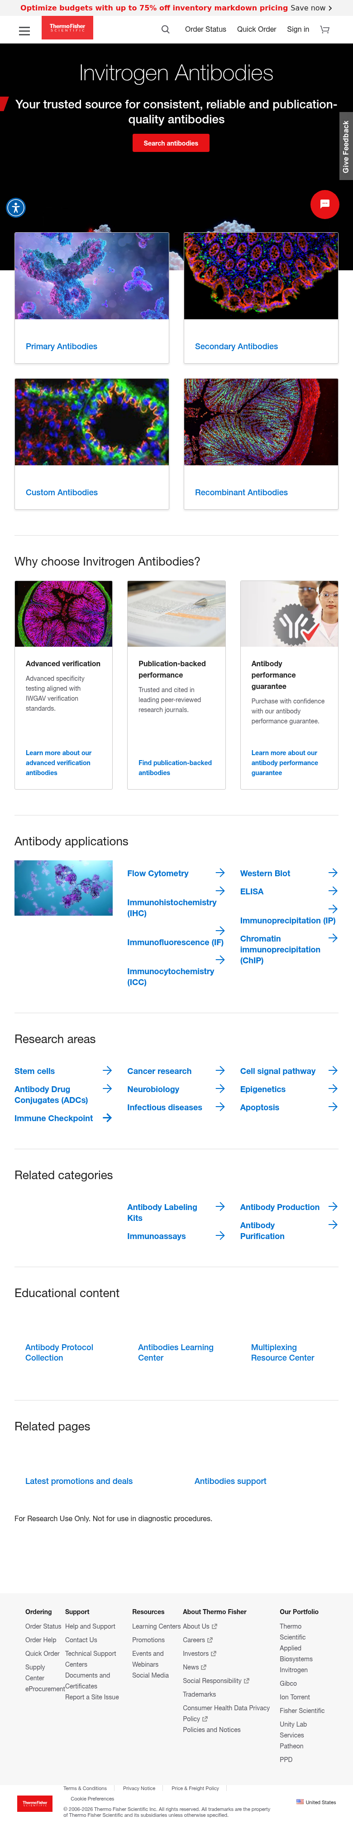
T2: Category Hub (Full-Width) - Antibodies page

T3: Category Hub (Sidebar)
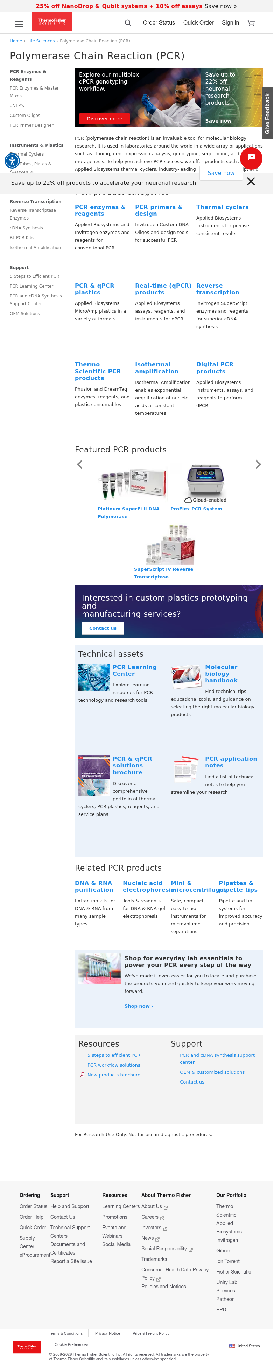
T3: Category Hub (Sidebar) - PCR page

T4: Brand Page (Text-Heavy)
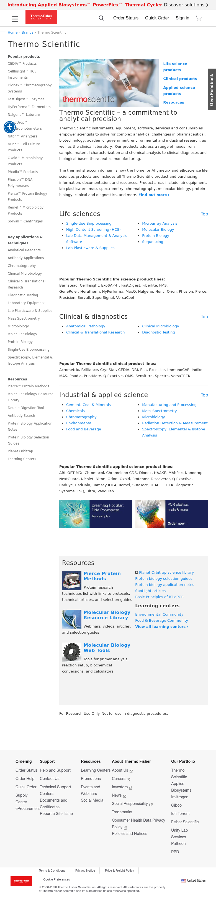
T4: Brand Page (Text-Heavy) - Thermo Scientific

T5: Brand Page (Visual)
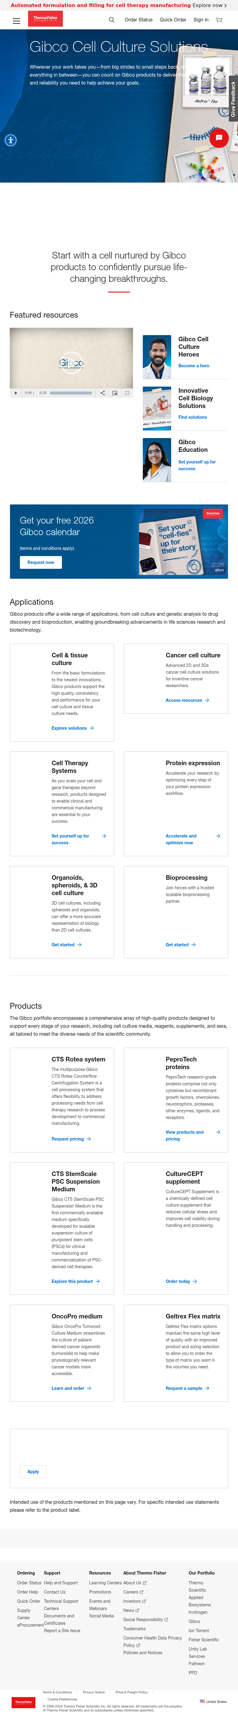
T5: Brand Page (Visual) - Gibco

T6: Solutions/Application Landing
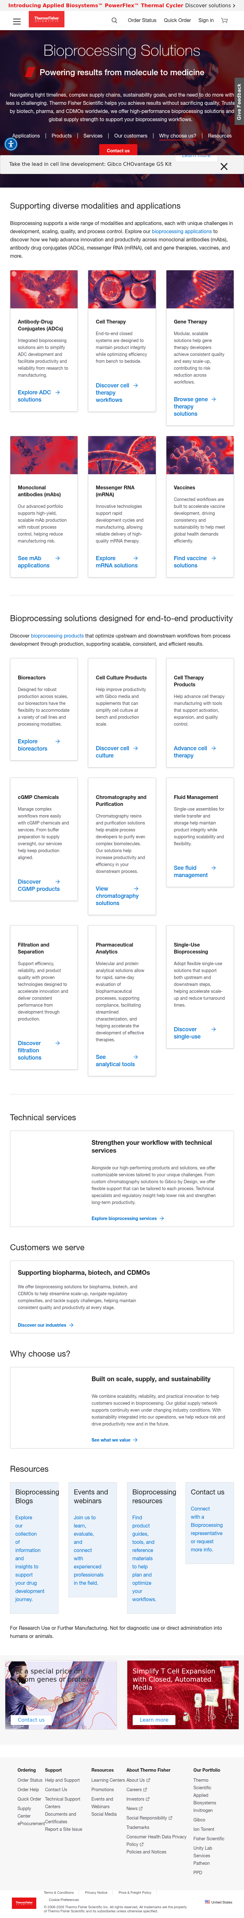
T6: Solutions/Application Landing - Bioprocessing

T8: Promotions Hub
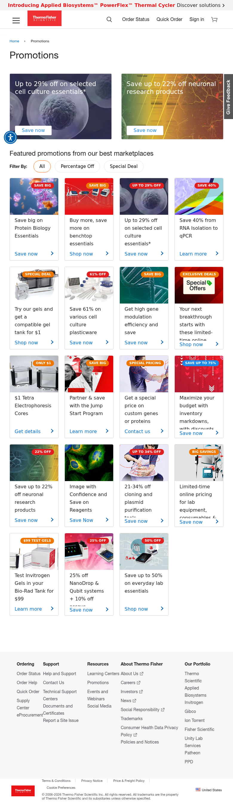
T8: Promotions Hub

T11: Product Detail Page (PDP)
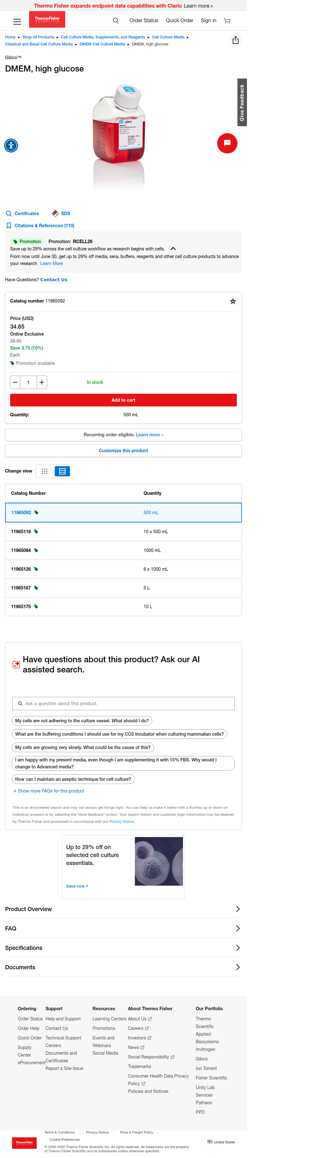
T11: Product Detail Page (PDP) - React SPA

