Thermo Fisher Scientific
US Locale (thermofisher.com/us/en/)
AEM-to-EDS Migration Assessment
Version 1.0 | March 15, 2026
CONFIDENTIAL

Executive Summary
This document provides a comprehensive migration assessment for thermofisher.com US locale (/us/en/) from Adobe Experience Manager (AMS) to Adobe Edge Delivery Services (EDS). The assessment covers technology stack analysis, page inventory, component catalog, integrations analysis, and a phased migration plan with effort estimates.

Metric | Value
CMS Content Pages (US Locale) | 12,161
Supplementary Pages (Product Catalog, Antibodies, etc.) | ~911,826 (out of EDS scope)
Unique Page Templates | 16
Reusable Blocks/Components | 48
Third-Party Integrations | 23
Web Forms Identified | 12
Design Variations (Same Content Model) | 15
Locales Served | 35 (23 countries, 9 languages)
Estimated Migration Duration | 7-9 months (realistic)
Estimated Team Size | 8-12 people

1. Current Technology Stack
The site is built on Adobe Experience Manager (AMS) with a server-rendered HTML architecture, supplemented by multiple client-side systems for commerce, personalization, and analytics.

Layer | Technology | Details
CMS | Adobe Experience Manager (AMS) | Server-rendered pages, AEM client libraries (/etc/designs/komodo/)
Frontend Framework | Vanilla JS + jQuery Migrate 3.4.1 | No SPA framework; progressive enhancement; BEM CSS
Commerce (Out of Scope) | Custom Java/AEM + React SPA | /order/, /store/ paths; React/Redux for product catalog
Blog (Out of Scope) | WordPress | acceleratingscience.com; API-fed into homepage
Search | Lucidworks Fusion | Migrated from Oracle Endeca; typeahead autocomplete
Analytics | Adobe Analytics + AEP/Alloy v2.23 | digitalData layer; edge.adobedc.net data collection
Tag Management | Adobe Launch (Experience Platform Tags) | assets.adobedtm.com; multiple extension bundles
Personalization | Adobe Target + DM Dynamic Offers | Pre-hiding containers; server-side offer injection
Authentication | Custom SSO + Gigya/SAP CDC | identity.thermofisher.com; /auth/initiate flow
CDN / Security | Akamai | Bot management, edge caching, WAF
Cookie Consent | TrustArc | GDPR compliance; consent.truste.com
Chat | Custom + Magellan GenAI (feature-flagged) | chat-api.thermofisher.com; Vue.js-based
Accessibility | UserWay | Widget overlay; account P3pDlQucOz
Feedback | Medallia / Kampyle | Form ID 29308; floating button
Design System | HelveticaNeue, 11 weights, WOFF2 | 7 breakpoints; #e71316 brand red

2. Integrations Analysis
23 third-party integrations identified across the site. Each integration is classified by type and complexity for migration planning.

# | Integration | Type | Complexity | Reference / Evidence
1 | Adobe Analytics | Embed / API | Medium | _satellite object, digitalData layer on all pages
2 | Adobe Experience Platform (Alloy) | API / SDK | High | alloy.min.js v2.23.0, edge.adobedc.net
3 | Adobe Launch (EP Tags) | Embed | High | assets.adobedtm.com, multiple RC bundles
4 | Adobe Target | API | High | /api/store/recommendations/recommendation/target/attributes
5 | DM Dynamic Offers | Custom Code | High | /dm-offers/offers.min.js; CSS template injection
6 | OOB Recommendation Engine | API | Medium | /api/store/recommendations/oobRecommendation/
7 | Price & Availability API | API | High | /api/store/recommendations/priceandavail (POST, 24 items/batch)
8 | TF Identity Service | Custom Code | High | identity.thermofisher.com; /auth/initiate SSO
9 | Gigya / SAP CDC | Plugin | Medium | digitalData.user.gigyaId field
10 | Lucidworks Fusion | Embed / API | High | /search/searchbar/, /search/static/resources/js/signals.min.js
11 | Custom Chat System | Embed / API | High | chat-api.thermofisher.com; eligibility API; Vue.js app
12 | Magellan GenAI Chat | API (Feature-flagged) | High | Cookie ts_magellan_genai; A/B tested
13 | TrustArc | Embed | Medium | consent.truste.com/notice; Accept/Reject/Manage
14 | Akamai CDN + Bot Mgmt | Infrastructure | High | akacd_TFCOM_Prod_AWS_Publish; bot detection scripts
15 | UserWay Accessibility | Embed | Medium | cdn.userway.org/widgetapp/; API tunings
16 | Medallia / Kampyle | Embed | Medium | nebula-cdn.kampyle.com; form IDs 29308, 46937
17 | WordPress Blog API | API | Medium | admin.acceleratingscience.com/wp-json/as-api/v1/blog-feed
18 | MasterControl | External Link | Low | thermofisher.mastercontrol.com (privacy policy)
19 | Adobe Cart System | API | High | /api/store/carts/{cartId}/minicart; cartV3Enabled
20 | jQuery Migrate 3.4.1 | Embed | Low | Legacy compatibility; deprecated APIs in use
21 | Hotjar | Embed | Low | Cookie _hjSessionUser_4539 (corporate subdomain)
22 | Form Security (CSRF) | Custom Code | Low | Cookie formSecurity
23 | TrustArc GTM Bridge | Plugin | Low | gtm=true parameter in consent notice

3. Pages and Assets Inventory

3.1 CMS Content Pages (In EDS Scope)
The US locale sitemap (sitemap-us-en.xml) contains 12,161 CMS-authored pages. These are the pages targeted for EDS migration.

Section | Page Count | % of Total | Avg Depth
Life Science | 3,476 | 28.6% | 4-5
Industrial | 1,978 | 16.3% | 4-5
References / Protocols | 1,545 | 12.7% | 3-4
Technical Resources | 1,223 | 10.1% | 3-4
Products & Services (incl. Promotions) | 837 | 6.9% | 3-4
Clinical | 628 | 5.2% | 4-5
About Us / Events | 573 | 4.7% | 2-3
Electron Microscopy | 418 | 3.4% | 3-4
Materials Science | 282 | 2.3% | 3-4
Brands | 250 | 2.1% | 2-3
Bioprocessing | 215 | 1.8% | 3-4
Chemicals | 169 | 1.4% | 3-4
Virtual / 3D Tours | 109 | 0.9% | 2
Other (Events, New Ideas, Global, etc.) | 458 | 3.8% | 2-3
TOTAL | 12,161 | 100% | —

3.2 Supplementary Pages (Out of EDS Scope)
These application-generated pages are served by dedicated systems (React SPA, antibody app, etc.) and are NOT in scope for EDS CMS migration.

System | URL Pattern | Approx. Pages | Technology
Product Catalog | /order/catalog/product/{SKU} | 393,254 | React SPA
Antibodies | /antibody/product/{name}/{id} | 359,830 | Dedicated App
Citations | /order/catalog/product/{SKU}/citations | 109,062 | React SPA
FAQ Pages | /store/sitemap/faq/ | 32,122 | React SPA
Antibody Videos | Video sitemap | 11,336 | Video CDN
CAS Chemical Search | /search/cas/{CAS-number} | 5,648 | Search App
Other (OneLambda, Allergy, etc.) | Various | 574 | Dedicated Apps
TOTAL OUT OF SCOPE | — | ~911,826 | —

3.3 Assets
Images and media assets are served from AEM DAM (/content/dam/) and Adobe Dynamic Media. Key observations:
- Hero banners and promotional images: dynamically served via DM Offers system
- Product images: served from product catalog CDN (shared across locales)
- Brand logos and icons: served from /etc/designs/ client libraries
- Blog images: served from WordPress (acceleratingscience.com)
- Estimated unique image assets: 15,000-25,000 (excluding product catalog)

4. Page Grouping by Traffic
Pages are classified into HIGH, MEDIUM, and LOW traffic groups based on URL depth, section importance, and typical user navigation patterns for a B2B scientific commerce site.

Traffic Group | Page Count | % of Total | Description | Migration Priority
HIGH | 233 | 1.9% | Homepage, L1 section hubs (27), L2 major categories (205) | Phase 1 - First
MEDIUM | 4,116 | 33.8% | L3-L4 subcategories, brand pages, promotions (710), events (562), virtual tours | Phase 2
LOW | 7,812 | 64.2% | Depth 5+ pages, reference articles (1,545), technical library (1,200+), deep subpages | Phase 3

Traffic Group Breakdown by Section
Section | HIGH | MEDIUM | LOW
Life Science | 24 | 1,168 | 2,284
Industrial | 18 | 569 | 1,391
References | — | 8 | 1,537
Technical Resources | — | 14 | 1,209
Products & Services | 1 | 126 | 710
Clinical | 12 | 76 | 540
About Us / Events | 1 | 91 | 481
Electron Microscopy | 1 | 110 | 307
Brands | 18 | 86 | 146
Support | 1 | 12 | —
Other | 157 | 1,856 | 1,207
TOTAL | 233 | 4,116 | 7,812

5. Templates Inventory
16 unique page templates identified across the US locale. Templates are classified by complexity and migration approach.

# | Template | Complexity | Count | Reasoning | Example URL
1 | Homepage | High | 1 | Dynamic offers, personalization, carousels, product carousel with pricing, blog feed | thermofisher.com/us/en/home.html
2 | L1 Category Hub | Medium | 27 | H1 title, featured links, 4-column category grid, banner images | /us/en/home/life-science.html
3 | L2 Category | High | 205 | Hero with CTA, image cards, value props, application links, research areas | /us/en/home/life-science/antibodies.html
4 | L3-L5 Product Category | Medium | 8,300 | Nested categories with sidebar nav, product specs, comparison content | /us/en/home/life-science/pcr/real-time-pcr.html
5 | Brand Page | Medium | 250 | Brand logo, sidebar nav, multi-section content, resource cards | /us/en/home/brands/thermo-scientific.html
6 | Technical Resources | Medium | 1,223 | Reference library pages, learning centers, document hubs | /us/en/home/technical-resources.html
7 | References / Protocols | Low | 1,545 | Structured document pages, text-heavy, minimal interactivity | /us/en/home/references/protocols.html
8 | Support Hub | Medium | 13 | Multi-column link grid, collapsible TOC, contact sidebar | /us/en/home/support.html
9 | Promotions / Campaign | Medium | 710 | Promo hero, product cards, CTAs, time-sensitive content | /us/en/home/products-and-services/promotions.html
10 | About Us | Low | 91 | Corporate content, text-focused, external links | /us/en/home/about-us.html
11 | Events / Webinars | Medium | 562 | Table-based layout, client-side filter, date-driven content | /us/en/home/events.html
12 | Virtual / 3D Tours | High | 109 | Embedded 3D product viewers, interactive experiences | /us/en/home/virtual/vanquish-horizon-hplc.html
13 | Clinical | Medium | 628 | Category pattern with clinical-specific content | /us/en/home/clinical/diagnostic-testing.html
14 | Industrial | Medium | 1,978 | Category pattern with industrial-specific content | /us/en/home/industrial/chromatography.html
15 | Global / Legal | Low | 52 | Simple text pages (terms, privacy, policies) | /us/en/home/global/terms-and-conditions.html
16 | Misc / Legacy | Low | 128 | Campaign landing pages, test pages, unsubscribe | /us/en/home/homepage2020.html

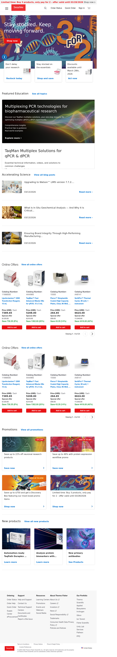
Figure 1: Homepage Template — Hero carousel, product offers, promotions, blog feed
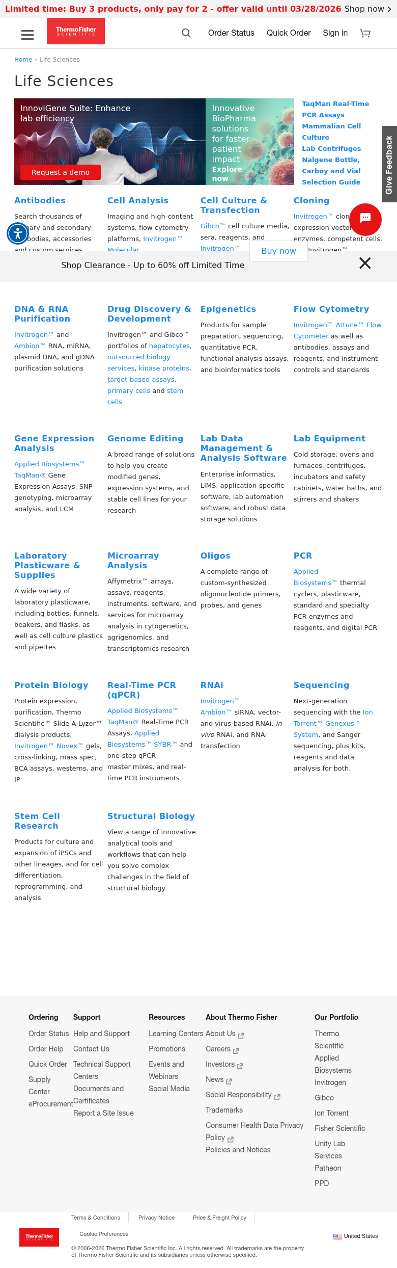
Figure 2: L1 Category Template — Life Sciences hub with 4-column category grid
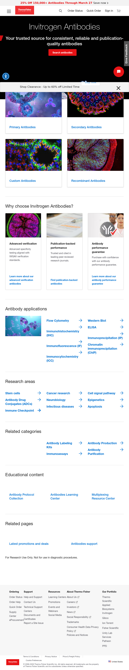
Figure 3: L2 Category Template — Antibodies with hero, image cards, research areas
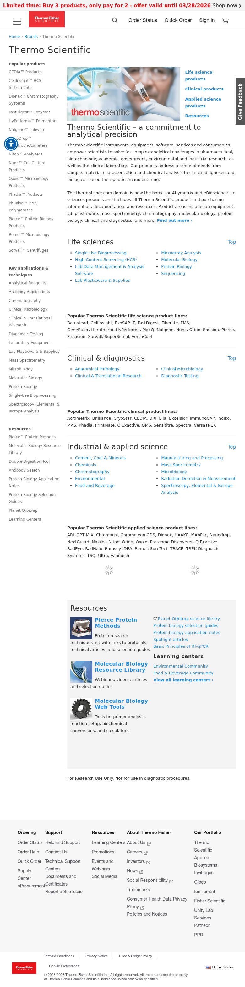
Figure 4: Brand Page Template — Thermo Scientific with sidebar nav, resource cards
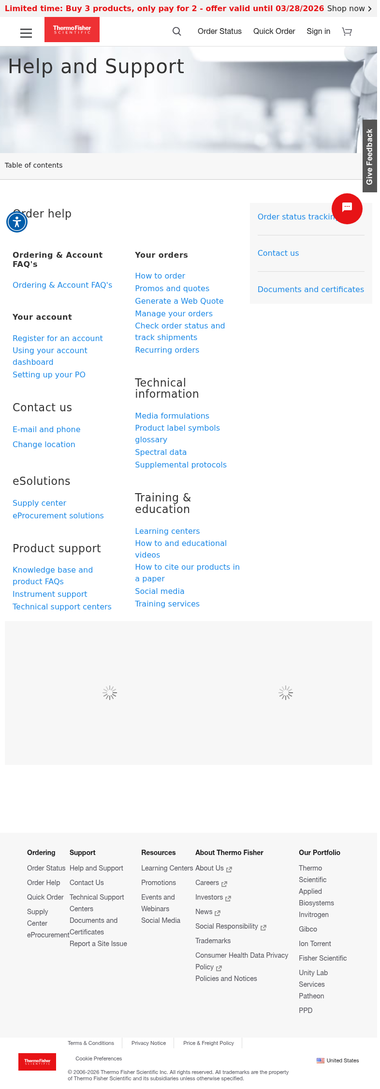
Figure 5: Support Hub Template — Multi-column link grid with collapsible TOC
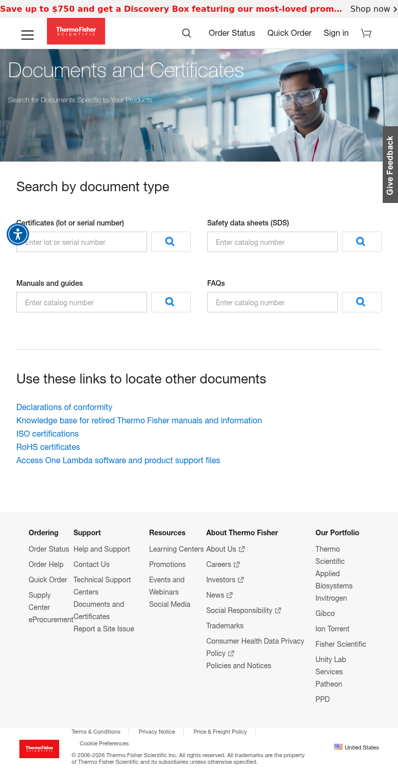
Figure 6: Documents & Certificates — CoA, SDS, Manuals lookup forms
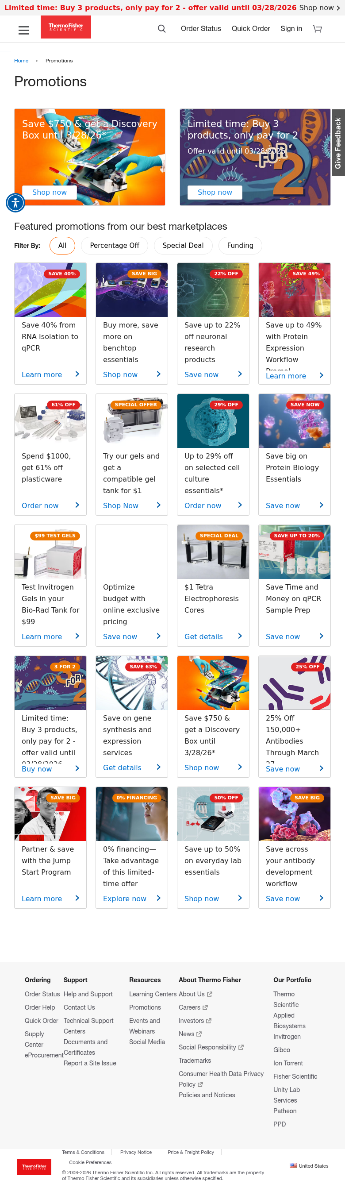
Figure 7: Promotions Template — Card grid with promo imagery and CTAs
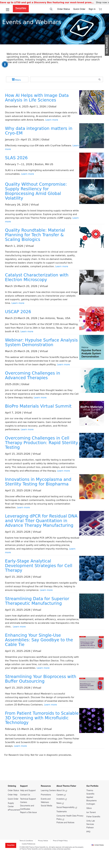
Figure 8: Events Template — Table-based layout with client-side filter

6. Blocks / Components Catalog
48 unique reusable blocks/components identified. Where the same content model has different visual layouts, these are cataloged as design variations rather than separate blocks.

6.1 Navigation Components (10)
Block | Complexity | Behavior & Functionality | Pages | Reference URL
Global Header Bar | High | Fixed position, responsive (60px mobile/88px desktop), logo, search, utility icons, z-index:80 | All pages | /us/en/home.html
Promotional Top Bar | Medium | Rotating promo banner above header, full-width clickable link, dismiss button | All pages | /us/en/home.html
Mega Navigation Menu | High | Left slide-out on mobile (380px), horizontal mega-menu desktop (993px+), multi-level hierarchy | All pages | /us/en/home.html
Breadcrumb Trail | Low | Home > Category > Subcategory with ">" separator, linked parents | Category, Brand | /us/en/home/life-science.html
Utility Bar | Medium | Order Status, Quick Order, Sign In, Bell, Cart icons; hidden below 993px | All pages | /us/en/home.html
Account Dropdown | Medium | 330px dropdown with user name, My Account, loyalty info, Sign Out | All pages (auth) | /us/en/home.html
Left Sidebar Nav | Medium | Sticky vertical nav: Popular Products, Key Applications, Resources sections | Brand pages | /us/en/home/brands/thermo-scientific.html
Collapsible TOC | Medium | Accordion button expanding/collapsing page content outline | Support | /us/en/home/support.html
In-Page Anchor Nav | Low | Horizontal link list linking to #anchor sections within page | Brand pages | /us/en/home/brands/thermo-scientific.html
Country/Locale Selector | Low | Footer element: flag icon + country name, locale picker modal | All pages | /us/en/home.html

6.2 Hero & Banner Components (5)
Block | Complexity | Behavior & Functionality | Pages | Reference URL
Full-Width Hero Banner | High | DM Offers dynamic content, background image, overlaid text + CTA, multiple rotating variants | Homepage | /us/en/home.html
Category Hero Banner | Medium | Colored background (#A51C36), H1 heading, subtitle, primary CTA button | L2 categories | /us/en/home/life-science/antibodies.html
Brand Hero Image | Low | Large brand logo image with in-page anchor nav below | Brand pages | /us/en/home/brands/thermo-scientific.html
Page Title Header | Low | Plain H1 on light gray background strip | L1, Support | /us/en/home/life-science.html
Sticky Bottom Promo Bar | Medium | Fixed bottom bar with promo text, CTA link, dismiss "x" button | Homepage, L1, L2 | /us/en/home.html

6.3 Content Blocks (11)
Block | Complexity | Behavior & Functionality | Design Variations
Featured Education Section | Medium | H2 + "See all" link, teaser cards with full-width image, title, bullet points, CTA | —
Blog Post List | Medium | H2 + "View all" link, 3 entries: thumbnail, title, date, "Read more" | —
Category Description Grid | Medium | 4-column grid of H3-linked categories with paragraph descriptions (18 categories) | —
Value Proposition Cards | Medium | 3-card horizontal: image, H4, description, "Learn more" link | —
Application Links + Image | Medium | Left image + right 2-column link list with arrow icons | Variation: Research Areas (3-col no image)
Research Areas Grid | Low | 3-column grid of arrow-prefixed links (9 links) | Variation of Application Links
Related Categories | Medium | Image + 2-column link list with arrows | —
Brand Description Block | Low | H2 + multi-paragraph rich text with inline links, separated by <hr> | —
Multi-Column Support Grid | High | 2-column layout with 10+ H2/H3 categorized link sections | —
Supply Center Block | Low | H2 + subtitle + CTA link, text-only, no image | —
Regulatory Disclaimer | Low | Single-line "For Research Use Only" text at page bottom | —

6.4 Card Components (10)
Block | Complexity | Behavior & Functionality | Design Variations
Promotional Pod Cards (3-up) | Medium | Background image, short text, CTA link; part of DM offers system | —
Product Carousel Card | High | Catalog #, name, image, strikethrough price, special offer, savings %, "Add to cart" | —
Promotion Banner Card (2-up) | Medium | Background image, text overlay, badge label, primary CTA button | Variation: 4-up layout
New Product Card (3-up) | Medium | Product image, title, description, "Learn more" CTA | —
Educational Content Card | Low | 3-up horizontal: icon image + linked title, no description | —
Related Pages Card (2-up) | Low | Icon + linked title only | —
Resource Card w/ Thumbnail | Medium | 70x70 thumbnail left, H3 linked title + description right | —
Category Image Card (2x2) | Medium | Full-width image + linked label below; grid layout | —
Event Table Row | Medium | Table-based layout: date, title, location, type, CTA | —
Promotion Listing Card | Medium | Image, promo badge, description, CTA; filterable grid | Variation: with/without badge

6.5 Interactive & Third-Party Components (12)
Block | Complexity | Behavior & Functionality | Pages
Product Offer Carousel | High | 4 visible cards, arrow + dot nav, 24 products, pricing, "Add to cart" | Homepage
Promotional Carousel | Medium | 2-4 visible cards, arrow + dot navigation | Homepage
Global Search Bar | High | Typeahead autocomplete, provider dropdown, mobile full-screen overlay | All pages
Cookie Consent Banner | Medium | TrustArc: Accept All / Reject All / Manage Settings | All pages
Cart Drawer Sidebar | High | Right-slide 440px, product list, pricing, suggested products, checkout CTA | All pages
Notification Bell Dropdown | Medium | 420px dropdown, scrollable notifications, timestamps, "See All" | All pages
TrustArc Cookie Manager | High | Full GDPR consent system, tag injection management | All pages
Adobe Launch/DTM | High | Tag management, Adobe Target personalization with 3s pre-hiding | All pages
Kampyle/Medallia Feedback | Medium | Fixed "Feedback" button, form ID 29308 | Most pages
AI Chat Widget | High | Chat launcher, eligibility API, Vue.js app | Category, Support
Accessibility Quick Menu | Medium | 4 buttons: skip content, visual impairment, a11y menu, a11y nav | All pages
Global Footer (5-column) | High | Ordering, Support, Resources, About TF, Portfolio; legal bar | All pages

7. Page Counts by Template (Migration Approach)
Template | Total | Auto-Migratable | Manual Migration | Notes
Homepage | 1 | 0 | 1 | Dynamic offers, personalization, carousels require manual setup
L1 Category Hub | 27 | 22 | 5 | Standard grid pattern; some have custom promo banners
L2 Category | 205 | 155 | 50 | Hero + cards + links; variable section counts
L3-L5 Product Category | 8,300 | 7,300 | 1,000 | Bulk-importable with templates; edge cases need manual review
Brand Page | 250 | 190 | 60 | Sidebar nav + mixed content; some heavily customized
Technical Resources | 1,223 | 1,050 | 173 | Reference content, mostly structured text
References / Protocols | 1,545 | 1,400 | 145 | Highly structured document pages
Support Hub | 13 | 0 | 13 | Complex multi-column layouts, all need manual work
Promotions / Campaign | 710 | 550 | 160 | Variable layouts, some time-sensitive logic
About Us | 91 | 75 | 16 | Text-focused, some link to corporate subdomain
Events / Webinars | 562 | 450 | 112 | Table-based with filter; date-driven content
Virtual / 3D Tours | 109 | 0 | 109 | Embedded 3D viewers need custom implementation
Clinical | 628 | 520 | 108 | Standard category pattern with clinical specifics
Industrial | 1,978 | 1,700 | 278 | Standard category pattern, deepest hierarchy
Global / Legal | 52 | 48 | 4 | Simple text pages
Misc / Legacy | 128 | 40 | 88 | Campaign pages, test pages, varied layouts
TOTALS | 12,161 | 9,500 (78%) | 2,661 (22%) | —

8. Complex Use Cases & Observations
# | Use Case | Instances | Where Found | Why Complex
1 | Product Recommendation Engine (Adobe Target) | 1 carousel + multiple placements | Homepage, category pages | Real-time API calls to /api/store/recommendations/; personalized per user context (region, cart, history). Requires EDS integration with Target APIs.
2 | Dynamic Pricing Display | 24+ products per carousel | Homepage Online Offers | Dual pricing (regular + special offer), savings calculation, real-time price API. Currency/locale-aware.
3 | DM Dynamic Offers System | 3-5 placements per page | Homepage, category pages | Server-side personalization injecting HTML into placeholders. 200+ country code validation. CSS template loading. Retry mechanism (25 attempts).
4 | Geolocation / Locale Detection | Global | 35 locales, 23 countries | Cookie-based (CK_ISO_CODE), hreflang tags, marketing region mapping. EDS needs edge-side detection or cookie routing.
5 | Real-Time Cart Management | Global | All pages (mini-cart) | Server-side cart with cartId cookie, version flag (cartV3Enabled), suggested products. Cross-page persistence.
6 | Certificate of Analysis Lookup | 1 form | Documents & Certificates page | AJAX lot/serial number lookup against backend API. Critical for regulated customers.
7 | Safety Data Sheet Search | 1 form | Documents & Certificates page | Catalog number-based document retrieval. Regulatory compliance requirement.
8 | AI Chat (Magellan GenAI) | Feature-flagged | Category, Support pages | Generative AI-powered chat being A/B tested. Feature flag via cookie ts_magellan_genai.
9 | Multi-Step Contact Routing | 1 hub | /store/v2/contact-us | 6 topic cards leading to specialized contact methods. Real-time chat eligibility API check.
10 | Event Table with Client-Side Filter | 1 page + subpages | /us/en/home/events.html | Table-based layout with text search filtering. Not server-side search.
11 | WordPress Blog Feed Integration | 1 section | Homepage | API-fed content from acceleratingscience.com. Dynamic date/title/thumbnail rendering.
12 | Virtual / 3D Product Tours | 109 pages | /us/en/home/virtual/* | Embedded interactive 3D viewers. Each product has custom viewer configuration.

9. Web Forms Analysis
12 form types identified across the site. Forms are grouped by structure similarity and tagged by complexity.

# | Form | Location | Complexity | Fields | Reasoning
1 | Global Search Bar | All pages (header) | High | 1 text + 1 dropdown | Typeahead autocomplete, Lucidworks integration, mobile-responsive overlay, search signals analytics
2 | Contact Us Hub | /store/v2/contact-us | High | 6 topic cards + sub-forms | Multi-step routing, chat eligibility API, multiple contact methods per topic
3 | CoA Lookup | Documents & Certificates | Medium | 1 text + 1 submit | AJAX lot/serial number lookup against backend API
4 | SDS Lookup | Documents & Certificates | Medium | 1 text + 1 submit | AJAX catalog number lookup; regulatory compliance
5 | Manuals & Guides Lookup | Documents & Certificates | Medium | 1 text + 1 submit | AJAX catalog number lookup
6 | FAQ Search | Documents & Certificates | Medium | 1 text + 1 submit | AJAX catalog number lookup
7 | Shopping Cart / Mini-Cart | All pages (sidebar) | High | Qty selectors + remove buttons | Cart API integration, real-time updates, suggested products
8 | Authentication / Sign-In | Header account | High | SSO redirect flow | identity.thermofisher.com; Gigya/SAP CDC integration
9 | Medallia Feedback | Floating button | Medium | Survey form | Kampyle SDK; form ID 29308
10 | Cookie Consent | Bottom banner | Low | Accept / Reject / Manage | TrustArc integration
11 | Event Text Filter | Events page | Low | 1 text input | Client-side table filtering
12 | Webinar Registration | /global/forms/* | Medium | 5-10 fields | Standardized registration form template for events/webinars

Form Complexity Summary
Complexity | Count | Forms
High | 4 | Global Search, Contact Hub, Shopping Cart, Authentication
Medium | 6 | CoA Lookup, SDS Lookup, Manuals Lookup, FAQ Search, Medallia Feedback, Webinar Registration
Low | 2 | Cookie Consent, Event Text Filter

10. Analysis Summary
Category | Total | Low | Medium | High
Page Templates | 16 | 4 | 8 | 4
Blocks / Components | 48 | 14 | 22 | 12
Design Variations | 15 | 8 | 5 | 2
Third-Party Integrations | 23 | 5 | 7 | 11
Web Forms | 12 | 2 | 6 | 4
Complex Use Cases | 12 | — | 4 | 8

Key Metrics:
- Total CMS pages in scope: 12,161
- Auto-migratable pages: 9,500 (78%)
- Manual migration pages: 2,661 (22%)
- High-traffic pages (migration priority): 233
- Out-of-scope application pages: ~911,826
- Supported locales: 35 (potential for multi-locale rollout)

11. Migration Estimates

11.1 Effort Summary
Activity | Optimistic (days) | Realistic (days) | Pessimistic (days)
Discovery & Planning | 15 | 20 | 30
Design System Migration | 15 | 20 | 25
Core Block Development (48 components) | 80 | 110 | 140
Integration Layer (23 integrations) | 45 | 65 | 85
Import Infrastructure (parsers, transformers) | 30 | 45 | 60
Content Migration (12,161 pages) | 90 | 130 | 175
QA & Validation (visual, a11y, performance) | 45 | 65 | 85
UAT & Launch (stakeholder review, cutover) | 20 | 30 | 40
TOTAL | 340 | 485 | 640

11.2 Team & Timeline
Scenario | Team Size | Duration | Total Person-Days | Cost @ $150-200/hr
Optimistic | 6-8 | 5-6 months | 340 | $408K - $544K
Realistic | 8-12 | 7-9 months | 485 | $582K - $776K
Pessimistic | 10-14 | 9-12 months | 640 | $768K - $1.02M

12. Three-Phase Migration Plan
The migration is structured into 3 sequential phases with no parallel execution. Each phase has defined workstreams, deliverables, and exit criteria.

12.1 Sequential Roadmap
PHASE 1: Foundation PHASE 2: Build & Migrate PHASE 3: Scale & Launch
Month 1 ---- Month 3 Month 4 ---- Month 7 Month 8 ---- Month 9
┌─────────────────────┐ ┌───────────────────────┐ ┌─────────────────────┐
│ AEM: Content Audit │ │ AEM: Bulk Import │ │ AEM: Remaining Pages │
│ Template Mapping │ │ Manual Migration │ │ Content Freeze │
│ Asset Inventory │ │ Content Validation │ │ Final Validation │
├─────────────────────┤ ├───────────────────────┤ ├─────────────────────┤
│ EDS: Design System │ │ EDS: All 48 Blocks │ │ EDS: Perf Tuning │
│ Core Blocks (15) │ │ Template Refinement │ │ SEO Validation │
│ Header/Footer │ │ Visual QA │ │ Lighthouse 100 │
├─────────────────────┤ ├───────────────────────┤ ├─────────────────────┤
│ INT: Analytics Setup │ │ INT: Target/Offers │ │ INT: E2E Testing │
│ Search POC │ │ Cart Integration │ │ DNS Cutover │
│ Auth Planning │ │ Chat/Consent/A11y │ │ Monitoring Setup │
└─────────────────────┘ └───────────────────────┘ └─────────────────────┘
EXIT: 233 HIGH pages EXIT: 4,116 MED pages EXIT: All 12,161 pages

12.2 Phase 1: Foundation (Months 1-3)
Establish the EDS project, migrate design system, build core blocks, and migrate all HIGH-traffic pages (233 pages).

AEM Workstream
Activity | Duration | Deliverables
Content Audit & Template Mapping | 2 weeks | Complete page-template mapping for all 12,161 pages
Asset Inventory | 1 week | Catalog of 15-25K unique images with source/format/dimensions
Content Export Tooling | 2 weeks | AEM content extraction scripts and bulk export pipeline
HIGH Page Content Prep | 3 weeks | Content for 233 high-traffic pages exported, cleaned, validated

EDS Workstream
Activity | Duration | Deliverables
EDS Project Setup | 1 week | GitHub repo, aem.live config, local dev environment
Design System Migration | 3 weeks | CSS custom properties, HelveticaNeue fonts, 7 breakpoints, brand colors
Global Header Block | 2 weeks | Responsive header with search, utility bar, mega nav
Global Footer Block | 1 week | 5-column footer with legal bar and locale selector
Core Blocks (15 priority) | 4 weeks | Hero, cards, content blocks, breadcrumbs, sidebar nav
HIGH Pages Import & Validation | 2 weeks | 233 pages migrated, visually verified against original

Integrations Workstream
Activity | Duration | Deliverables
Analytics Setup (Adobe Analytics + AEP) | 2 weeks | digitalData layer, Launch integration, event tracking
Search POC (Lucidworks) | 2 weeks | Searchbar integration proof-of-concept on EDS
Auth Architecture Planning | 1 week | SSO flow design for identity.thermofisher.com on EDS
Cookie Consent (TrustArc) | 1 week | TrustArc script integration and consent flow
Phase 1 Exit Criteria:
- 233 HIGH-traffic pages live on EDS preview environment
- Design system fully implemented with visual parity
- 15 core blocks functional and responsive
- Analytics and consent tracking operational

12.3 Phase 2: Build & Migrate (Months 4-7)
Complete all block development, migrate MEDIUM-traffic pages (4,116 pages), and implement all integrations.

AEM Workstream
Activity | Duration | Deliverables
Bulk Import Pipeline Execution | 4 weeks | ~3,200 auto-migratable MEDIUM pages imported
Manual Migration (Complex Pages) | 4 weeks | ~916 MEDIUM pages requiring manual content work
Content Validation & QA | 3 weeks | Visual regression testing against original for all MEDIUM pages
Asset Migration | 2 weeks | All images and media for MEDIUM pages transferred
Redirect Mapping | 1 week | URL mapping document for all migrated pages

EDS Workstream
Activity | Duration | Deliverables
Remaining Blocks (33) | 6 weeks | All 48 blocks complete: interactive, commerce, third-party widgets
Product Carousel Block | 2 weeks | Carousel with pricing, add-to-cart, Target API integration
Template Refinement | 2 weeks | All 16 templates polished for content author experience
Visual QA & Responsive Testing | 3 weeks | Cross-browser, cross-device validation for all blocks
Accessibility Audit | 1 week | WCAG 2.1 AA compliance for all blocks and pages

Integrations Workstream
Activity | Duration | Deliverables
Adobe Target / DM Offers | 3 weeks | Personalization engine on EDS with pre-hiding, offer injection
Cart Integration | 2 weeks | Cart drawer sidebar, add-to-cart, mini-cart API on EDS pages
Lucidworks Search (Full) | 2 weeks | Complete searchbar with typeahead, signals, provider selector
Chat Widget (Custom + Magellan) | 2 weeks | Chat launcher, eligibility API, GenAI feature flag
UserWay Accessibility | 1 week | Accessibility overlay widget integration
Medallia Feedback | 1 week | Kampyle SDK integration, floating feedback button
WordPress Blog Feed | 1 week | API integration for homepage blog section
Phase 2 Exit Criteria:
- 4,349 pages (HIGH + MEDIUM) live on EDS preview
- All 48 blocks complete and tested
- All 23 integrations functional
- Visual regression pass rate > 95%

12.4 Phase 3: Scale & Launch (Months 8-9)
Migrate all remaining LOW-traffic pages (7,812 pages), performance tuning, SEO validation, and production launch.

AEM Workstream
Activity | Duration | Deliverables
Bulk Import: Remaining LOW Pages | 3 weeks | ~6,300 auto-migratable LOW pages imported
Manual Migration: Complex LOW Pages | 2 weeks | ~1,512 LOW pages requiring manual work
Content Freeze & Final Validation | 1 week | No new AEM content changes; final content verification
Redirect Implementation | 1 week | All 12,161 redirects configured and tested

EDS Workstream
Activity | Duration | Deliverables
Performance Optimization | 2 weeks | LCP < 2.5s, CLS < 0.1, FID < 100ms on all templates
SEO Validation | 1 week | Meta tags, structured data, sitemap, canonical URLs verified
Lighthouse Score Target: 100 | 1 week | PageSpeed Insights validation on all template types
Edge Worker Configuration | 1 week | Akamai/EDS edge rules for locale routing, caching, redirects

Integrations Workstream
Activity | Duration | Deliverables
End-to-End Integration Testing | 2 weeks | Full test suite: analytics, search, cart, auth, chat, consent
DNS Cutover Planning & Execution | 1 week | Phased DNS migration with rollback plan
Production Monitoring Setup | 1 week | Error tracking, performance monitoring, uptime alerts
Hypercare / Post-Launch Support | 2 weeks | Dedicated team for issue triage and hotfixes
Phase 3 Exit Criteria:
- All 12,161 pages live on EDS production
- Lighthouse score >= 95 on all template types
- All redirects functional with zero 404 errors
- All integrations verified in production
- Hypercare team in place for 2-week post-launch

13. Assumptions & Boundary Conditions

13.1 Assumptions
- AEM AMS environment remains available for content extraction throughout the migration period
- Product catalog pages (/order/catalog/, /antibody/, /search/) remain on their current React SPA and are NOT migrated to EDS
- WordPress blog (acceleratingscience.com) remains on WordPress; only the API feed integration is migrated
- corporate.thermofisher.com (About Us) remains a separate AEM instance and is NOT in scope
- Identity service (identity.thermofisher.com) remains as-is; EDS integrates via redirect-based SSO
- Content authors will use AEM Universal Editor or Google Docs/Sheets for EDS content authoring
- Existing Akamai CDN configuration can be adapted for EDS edge delivery
- No new feature development during migration (feature freeze on CMS pages)
- Image assets can be referenced via existing CDN URLs (no re-hosting required initially)

13.2 Boundary Conditions (Scope Creep Risks)
Risk | Impact | Likelihood | Mitigation
Multi-locale rollout requested | High — 34 additional locales × 12K pages each | Medium | Scope US-only first; design for locale reuse from Day 1
Product catalog pages added to scope | Very High — 393K+ React SPA pages | Low | Maintain clear boundary: /order/* stays on React SPA
Custom eCommerce on EDS | High — cart/checkout rebuild | Low | Keep cart as shared JS widget; don't rebuild commerce
New brand/design refresh during migration | High — rework all blocks and CSS | Medium | Freeze design system in Phase 1; absorb changes post-launch
Legacy page discovery (unlisted pages) | Medium — additional manual migration | High | Buffer 15% in estimates for undiscovered content
Third-party integration changes | Medium — API contract changes | Medium | Lock integration versions; defer upgrades to post-launch
Performance targets increased | Medium — additional optimization | Low | Design for 100 Lighthouse from start; use EDS best practices
Accessibility compliance upgrade (WCAG 2.2) | Medium — additional testing/remediation | Medium | Build to WCAG 2.1 AA; assess 2.2 delta post-launch
Content authoring training delays | Low — author productivity impact | Medium | Start training in Phase 2; provide comprehensive documentation
jQuery dependency in shared components | Medium — header/footer rely on jQuery | High | Rebuild header/footer as vanilla JS blocks; no jQuery in EDS

14. Recommended Team Composition
Role | Count | Phase Allocation | Key Responsibilities
Technical Architect / Lead | 1 | P1-P3 | Integration design, block architecture, EDS patterns, technical decisions
Senior Frontend Developer | 2 | P1-P3 | Core block development, design system, responsive implementation
Frontend Developer | 2-3 | P1-P3 | Block development, CSS/JS, template implementation
Content Migration Engineer | 2 | P1-P3 | Import scripts, parsers, bulk migration tooling, content validation
Integration Developer | 1-2 | P1-P3 | Adobe Target, Analytics, Cart API, Auth, Chat, Search integration
QA Engineer | 1-2 | P2-P3 | Visual regression, accessibility, performance, cross-browser testing
Content Author / Editor | 1-2 | P2-P3 | Manual content review, content validation, author training
Project Manager | 1 | P1-P3 | Sprint planning, stakeholder communication, risk management
TOTAL | 11-15 | — | —

