Thermo Fisher Scientific
www.thermofisher.com
AEM AMS → Edge Delivery Services
Site Assessment & Migration Analysis Report
Prepared: March 15, 2026
CONFIDENTIAL

Table of Contents
1. Executive Summary
2. Current Technology Stack
3. Integrations Analysis
4. Page & Asset Inventory
5. Templates Inventory
6. Blocks / Components Catalog
7. Page Counts by Template
8. Web Forms Analysis
9. Complex Use Cases & Observations
10. Analysis Summary
11. Migration Estimates

1. Executive Summary
Thermo Fisher Scientific (thermofisher.com) is one of the world's largest scientific services companies, with a complex web presence built on Adobe Experience Manager (AEM) Managed Services (AMS). This report provides a comprehensive analysis of the site for migration to Adobe Edge Delivery Services (EDS).

Key Findings:
- Total estimated URLs across all sitemaps: ~138,300+
- EDS migration scope (CMS content pages): ~31,200 pages across 39 locales
- Multiple technology stacks: AEM CMS, React SPA (commerce), WordPress (blog)
- 23 third-party integrations identified
- 35 unique blocks/components cataloged with 15+ design variations
- 11 distinct page templates identified
- 9 web form types across the site
- Estimated migration effort: 532-821 person-days (~6-9 months)

2. Current Technology Stack
The following table outlines the complete technology stack currently powering thermofisher.com:

Layer | Technology | Details
CMS | Adobe Experience Manager (AEM AMS) | AEM 6.5+, release/2025.9.0 - ETO
Frontend (CMS) | Vanilla JavaScript + jQuery Migrate 3.4.1 | No framework; custom Design System
Frontend (Commerce) | React + Redux | SPAs at /store/, /order/, /search/
Frontend (Blog) | WordPress + jQuery | Genesis theme "accelerating-science"
CSS | Custom Design System + BEM | HelveticaNeue font stack, CSS custom properties
CDN | Akamai | Edge caching, TLS termination
Cloud | AWS (S3, ELB, Kubernetes) | Microservices orchestration
API Gateway | Apache APISIX (NGINX) | Request routing, rate limiting
Analytics | Adobe Experience Platform Web SDK (Alloy) v2.30.1 | Loaded via Adobe Launch
Tag Management | Adobe Launch (2 properties) | Build date: 2026-03-10
Personalization | Adobe Target (via Alloy) | Server-side + client-side targeting
Identity | Custom OIDC + SAP Gigya | identity.thermofisher.com
Commerce | Custom .NET + K8s microservices | commerce.thermofisher.com
Search | Custom SearchBar v2023 + Lucidworks Solr | React SPA at /search/results
Consent | TrustArc | consent.truste.com
Responsive Breakpoints | 361px / 577px / 768px / 993px / 1201px / 1441px | 6 breakpoint system

3. Integrations Analysis
The following third-party integrations and embedded services have been identified across the site:

# | Integration | Type | Complexity | Where Used
1 | Adobe Experience Platform Web SDK | API/SDK | High | All pages
2 | Adobe Launch (Tag Management) | Embed | Medium | All pages (2 properties)
3 | Adobe Target | API/SDK | High | All pages - personalization, A/B testing
4 | Adobe Audience Manager | API | Medium | All pages - audience segmentation
5 | Akamai CDN | Infrastructure | Medium | All pages - edge caching
6 | AWS S3 | API/Storage | Low | Static asset delivery
7 | AWS ELB / Kubernetes | Infrastructure | High | Commerce microservices
8 | SAP Gigya (Customer Data Cloud) | API/OAuth | High | Sign-in, registration
9 | TrustArc | Embed/SDK | Medium | All pages - GDPR/CCPA consent
10 | Medallia / Kampyle | Embed/SDK | Low | All pages - feedback overlay
11 | Google reCAPTCHA v3 | API | Low | Password reset form
12 | Genesys Cloud Chat | Embed/API | High | Category/product pages - AI chat
13 | Custom Commerce API | Custom API | High | Cart, pricing, recommendations
14 | Product Recommendations Engine | Custom API | High | Cart sidebar, product pages
15 | Lucidworks Fusion / Solr | API | High | Search, autocomplete, typeahead
16 | Custom OIDC Identity Provider | Custom API | High | Authentication flow, JWT tokens
17 | Endeca (Search Focus Areas) | API | Medium | Faceted navigation
18 | WordPress (Blog CMS) | Separate CMS | Medium | /blog/ - Accelerating Science
19 | Magellan GenAI | Custom API | High | AI product Q&A (feature-flagged)
20 | MasterControl | External Link | Low | Privacy policy document hosting
21 | UserWay | Embed | Low | Accessibility overlay widget
22 | Custom Digital Data Layer | Custom Code | Medium | All pages - analytics data layer
23 | DM Preload Offers System | Custom Code | High | All pages - dynamic offer injection

Integration Complexity Summary:
Complexity | Count | Examples
High | 12 | Adobe Target, Gigya Auth, Commerce API, Genesys Chat, Search
Medium | 6 | Adobe Launch, Audience Manager, TrustArc, Endeca, Digital Data Layer
Low | 5 | reCAPTCHA, Medallia, AWS S3, MasterControl, UserWay

4. Page & Asset Inventory
Page counts were derived from analysis of 11 sitemap hierarchies declared in robots.txt:

Category | Technology | Estimated URLs | In EDS Scope?
Regional CMS Content (39 sitemaps) | AEM CMS | ~31,200 | Yes - Primary
Store Product Catalog (239 sitemaps) | React SPA | ~47,800 | No - Separate SPA
Product FAQs (17 sitemaps) | React SPA | ~17,000 | No - Separate SPA
Product Citations (13 sitemaps) | React SPA | ~13,000 | No - Separate SPA
Antibody Products (16 sitemaps) | Custom App | ~14,750 | No - Separate App
Allergy Microsite (18 sitemaps) | AEM CMS | ~3,600 | Phase 2
Clinical Mass Spec (17 sitemaps) | AEM CMS | ~1,275 | Phase 2
One Lambda (1 sitemap) | AEM CMS | ~641 | Phase 2
Binding Site (12 sitemaps) | AEM CMS | ~960 | Phase 2
CAS Number Pages (6 sitemaps) | Custom App | ~570 | No - Separate App
Blog | WordPress | ~1,000-3,000 | No - Separate CMS
Antibody Video Sitemap | Mixed | ~7,500 | No - Video index

Total Estimated URLs: ~138,300+
Phase 1 EDS Migration Scope: ~31,200 CMS content pages
Phase 2 EDS Migration Scope: ~6,476 microsite pages

Estimated Digital Assets
Asset Type | Estimated Count | Notes
Product Images | ~500,000+ | Managed by PIM/DAM system; referenced via CDN
Marketing/Content Images | ~50,000-100,000 | AEM DAM - hero banners, category images, icons
PDF Documents | ~10,000-25,000 | SDS, CoA, protocols, datasheets, manuals
Video Assets | ~7,500+ | Hosted via video sitemap; YouTube/Vimeo embeds
SVG Icons | ~200-500 | UI icons, brand logos, navigation elements
Font Files | ~20-30 | HelveticaNeue variants (WOFF2)

5. Templates Inventory
The following unique page templates have been identified across the site:

# | Template Name | Complexity | Reasoning | Reference URL(s)
1 | Homepage | High | Heavy personalization (Adobe Target), dynamic carousels, multiple API integrations, hero with dynamic content | thermofisher.com/us/en/home.html
2 | L1 Category Page | Medium | Multi-column category card grid, quick links, breadcrumbs, standard component layout | thermofisher.com/us/en/home/life-science.html
3 | L2+ Category / Subcategory | Medium | Icon cards, value props, image+link layouts, deeper hierarchy | thermofisher.com/us/en/home/life-science/antibodies.html
4 | Brand Page | Medium | Sidebar nav, anchor jump nav, multi-section link lists, resources section | thermofisher.com/us/en/home/brands/thermo-scientific.html
5 | Product Detail Page (PDP) | High | React SPA, Redux state, real-time pricing, stock, citations, AI Q&A | thermofisher.com/order/catalog/product/44-2ML
6 | Antibody Product Page | High | Separate custom app, specialized search, antibody data model | thermofisher.com/antibody/product/CD4-Antibody-...
7 | Learning Center Hub | Medium | Educational modules, tutorial navigation, persistent learning menu | thermofisher.com/us/en/home/technical-resources/learning-centers.html
8 | Support Hub | Medium | TOC navigation, expandable sections, multi-column link directory | thermofisher.com/us/en/home/support.html
9 | Events / Webinars | Medium | Dynamic JS rendering, event registration, filters | thermofisher.com/us/en/home/events.html
10 | Promotions | Medium | Adobe Target personalization, dynamic offer cards, geo-filtering | thermofisher.com/us/en/home/products-and-services/promotions.html
11 | Contact / Forms | Medium | React-based rendering, multi-step forms, validation | thermofisher.com/us/en/home/technical-resources/contact-us.html

Template Screenshots
Homepage Template
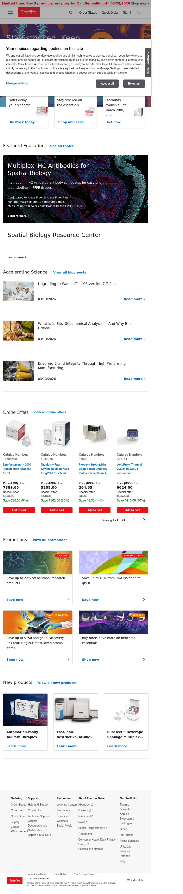
L1 Category Template (Life Sciences)
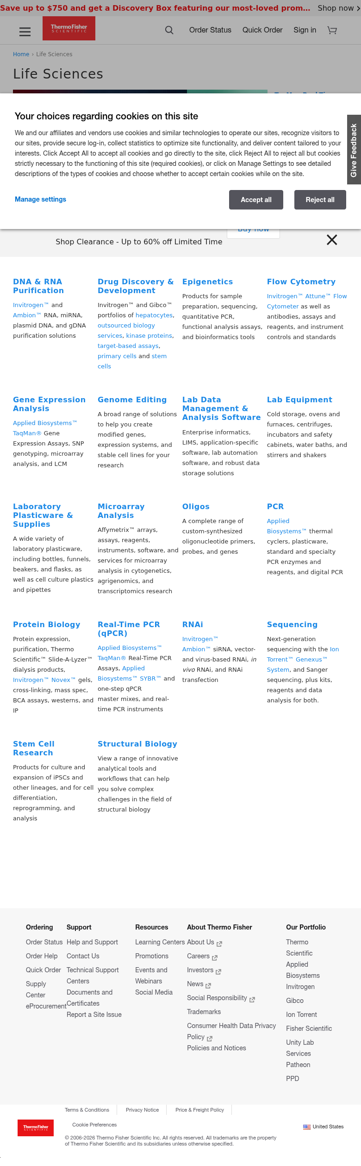

L2 Category Template (Antibodies)
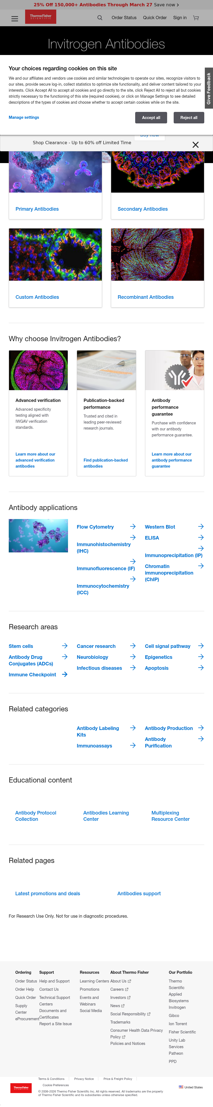
Brand Page Template (Thermo Scientific)
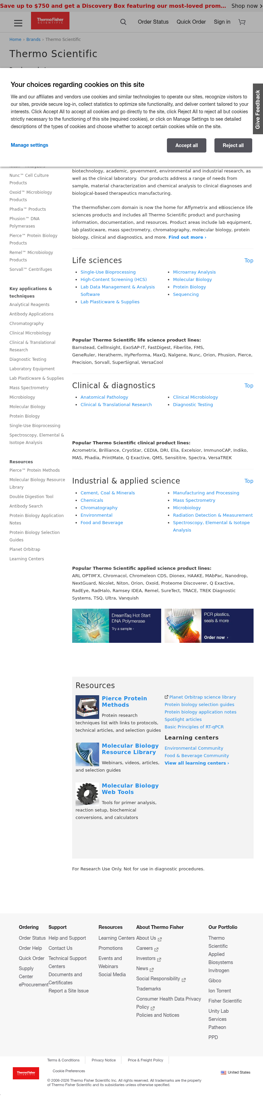

Support Hub Template
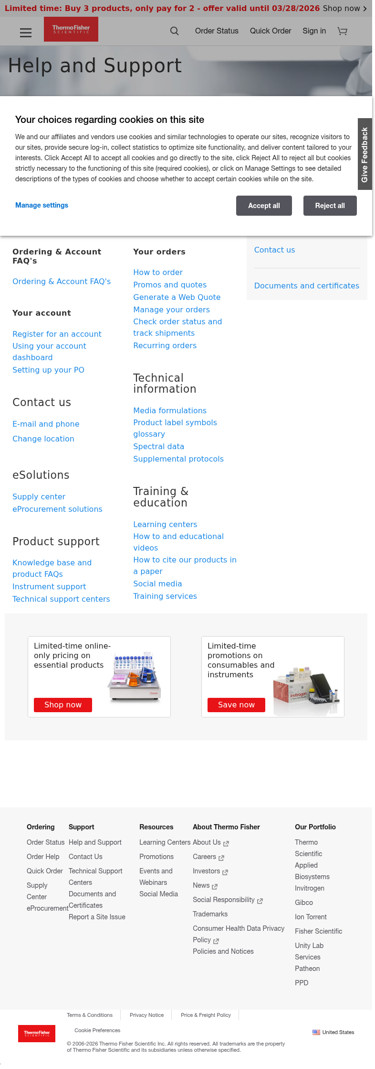

6. Blocks / Components Catalog
All reusable blocks and components identified across the site. Design variations of the same content model are grouped under a single block rather than listed as separate blocks.

6.1 Global Components
# | Block Name | Complexity | Description | Variations | Reference URL
1 | Header / Mega Navigation | High | Fixed header with multi-level mega-nav, search, account, cart, notifications, responsive drawer | Desktop mega-nav / Mobile drawer | All pages
2 | Search Bar + Typeahead | High | Autocomplete with category provider selector, recent searches, signals tracking | Context-aware scope per page | All pages
3 | Shopping Cart Sidebar | High | Right-sliding drawer with real-time cart, OOB recommendations API, pricing, quantity adjustment | Empty / Populated states | All pages
4 | Footer (6-column) | Low | Multi-column link groups, legal bar, copyright, country selector with flag | None | All pages
5 | Cookie Consent Banner | Medium | TrustArc GDPR/CCPA consent with preference management modal | None | All pages
6 | Messaging Bar | Low | Sticky top promotional banner, dismissible, campaign-specific content | Content varies by campaign | All pages
7 | Account Dropdown | Medium | Auth state-aware dropdown (guest sign-in vs. logged-in user details) | 2 states (guest / auth) | All pages
8 | Notification Bell | Medium | Order update notifications, badge count, delete/clear actions | Empty / Populated | All pages
9 | Chat Widget (Genesys) | High | AI-powered chat with eligibility API, async chunk-based loading | None (eligibility-gated) | Category/product pages
10 | Feedback Tab | Low | Fixed "Give Feedback" tab triggering Medallia/Kampyle overlay | None | All pages

6.2 Hero & Banner Components
# | Block Name | Complexity | Description | Variations | Reference URL
11 | Hero Banner / Teaser | Medium | Full-width hero with bg image, headline, body, CTA. Supports Adobe Target personalization | Static / Dynamic (personalized) | Homepage
12 | Promotional Tile Strip (3-up) | Low | Row of 3 small promotional tiles with icon, short copy, CTA link | None | Homepage

6.3 Navigation Components
# | Block Name | Complexity | Description | Variations | Reference URL
13 | Breadcrumbs | Low | Hierarchical path nav with ">" separator, last item plain text | Depth varies by page level | All non-homepage pages
14 | Sidebar Navigation | Low | Left-column categorized link lists (Popular products, Key apps, Resources) | Content varies by brand | Brand pages
15 | Anchor / Jump Navigation | Low | Horizontal in-page hash anchors with "Top" back-links | Items vary by content | Brand pages
16 | Quick Links Row | Low | Horizontal row of popular product links | Content varies per category | L1 Category pages
17 | Table of Contents (Collapsible) | Medium | Expandable section navigator for support/reference content | None | Support pages

6.4 Content Components
# | Block Name | Complexity | Description | Variations | Reference URL
18 | Category Card Grid | Low | Grid of heading+description cards for subcategories (4-column responsive) | None | L1 Category pages
19 | Icon Link Cards (4-up) | Low | Row of 4 icon+label navigation cards for sub-categories | None | L2 Category pages
20 | Value Proposition Cards (3-up) | Low | Feature cards with icon/number, heading, description, CTA | None | L2 Category pages
21 | Image + Link List (Split) | Low | Large image with adjacent application link columns | Image left / Image right | L2 Category pages
22 | Link Grid (3-col with icons) | Low | Three-column icon+text link grid for research areas | None | L2 Category pages
23 | Resource Card Row | Low | Cards with thumbnail, title, description, CTA. Horizontal or vertical layout | Horizontal / Vertical | Multiple pages
24 | Text Block (Rich Text) | Low | Standard heading + paragraph content with inline links | Various heading levels | All pages
25 | Section Divider | Low | Styled horizontal rule between content sections | None | Multiple pages
26 | Categorized Link Lists (2-col) | Low | Two-column bulleted link sections under heading | None | Brand pages
27 | Resource Section + Thumbnails | Low | Boxed section with 3 resource cards (70x70 thumbnail) + link list | None | Brand pages

6.5 E-Commerce Components
# | Block Name | Complexity | Description | Variations | Reference URL
28 | Online Offers Grid (4-up) | Medium | Product cards with pricing, discount badge, add-to-cart, pagination | None | Homepage
29 | Promotion Card Grid (2x2) | Low | Promo cards with image, discount badge overlay, CTA | Badge style varies | Homepage, Support
30 | New Products Row (3-up) | Low | Product feature cards with image, title, description, CTA | None | Homepage
31 | Suggested Products (Cross-sell) | Medium | API-driven recommendation strip in cart sidebar | None | All pages (in cart)

6.6 Interactive & Utility Components
# | Block Name | Complexity | Description | Variations | Reference URL
32 | CTA Button | Low | Multi-variant button/link: primary(red), secondary, outline, info, white, text-link | 6+ visual variants, 4 sizes | All pages
33 | Blog Post Cards (3-up) | Low | Blog cards with thumbnail, title, date, "Read more" CTA | None | Homepage
34 | Featured Education Section | Medium | Mixed content tiles - interactive tool cards + simple text cards | Mixed content types | Homepage
35 | Preload Offers Engine | High | Adobe Target dynamic content injection framework with fallback handling | Default / Personalized | All pages

7. Page Counts by Template
# | Template | Est. Pages | Auto-Migrate | Manual Migrate | Notes
1 | Homepage | ~38 | No | Yes (100%) | 1 per locale, heavy personalization
2 | L1 Category Pages | ~800-1,200 | Partial (70%) | Partial (30%) | Standard layout; dynamic offers manual
3 | L2+ Category / Subcategory | ~15,000-25,000 | Yes (90%) | ~10% manual | US-EN industrial alone = 1,031 URLs
4 | Brand Pages | ~300-450 | Yes (85%) | ~15% manual | ~12 brands x 39 locales
5 | Product Detail (React SPA) | ~47,800 | Out of Scope | Out of Scope | Separate React application
6 | Antibody Product Pages | ~14,750 | Out of Scope | Out of Scope | Separate custom application
7 | Learning Center Hubs | ~100-200 | Partial (50%) | Yes (50%) | Educational content modules
8 | Support Hub | ~50-100 | No | Yes (100%) | Dynamic expandable content
9 | Events / Webinars | ~50-100 | No | Yes (100%) | JS-heavy dynamic rendering
10 | Promotions | ~50-100 | No | Yes (100%) | Adobe Target personalization
11 | Contact / Forms | ~100-200 | No | Yes (100%) | React-based forms

Migration Scope Summary:
Category | Pages | Strategy
Automatically Migratable | ~18,000-28,000 | Standard templates, batch processing
Manual Migration Required | ~4,000-7,000 | Dynamic, personalized, custom logic
Out of Scope (Separate Apps) | ~97,000+ | React SPA, WordPress, custom apps
Phase 1 Total | ~31,200 | CMS content pages across 39 locales

8. Web Forms Analysis
Analysis of all pages capturing user input via form controls:

# | Form Name | Location | Complexity | Reasoning
1 | Quick Order (Multi-Mode) | /store/v2/quick-order | High | 3 input modes (manual/bulk/paste), dynamic autocomplete, conditional fields, dynamic rows, cart API
2 | Return / Report Issue | /store/order/report/issues | High | 15+ fields, 5 sections, cascading dropdowns, drag-drop file upload, conditional validation
3 | Sign-In (Multi-Step Auth) | identity.thermofisher.com/signin | Medium | Multi-step OAuth/OIDC, Gigya integration, JWT tokens
4 | Account Registration | identity.thermofisher.com/registration | Medium | Gigya-managed, password strength meter, country selector, reCAPTCHA
5 | Contact Us Form | /store/v2/contact-us | Medium | React SPA, multi-section layout, validation, file attachment
6 | Global Site Search | Header (all pages) | Medium | Advanced autocomplete, category filtering, signals capture
7 | Password Reset | identity.thermofisher.com/reset-password | Low | Single field + reCAPTCHA v3
8 | Feedback (Medallia) | Footer "Report a Site Issue" | Low | Third-party managed overlay (Kampyle SDK)
9 | Add to Cart / Quantity | Product detail pages | Low | Single numeric spinbutton + "Add to Cart" button

Forms Complexity Summary:
Complexity | Count | Forms
High | 2 | Quick Order, Return/Report Issue
Medium | 4 | Sign-In, Registration, Contact Us, Site Search
Low | 3 | Password Reset, Feedback (Medallia), Add to Cart

Note: Legacy standalone form URLs (/global/forms/inquiry.html, /global/forms/sample-request.html, /global/forms/quote-request.html, /global/forms/newsletter-signup.html) all return 404 — Thermo Fisher has consolidated forms into JavaScript-rendered experiences within the /store/v2/ framework.

9. Complex Use Cases & Observations
The following complex behaviors require special attention during migration:

# | Complex Use Case | Instances | Where Found | Why Complex
1 | Adobe Target Personalization | ~31,200+ pages | Preload Offers system on every page | Dynamic content varies by user segment, geography, behavior. EDS lacks native server-side personalization at this scale.
2 | React SPA Commerce | ~78,000+ pages | /order/, /store/, /search/ | Separate React apps with Redux. NOT AEM pages — need independent architecture or continued SPA operation.
3 | Multi-Locale Content (39 locales) | 39 locale variants | All CMS pages | Content translation, country-specific pricing, regional compliance (GDPR vs CCPA). Robust locale management needed.
4 | Dynamic Cart Integration | All pages | Cart sidebar, OOB recommendations API | Real-time cart state synced across all pages via API. Requires client-side JS integration with custom commerce APIs.
5 | Custom Authentication (OIDC+Gigya) | All auth flows | identity.thermofisher.com | Custom identity provider with OIDC, JWT. Contracted pricing, order history depend on auth state.
6 | AI-Powered Features (Magellan) | Product/Search pages | Feature-flagged globally | Semantic search, AI product Q&A in testing. Rapidly evolving; may change during migration.
7 | Genesys Cloud Chat Bot | ~5,000+ pages | Category & product pages | AI chat with eligibility API. Async loading, chunk-based JS/CSS, and API integration.
8 | Dynamic Offer System | All pages | window.preloadOffers | Client-side Adobe Target content injection with timeout/fallback. Drives hero banners, offer bars, promotions.
9 | Sub-sites (Separate Templates) | 3 sub-sites | Allergy, One Lambda, Binding Site | Separate AEM content trees, independent nav/branding. Need separate EDS configs.
10 | E-commerce Pricing & Stock | Product pages | Pricing & stock APIs | Real-time pricing, inventory, contracted pricing, multi-currency. Critical for buyer experience.

10. Analysis Summary

Category | Count | Low | Medium | High
Page Templates | 11 | 0 | 7 | 4
Blocks / Components | 35 | 20 | 9 | 6
Design Variations | ~15 | 10 | 4 | 1
Third-Party Integrations | 23 | 5 | 6 | 12
Web Forms | 9 | 3 | 4 | 2
Complex Use Cases | 10 | 0 | 3 | 7

Site Scale Overview:
Metric | Value
Total Estimated URLs (all sitemaps) | ~138,300+
CMS Content Pages (EDS Phase 1 Scope) | ~31,200
Microsite Pages (EDS Phase 2 Scope) | ~6,476
Product Catalog (React SPA - separate) | ~77,800
Antibody Products (Custom app - separate) | ~14,750
Blog (WordPress - separate) | ~1,000-3,000
Locales | 39
Estimated DAM Assets (images) | ~50,000-100,000
Estimated PDF Documents | ~10,000-25,000

11. Migration Estimates

Scope Definition
The EDS migration scope covers AEM CMS content pages only (~31,200 pages in Phase 1). React commerce SPA, WordPress blog, and antibody application remain as separate systems operating independently.

Effort Breakdown by Phase
Phase | Activity | Person-Days (Range) | Calendar Duration
Phase 1 | Foundation & Setup
 | EDS project setup, CI/CD, environments | 5-10 | 1 week
 | Design system extraction & CSS custom properties | 15-20 | 2 weeks
 | Global header / mega-navigation | 15-25 | 2-3 weeks
 | Global footer | 3-5 | 1 week
 | Cookie consent (TrustArc) integration | 3-5 | 1 week
 | Phase 1 Subtotal | 41-65 | 3-4 weeks
Phase 2 | Block Development
 | Low-complexity blocks (20 blocks × 2-3 days) | 40-60
 | Medium-complexity blocks (9 blocks × 5-8 days) | 45-72
 | High-complexity blocks (6 blocks × 10-15 days) | 60-90
 | Design variations (15 variants × 1-1.5 days) | 15-22
 | Phase 2 Subtotal | 160-244 | 8-12 weeks
Phase 3 | Template Implementation
 | Homepage template | 10-15
 | Category templates (L1 + L2) | 10-15
 | Brand page template | 5-8
 | Learning center, Support, Events, Promos | 15-23
 | Contact/Forms template | 5-8
 | Phase 3 Subtotal | 48-74 | 3-5 weeks
Phase 4 | Integrations
 | Adobe Analytics / Launch integration | 10-15
 | Adobe Target / personalization | 15-25
 | Commerce API integration (cart, pricing) | 15-20
 | Authentication (OIDC/Gigya) | 10-15
 | Search integration | 10-15
 | Chat, Medallia, UserWay, reCAPTCHA | 10-16
 | Phase 4 Subtotal | 70-106 | 4-6 weeks
Phase 5 | Content Migration
 | Migration script development & testing | 15-20
 | Automated migration (~18,000-28,000 pages) | 20-30
 | Manual migration (~4,000-7,000 pages) | 40-70
 | Multi-locale content (39 locales) | 20-30
 | Asset migration (images, documents) | 10-15
 | Phase 5 Subtotal | 105-165 | 5-8 weeks
Phase 6 | Forms Migration
 | Low-complexity forms (3) | 3-5
 | Medium-complexity forms (4) | 12-20
 | High-complexity forms (2) | 10-16
 | Phase 6 Subtotal | 25-41 | 2-3 weeks
Phase 7 | QA & Testing
 | Visual regression testing | 15-25
 | Functional testing | 15-20
 | Performance testing (Lighthouse 100) | 10-15
 | Accessibility testing (WCAG 2.1 AA) | 10-15
 | UAT support | 10-15
 | Phase 7 Subtotal | 60-90 | 4-6 weeks
Phase 8 | Deployment & Cutover
 | Staging environment & validation | 5-8
 | Redirect mapping (URL mapping) | 10-15
 | DNS / CDN cutover planning | 3-5
 | Go-live support & monitoring | 5-8
 | Phase 8 Subtotal | 23-36 | 2-3 weeks

Total Estimates Summary
Category | Person-Days (Range) | Calendar Duration
Phase 1: Foundation & Setup | 41-65 | 3-4 weeks
Phase 2: Block Development | 160-244 | 8-12 weeks
Phase 3: Template Implementation | 48-74 | 3-5 weeks
Phase 4: Integrations | 70-106 | 4-6 weeks
Phase 5: Content Migration | 105-165 | 5-8 weeks
Phase 6: Forms Migration | 25-41 | 2-3 weeks
Phase 7: QA & Testing | 60-90 | 4-6 weeks
Phase 8: Deployment & Cutover | 23-36 | 2-3 weeks
TOTAL | 532-821 person-days | ~6-9 months (parallel phases)

Recommended Team Composition
Role | Count | Focus Area
Technical Lead / Architect | 1 | Architecture, integration design, decisions
Senior EDS Developer | 2-3 | Block development, template implementation
Frontend Developer | 2-3 | CSS/design system, responsive, a11y
Content Migration Engineer | 1-2 | Import scripts, batch processing, validation
QA Engineer | 1-2 | Automated testing, visual regression, performance
Integration Developer | 1 | Adobe Target, analytics, commerce APIs, auth
Recommended team size: 8-12 people

Key Risks & Mitigations
Risk | Impact | Mitigation
Personalization complexity (Adobe Target) | High | Plan edge-based personalization early; use EDS experimentation features
Commerce SPA dependency | High | Keep React SPA separate; integrate via client-side JS
39-locale content volume | High | Automate batch processing; prioritize top 5-10 locales for initial launch
Custom identity system | Medium | Plan auth integration early; may require token relay proxy
AI features rapidly evolving | Medium | Feature-flag based integration; expect changes during migration
Blog (WordPress) separate CMS | Low | Maintain as-is or plan separate migration project

— End of Report —

