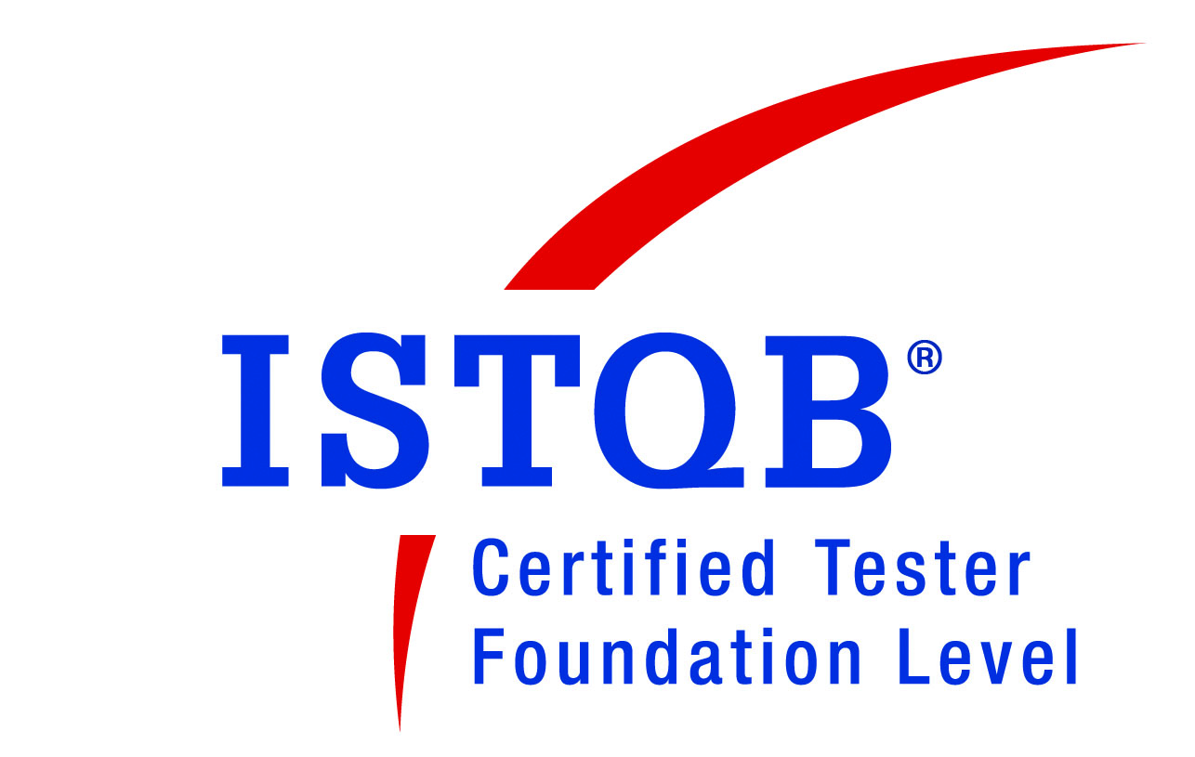
Mukesh S
Phone No: +91 98406 22196
E-mail: mukesh.subramanian24@gmail.com

PROFILE:

- 9 years of experience in testing Data Warehouse / Business Intelligence, WEB-based and Client/Server applications.
- Extensive experience in ETL/ Data warehouse backend testing and BI Intelligence reports testing using Pentaho 4.8/4.1/3.5 (Pentaho Report Designer/ Schema workbench (OLAP), Dashboard).
- Extensive experience in testing IBM Tivoli products such as Tivoli Netcool Performance Manager for Wireless
- Expertise in Testing in standalone/distributed UNIX Environments.
- Good understanding of ETL, Data Warehouse and BI applications.
- Expertise in creating Test Plans, Test Cases, Test Scenarios, Test Strategies to test all the business requirements.
- Good experience of Quality Assurance methodologies like Agile, Waterfall and V-Model.
- Actively involved in User Acceptance Testing (UAT) and Training of the end users.
- Proven abilities in leading teams during the project phase, training & guiding team members and enabling knowledge sharing among the team.
- Commitment to Quality, ability to work under tight deadlines, strong attention to detail, ability to communicate and articulate technical problems in a concise and coherent manner.
- Demonstrate strong analytical and problem solving skills and ability to follow through with projects from inception to completion.
- Effective communicator with exceptional analytical, inter-personal, presentation and problem solving skills

PROFESSIONAL EXPERIENCE

- Presently working with ATLAS Systems Pvt Ltd, Chennai as QA Lead from OCT 2010 to till date.
- Worked with Quintegra Solutions, Chennai as Senior Test Engineer from Feb 2007 to SEP 2010.
- Worked with Reliance Infostreams Pvt. Ltd, Chennai as a Customer Support Representative from July 2003 – May 2005.

EDUCATION:

- Bachelor of Engineering in Electronics and Communication Engineering,
GKM College of Engineering and Technology, University of Madras (71%)

Project Details:

Project #1 Flood Pro Analytics

Client : National Flood Services (NFS), USA
Environment : Pentaho Business Intelligent tool EE, SQL Server 2005
Defect Tracking Tool : TFS, Rally
Role : Test Lead

Description:

The Scope of this project is to load data from 3 different systems in to a centralized database. The data from the centralized database is converted to data mart and BI reports are generated. The data from the source system is loaded into data mart using SSIS Packages. The reports generated are used by various insurance companies and NFS customer support representatives.

Roles & Responsibilities:

- Responsible for setting up the SQA Environment and monitoring the DWH nightly jobs.
- Trouble shooting the nightly jobs when failure.
- Responsible for preparing test plan, writing as well as execution of Test Cases and Logging the defects in Defect Log.
- Mentoring the team and allocating work to team members.
- Training the team member with the application.
- Responsible for handling QA activities.
- Preparation of QA Summary Report and Peer review of Test cases.
- Preparation of Level of Estimate (LOE).
- Preparation of Daily and Weekly status Report.
- Involved in Escaped Defect Analysis (EDA).

Project #2 Tivoli Netcool Performance Manager for Wireless (TNPMW).

Client : IBM Corp (Previously Vallent Corp), Ireland
Environment : Solaris 9 UNIX, ORACLE 10g, Java, Jboss 4.0.3SP1
Defect Tracking Tool : Rational Clear Quest
Role : Test Lead

Description:

TNPMW is a telecom network performance monitoring tool. The TNPMW system is comprised of TNPMW Server and a client layer. The TNPMW server manages the core framework, which is the basis of TNPMW product. The TNPMW server is used to connect a TNPMW user to the data source. The client layer is a web based user interface to the TNPMW server that provides the static and dynamic content. This web based user interface is used for creating and running performance reports based on the data collected in the data source. Gateways are used to transfer, parse and manipulate incoming performance data received from network elements and convert them in to common loader format

Roles & Responsibilities:

- Responsible for preparing test plan, writing as well as execution of Test Cases and Logging the defects in Defect Log.
- Mentoring the team and allocating work to team members.
- Training the team member with the application.
- Responsible for handling QA activities.
- Preparation of QA Summary Report and Peer review of Test cases.
- Preparation of Level of Estimate (LOE).
- Preparation of Daily and Weekly status Report.
- Involved in Escaped Defect Analysis (EDA).
- Involved in setting up of the Test Environment.

Project #3 Electronic Medical Record (EMR)

Client : Quintegra Solutions Ltd.,
Environment : ASP .Net 4.0, SQL Server 8.0
Defect Tracking Tool : Whizible
Role : Test Lead

Description:

Electronic Medical Record (EMR) application is medical software that helps medical professionals to automate patient management. This application makes the entire process of patient records keeping easier, more accurate and comprehensive and more efficient. With an EMR system, doctors use specialized software that allows them to enter their patient records electronically. The software stores the patient information on a server and each patient’s complete history is available instantly, including digitized copies of x-rays, lab results, prescriptions ordered and other necessary medical data. Physicians can use their desktop, laptop, or an electronic clipboard-type computer to navigate through their patient charts and record notes.

Roles & Responsibilities:

- Involve in requirement gathering and analysis.
- Leading the team and manage project workflow to preset deadlines.
- Allocate task within the team and ensure that all have sufficient work.
- Test plan preparation, monitoring test case preparation & test execution progress.
- Reviewing the test case and results.
- Participate in daily scrum meetings adhering to agile development methodology.
- Preparing status reports and metrics.
- Mentoring and training new team members.

Project #4 OnMedica India.

Client : OnMedica, UK
Environment : ASP .Net 4.0, SQL Server 8.0
Defect Tracking Tool : Whizible
Role : Test Lead

Description:

OnMedicaIndia.com is a leading online medical publication for daily news, views, blogs and learning. This application provides high-quality journalism with medical expertise to cater for the daily information and professional development needs of doctors. Although primarily aimed at doctors, onmedicaindia.com is also a valuable resource for nurses, pharmacists, medical students, and other healthcare professionals.

Roles & Responsibilities:

- Involve in analysis and test case design.
- Involve in the initial discussions to understand the scope for new applications to be taken up for testing, planning the overall transition of the application.
- Monitoring test case preparation & test execution progress.
- Reviewing the test case and results.
- Preparation of Level of Estimate (LOE).
- Preparation of Daily status Report and Weekly Status Reports.

Project # 5 Metrica Performance Manager (MPM)

Client : IBM Corp (Previously Vallent Corp), Ireland
Environment : Solaris 9 UNIX, IBM Informix database, JBOSS
Defect Tracking Tool : IBM Clear Quest
Role : Senior Test Engineer

Description:

Metrica Performance Manager is a real-time and historical network performance management solution application. It provides a comprehensive view of both top-level key performance indicators and low-level diagnostic data, giving network operators a complete view of network quality and utilization. These include GSM, CDMA, GPRS, UMTS and most other wireless network technologies. Using Metrica Performance Manager, network operators can identify network performance problems and capacity issues easily and proactively, allowing them to optimize their network and improve quality.

Roles & Responsibilities:

- Involve in test case Design and test data Preparation.
- Involve in test case Execution and Defect Reporting.
- Working on Gateways which is required for the production of application supported performance data.
- Performing Product Validation, Reliability Testing, Data Loading and Data Validation.

CERTIFICATION:

- ISTQB Foundation Certification.

