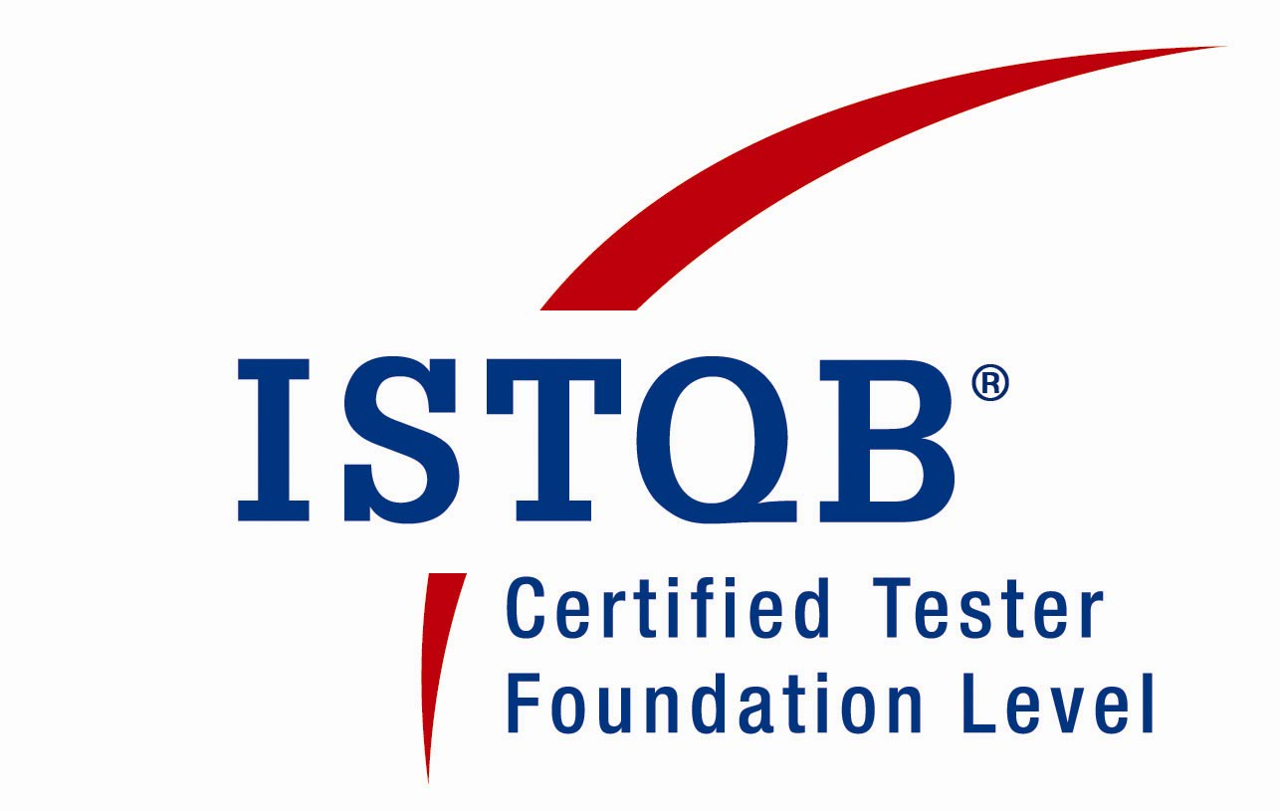
Email:alisettysreedhar@gmail.com
Handy :+91 9960743927

PROFESSIONAL SUMMARY

- Having 8+ years of experience in Testing Software applications.
- Managing Team of 12 people across two projects under Online Service.
- Handling Resourcing, Costing, Estimation, Scope Management, Testing KPIs and Quality plan for the Team.
- Involved in People Management-Appraisal Process, Learning & Development Program,KT,Induction Plan and Team building activities
- Lead the management meetings i.e. Weekly status, Resource Management, Roadmap discussion. Effort estimations, Capacity Tracking etc.
- Involved in Quality Checks for Account covering Root Cause Analysis of the escaping defects, Lesson Learnt and coordinated discussion with site on the same.
- Worked Onsite – Vodafone Qatar Project. Was majorly involved in the E2E Testing and UAT Support.
- Extensive experience in GUI, Smoke, Functional, Regression, Integration and System testing.
- Experience in Design, Execution and reporting of test cases.
- Experience on reporting and tracking defects using Quality Center, Rational Clear Quest, JIRA, and RQM & Star Team.
- Proactive and timely communication (oral/written) with the Development, Business Analyst teams to understand the requirements correctly and regarding all issues encountered.
- Experience in Commodity Trading, Telecom, Online and Mortgage Domains.
- Experience in SAP testing with integration of Commodity XL product.
- Preparation of Test strategy, Test Estimation and Test Plan documents.
- Received various appreciations throughout my tenure in various roles like Test Lead/Senior Tester and Tester.
QUALIFICATION

- Bachelor of Technology from J.N.T.U University with an aggregate of 70 %

CERTIFICATION

- ISTQB (International Software Testing Qualifications Board) Certification.

- NSE’s Certification in Commodities Market Module.

WORK EXPERIENCE

- Working as Assistant Manager with Vodafone Shared Services India Pune from Oct 2012 to till date.
- Worked as Sr.Technical Associate with Tech Mahindra Limited Pune from May 2010 to Oct 2012.
- Worked as Quality Analyst with Triple Point Technology, (India) PVT. LTD. Ltd. Pune, from March 2009 to May 2010.
- Worked as Software Engineer with Hexaware Technologies (India) Ltd. Pune, July 2006 to March 09.

TECHNICAL EXPERTISE

- Databases : Oracle 11G,SQL Server2000
- Operating Systems : Windows, UNIX
- Test Management Tools : QC, Rational Clear Quest, Star Team,
Serena, JIRA, RQM

PROJECT PROFILE

Company: VSSI
Project # 1: Vodafone Online Assurance-Ask Online

Team size : 6
Tools : RQM, Share Point
Role : Test Lead

Description: AOL is a Vodafone Group online interactive Self Service portal for customer. It is a knowledge management portal, which provides a customer-facing web based self service module, also customers can visit to find answers to their queries and issues. The solution can make use of customer information, to provide customized answers. The way customer related information is forwarded to the solution is Local Market integration dependent. Agents can view the full history of a given customer across all channels.

Project # 2: Vodafone Online Assurance-eShop

Team size : 6
Tools : RQM, Share Point
Role : Test Lead

Description: Online Shop is an ATG ecommerce platform developed by Vodafone to allow their Customers to purchase their products and services over the internet. A Customer with a contract can upgrade his products and services by logging into the Online Shop application. The application supports the mobile platform and facilitates the shopping on mobile devices through its Mobile Shop application, which goes a step ahead by utilizing “Core ecommerce Business Solution” (CeCBS) capabilities in building a platform for mobiles.

Responsibilities:

- Involved in the Requirement Feasibility/Analysis along with the Business during the Requirement Phase.
- Responsible for Test Estimation, Test strategy, Test Plan preparation and Resource onboarding.
- Identification of High Level Scenarios against the User Stories/Use cases.
- Through review of the Test cases and the Test data sheets.
- Lead the management meetings- Daily/weekly status report Meetings.
- Generated defect report and involved in defect triage.
- Involved in Status updates, Review meetings with the stake holders.
- Work allocation to the Team Members
- Responsible for the preparation of Test Closure/Summary report to meet the exit criteria for the respective phase.
- Responsible for the QCP audit and represented as a SPOC for Organizational activities.

Company : Tech Mahindra Ltd.
Project # 1: Vodafone Qatar

Team size : 18.
Tools : Quality Center
Role : Acting Lead/Senior Tester

Description: Vodafone Qatar is one of the Wireless Operators in Qatar and is branding its Pre-pay products mainly under the two heads viz Red and Freedom. Red products are pre-activated SIMs mainly targeted at customers willing to recharge based on their needs. Freedom products are non-pre-activated SIMs which are targeted at customers who are willing to pay on a monthly basis a sum based on their monthly spend.
Vodafone Qatar wants to offer differentiated behavior to customers based on the value and the type of the customers. In order to achieve this, Vodafone has defined new Class of Services based on which they are planning to offer differentiated services to the customer.

Responsibilities:

- Developed and executed Test cases.
- Involved in Functional testing and Regression Testing.
- Generated defect report and involved in defect tracking
- Involved in Status updates, Review meetings with the clients.
- Worked Onsite during the SIT and UAT Phases.
- Work allocation to the Team Members and Status update to the Manager

Project # 2: EDB E2E

Team Size : 23.
Tools : JIRA, RQM
Role : Senior Tester

Description: Etisalat plans to launch its wireless (2G) operations in different parts of India targeting around 75 million subscribers in the first 10 years. Etisalat will operate in the three regions of India. They will have 15 operation circles. Each circle will have separate operation identity. Etisalat will maintain their operation centrally.

Responsibilities:

- Developed and executed Test cases.
- Involved in Functional testing and Regression Testing.
- Generated defect report and involved in defect tracking
- Involved in the PRM/CRM Module of the application
- Involved in Status updates, Review meetings with the clients.
- Work allocation to the Team Members and Status update to the Manager.

Company : Triple Point Technology Pvt. Ltd.
Project # 1: Commodity XL

Team size : 6.
Tools : Star Team.
Role : Senior Tester

Description: Commodity XL has a host of Manager Screens (or queries) that allow users to retrieve and report data on an ad-hoc or predefined basis. These Manager screens and their related functions serve as the primary tools for all day-to-day operations. Trading, Scheduling, Operations and Settlement are some of the examples.

Responsibilities:

- Developed and executed Test cases.
- Involved in Functional testing and Regression Testing.
- Generated defect report and involved in defect tracking
- Involved in Status updates, Review meetings with the clients.

Company : Hexaware Technology Ltd.
Project #1: Collections

Team size : 9.
Tools : Rational Clear Quest.
Role : Tester

Description: Option one is a mortgage-banking firm involved in the origination, purchase, and servicing of residential mortgage loans. Option One is able to provide financing to America’s homeowner’s who may have less than perfect credit histories or who may be disqualified from traditional lending sources. Collection is typically a Call centre application and provides consistent and efficient handling of each Customer contact. The System allows a single point of entry for each Customer to ensure a consistent Customer experience in keeping with Option One Collections objectives and standards.

Responsibilities:

- Understanding the Client Requirements by studying Functional document.
- KT sessions to team members on Application Functionality.
- Involved in the Preparation of Test data.
- Review of the Scripts and suggesting modification in the scripts.
- Executing the scripts and reporting the bugs through Defect tracking tool.
- Interacting with the onsite people and resolving the offshore issues.
- Attended weekly status meetings and provide detailed Status report to the Client.

Project #2 DARES

Team size : 9.
Tools : Rational Clear Quest
Role : Tester

Description: The Main purpose of this project is to provide the housing loans. Third party will provide credit report of the customer. Loan will be provides based on the customer income, savings, land cost, credits and liabilities. This project contains modules like Loss Mitigation, Real Estate. I involved Both Loss Mitigation module and Real Estate. When we get the information directly, we can consider them as inbound leads; if we got through third party we consider them as outbound leads.

Responsibilities:

- Involved in the preparation of test cases.
- Executed test cases and test data to validate Requirements.
- Regression testing and Functional Testing Are implemented at various phases.
- KT sessions to team members on Application Functionality.
- Logging the defects and monitoring the status till the Defect is closed.
- Participating in regular status meetings and prepared weekly reports on the status of the Application.

