B.UDAY KISHORE REDDY

E-Mail :: udaykishore.qa@gmail.com Phone Number : +91 – 9620354712

Objective:

To obtain a challenging position in the company and to utilize abilities developed through my experience and education for the growth of the company along with my professional growth.

Education Qualification:

Bachelor of Technology in Electronics and Control Engineering from JNTU, Hyderabad (B.Tech)

Professional Experience:

- Working in Enzen Technologies Pvt. Ltd., Bangalore, India from May 2010 to till date as Associate Consultant

- Worked in SGT India Pvt. Ltd., Bangalore, India from May 2007 to April 2010 as QA Analyst

Professional Summary:

- 7+ years of experience in Software Testing of Web based and client server applications
- Expertise in Analysis of Requirement documents, Design documents & Business Rules
- Expertise in preparing thorough and detailed Test Strategy / Test Plan
- Experience in Test Requirements gathering and Effort Estimation
- Experienced in reviewing the Functional and Product documentation
- Manage test case development and execution
- Correlate areas of focus and prioritize testing methodologies based on prior areas of concern, and areas of current/future development focus
- Developed status reporting mechanisms and implemented Process Improvement measures
- Experience in Compiling and deploying the code
- Strong trouble shooting and problem solving skill
- Proficient in Test management
- Knowledge of Test Management Tools (Quality Centre, QA Traq)
- Knowledge of automation tools (QTP, Selenium IDE)
- Knowledge of Business Intelligence Tools (Business Objects, Cognos, Cassius)
- Ability to work independently or as a team Member
- Good exposure to Energy, Utilities & Healthcare sector

Managerial - Project Management:

- Supervised a team of test professionals in UK and Bangalore
- Member of testing practice leadership team in current organisation
- Project scheduling and analysing the requirements for further proceedings
- Excellent coordinator, able to delegate tasks
- Possess excellent organizational skills with proven abilities in team and customer relationship management
- Project Delivery Tracking and Issue Escalations
- Delivering and implementing the project as per scheduled milestones
- Conducted user training sessions
- Experience in providing training for new joiners in Software Testing
- Excellent Communication and Management skills

Onsite Experience:

- Possessed around 2 years of Onsite experience (esp. in United Kingdom)

Certifications

- ISTQB - ISEB Certified Tester Foundation Level (CTFL)

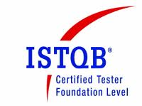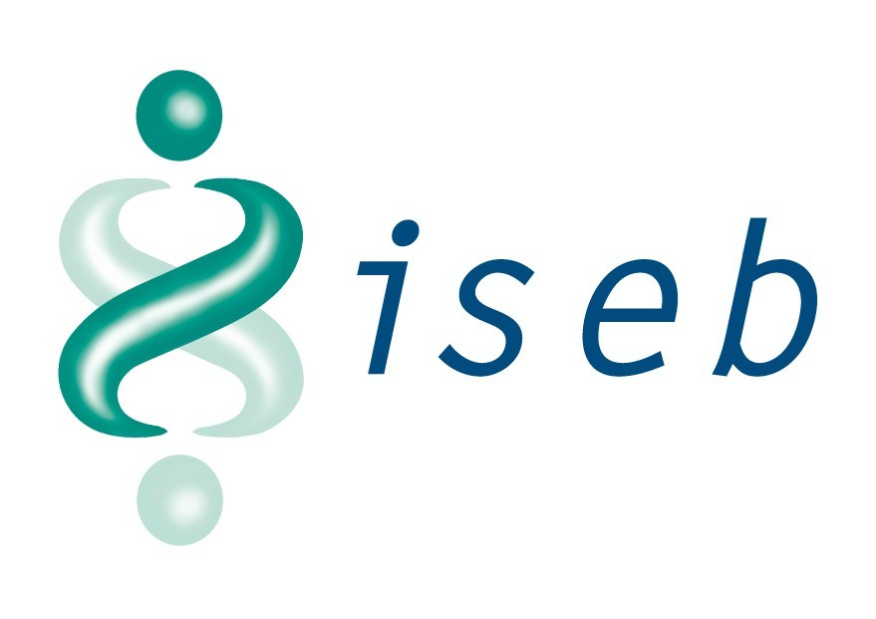

Technical Skills:

General : Software Testing Concepts
Defect Tracking Tool : Quality Center, JIRA, Jtrac, Zoho
Test Management Tool : HP Application Life Cycle Management, Zoho
Automation Tool : QTP, Selenium IDE
CM Tool : Visual Source Safe (VSS), Subversion (SVN)
Applications : Microsoft Office, Open Office
BI Tools : Business Objects, Cognos 8.2, Cassius
DBMS : MS-SQL Server 2005, Oracle 11g
Operating Systems : Windows

Recent Projects

1. Northern Gas Networks SC RIIO - (Dec 2013 – Till Date)

Client : Northern Gas Networks, UK
Role : Test Lead
Domain : Energy and Utilities
Environment: .Net, Oracle 11g

Description

The new price control review period (RIIO) started in April 2013 under which NGN has identified

- Demand Management
- Offtake Management
- Alarm Management
improvement as one of the key focus areas for development. This project has been created to identify requirements and implement solutions leading to business benefits.

Demand Management:

Annual Gas Demand forecasting is done by NGN to predict the Annual & Peak demand for ten years ahead for each LDZ. It is essential to carry out the process to comply with demand forecasting requirements of Section H of the UNC OAD and as a mandatory obligation under the gas transporter’s license and to determine the capacity and throughput requirements.

Demand Forecasting data feeds into different key business processes including network planning and analysis activities, setting of transportation charges and the interruption tendering process.

Offtake Management:

NGN runs a long term annual process that determines Demand, Storage and Intake strategy for the next 10 years. The Offtake form a major part of the distribution network (DN) intakes. The Uniform Network Code (UNC) governing gas transporters in the UK defines an ‘Individual Offtake Point’ as an Individual System Point which is the point of connection between:

- the NTS and an LDZ; or
- two LDZs which are not comprised in the same Distribution Network;

comprising a single pipe at which gas can flow from the NTS into the LDZ or (as the case may be) from one of such LDZs to the other. The UNC also defined an offtake as one or more Individual Offtake Points, located on the same site, at each of which gas can flow into the same LDZ.

The transfer of gas from offtakes is enforced by supplemental agreements that must be followed to avoid penalties. The management of offtakes requires long term planning and adherence to rules each day by shift operators to ensure breaches are avoided while distributing gas.

Alarm Management:

Alarm Systems form an essential part of the operator interface to large automated industrial facilities and complex transportation networks such as that owned and Operated by NGN. They provide vital support to the operators by warning them of situations that need their attention and have an important role in preventing, controlling and mitigating the effects of abnormal situations.

NGN has made enormous progress in analysing and implementing industry best practices as recommended by EEMUA and supported by Britain’s Health & Safety Executive. However, existing mechanisms are unstructured, manual/time consuming, inefficient and prone to error.

Responsibilities:

- Responsible for test delivery of applications from offshore
- Involved in complete QA Life Cycle
- Analyzed Business requirements
- Designing and reviewing the test conditions / test cases
- Assigning task to all Testing Team members and ensure that all the assigned tasks are completed in stipulated time frame
- Submitting defect logs through defect tracking system (Zoho) to development team for defect analysis and fixing
- Conducting Functional testing on newly developed functionality.
- Managing a team of 3 members
- Interacting with Developers for assisting them in the Identification, Simulation, Resolving and Tracking of problem events
- Preparing / updating the metrics dashboard at the end of a test phase and project
- Generating daily / weekly testing tracking status and Issue Escalations

2. National Grid RIIO - (Jun 2013 – Nov 2013)

Client : National Grid, UK
Role : Test Lead
Domain : Energy and Utilities
Industry : Utilities
Environment : .Net, Oracle 11g

Description

National Grid is funded by a price control mechanism which is agreed with and set by Ofgem (Office of Gas and Electricity Markets). Ofgem has introduced a new regulatory framework to replace RPI-X known as RIIO:

Revenue= Incentives + Innovation + Outputs

The RIIO model offers network companies real incentives for securing investment and driving innovation. This is to ensure the delivery of sustainable energy networks for current and future customers at the lowest cost. The period of the next Gas / Electricity Distribution and Transmission Price Control Review, on which we are now consulting, is from 2013 to 2021.

Performance and Workload Tracking Solution - PWTS:

A new centralized Cost Management and Estimating hub is being established within Capital Delivery, building a center of excellence in capital projects costs estimation, cost control, risk and contingency pricing, performance reporting and benchmarking. The first priority is to standardize and productionise the capital scheme estimating process. PWTS will broadly implement the functionality of existing eHub Tracker with necessary enhancements to facilitate eHub Manager

Engineering Estimation System (EES) is likely to provide necessary capability for scheme estimation using established Cost Breakdown Structure (CBS)

In addition, there is a need to develop the following capabilities:

- Work Flow Management: Track progress of a schemes estimation through the different status within eHub
- Work Allocation and Efforts Tracking: To track resource allocation and the efforts spent by individual resources per estimate
- Performance Management: Capture number of iteration, overall time, and delivery against defined KPI (RAG Status) etc., of an estimate prepared and delivered by eHub team.

Responsibilities:

- Responsible for test delivery of applications from offshore
- Involved in complete QA Life Cycle
- Analyzed Business requirements
- Helping the onsite test lead in preparing Test Plan and Test Strategy
- Designing and reviewing the test conditions / test cases
- Assigning task to all Testing Team members and ensure that all the assigned tasks are completed in stipulated time frame
- Submitting defect logs through defect tracking system (Jtrac) to development team for defect analysis and fixing
- Conducting Functional testing on newly developed functionality.
- Managing a team of 6 members
- Interacting with Developers for assisting them in the Identification, Simulation, Resolving and Tracking of problem events
- Preparing / updating the metrics dashboard at the end of a test phase and project
- Generating daily / weekly testing tracking status and Issue Escalations

3. BT Secondary Uses Services (Delivered for NHS, UK) - (Jul 2012 – May 2013)

Client : BT Global Services, UK
Role : Test Lead
Domain : Healthcare
Environment : Cassius, Oracle 11g

Description

The Secondary Uses Service (SUS) is primarily a data warehouse that provides access to anonymous patient-based data for purposes other than direct clinical care such as:

- Healthcare Planning
- Commissioning Services
- Public Health
- National Policy Development

SUS is delivered by The NHS Information Centre and NHS Connecting for Health.

SUS Payment by Results (PbR):
A set of HPA extracts will be created for the SUS 12 Release and made available via the Cassius Reporting tool. The Component will consist of 18 extracts, 9 for CCG of Residence and 9 CCG of Responsibility, allowing users from Proxy organisations to download PbR 12/13 data for patients whose activity they are authorised to receive.

The PbR Online Service allows Providers, Commissioners and Strategic Health Authorities, with the appropriate authorisation, to select, configure and run their own PbR Extracts convenient to their business needs.

PbR Managed Service Extracts are also made available to registered users at reconciliation and post-reconciliation points. These are generated by the SUS system and delivered direct to the inboxes of registered users with appropriate access rights. The extracts provide point in time snapshots to support users' business needs.

SUS Extract Mart (SEM):
A new application, Extract Mart 2012, will be created containing a single sub folder, Standard Extracts, as per previous versions of the SEM application. These will contain the updated extracts developed to meet the requirements for SUS Release 12. There will be extracts available for all CDS Types and a separate linked extract for related CCMDS data will be created on execution of either the APC Finished or Unfinished extracts.

SUS Extract Mart (SEM) allows users to extract clear or pseudonymised data for all records for a given organisation within a specified period of activity. Users can download data on request from the SUS Extract Mart, which can then be loaded into local systems. Commissioners and providers, including agencies acting on their behalf, will have access to clear data in this release. SHAs and recipients of value added services have access to pseudonymised data.

Responsibilities:

- SPOC (Single Point Of Contact) for the delivery of application from offshore
- Involved in complete QA Life Cycle
- Analyzed Business requirements
- Designing and reviewing the test conditions / test cases
- Deployment of the code
- Assigning task to all Testing Team members and ensure that all the assigned tasks are completed in stipulated time frame
- Submitting defect logs through defect tracking system (Quality Centre) to development team for defect analysis and fixing
- Conducting Functional testing on newly developed functionality.
- Managing a team of 7 members
- Interacting with Developers for assisting them in the Identification, Simulation, Resolving and Tracking of problem events
- Giving project demos to BT testing team
- Preparing / updating the metrics dashboard at the end of a test phase and project
- Managing stake holders

4. Streetworks - (Nov 2011 – Jun 2012)

Client : UK Power Networks, UK
Role : Associate Test Lead
Domain : Energy and Utilities
Industry : Utilities
Environment : .Net, Oracle 11g

Description

The aim of this project is to improve the efficiency in street works. The requirements are being captured to primarily meet some of the key objectives to:

- Improve the efficiency in Job Management by better planning, quality of information and job tracking
- Single source of Information
- Improve the Timeliness and Quality of Notices to minimise Penalties on inaccurate job location details at Job initiation, scheduling and initial notice / permit request phases
- Improve the Timeliness and Quality of Job packs to minimise rejections from Contractors
- Analyse the reasons for Permit cancellation / extensions and formulate plan to reduce further cancellations / extensions

As a part of solution, HUB Interfaces are introduced to facilitate IDS Web (Job Requesting System) and ENMAC (Fault Requesting System) to integrate with MAYRISE

Responsibilities:

- Preparing Test Plan and Test Strategy
- Analyzed business requirements and functional design documents
- Interacting with Developers for assisting them in the Identification, Simulation, Resolving and Tracking of problem events
- Generating daily / weekly testing tracking status and Issue Escalations

5. Distribution Network Control System (DNCS) - (May 2010 – Oct 2011)

Client : National Grid, Northern Gas Networks, Wales and West Utilities, Scotia Gas Networks
Role : Senior Test Engineer
Domain : Energy and Utilities
Industry : Gas
Environment : .Net, Oracle 11g

Description

DNCS is a combination of two sub-systems:

- Business Applications (BA)
- SCADA Real time sub system

The web based business application for DNCS will be used for strategy related functionality for Demand Forecast, Storage, Intake and Balancing. This application is based on a 3 tiered architecture where the UI and business logic tiers are designed on a modular and loosely coupled approach. The web/UI tier will be implemented as an ASP.Net 3.5 web. The reporting will be also be implemented as part of the web application using Crystal Reports. The UI layer will be designed to make accessible through web browser and remote access infrastructure like Citrix and Windows Terminal Server. SCADA need to exchange data with BA through Data feeder. The SCADA system is responsible for current value information which might be required by Business Application to generate the Demand/Intake profiles which contain both past and future elements.

Supervisory Control and Data Acquisition (SCADA) is used to measure the important parameters (pressure, temperature, quantity) of gas in the system and transmit (telemeter) the data to the Control room. It helps in monitoring and controlling the flow of gas in pipelines for Gas Distribution.

Responsibilities:

- Involved in complete QA Life Cycle
- Analyzed Business requirements
- Designing and documenting the test conditions and test cases
- Deploying the code
- Conducted System Testing and User Acceptance Testing
- Involved in Operational Acceptance Testing (OAT) and Model Office Testing (MOT)
- Review of the test cases written for unit and integration level
- Submitting defect logs through defect tracking system (Quality Centre) to development team for defect analysis and fixing
- Conducting Functional testing on newly developed functionality.
- Accessing Visual Source Safe (VSS)
- Managed a team of 5 members
- Interacting with Developers for assisting them in the Identification, Simulation, Resolving and Tracking of problem events
- Reviewing the Functional and Product documentation
- Giving training on the product for new resources

6. FUEL MANAGEMENT SYSTEM (FMS) - (May 2007 – April 2010)

Client : Fuelquest, USA
Role : Quality Assurance Analyst
Domain : Energy and Utilities
Industry : Oil and Gas
Environment : J2EE, Oracle 11g

Description

Fuelquest's Fuel Management System (FMS) is the most comprehensive, end-to-end supply chain solution focused on reducing the cost of procuring, managing and accounting for bulk fuel. FMS powers the largest fuel management network in North America with more than 15 billions gallons managed annually. Using FMS, fuel managers and procurement managers can capture and minimize true fuel costs by understanding demand patterns, optimizing inventory, centralizing supply contracts, determining best price on market versus contract, and reconciling invoicing and taxes. FMS is also used by Fuelquest as a platform to deliver additional value-added service offerings provided by our expert fuel and compliance teams.

Responsibilities:

- Involved in complete QA Life Cycle
- Analyzed Business requirements
- Designing and documenting the test conditions and test cases
- Compiling and Deploying the code
- Conducted System Testing and User Acceptance Testing
- Review of the test cases written for unit and integration level
- Submitting defect logs through defect tracking system ( JIRA ) to development team for defect analysis and fixing
- Prepared bug documentation
- Conducting Functional testing on newly developed functionality
- Accessing Visual Source Safe (VSS)
- Testing simple Cognos reports
- Aligning and Formatting of Cognos reports
- Wrote product documentation
- Involved in Client Training
- Interacting with the clients
- Interacting with Developers for assisting them in the Identification, Simulation, Resolving and Tracking of problem events
- Reviewing the Functional and Product documentation
- Giving training on the product for new resources

