KUMAR VISHAL RAJ
: +91 - 9035122704
: vish.xxx@gmail.com

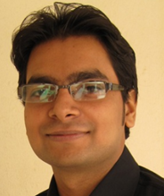

JOB OBJECTIVE

Seeking entry level assignments in the field of Design Engineering and Production Operations with an organization of high repute, preferably in Electrical / Electronics / Steel / Energy / Power / Oil / Software Industry

SUMMARY
- B.E. (Electrical & Electronics Engineering) professional with nearly 2 years of experience in Design Engineering and Digital Cell Libraries Development & Support  - Sound understanding of digital backend and how libraries fit into the back-end flow  - Proven ability in working in the environment of Linux, Solaris where Linux was used for creation, modification and control of work environment along with hands on Shell Scripting  - Independent contributor with good working experience in digital cell library development and expertise in various aspects of library creation  - Proactive in turning the research ideas into technical plans and considering cost, effectiveness and safety of designs  - Highly skilled in reviewing and verifying design drawings and other technical documentation prepared by others to ensure accuracy in form, fit and function  - Expertise in evaluating specifications for all internal/ external finishes within a given project based on aesthetics and budgets assigned to all prime areas  - Deft in handling priorities, with a bias for action and a genuine interest in personal & professional development  - An individual with good interpersonal skills & willingness to learn further | 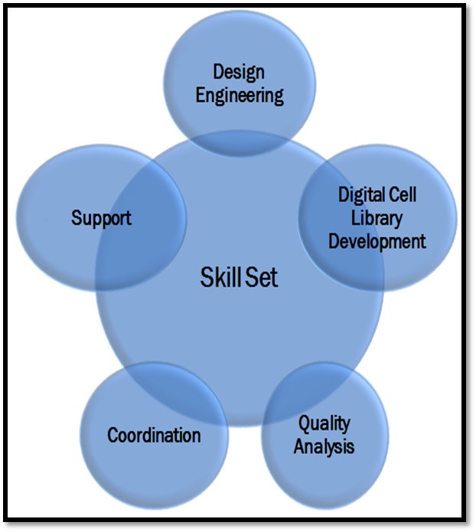
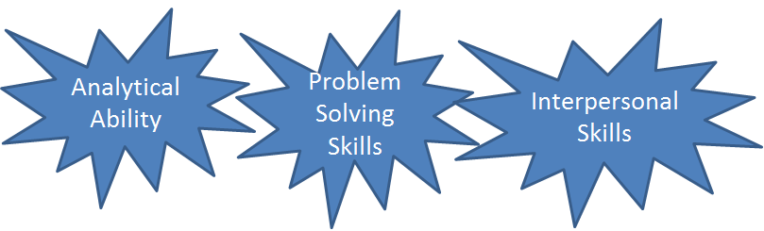
ORGANIZATIONAL EXPERIENCE
Jul’11 – Mar’13 with Sankalp Semiconductor Pvt. Ltd., Hubli, Karnataka as Design Engineer
(Joined as Design Engineer and rose to the position of Design Engineer)

Key Result Areas:
- Worked on Digital Cell Libraries Development and Support / Quality Analysis
- Carried out the design of digital circuits for standard cell libraries with robust design methodology and managed statistical failure analysis, application of the standard cell library and usage of the same
- Designed core cell library architecture with analysis and trade-offs across actual design scenarios
- Understanding of core cell library usage in industry tools such as RC, EDI, etc.
- Executed the complete digital cell library from library specifications to library release in Deep Sub-micron processes independently
- Involved in handling library schematic design, layout design, characterization/dotlib generation, library modelling/packaging, QC and release\
- Worked with industry experts on the state-of-the-art processes, tools, flows and methodologies.
- Have a nearly 2 years of experience in Automation of Qc flow and Qc Analysis (now industry standard) using PERL.



Accomplishment:
- Bestowed with the Performance Appreciation Certificate from Senior Management

TRAININGS
- Successfully attended the following trainings:
- Satellite Transmission-Certification by Doordarshan Maintenance Centre, Jamshedpur
- PLC and its application-Certification by TATA Tinplate, Jamshedpur
- Understanding the functionality and basic design of PLC.
- Live coding of PLC for Tempering MILL (4hi) drive in operation at works.
- Creating the better version of exiting logic and code for automation of Tempering Mill Drive which was in continuous operation throughout the development of better version
- UNIX from Accenture

EDUCATION

- B.E. (Electrical & Electronics Engineering) from SDM College of Engineering and Technology (VTU), Dharwad, Karnataka (India) in 2011 (Secured 7.6 CGPA on the scale of 10)

Other Course:
- Pursuing Certificate Course in French from Karnataka University, Dharwad 2010

ACADEMIC PROJECTS
Title: Simulation of DVR on MATLAB and Its Application
Domain: Hardware and Software
Description: A circuit designed to control the voltage surges and dips

Title: Device Temperature Controller
Domain: Hardware
Description: An electronic circuit which controls the temperature of appliances within specified temperature ranges

TECHNICAL SKILL - SET

- Well versed with the:
- Cross Talk Noise Analysis of Digital Cell Library
- Generation of Port Power Grid Views of Digital Cell Library
- Perl Scripting, used for Automation of Cross Talk Noise Analysis and Power Grid Views
- C, C++ and PERL

EXTRACURRICULAR ACTIVITIES
- Actively participated in:
- Paper Presentation Contests held at State Level in Karnataka
- Karnataka State Inter-collegiate Ethical Hacking Competition ”Builders ‘n’ Hackers” held at AIT, Bangalore
- Troubleshoot Event of Think-09 held at SDM College of Engineering and Technology, Dharwad
- Part of organising team of THINK-10 (national level event) held at SDM College of Engineering and Technology, Dharwad
- Played Basketball for the state team of Jharkhand

VOLUNTARY ASSIGNMENT
- Donated blood to needy patients at various blood donation camps held at SDMCET, Dharwad

PERSONAL DETAILS
Date of Birth: 28th November, 1987
Residential Address: 32. Dhala Road, Tinplate, Golmuri, Jamshedpur – 831003, Jharkhand
Linguistics: English, Hindi and French
Location Preference: Bangalore, Pune, Jamshedpur, Hyderabad, Delhi

