RESUME
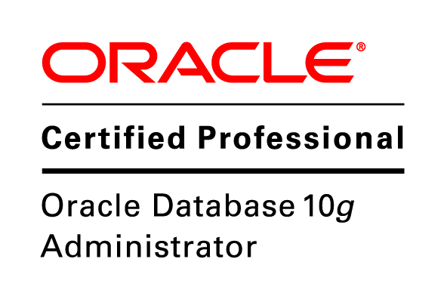

VIGNESH.G
Email : vigneshcse1@gmail.com

Mob : 8792124575

Carrier Objective

To work in an organization that gives me scope to update my knowledge & skills and be a part of the team that works towards the growth of the organization.

Educational Profile

Course | Institution | Board/ University | Year of Completion | Marks %
B.E(CSE) | Jayam College of Engineering and Technology, Dharmapuri. | Anna University | 2012 | 78.4
HSC | Vailankanni Mat. Hr.Sec School,Denkanikottai. | Matric | 2008 | 68.5
SSLC | Vailankanni Mat. Hr.Sec School,Denkanikottai.. | Matric | 2006 | 67.5

Personal Experience

Software Engineer at Pinaka Aerospace Pvt. Ltd.

April 2013 – Till Date

→ 0.6+ years of experience in Oracle developer suite 10g (forms and reports).

→ Established good understanding and knowledge of Oracle Technologies .
→ Established good understanding and knowledge of Oracle developer suite 10g.

Software Skills
- Software package : MS office
- Programming language : C,Dot Net (.Net)
- Operating system : Windows,UNIX
- Database : SQL,ORACLE

Project Profile

Pinaka Aerospace Pvt. Ltd. Project

Project : DARE Payroll
Language/Platform : Oracle form developer, Oracle 10g, SQL, PL/SQL
Client : Defence Avionics Reasearch Establishment (DARE)
Role : Application Maintenance,Enhancement and Oracle Reports

Project Description:

DARE Payroll is an ERP system. This ERP system is developed for internal
clients (DARE Employees) where employee payroll and visitor details are
maintained.

Roles and Responsibilities:

→ Requirement gathering and analysis.
→ Design, development/enhancement and implementation.
→ Involved in enhancement of forms and reports.
→ Ensure timely delivery & quality of delivery by adhering to Quality
Process

Co-Curicular Activities
- Member of ISTE(Indian Society of Technical Education)
- Zonal Runners up in cricket tournament

Strengths

- Dedication, hard work and confidence to achieve goals.
- Self Motivation and positive attitude.
- Ability to mingle well in the group and adaptive to any kind of situation
- Completed ORACLE CERTIFICATION in VERSATILE.

Areas Of Interest
- Database Management System.

Hobbies

- Listening music and playing games in computer
- Playing Cricket.
- Playing indoor games

Personal Profile

- Name : Vignesh.G
- Nationality : Indian .
- Gender : Male .
- D.O.B : 20-08-1991.
- Father’s Name : Govinda raju.N.S
- Mother’s Name : Sumathi.G
- Address :No.75/1-1,1st Main,
Dhathatreya extension,
K.G.Nagar,
Bangalore-19
- Blood Group : O+ve.
- Languages known : Tamil,English,Telugu,Kannada.

i
Declaration

I here by declare that all the information furnished here in above is true to the best of my knowledge and belief.

Date:
Place: (G.VIGNESH)

