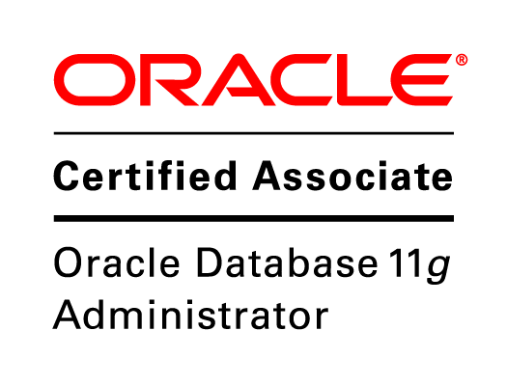

**Leonard Minin Suares.**

Mob no- +91-8884888979

Email- [leonard.suares@gmail.com](mailto:leonard.suares@gmail.com)

**CAREEROBJECTIVE**

Seeking a challenging and innovative job where I can work to enhance my skills while contributing to organizational goals.

**CERTIFICATIONS**

• Oracle Database 11g Administrator Certified Associate.

• Certified for the SQL fundamental 1 by Oracle.

**TECHNICAL SKILLS**

**Database** : ORACLE 11g

**Languages** : C, SQL and PL/SQL, SHELL-SCRIPTING

**Operating Systems** : ORACLE ENTERPRISE LINUX, LINUX

**Database Tools** : Import, Export, RMAN,DATA-GUARD,DB LINKS

**SUMMARY OF SKILLS**

* Expertise in installing different versions of Oracle database software On Linux and Windows operating systems.
* Experienced in development and production environments.
* Good knowledge on Oracle database architecture.
* Having experience in **database cloning** with **cold, hot** and **rman** backups.
* Experienced in taking regular **off-line, online** and **logical Backups**.
* Experienced in **RMAN backup** and recovery skills.
* Familiar with **Table space Management, User Management**.
* Implemented oracle **Data Guard (Standby Database) as** adisaster recoverysolution**.**
* Creating users providing roles, privileges and quotas as per requirement.
* Creating table spaces and data files, monitoring table space.
* House Keeping activities of **Archive logs** and **Trace files**
* Resolving user’s **day-to-day issues.**

**Professional Experience Summary**

Company – Infosys

Designation – Sr Process Executive

Project – BT

From: 09/08/2010 To: Present

•In-depth knowledge of Network concepts and Broadband operations in IT/Tech Support environment.

•Managing and handling Broadband connections, orders and trouble-shooting on customer’s faults.

•Worked with applications like Siebel, Amdocs, telnet and remote testing applications.

**EDUCATIONAL QUALIFICATION:**

**Educational Qualifications (Academic):**

|  |  |  |  |
| --- | --- | --- | --- |
| cOURSES | INSTITUTION | YEAR | PERCENTAGE |
| M.C.A(final year) | Sikkim Manipal University, Bangalore. (correspondence) | 2010 - 2013 | B Grade |
| B.C.A | BIMS Degree College, Shaikh campus, Belgaum. | 2007-2010 | 64% |
| P.U.C | Wardlaw Pre-University, Bellary. | 2004-2007 | 49% |
| S.S.L.C | Vianney Vidyalaya, Bellary. | 2004 | 76% |

**Personal Details:**

* Father’s Name : Dominic Suares
* Date of Birth : 10-12-1988
* Gender : Male.
* Nationality : Indian.
* Mother tongue : English
* Languages known : English, Hindi and Kannada.
* Hobbies : playing hockey, music and painting.

If deemed a worthy candidate, you can be rest assured of my integrity, sincerity to the best of my ability towards your renowned establishment.

Thanking you.

Place : Bangalore. (Leonard Minin Suares.)