**Virtual machine Angular UI code path-**

C:\Bala\workspace\vsc\ProjectManagerCertification

**Virtual machine SpringBoot middleware code path-**

C:\Bala\workspace\sts\SpringCertificationProjectManager

**GIT repo Angular UI code path-**

http://172.18.2.18/Balakumaran/AngularProjectManagerCertification

**GIT repo SpringBoot middleware code path-**

http://172.18.2.18/Balakumaran/SpringBootProjectManagerCertification

**Jenkins job Angular UI path-**

http://localhost:8080/job/AngularProjectManagerCertification/

**Jenkins job SpringBoot middleware path-**

http://localhost:8080/job/SpringBootProjectManagerCertification/

**Virtual machine Docker path-**

C:\Bala\docker\docker-17.09.0-ce\docker

**Angular Testing-**

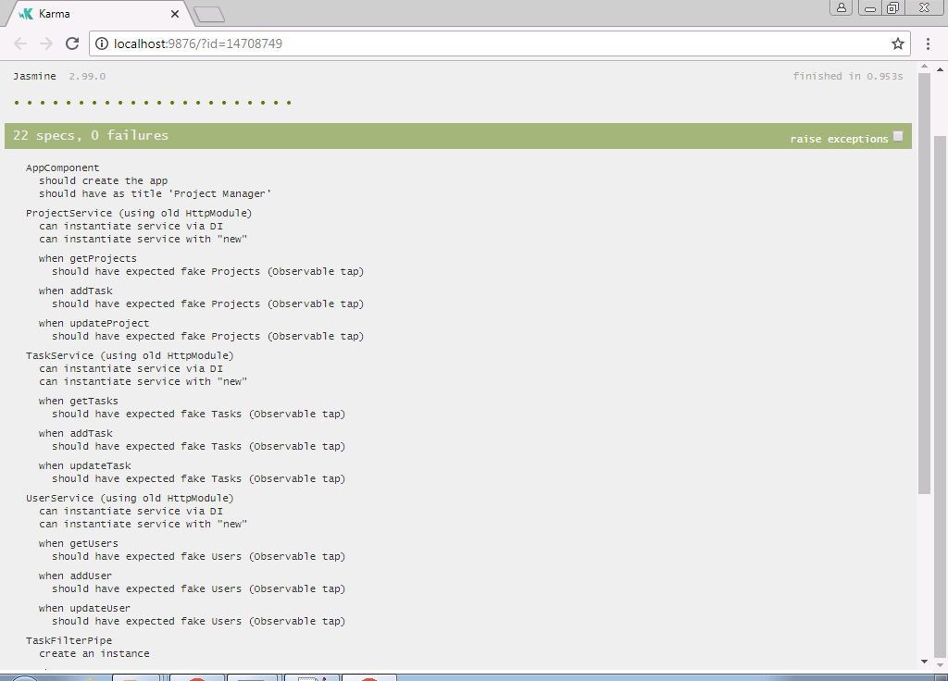

**Docker--**

**SpringBoot Docker file-**

From tomcat:8.0.51-jre8-alpine

RUN rm -rf /usr/local/tomcat/webapps/*

COPY ./SpringCertificationProjectManager.war /usr/local/tomcat/webapps/ROOT.war

CMD ["catalina.sh","run"]

**Angular Docker file-**

FROM nginx:1.13.3-alpine

COPY nginx.conf /etc/nginx/nginx.conf

WORKDIR /usr/share/nginx/html

COPY dist/ .

**Network commands -**

dockerx network create my-network

**Mysql commands-**

dockerx run --name some-mysql --net=my-network -e MYSQL_ROOT_PASSWORD=password -d mysql:5.6.41

dockerx exec -it some-mysql bash

mysql -u root -p

CREATE DATABASE fsddb;

use fsddb;

SET PASSWORD FOR 'root'@'localhost' = PASSWORD('password');

CREATE USER 'usernameall'@'%' IDENTIFIED BY 'ThePassword';

grant all on *.* to 'usernameall'@'%';

**SpringBoot commands -**

dockerx image build -t springbootprojectmanager .

dockerx container run --name 03 --net=my-network -p 9111:9111 -d springbootprojectmanager

**Angular commands -**

dockerx image build -t my-angular-app .

dockerx container run --name 01 --net=my-network -p 4000:9001 -d my-angular-app

