**CapsuleProject_314395_balakumaranrajendran**

**Vitual Machine Angular UI code path-**

C:\Bala\workspace\vsc\TaskManagerCapsuleProject

**Vitual Machine SpringBoot middleware code path-**

C:\Bala\workspace\sts\SpringCapsuleTaskManager

**GIT repo Angular UI code path-**

http://172.18.2.18/Balakumaran/AngularTaskManagerCapsuleProject

**GIT repo SpringBoot middleware code path-**

http://172.18.2.18/Balakumaran/SpringBootTaskManagerCapsuleProject

**Jenkins Job Angular UI path-**

http://localhost:8080/job/AngularTaskManagerCapsuleProject/

**Jenkins Job SpringBoot middleware path-**

http://localhost:8080/job/SpringBootTaskManagerCapsuleProject/

**Jenkins Job Angular UI:**

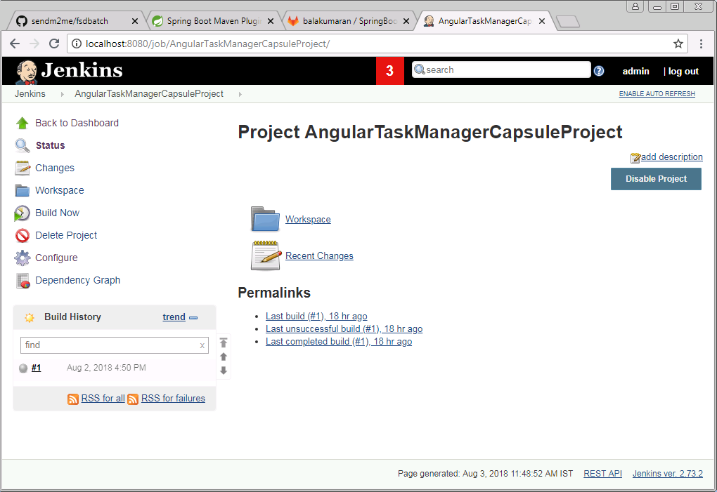

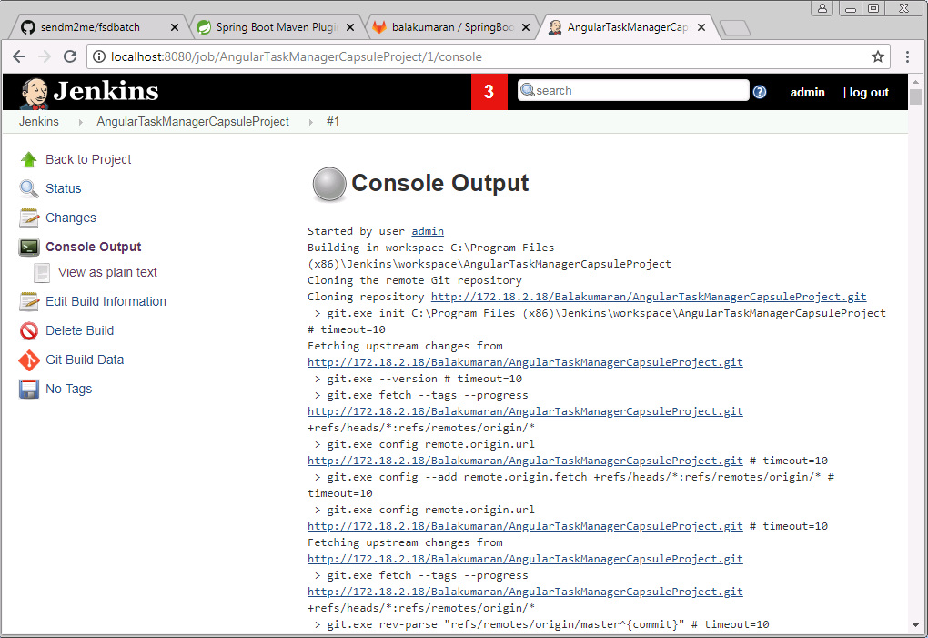

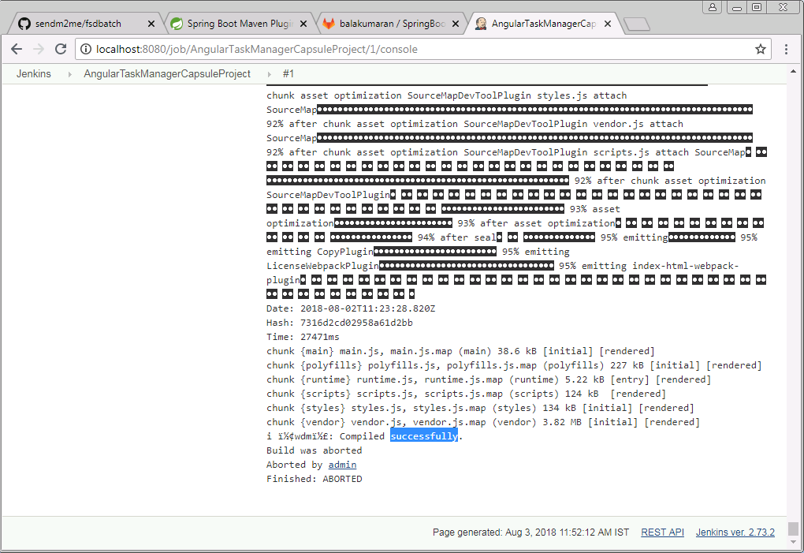

**Jenkins Job SpringBoot Middleware:**

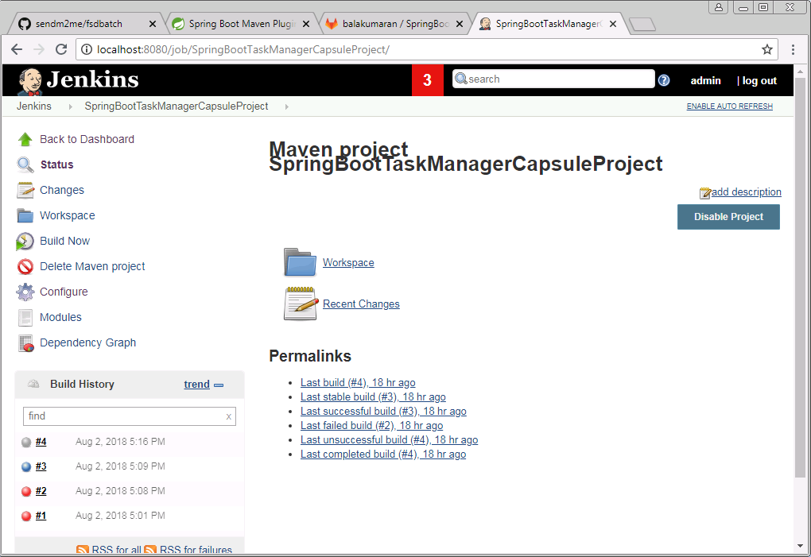

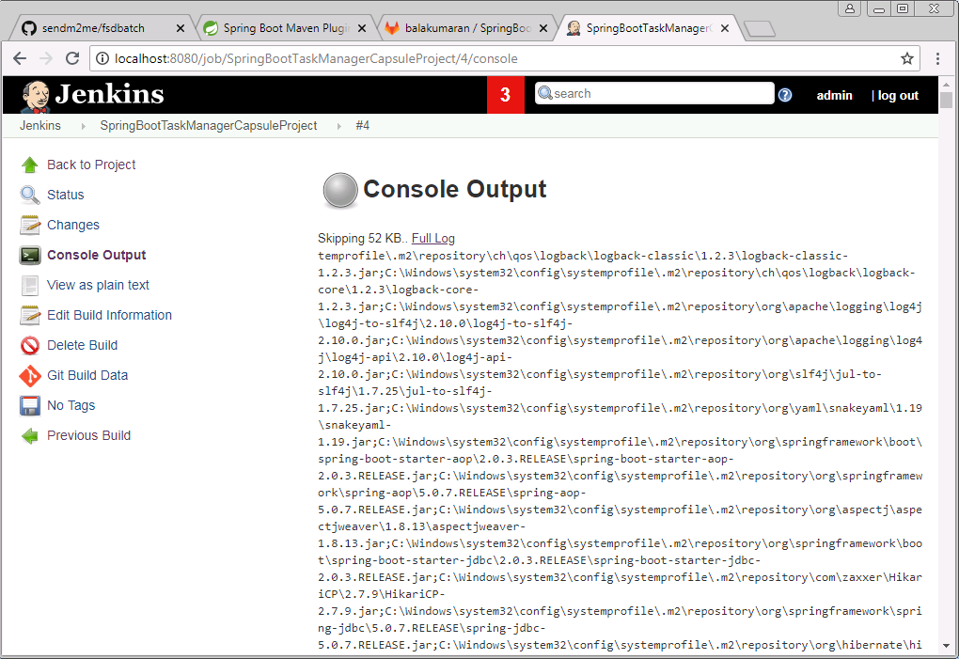

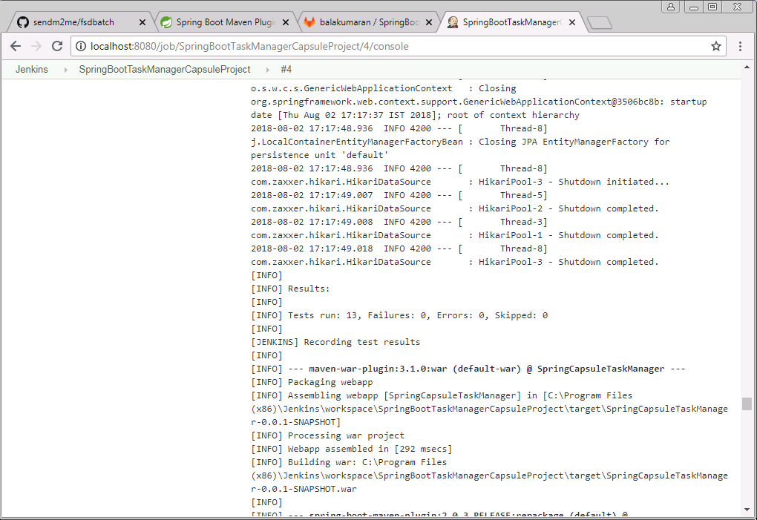 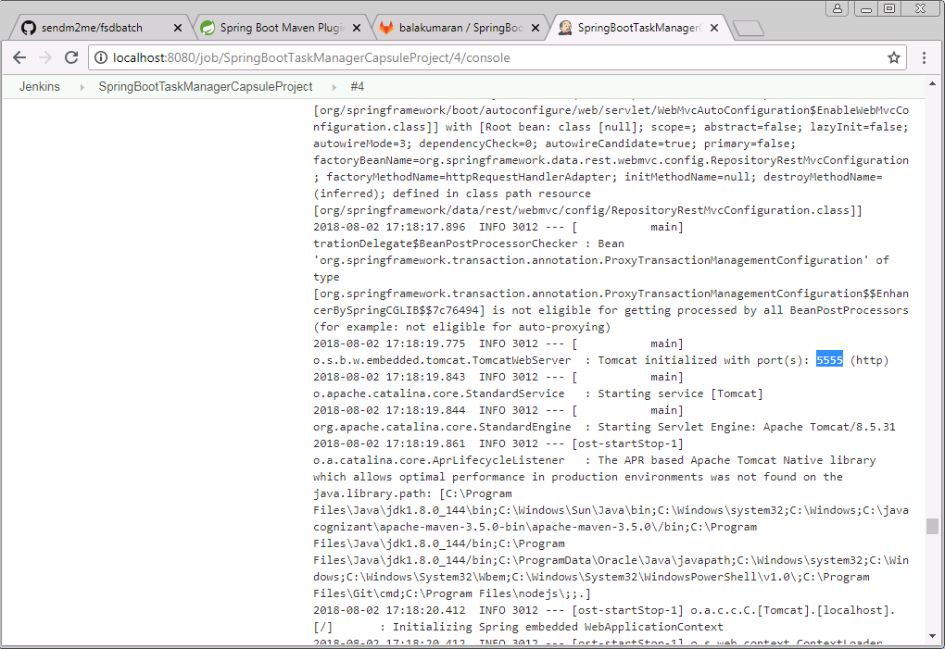

**Angular app execution page:**

