https://github.com/github/awesome-copilot/tree/main/plugins/software-engineering-team

https://github.com/github/awesome-copilot/tree/main/plugins/project-planning

https://github.com/github/awesome-copilot/tree/main/plugins/technical-spike

https://github.com/github/awesome-copilot/tree/main/plugins/testing-automation

My team is planning a workshop with customer who will bring the use-case as business problem or business requirement document. based on this we need guide them how to use AI in each phase of SDLC software development life cycle using AI pair programming strictly github copilot using Github platform and IDE preferably VS code editor. We need to strictly follow on following criteria:
1) objective of workshop is to influence customer on how to solve and build a given business problem using AI. This more about methodology which we will teach to customer team. we will invite customer team and co-innovate or co-develop with them where our role is too guide them on how to solve and build software by using AI in each phase of SDLC. This kind of practice will influence customer to adopt Github platform features and Github Copilot features and if platform is required then Azure AI foundry and cloud platform.
2) workshop should be in either short format of 1 day (8 hours) or 2 days ( 16 hours)
3) pre-requisite of workshop is customer has to share a use-case and workshop will influence the customer by guiding them to use AI DLC way of rapidly buidling the prototype of customer use-case depending upon short or long format of workshop
4) once customer share use-case, we need to refine that what could be the prototype that can be build with-in the duration of workshop.
5) we need to build a framework from the features of of Github platform and github copilot such as github repo, action, PR, issues, workflow, agents, plugins, skills, instructions. We need to also explore what other features can be used in this framework. Lets call this framework as AIDLC framework.
6) Customer team should come with all persona of SDLC such as product team, architects, developers, testers, DevOps or SREs etc. Each persona will partcipate in each stages of Workshop, which should follow on stages of SLDC as shown in images and AI DLC framework should help on each stage

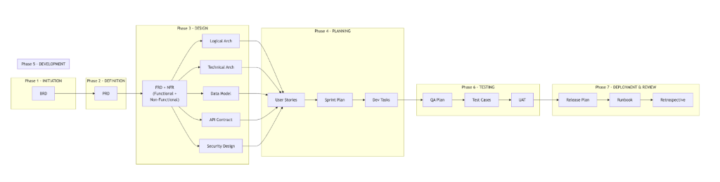

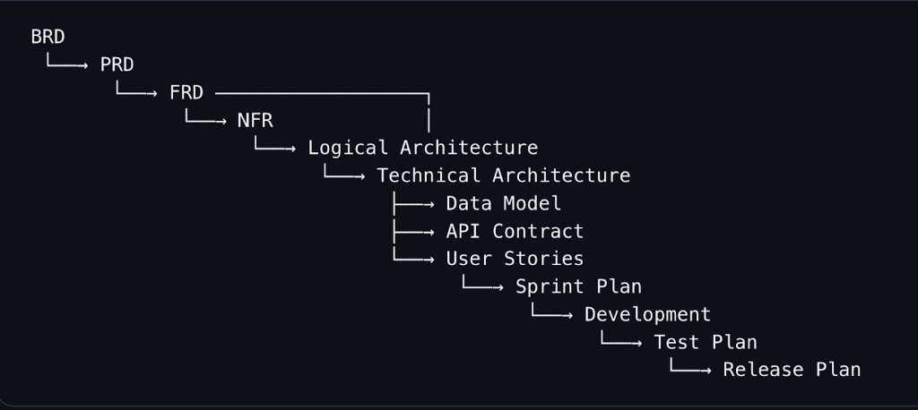

3. Master Role Responsibility Matrix
Role | BRD | PRD | FRD | NFR | Logical Arch | Technical Arch | User Stories | Dev | Testing | Deploy
Business Sponsor | 🌟 | Approver | - | - | - | - | - | - | Sign-off | 🌟
Business Analyst | 🌟 | Contributor | 🌟 | Contributor | Reviewer | Observer | Contributor | Advisor | UAT | -
Product Manager | Contributor | 🌟 | Reviewer | Sign-off | Reviewer | Aware | Contributor | Advisor | Sign-off | Communicator
Product Owner | Contributor | Contributor | Reviewer | - | - | - | 🌟 | Advisor | UAT | -
UX / Designer | - | Contributor | Contributor | - | - | - | Contributor | Advisor | - | -
Enterprise Architect | Observer | - | - | Reviewer | 🌟 | Reviewer | - | - | - | -
Solution Architect | Observer | Reviewer | 🌟 | 🌟🌟 | 🌟 | 🌟 | Guardian | Reviewer | NFR review | Reviewer
Security Architect | Contributor | - | Reviewer | 🌟 | Reviewer | 🌟 | - | Reviewer | 🌟 | Reviewer
Technical Lead | - | Reviewer | Contributor | Contributor | Reviewer | 🌟 | Contributor | 🌟 | Reviewer | Validator
DevOps / Infra | - | - | - | 🌟 | Contributor | 🌟 | - | CI/CD | Infra tests | 🌟
Developers | - | - | - | - | Observer | Consumer | Estimator | 🌟 | Fix defects | -
QA Lead | - | Reviewer | Contributor | Contributor | Observer | Contributor | Contributor | Test design | 🌟 | Sign-off
QA Engineers | - | - | - | - | - | - | Scenarios | Test dev | 🌟 | Validate
Compliance / Legal | Contributor | - | Reviewer | Contributor | - | Reviewer | - | - | - | -
Finance | Contributor | - | - | - | - | - | - | - | - | -

4. Document Dependency Chain

BRD

└──→ PRD

└──→ FRD ──────────────────┐

└──→ NFR │

└──→ Logical Architecture

└──→ Technical Architecture

├──→ Data Model

├──→ API Contract

└──→ User Stories

└──→ Sprint Plan

└──→ Development

└──→ Test Plan

└──→ Release Plan

# | Document | Phase | Answers | Owned By | Tech Level
1 | BRD | Initiation | Why are we building this? | Business Analyst | None
2 | PRD | Definition | What are we building? | Product Manager | Low
3 | FRD | Design | How should it behave? | Business Analyst + Tech Lead | Medium
4 | NFR | Design | How well must it perform? | Solution Architect | Medium
5 | Logical Architecture | Design | What are the components? | Solution Architect | Medium
6 | Technical Architecture | Design | How will we build it? | Solution Architect + Tech Lead | High
7 | Data Model + API Contract | Design | What is the exact structure? | Technical Lead | Very High
8 | User Stories | Planning | What does each developer build? | Product Owner | Low-Medium
9 | Test Plan + Cases | Testing | How do we verify it works? | QA Lead | Medium
10 | Release Plan + Runbook | Deployment | How do we go live safely? | DevOps | High

BRD = Why → PRD = What → FRD = How it behaves → NFR = How well → Logical Arch = What components → Technical Arch = Which technologies → User Stories = Who builds what → Tests = Does it work → Release = Go live safely

Dp a deep research How to develop such a framework using features of github platform and github copilot?

