P1:

A number series is defined by the following rules. The numbers range from 1 to 100, divisible by 5 and also have reminders 1 and 3. Print the list of numbers.

P2

Implement the following. Assume M= 1 and N = 10.

$$\sum_{j=M}^{N}{q\left(j\right), where q\left(j\right)=\frac{1}{j^{2}}}$$

P3:

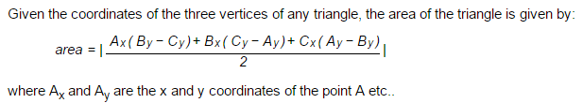

**For triangle (A,B,C), find the area of the triangle where A=(15,15) , B=(23,30) and C= (50,25)**

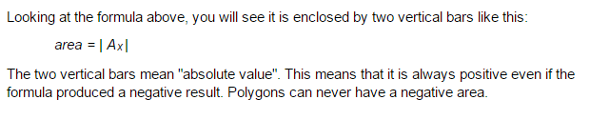

P4



P5 

Note:

CSCE206 Scientific Application Programming using Python

􀁸 The dropbox for each homework will be closed after due date. So be sure to submit it before

deadline.

􀁸 You are encouraged to do the other exercises to test your learning

􀁸 please name your program files as suggested by the book.

􀁸 You need to make your programs run without any error. When I grade it, I will check the results.

􀁸 Write your code with reasonable comment