**HRMS Rebuild Setup Document**

1. Clone from GitLab repo
   * <https://gitlab.com/senecagobal/hrms/hrmsrebuild.git>
2. .NET Setup
   * Open the code in VS 2019 (Microservices)
   * Rebuild the solution and do Publish.
   * Now copy the “Publish” folder to the server.
3. Angular Setup
   * Open the Angular UI Code in VS Code and do npm install
   * And run command >> ng build
   * Copy the files from “dist” folder.
4. Server Website or Virtual Directory:
   * Create a folder in the server
     + For API 🡪 E:\Sites\HRMS\Dev\HRMSRebuild\API\
     + There are 4 microservices

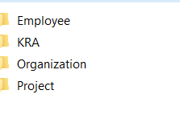

* + - For UI 🡪 E:\Sites\HRMS\Dev\HRMSRebuild\UI-Material\dist

1. Give Full Control to the above folders for the **IIS_IUSRS** user.

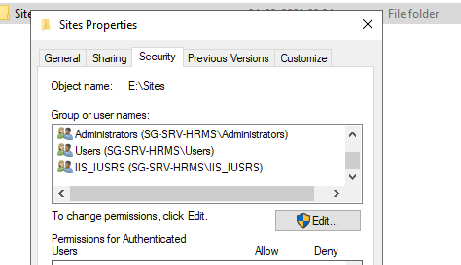

1. Needed Software’s in the Server
   * Latest IIS Server
   * Redis for Windows
   * URL Rewriter
2. URLs for the above software’s:
   * Redis for Windows
     + Download Redis for Windows
     + Redis-x64-3.0.504.msi
     + <https://github.com/microsoftarchive/redis/releases>

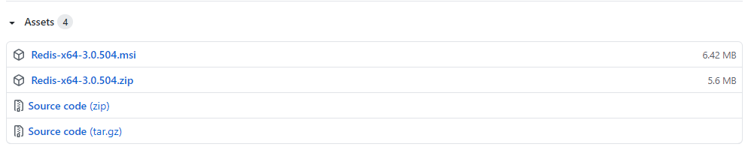

* + Install IIS URL Rewriter
    - <https://www.iis.net/downloads/microsoft/url-rewrite>

1. Create Websites in IIS for the four microservices and UI with the below port numbers. Like below:
2. For UI
   1. http://sg-srv-hrms:2028/
3. For Microservices:
   1. Org Services - http://sg-srv-hrms:2021/
   2. Emp Services - http://sg-srv-hrms:2022/
   3. Project Services - http://sg-srv-hrms:2023/
   4. KRA Services - http://sg-srv-hrms:2024/
   5. Report Services - <http://sg-srv-hrms:2025/>
4. When creating the Website, make sure you select the correct “Application Pools”.

