Faculty of Science
Software Engineering Teaching Unit
University of Kelaniya, Sri Lanka

SOFTWARE REQUIREMENTS SPECIFICATION
SmartTech
A SaaS Marketplace for Mobile Phones, Laptops & Accessories

Course | SENG 31242 – System Design Project
Academic Year | 2024 / 2025
Team | Code Crafters
Version | 1.0
Date | 2026
Status | Draft – For Supervisor Review

Team Members
SE/2022/012 – Amillthan
SE/2022/013 – Harislan
SE/2022/052 – Khaviya
SE/2022/054 – Piranavi

Chapter 1: Introduction

1.1 Purpose
This Software Requirements Specification (SRS) document defines the complete functional and non-functional requirements for SmartTech, a Software-as-a-Service (SaaS) e-commerce marketplace platform dedicated to the buying and selling of mobile phones, laptops, and their accessories.
This document is intended to serve as the primary reference for all stakeholders including the development team (Code Crafters), academic supervisors, and end-users. It provides a detailed description of system behaviour, constraints, and quality attributes that the SmartTech platform must satisfy prior to and throughout development.
This SRS forms the foundation for the Software Design Specification (SDS) and all subsequent development work in SENG 34213.

1.2 Scope
SmartTech is a multi-sided SaaS marketplace platform that connects Buyers (individuals seeking to purchase mobile phones, laptops, and accessories) with Sellers (individuals or small businesses listing products for sale). The platform additionally provides Administrators with tools to manage listings, users, categories, and platform health.
The system will be accessible via web browser (desktop and mobile-responsive) and will support the following high-level functional domains:
- User registration, authentication, and profile management for both Buyers and Sellers.
- Product listing creation, management, and categorisation by Sellers.
- Product discovery through search, filter, and browse functionality for Buyers.
- Shopping cart management and multi-step checkout process.
- Secure payment processing through an integrated payment gateway.
- Order tracking and management for both Buyers and Sellers.
- Review and rating system for products and Sellers.
- Seller dashboard with sales analytics and inventory management.
- Administrative panel for platform governance and moderation.
- Notification system (email and in-app) for key events.

SmartTech is explicitly out of scope for: physical delivery logistics, device repair services, product insurance, and peer-to-peer chat/messaging in version 1.0.

1.3 Definitions, Acronyms, and Abbreviations
Term / Acronym | Definition
SRS | Software Requirements Specification – this document.
SDS | Software Design Specification – produced in the design phase.
SaaS | Software as a Service – cloud-hosted software delivered via web browser.
Buyer | A registered user who browses, searches, and purchases products on SmartTech.
Seller | A registered user who lists, prices, and sells products on SmartTech.
Admin | An authorised platform administrator responsible for governance and moderation.
SKU | Stock Keeping Unit – a unique identifier for each distinct product variant.
UC | Use Case – a numbered scenario describing a system interaction.
FR | Functional Requirement – a numbered capability the system must provide.
NFR | Non-Functional Requirement – a quality attribute the system must satisfy.
GUI | Graphical User Interface.
API | Application Programming Interface.
JWT | JSON Web Token – used for stateless authentication.
HTTPS | Hypertext Transfer Protocol Secure – encrypted web communication.
OWASP | Open Web Application Security Project – security best practices reference.
KYC | Know Your Customer – seller identity verification process.
UI | User Interface.
UX | User Experience.
CRUD | Create, Read, Update, Delete – basic data operations.
MVP | Minimum Viable Product.

1.4 References
- SENG 31242 System Design Project – Course Guideline & Industrial Standards, Version 1.0, Software Engineering Teaching Unit, University of Kelaniya, 2026.
- IEEE Std 830-1998 – IEEE Recommended Practice for Software Requirements Specifications.
- ISO/IEC/IEEE 29148:2018 – Systems and software engineering – Life cycle processes – Requirements engineering.
- OWASP Top 10 Web Application Security Risks, 2021. https://owasp.org/Top10/
- Shopify Developer Documentation – Platform architecture reference. https://shopify.dev/
- Sri Lanka Central Bank Payment Systems – LankaPay payment gateway documentation.

1.5 Overview of Document
The remainder of this document is organised as follows:
- Chapter 2 – Overall Description: Product perspective, user characteristics, operating environment, constraints, assumptions.
- Chapter 3 – System Analysis: Fact-finding methods, existing system analysis, use case diagram, use case descriptions, activity diagrams, and system sequence diagrams.
- Chapter 4 – Functional Requirements: Complete numbered list of all system capabilities.
- Chapter 5 – Non-Functional Requirements: Performance, security, usability, reliability, scalability, and maintainability constraints.
- Chapter 6 – Alternative Solutions & Feasibility Study: Analysis of alternatives and recommended approach.

Chapter 2: Overall Description

2.1 Product Perspective
SmartTech operates as a standalone, cloud-hosted SaaS marketplace. It does not extend or replace any existing internal system; rather, it introduces a new, dedicated platform for tech product commerce in the Sri Lankan and regional market.
The platform follows a three-tier architecture: a client-side web application (Browser/UI Layer), a server-side application layer (API / Business Logic), and a persistent data layer (Database). External integrations include a payment gateway, email notification service, and cloud file storage for product images.

Context Diagram (described textually): The central system is SmartTech. External entities interacting with it are: (1) Buyer – submits orders, writes reviews, makes payments; (2) Seller – creates listings, manages inventory, receives payments; (3) Admin – moderates platform, manages users; (4) Payment Gateway (e.g. PayHere / LankaPay) – processes transactions; (5) Email Service (e.g. SendGrid) – sends notifications; (6) Cloud Storage (e.g. AWS S3) – stores product images.
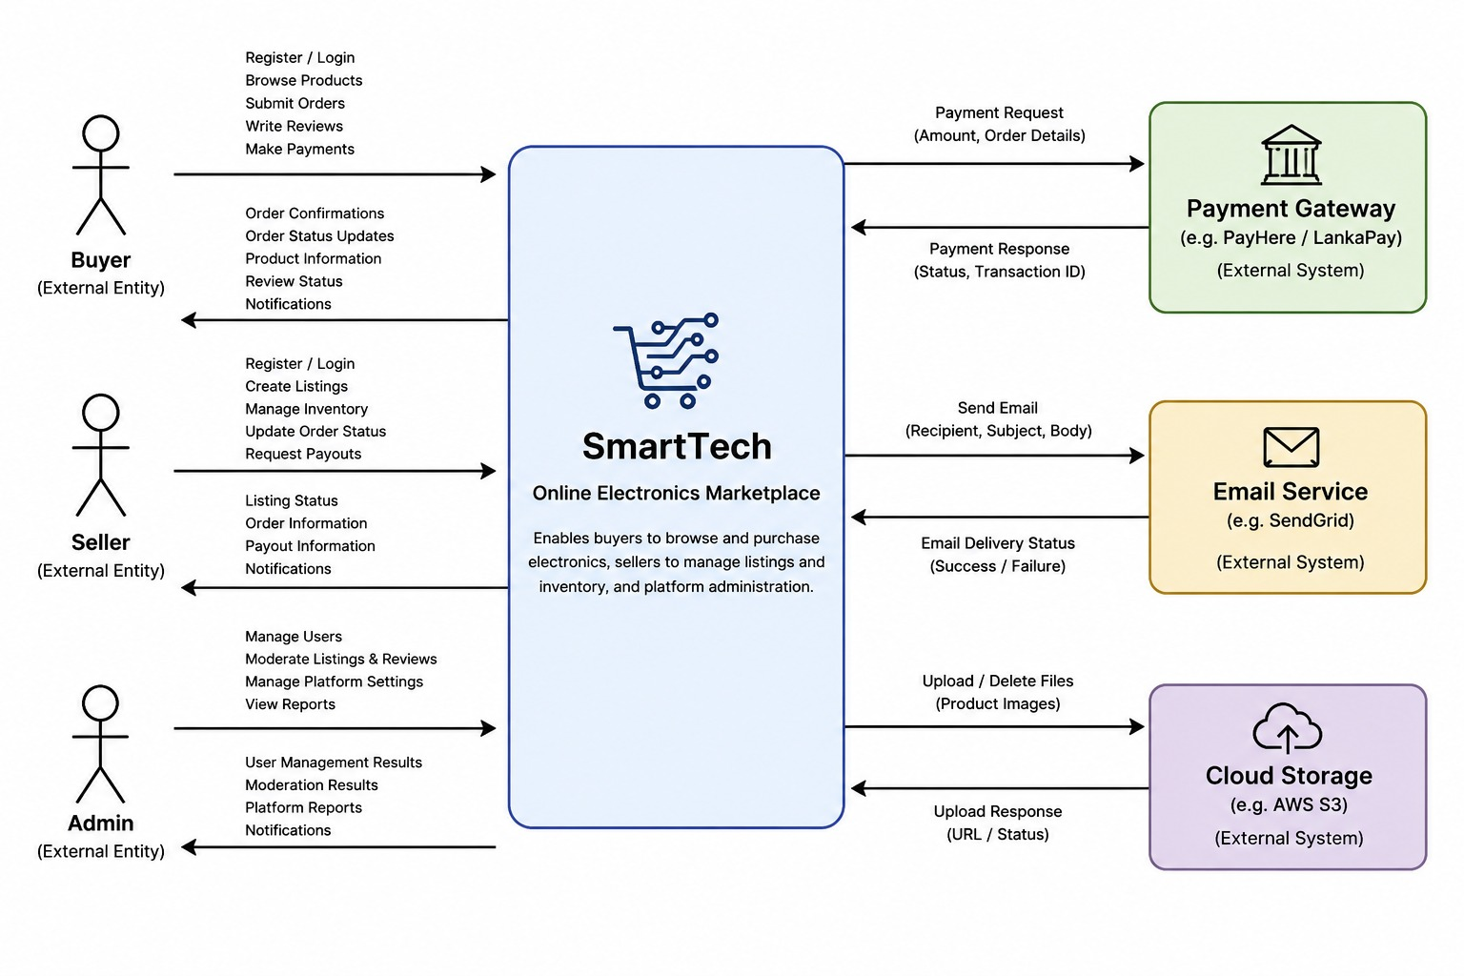

2.2 User Classes and Characteristics
SmartTech serves three primary user classes:

User Class | Description | Technical Proficiency | Access Level
Buyer | Individual purchasing mobile phones, laptops, or accessories. May be a student, professional, or general consumer. | Low to Medium – comfortable using e-commerce websites. | Browse, search, purchase, review, manage own orders and profile.
Seller | Individual or small business listing tech products for sale. Ranges from private individuals reselling devices to small retailers. | Medium – familiar with online selling platforms such as Daraz or eBay. | Full product management, seller dashboard, order fulfilment, analytics.
Administrator | Authorised platform staff responsible for governance, content moderation, user management, and system health monitoring. | High – comfortable with administrative dashboards and data tools. | Full platform access including user management, listing approval/removal, category management, and analytics.

2.2.1 User Personas
Persona 1 – Vimalarajan (Buyer): 57-year-old Tv mechanic. Looking to purchase a laptop for his son for studies. Budget-conscious; needs to compare specifications and prices across multiple sellers. Uses his smartphone primarily. Frustrated by irrelevant results on general marketplaces.
Persona 2 – Vipilakumar(Seller): 45-year-old entrepreneur running a small Laptop ,Laptop accessories & mobile accessories business in Jaffna. Sells phone cases, chargers, and earphones,etc... Currently sells through TikTok pages . Wants an organised storefront with order tracking and payment management without building her own website.
Persona 3 –Amillthan(Admin): 24-year-old University Student employed by SmartTech. Responsible for approving new seller registrations, removing counterfeit listings, resolving disputes, and monitoring platform performance dashboards.

2.3 Operating Environment
- Web Browser: Google Chrome (v110+), Mozilla Firefox (v110+), Microsoft Edge (v110+), Safari (v15+).
- Devices: Desktop computers, laptops, tablets, and mobile phones (responsive design, minimum viewport 360px).
- Operating System: Platform-independent (browser-based). Server hosted on Linux (Ubuntu 22.04 LTS).
- Internet Connectivity: Minimum 1 Mbps connection for acceptable performance; optimised for low-bandwidth environments.
- Server Environment: Cloud-hosted (AWS / DigitalOcean); PostgreSQL database; Node.js / React stack.
- Payment Gateway: PayHere or LankaPay (Sri Lanka); Stripe (international).
- Email Service: SendGrid or AWS SES for transactional emails.
- File Storage: AWS S3 or equivalent for product image hosting.

2.4 Design and Implementation Constraints
- The system must comply with Sri Lanka's Personal Data Protection Act (PDPA) 2022 for handling user personal data.
- Payment processing must integrate with at least one Sri Lanka-approved payment gateway (PayHere or LankaPay).
- All user passwords must be stored using bcrypt hashing (minimum work factor 12); plain-text storage is strictly prohibited.
- The frontend must be mobile-responsive and pass WCAG 2.1 Level AA accessibility guidelines.
- All API endpoints must be secured with JWT-based authentication; unauthenticated requests must be rejected with HTTP 401.
- Product images must be stored externally (cloud storage); the database must store only image URLs.
- The system must operate within the team's allocated cloud budget; expensive third-party services must have free-tier equivalents during development.
- The technology stack is constrained to skills held by the four-member team: React.js (frontend), Node.js/Express (backend), PostgreSQL (database).

2.5 Assumptions and Dependencies

2.5.1 Assumptions
- All users have access to a modern web browser and reliable internet connection.
- Sellers are assumed to be adults (18+) legally permitted to sell goods under Sri Lankan commercial law.
- Product listings submitted by Sellers are assumed to be genuine; the system provides moderation tools but cannot guarantee authenticity.
- Payment gateway APIs (PayHere/LankaPay) will remain stable and available throughout development.
- Users are assumed to read and accept the Terms of Service and Privacy Policy during registration.
- Email delivery is assumed to be reliable via the chosen transactional email service.

2.5.2 Dependencies
- Payment Gateway (PayHere / LankaPay): The checkout and payment processing features are dependent on third-party payment gateway availability and API stability.
- Cloud Storage (AWS S3): Product image upload and display depends on cloud storage service availability.
- Email Service (SendGrid): All email notifications (verification, order confirmation, password reset) depend on the email service provider.
- University Network Infrastructure: Development and testing activities depend on University of Kelaniya network access.

