**CodeIgniter 4 - Setup**

**CodeIgniter** is a PHP MVC framework **used for** developing web applications rapidly.

**Step One: Application require**

- Xampp: <https://www.apachefriends.org/index.html>

- Vscode: <https://code.visualstudio.com/>

- Browsers (Chrome or Firefox)

- Composer: <https://getcomposer.org/doc/00-intro.md>

**Step Two: Installation CI 4**

**- Download Installation:** We can download the source code of CodeIgniter 4 for setup and go.

**- Composer Installation:**  We can use App Starter by install with composer

composer create-project codeigniter4/appstarter project-name

First time when you start to this command you will got the message like below:

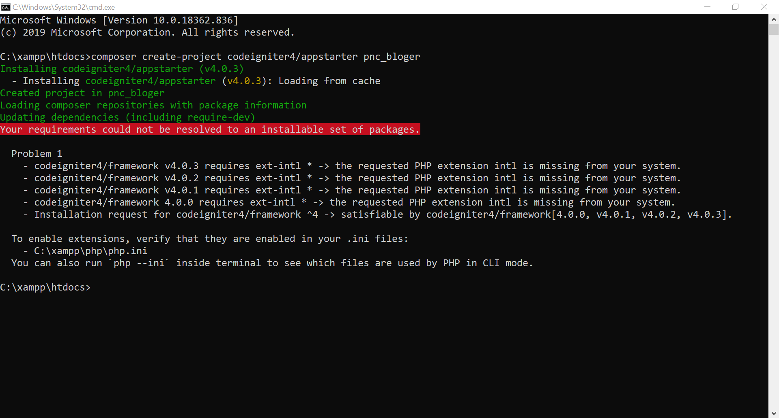

So what you need to do for fix this error?

You need to go to Xampp and find the **php.ini** file

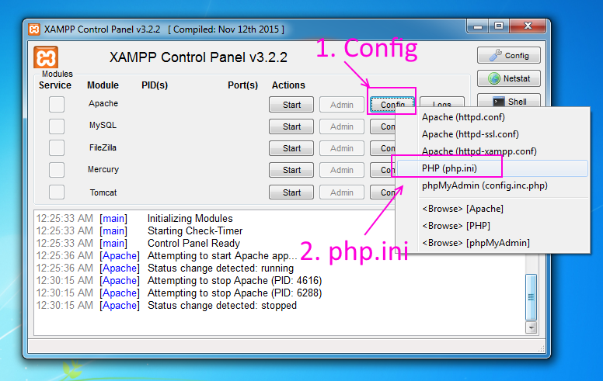

After that you can search about **extension** to find ;**extension=intl**

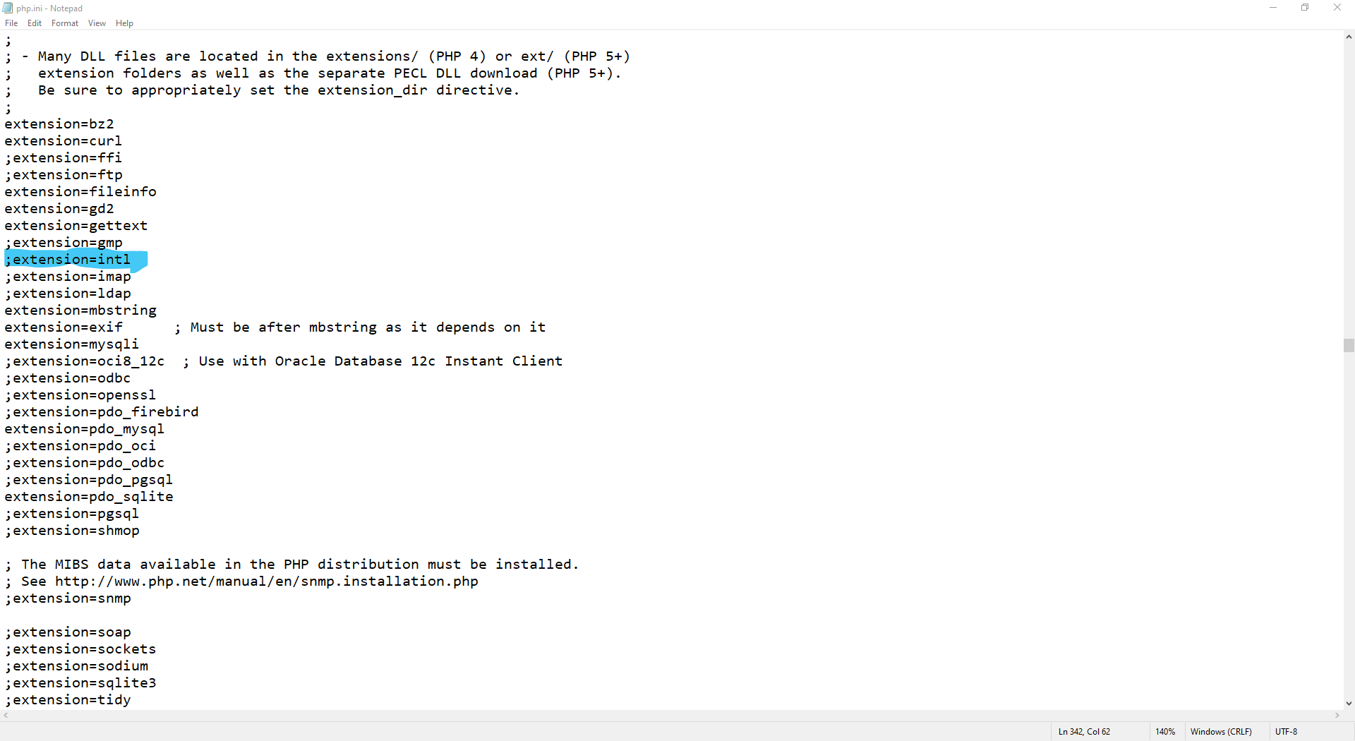

You just delete the semicolon (;) before **extension=intl**  so after that don’t forgot to **restart your Apache server**.

So let start command: composer create-project codeigniter4/appstarter pnc_bloger

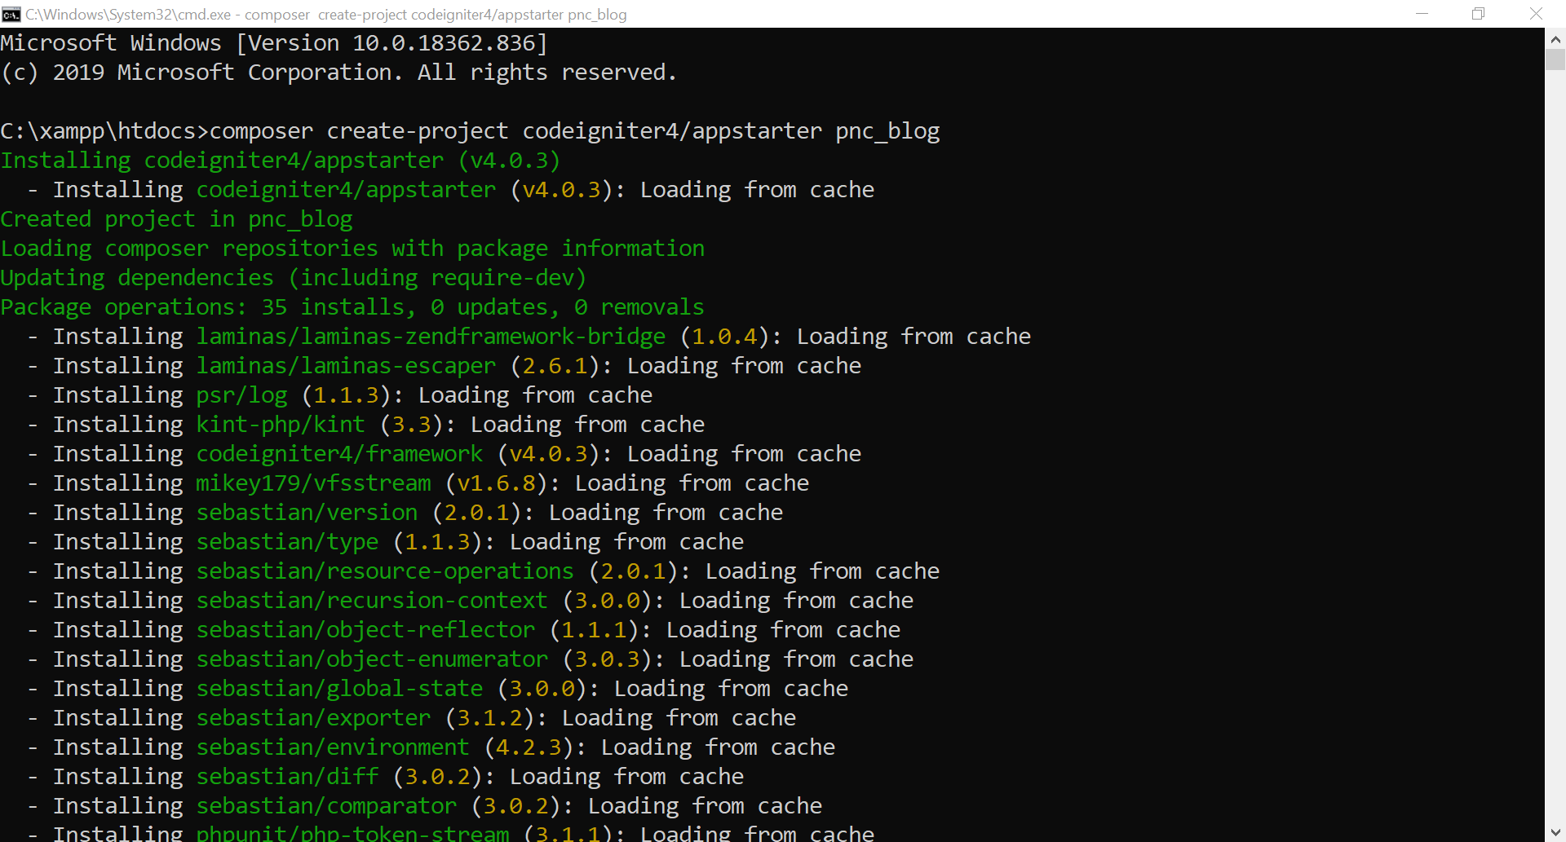

It is working fine now.

**Step Three: Run application**

We can run it just type **localhost/projectname/public** but we are not recommend that because of url friendly. So we recommend you to run by using **spark server** with command:

php spark serve

In your terminal or vscode terminal like:

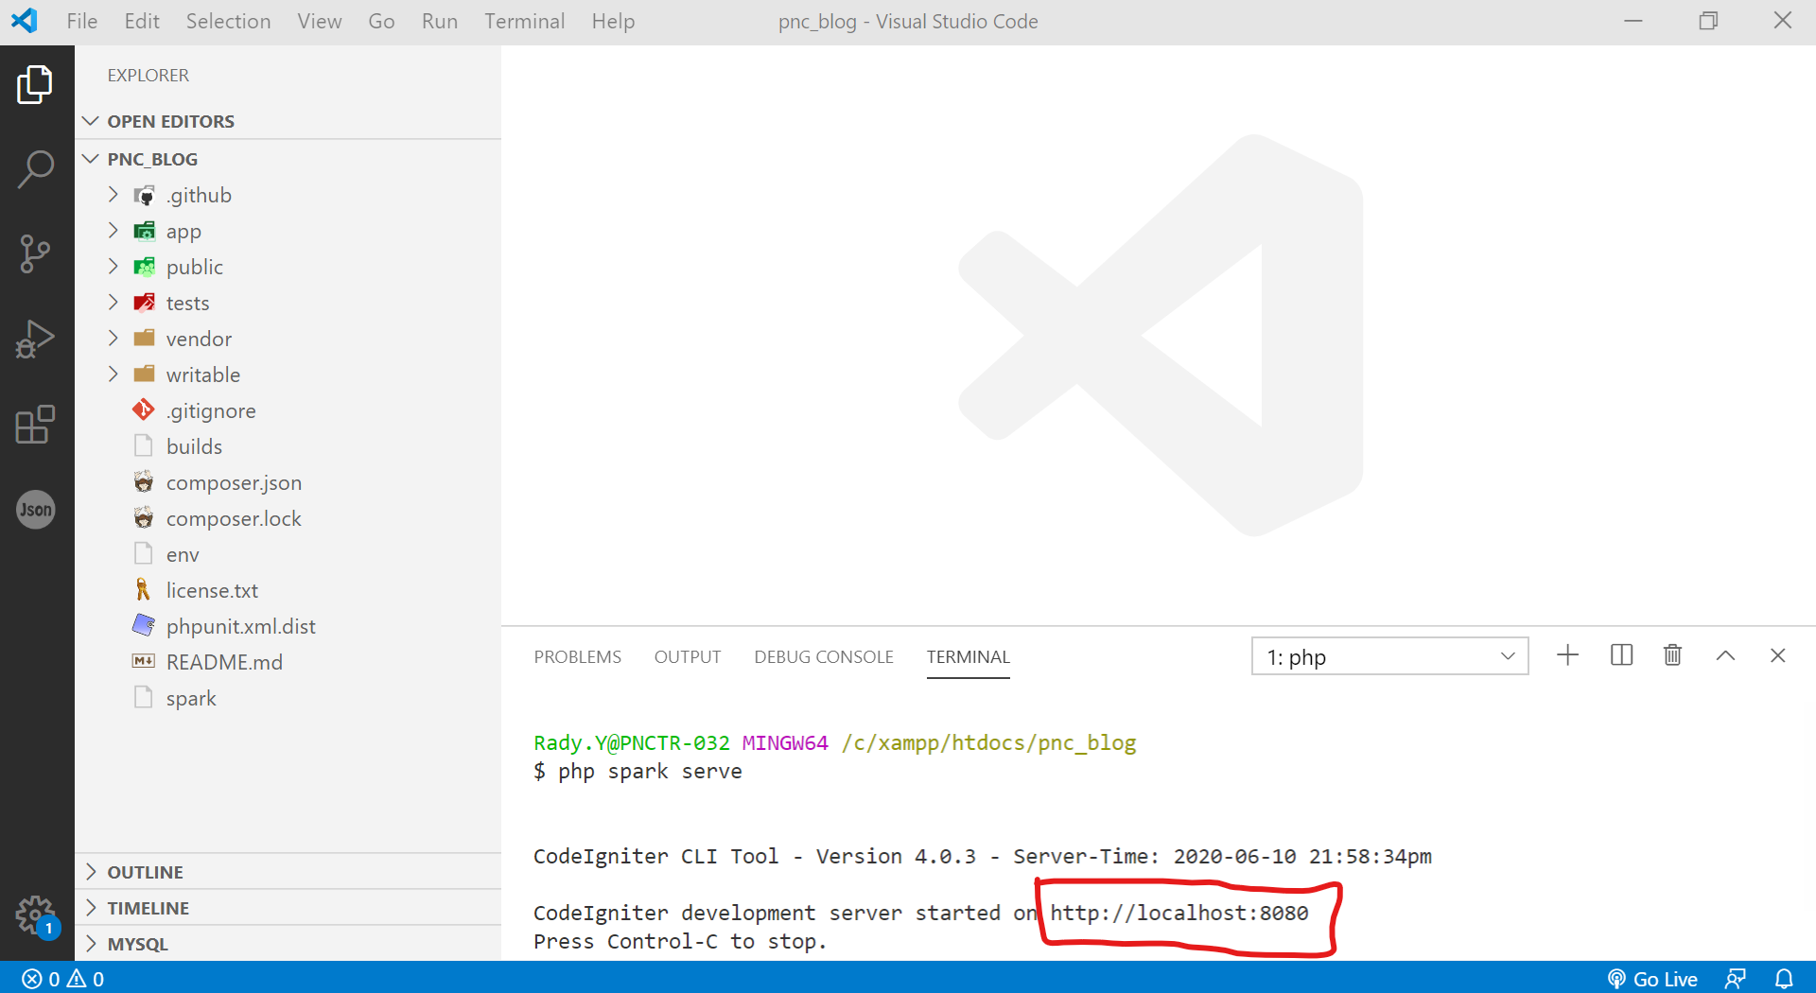

You just **ctrl + click** on <http://localhost:8080> to open on web browser.

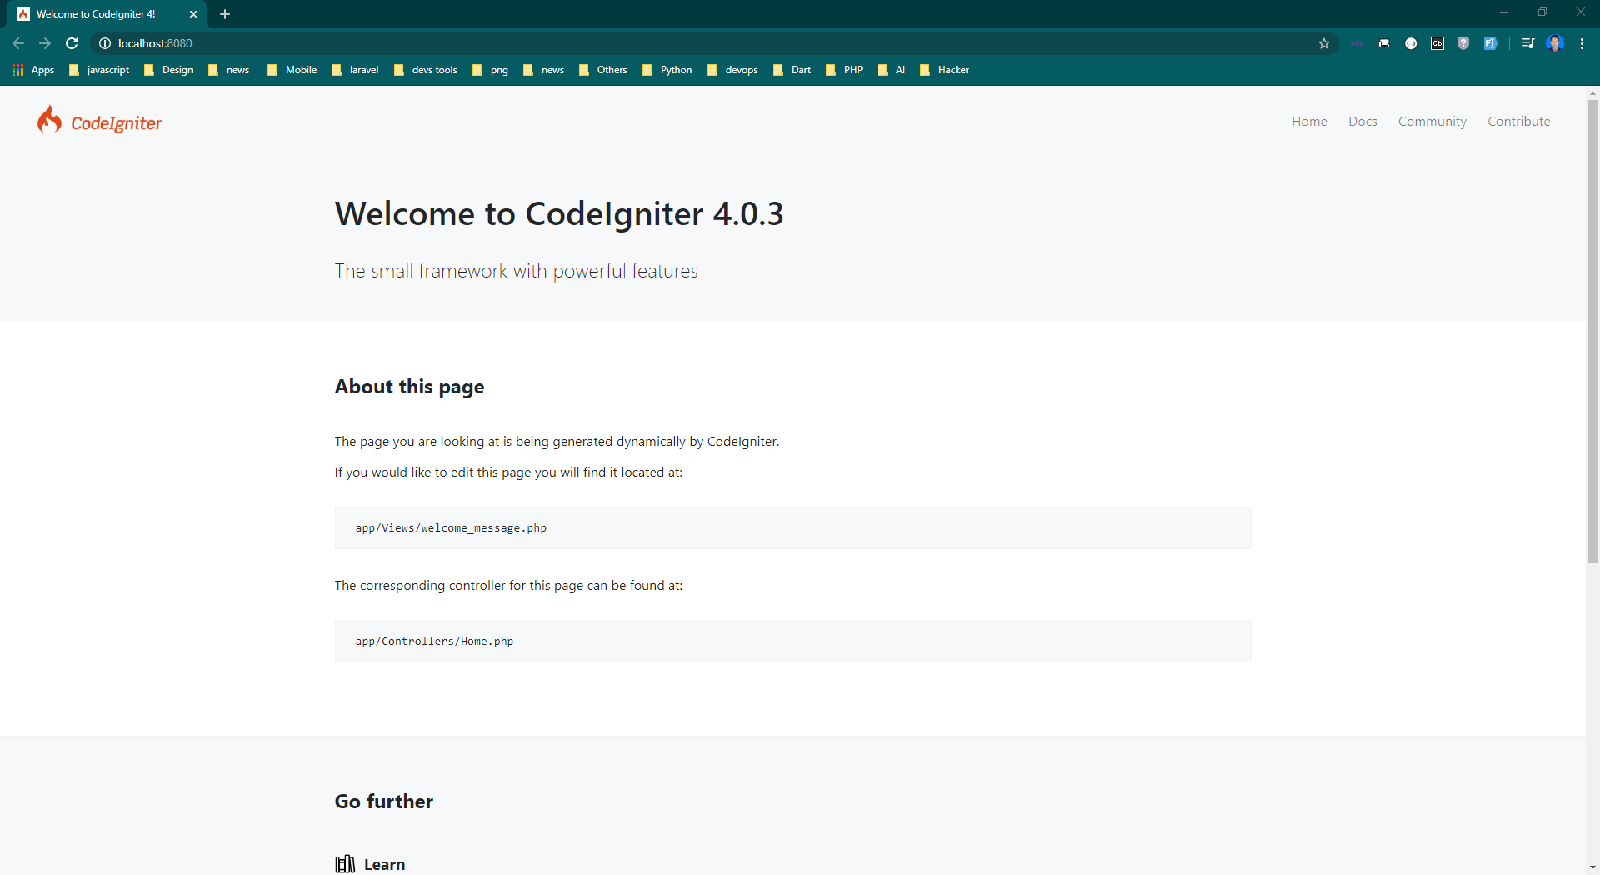

**Successful Installation CI 4**