**Exercise 1**

**Validation…….**

|  |  |
| --- | --- |
| Student Table field | type |
| id | Int(11) |
| name | Varchar(100) |
| email | Varchar(200) |
| age | Int(11) |
| profile | Varchar(100) |

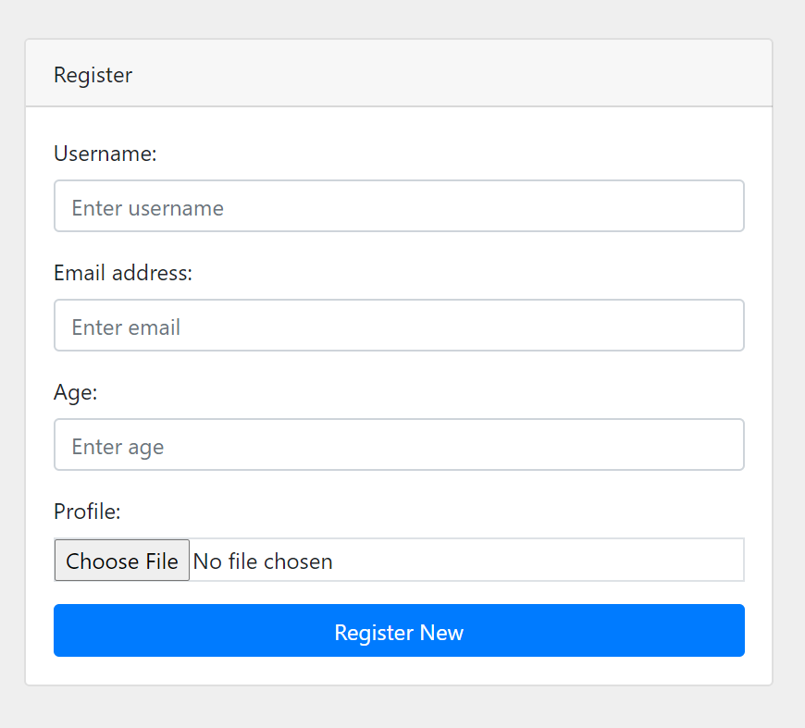

|  |  |
| --- | --- |
| Form Field | Rules |
| name | Required, alpha_numeric, min_length[3], max_length[20], |
| email | Required, valid_email, min_length[6], max_length[50], |
| age | required, max_length[3], numeric |
| profile | required |