1. Executive Summary
The Mutual Fund Analytics Capstone Project was developed to analyze and visualize mutual fund performance, investor behavior, portfolio composition, and market trends using data analytics techniques. The project integrates multiple datasets related to mutual fund schemes, NAV history, investor transactions, fund performance metrics, portfolio holdings, and industry-level inflows.
The primary objective of the project is to build an end-to-end analytics solution that enables stakeholders to gain insights into mutual fund performance and investor activities. The project includes data ingestion, cleaning, transformation, exploratory data analysis (EDA), performance analytics, advanced risk metrics, and dashboard development.
A structured ETL pipeline was implemented using Python and Pandas to process raw data into analysis-ready datasets. Exploratory Data Analysis was performed to identify trends in fund categories, investor demographics, SIP contributions, and asset growth. Performance analytics included CAGR comparisons, Sharpe Ratio, Sortino Ratio, Alpha, Beta, and Maximum Drawdown calculations. Advanced analytics techniques such as Value at Risk (VaR), Conditional Value at Risk (CVaR), rolling Sharpe ratio analysis, investor cohort analysis, SIP continuity analysis, and sector concentration measurement using the Herfindahl-Hirschman Index (HHI) were also implemented.
Interactive dashboards were developed in Power BI to present key insights through KPI cards, trend visualizations, investor analytics, fund performance comparisons, and market inflow analysis. The dashboard enables users to explore data dynamically using filters and drill-down capabilities.
The project demonstrates the practical application of data engineering, financial analytics, business intelligence, and visualization techniques in the mutual fund domain. The final solution provides actionable insights that can assist investors, analysts, and fund managers in making informed investment decisions.

2. Problem Statement
The mutual fund industry generates large volumes of data related to fund performance, investor transactions, portfolio holdings, and market inflows. Analyzing this data manually is time-consuming and often fails to provide meaningful insights for investors and fund managers.
Investors need reliable methods to evaluate fund performance, understand risk levels, compare investment options, and monitor market trends. Similarly, fund managers require analytical tools to track asset growth, investor behavior, portfolio concentration, and risk-adjusted returns.
The challenge is to transform raw mutual fund data into a structured analytical system that can provide meaningful insights through data processing, statistical analysis, risk assessment, and interactive visualizations. The solution should support data-driven decision-making and improve the understanding of mutual fund performance and investor activities.

3. Project Objectives
The primary objectives of this project are:
- To collect and integrate mutual fund datasets from multiple sources.
- To design and implement an ETL pipeline for data cleaning and transformation.
- To perform Exploratory Data Analysis (EDA) to identify trends and patterns.
- To analyze mutual fund performance using key financial metrics.
- To calculate advanced risk metrics such as VaR, CVaR, Sharpe Ratio, and Maximum Drawdown.
- To study investor behavior using demographic and transaction data.
- To develop an interactive Power BI dashboard for business intelligence and reporting.
- To generate actionable insights that support investment decision-making.

4. Data Sources
This project utilizes multiple datasets related to mutual fund operations and investor activities.
Dataset | Description
Fund Master | Contains scheme-level information including fund house, category, and plan type.
NAV History | Historical Net Asset Value (NAV) records used for return calculations.
AUM by Fund House | Assets Under Management data for different fund houses.
Monthly SIP Inflows | Monthly SIP contribution statistics across the industry.
Category Inflows | Net inflows and outflows by mutual fund category.
Investor Transactions | Transaction-level investor activity including SIPs, redemptions, and lump-sum investments.
Portfolio Holdings | Equity holdings and sector allocations of mutual funds.
Scheme Performance | Performance metrics including returns, Sharpe Ratio, Alpha, Beta, and risk grades.

5. ETL Pipeline Design
The project follows a structured Extract, Transform, and Load (ETL) process to convert raw datasets into analysis-ready data.

Extract
Raw mutual fund datasets were collected and stored in the project's data directory. The datasets included NAV history, investor transactions, scheme performance metrics, portfolio holdings, category inflows, and industry statistics.

Transform
Data transformation was performed using Python and Pandas. The following cleaning activities were carried out:
- Removed duplicate records.
- Handled missing and invalid values.
- Standardized column names and data formats.
- Converted date columns into proper datetime formats.
- Validated AMFI codes across datasets.
- Created processed datasets for analysis.

Load
The cleaned datasets were stored in the processed data directory and loaded into Jupyter notebooks and Power BI for analytics and visualization.

ETL Workflow
Raw Data
↓
Data Validation
↓
Data Cleaning
↓
Data Transformation
↓
Processed Datasets
↓
EDA & Analytics
↓
Power BI Dashboard

6. Exploratory Data Analysis (EDA)
Exploratory Data Analysis was performed to understand the characteristics of the mutual fund datasets and identify meaningful patterns.

Category Inflow Analysis
Category-wise inflow analysis was conducted to determine which mutual fund categories attracted the highest investments. Categories such as Liquid Funds, Large Cap Funds, and Flexi Cap Funds showed significant investor interest during the analysis period.

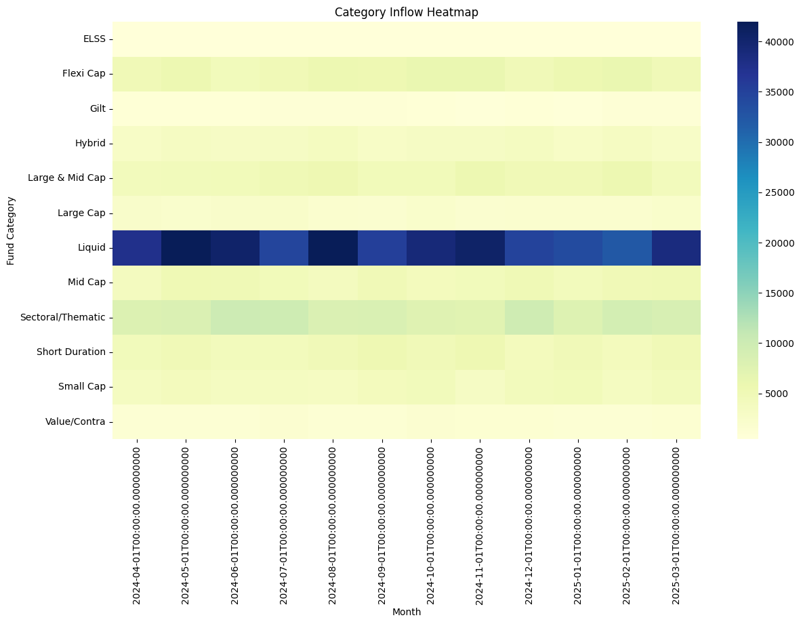Investor Demographics Analysis
Investor transaction data was analyzed across age groups, gender, and geographic regions. The analysis helped identify investor participation trends and contribution patterns.
Key observations included:
- The 26–35 age group contributed the highest transaction volume.
- SIP investments represented a significant portion of investor activity.
- Major metropolitan cities accounted for a large share of transactions.

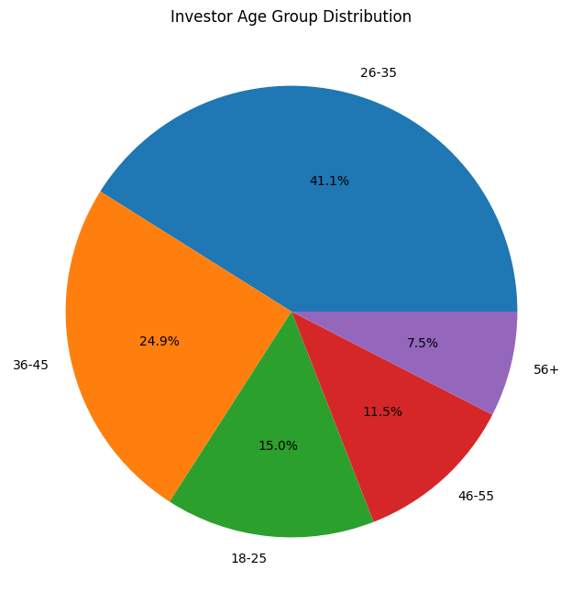SIP Trend Analysis
Monthly SIP inflow data was analyzed to identify growth patterns and investment trends over time.
Key findings:
- SIP inflows demonstrated steady growth throughout the observation period.
- Market fluctuations influenced short-term investment behavior.
- Long-term participation in SIP investments remained strong.

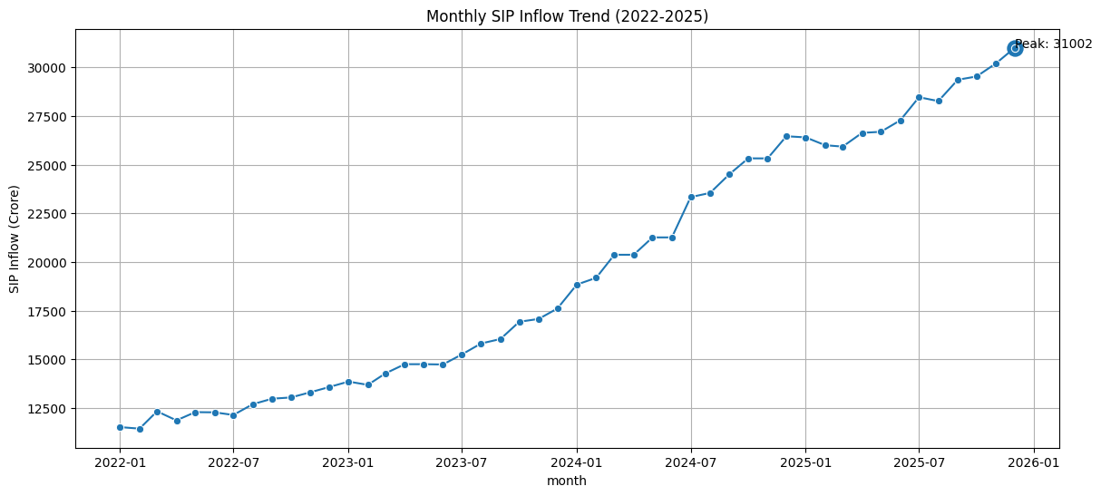Portfolio Composition Analysis
Portfolio holdings data was analyzed to understand sector allocation and diversification.
Key observations:
- Financial Services and Information Technology sectors accounted for significant portfolio allocations.
- Sector diversification varied across mutual fund schemes.
- Portfolio concentration analysis was later extended using HHI calculations.
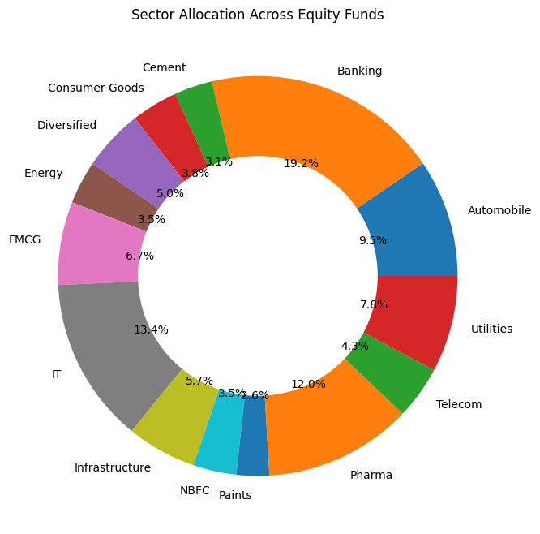
7. Performance Analytics
Performance analytics was conducted to evaluate mutual fund returns, risk-adjusted performance, and portfolio efficiency.

Return Analysis
Historical performance metrics including 1-year, 3-year, and 5-year returns were analyzed across all mutual fund schemes.
Key observations:
- Equity-oriented schemes generally delivered higher long-term returns.
- Large Cap, Mid Cap, and Flexi Cap categories demonstrated strong growth performance.
- Return distribution varied significantly across risk categories.

CAGR Analysis
Compound Annual Growth Rate (CAGR) was calculated to compare long-term growth across mutual fund schemes.
The CAGR analysis enabled standardized comparison of investment performance over different periods.

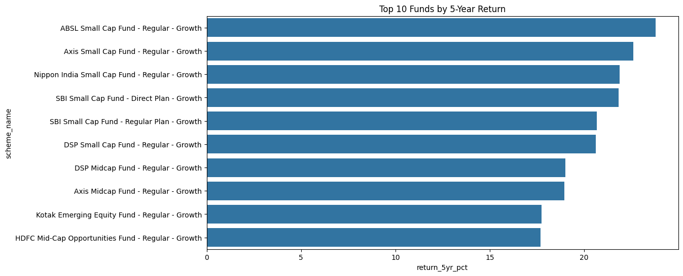Sharpe Ratio Analysis
The Sharpe Ratio was used to measure risk-adjusted returns by comparing excess returns against portfolio volatility.
Key observations:
- Higher Sharpe Ratios indicated better risk-adjusted performance.
- Certain schemes achieved strong returns with relatively lower risk.

Sortino Ratio Analysis
The Sortino Ratio was calculated to focus specifically on downside risk.
Benefits:
- Measures return relative to harmful volatility.
- Provides a more investor-focused risk assessment than standard deviation alone.

Alpha and Beta Analysis
Alpha and Beta metrics were used to evaluate fund performance relative to benchmark indices.
- Alpha measures excess returns beyond benchmark expectations.
- Beta measures sensitivity to market movements.

Maximum Drawdown Analysis
Maximum Drawdown was calculated to identify the largest historical decline experienced by each scheme.
Key findings:
- Higher-risk funds generally experienced larger drawdowns.
- Drawdown analysis provides insight into downside risk exposure.

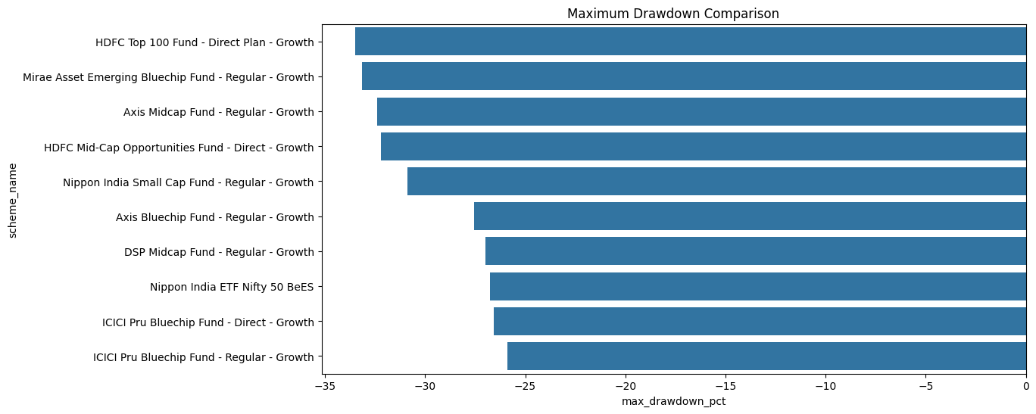Fund Scorecard
A composite scorecard was created using:
- Return Rank
- Sharpe Ratio Rank
- Alpha Rank
- Expense Ratio Rank
- Maximum Drawdown Rank
The scorecard was used to identify top-performing mutual fund schemes based on multiple evaluation criteria.
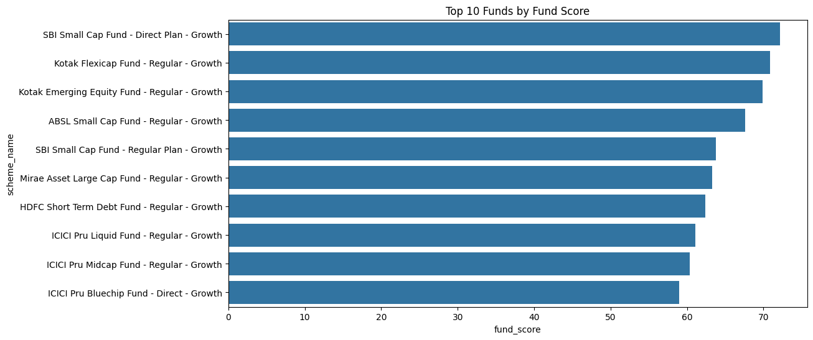

8. Dashboard Development
An interactive dashboard was developed using Microsoft Power BI to provide a consolidated view of mutual fund analytics.
The dashboard was designed to support business intelligence, investment analysis, and performance monitoring.

Dashboard Features

Industry Overview
The Industry Overview page contains:
- Total Assets Under Management (AUM)
- Total SIP Inflows
- Number of Schemes
- Fund House Statistics
- Industry Growth Trends

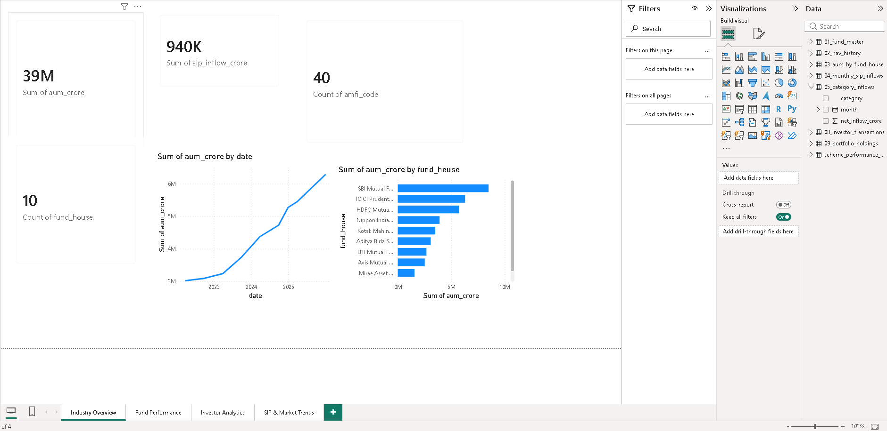

Fund Performance
The Fund Performance page provides:
- Risk vs Return Scatter Plot
- Fund Scorecard
- Return Comparison Metrics
- Benchmark Performance Analysis
- Interactive Filters

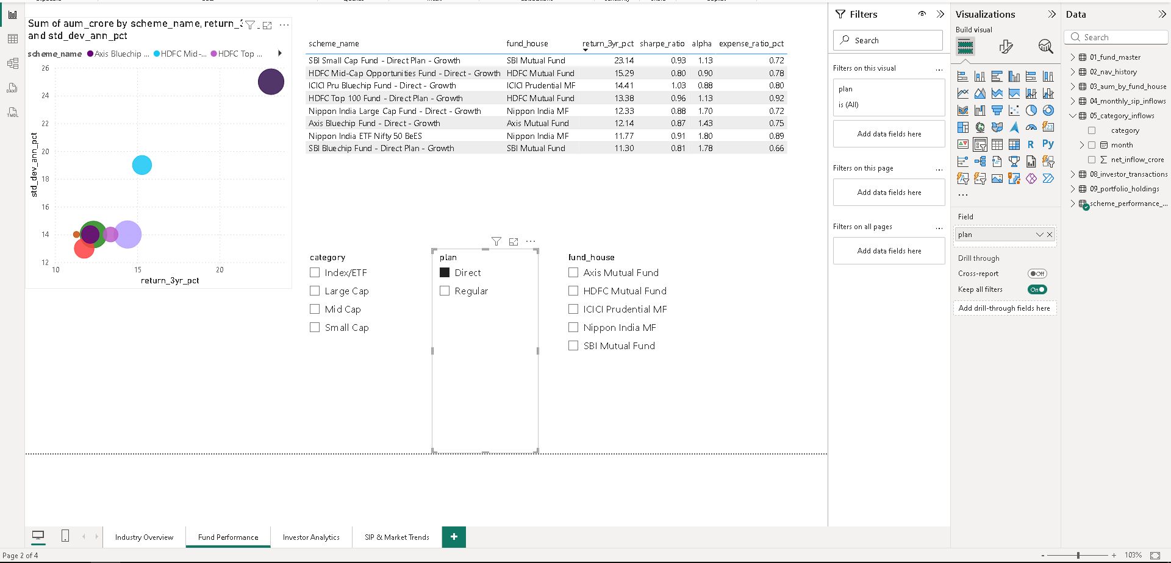

Investor Analytics
The Investor Analytics page includes:
- State-wise Transaction Analysis
- Age Group Analysis
- Transaction Type Distribution
- Monthly Transaction Trends

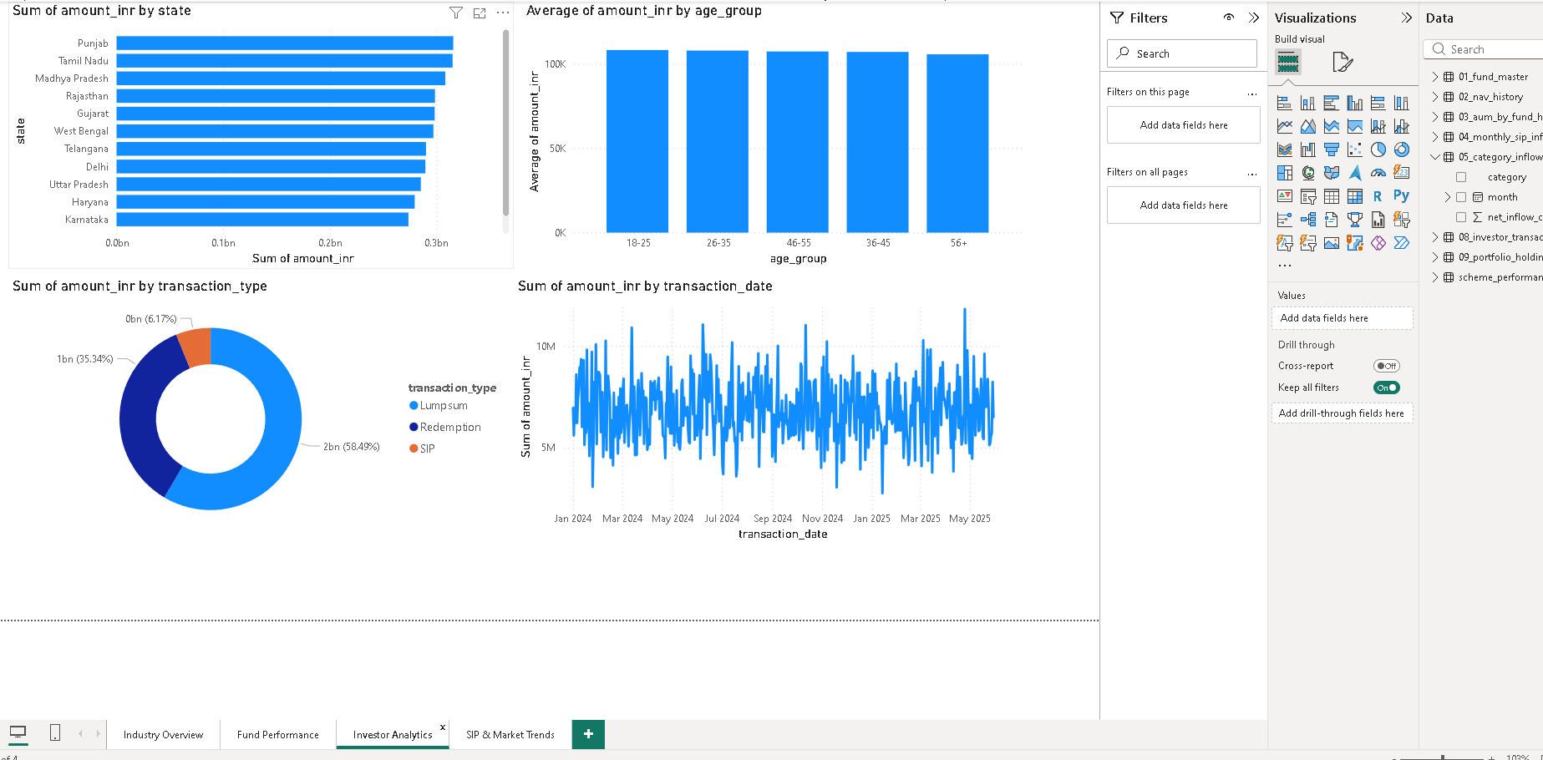

Market Trends
The Market Trends page contains:
- SIP Growth Trends
- Category Inflow Analysis
- Industry Trend Visualizations
- Market Participation Metrics

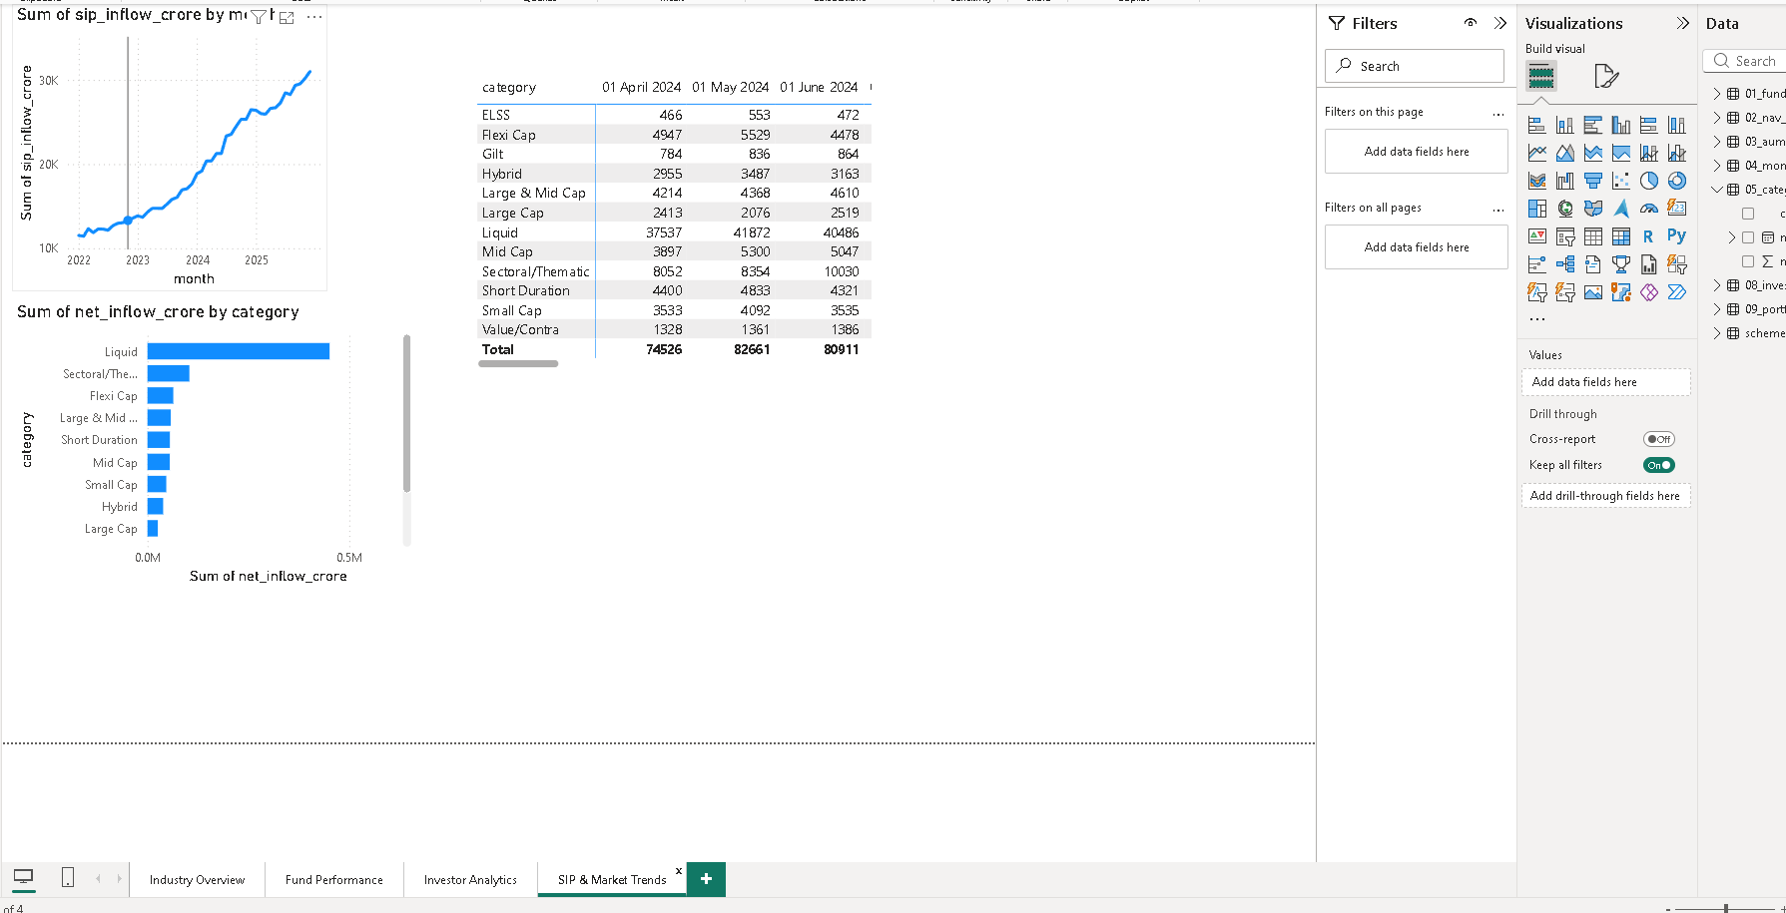

Benefits of the Dashboard
- Real-time visual analysis of mutual fund data.
- Interactive filtering and drill-down capabilities.
- Simplified interpretation of complex financial information.
- Improved decision-making support for investors and analysts.

9. Advanced Analytics & Risk Metrics
Advanced analytical techniques were applied to evaluate investment risk, investor behavior, and portfolio concentration.

Value at Risk (VaR)
Value at Risk (VaR) was calculated using the historical simulation method at the 95% confidence level.
Purpose:
- Estimates the maximum expected loss under normal market conditions.
- Helps investors understand downside risk exposure.
Key observations:
- High-risk funds exhibited larger VaR values.
- Conservative funds showed relatively lower risk exposure.

Conditional Value at Risk (CVaR)
Conditional Value at Risk (CVaR) was calculated as the average loss beyond the VaR threshold.
Benefits:
- Provides a more comprehensive view of extreme downside risk.
- Complements VaR analysis for risk management.

Rolling Sharpe Ratio
A rolling 90-day Sharpe Ratio was calculated to evaluate changes in risk-adjusted performance over time.
Key observations:
- Performance varied across different market conditions.
- Some schemes maintained consistently strong risk-adjusted returns.

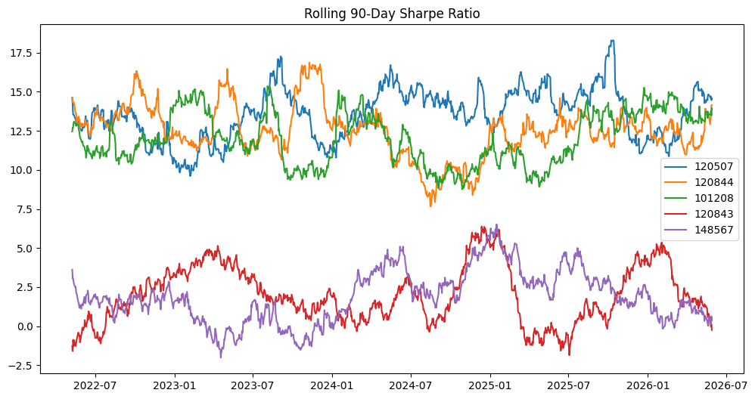Investor Cohort Analysis
Investors were grouped according to the year of their first transaction.
Findings:
- The majority of investors joined during 2024.
- New investor acquisition slowed during the later period.

SIP Continuity Analysis
SIP transaction behavior was analyzed by measuring the average gap between transactions.
Purpose:
- Identify investors at risk of discontinuing SIP investments.
- Measure investor engagement and consistency.

Fund Recommendation System
A recommendation model was developed using:
- Risk Grade
- Sharpe Ratio
- Historical Performance
The system recommends top-performing schemes within a selected risk category.

Sector Concentration Analysis (HHI)
The Herfindahl-Hirschman Index (HHI) was used to measure portfolio concentration across sectors.
Benefits:
- Quantifies diversification levels.
- Identifies portfolios with excessive sector concentration.

10. Key Insights
- Liquid Funds, Large Cap Funds, and Flexi Cap Funds attracted significant investor inflows.
- Investors in the 26–35 age group contributed the largest share of transactions.
- SIP investments represented the dominant mode of investment activity.
- Risk-adjusted performance varied considerably across mutual fund schemes.
- Higher Sharpe Ratio funds generally provided better investment efficiency.
- Investor participation was concentrated among a limited number of cohorts.
- Certain sectors accounted for a large share of portfolio allocations, indicating concentration risk.
- Dashboard visualizations significantly improved the interpretation of complex financial metrics.

11. Limitations
- Analysis was performed using historical data and may not predict future performance.
- Market conditions can change rapidly and affect investment outcomes.
- Risk metrics are dependent on the quality and availability of historical data.
- Some datasets were limited to the available project scope.
- External economic and geopolitical factors were not incorporated into the analysis.

12. Recommendations
- Investors should evaluate both return and risk before selecting mutual funds.
- Regular monitoring of portfolio concentration is recommended.
- SIP investments should be encouraged for long-term wealth creation.
- Risk-adjusted performance metrics should be considered alongside raw returns.
- Fund managers should monitor drawdown risk and sector concentration levels.
- Future versions of the project may incorporate predictive analytics and machine learning models.

13. Conclusion
The Mutual Fund Analytics Project successfully demonstrated the application of data engineering, financial analytics, and business intelligence techniques in the mutual fund domain.
The project transformed raw financial datasets into meaningful insights through ETL processes, exploratory analysis, performance evaluation, advanced risk metrics, and interactive dashboard visualizations.
The developed solution provides a comprehensive framework for understanding fund performance, investor behavior, market trends, and portfolio risk. The dashboard and analytical reports can assist investors, analysts, and fund managers in making informed decisions based on data-driven insights.
The project highlights the value of combining analytics and visualization technologies to solve real-world financial analysis problems.

14. References
• Association of Mutual Funds in India (AMFI) – https://www.amfiindia.com
• Microsoft Power BI Documentation – https://learn.microsoft.com/power-bi
• Pandas Documentation – https://pandas.pydata.org
• NumPy Documentation – https://numpy.org
• Matplotlib Documentation – https://matplotlib.org
• Seaborn Documentation – https://seaborn.pydata.org
• Financial Risk Management Concepts and Industry References
• Project datasets provided as part of the Mutual Fund Analytics Capstone Project

