**Course Code:** MECS 0033

**Course Name:** Artificial Intelligence

**Section:** 52

**Lecturer’s Name:** Dr. Shafaatunnur binti Hasan

**Session/Semester:** 202420252

**Assignment Title:** UTM Campus Assistance Chatbot

**Group:** 3 (College Facilities)

**Member Details**:

|  |  |
| --- | --- |
| **Matrix No.** | **Name** |
| MEC245057 | Tan Zhuang Min |
| MEC245056 | Tan Seng Hooi |
| MEC245046 | Nurul ‘Aini Hamdan |
| MEC245041 | Teng Jiun Wah |

1.0 Objectives

The objective of this AI-based Campus Assistant Chatbot is to enhance the efficiency, transparency, and responsiveness of college facility management by leveraging natural language processing (NLP) to provide a centralized, intuitive, and intelligent platform where students can enquire about, report, and track facility-related issues. The chatbot aims to streamline communication between students, administrative staff, and maintenance teams, providing real-time responses and highlighting issues to ensure prompt action. This solution not only empowers students with a user-friendly reporting and enquiry tool but also equips campus authorities with actionable insights and analytics to proactively manage infrastructure and improve the overall campus experience.

2.0 Problem Statement

Despite advancements in digital campus systems, many colleges continue to struggle with inefficient facility management processes and information communication. Issues such as broken classroom equipment, malfunctioning air conditioning, and unclean restrooms frequently go unreported or unresolved due to a lack of a clear, accessible reporting mechanism. Students are often unaware of how to lodge complaints or are discouraged by the absence of status updates once an issue is reported. This lack of communication and transparency not only causes frustration but can negatively affect the learning environment, reduce student satisfaction, and hinder overall academic performance. There is a pressing need for an intelligent, centralized system that simplifies issue reporting and enhances the responsiveness of campus facility services.

2.1 Introduction

In today’s digitally connected world, the expectations for smart and efficient campus services are higher than ever. While many universities have embraced online learning platforms and student portals, facility management remains an overlooked area in terms of digital transformation. Students often encounter daily inconveniences such as broken lights, malfunctioning air conditioning, or unclean restrooms, yet lack a convenient way to report these problems or receive timely updates. These inefficiencies not only disrupt the campus experience but also affect student well-being and academic focus. To address these challenges, this proposal introduces an AI-powered Campus Assistant Chatbot designed to serve as a bridge between students and campus maintenance teams. By enabling quick, accessible issue reporting, facility enquiries, and real-time tracking through natural language processing, the chatbot aims to improve the responsiveness, transparency, and overall effectiveness of facility management in UTM campus.

2.2 Problem Background

2.2.1 Disorganized and Decentralized Platform to Report Facility Issues

Many campuses lack a unified platform for students to report facility issues. Reports may be submitted via multiple channels such as emails, verbal complaints, social media, or physical noticeboards, resulting in inconsistency, duplication, and confusion. This scattered approach makes it difficult to track and manage facility-related problems effectively.

2.2.2 Ineffective Facilities Issues Reporting and Communication

A student may be unclear on which department to direct their complaint to, which could potentially cause the complaint to end up in the wrong department, resulting in additional work by the staff to filter through complaints and ultimately lost time and frustration on both sides. Once a student submits a complaint, they rarely receive updates on its status or resolution as there is no standard protocol for notifying students about progress or completion, leaving them unsure whether action was taken.

2.2.3 Facilities Staff Receive Complaints Through Various Informal Channels

Facility teams often receive complaints through unofficial or non-standardized means such as hallway conversations, direct messages, or phone calls. These informal channels are not recorded, leading to missed or forgotten requests.

2.2.4 Absence of a Feedback Platform to Rate and Confirm the Solution of Issues

After an issue is reportedly resolved, there’s no system in place for students to confirm whether the fix was effective or to rate the response. This breaks the loop in ensuring service quality and improvement.

2.2.5 Difficulty in Finding Information About Campus Facilities

Due to the variety of facilities available on the campus, students may find it difficult to find facilities that suit their needs by navigating through UTM web portal. Navigating the portal becomes even more challenging when trying to access facility booking schedules, hindering efficient planning.

2.3 Significance of the problem

2.3.1 Disorganized and Decentralized Platform to Report Facility Issues

Without a centralized system, important maintenance issues may be overlooked or delayed. This results in prolonged discomfort for students and additional pressure on campus operations. Centralization is essential for prioritizing and managing requests efficiently, improving both student satisfaction and operational flow.

2.3.2 Ineffective Facilities Issues Reporting and Communication

The lack of communication erodes student trust in campus services. It creates frustration and discourages students from reporting future issues. Maintaining an open line of communication not only improves user experience but also fosters accountability within the facility management team.

2.3.3 Facilities Staff Receive Complaints Through Various Informal Channels

Manual and informal processes are inefficient, prone to human error, and difficult to audit. They prevent the facility team from tracking performance metrics or identifying recurring problem areas. An AI-based solution can automate task assignments and maintain detailed records for transparency and planning.

2.3.4 Absence of a Feedback Platform to Rate and Confirm the Solution of Issues

A missing feedback mechanism means that recurring issues can go unnoticed, and staff performance cannot be evaluated effectively. Structured feedback helps campuses continuously improve maintenance processes, gauge satisfaction, and build a more responsive facility service model.

2.3.5 Difficulty in Finding Information About Campus Facilities

Without a straightforward way for students to enquire about facility services and booking schedules, it may result in inefficient planning or underutilizing facility resources.

2.4 Needs of an AI solution

An AI-powered Campus Assistant Chatbot addresses these challenges in the following ways:

2.4.1 Disorganized Reporting

An AI chatbot provides a **centralized, always-available platform** where students can report facility issues quickly using natural language. Whether through a mobile app, website, or messaging platforms like WhatsApp, the chatbot ensures that all complaints are collected in a structured and organized manner. This eliminates fragmented reporting and builds a unified database of facility issues.

2.4.2 Poor Communication

AI can automate **real-time status updates** to keep students informed about the progress of their reports. Through notifications and chatbot responses, students are updated when their issue is received, assigned, in progress, or resolved—ensuring transparency and enhancing trust in campus services.

2.4.3 Manual Handling

AI systems can automatically **classify and route issues** to the appropriate maintenance team using natural language processing (NLP) and machine learning algorithms. This removes the inefficiencies of manual task allocation, reduces human error, and speeds up response time, allowing staff to focus on actual resolution rather than communication overhead.

2.4.4 Lack of Feedback Loop

The chatbot can **request structured feedback** after issue resolution, allowing students to confirm whether the problem was resolved and to rate the service. This creates a continuous improvement cycle and provides administrators with valuable performance insights.

2.4.5 Difficulty Finding Information

The chatbot extracts and analyses key details from student enquiries to identify the intent and requirements before suggesting the suitable facility and booking schedule.

3.0 Empathy Map

Figure 1

*Empathy map (Student)*

*Mind mapping link: https://www.canva.com/design/DAGkVsV4PTE/hq0hs-E6k9Utl3SFpK5vVA/edit?referrer=mind-maps-landing-page*

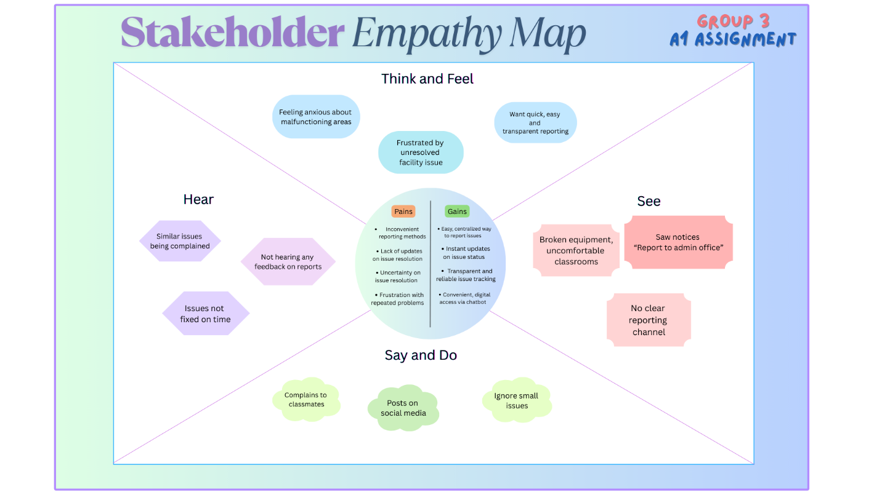

**Table 1**

*List of stakeholders for UTM Campus Assistance Chatbot*

|  |  |
| --- | --- |
| **Stakeholder** | **Role** |
| Students | Report issues, receive updates, give feedback |
| Facility Staff | Receive tasks, mark completion, provide updates |
| Admin Officers | Oversee reports, manage teams, view analytics |
| IT Team | Integrate and maintain chatbot in digital systems |

3.1 Empathy Map from the Stakeholder (Perspective of a Student)

3.1.1 Say and Do

* Why isn’t this fixed yet?
* Complaints to classmates or posts on social media.
* Ignore small issues due to the hassle of reporting.

3.1.2 Think and Feel

* Anxious about unclean or malfunctioning areas.
* Frustrated by unresolved facility issues.
* Want quick, easy, and transparent reporting.

3.1.3 Hear

* They never fix anything on time.
* Friends complaining about similar issues.
* Not getting any feedback on issues reported.

3.1.4 See

* Broken equipment, uncomfortable classrooms.
* Notice no clear reporting channel.
* Notices on walls that say "Report to the admin office.

3.1.5 Pains

* Inconvenient reporting methods.
* Lack of updates on issue resolution.
* Uncertainty about whether issues will be resolved.
* Frustration with repeated problems.

3.1.6 Gains

* Easy, centralized way to report issues.
* Instant updates on the status of their issues.
* Transparent and reliable issue tracking.
* Convenient, digital access via a chatbot.

3.2 Empathy Map from the Stakeholder (Perspective of a Facility Staff)

3.2.1 Say and Do

* I try to prioritize, but it’s hard without a clear system.
* I’m doing the best I can with what I have.

3.2.2 Think and Feel

* Overwhelmed with manually handling issues.
* Frustrated by inconsistent communication.
* Want efficient processes and task management.

3.2.3 Hear

* Why are students always complaining?
* I don’t know what needs to be fixed first.
* It’s hard to keep track of everything manually.

3.2.4 See

* Receives complaints from various channels.
* Often unsure about the status of reported issues.

3.2.5 Pains

* Manual tracking and handling of complaints.
* Lack of visibility on reported issues.
* Difficulty prioritizing maintenance tasks.
* Overwhelmed with informal, scattered reporting.

3.2.6 Gains

* Automated issue categorization and routing.
* Clear, organized view of issues needing attention.
* AI-driven prioritization of issues.
* Reduced workload with centralized reports.

3.3 Empathy Map from the Stakeholder (Perspective of a Admin Officers)

3.3.1 Say and Do

* We need a system that automates these tasks.
* I can’t keep track of all requests manually.

3.3.2 Think and Feel

* Concerned about facility inefficiencies.
* Needs a better way to track and manage requests.
* Want to improve overall campus service quality.

3.3.3 Hear

* Why are there so many complaints about facilities?
* The data we receive is hard to analyze.
* We need a better system for reporting and feedback.

3.3.4 See

* Issues piling up with no clear resolution timeline.
* Difficulty in monitoring facility performance.

3.3.5 Pains

* Difficulty tracking and managing facility issues.
* Lack of insights or data-driven decision-making.
* Struggles with managing manual tasks and reports.
* Poor coordination between students and staff.

3.3.6 Gains

* Real-time tracking of all issues and their statuses.
* Detailed analytics on reported issues and trends.
* Automated reporting and streamlined management.
* Improved communication and coordination via a chatbot.

3.4 Empathy Map from the Stakeholder (Perspective of a IT Team)

3.4.1 Say and Do

* We’ll need to test this thoroughly before launch.
* We need clear specifications and timelines.

3.4.2 Think and Feel

* Concerned about system reliability and scalability.
* Wants to ensure security and privacy of student data.
* Feels overwhelmed by the tech requirements of the chatbot.

3.4.3 Hear

* “We need to integrate everything smoothly."
* “Can the system handle the load during peak times?”
* "It’s a challenge to implement AI systems."

3.4.4 See

* The complexity of integrating the chatbot into existing systems.
* Technical issues arising from system limitations.

3.4.5 Pains

* Challenges in integrating AI technology with current systems.
* Concerns over system performance and scalability.
* Security and data privacy issues.
* Complexity in maintaining and updating the system.

3.4.6 Gains

* Seamless integration of AI-based chatbot into existing infrastructure.
* Scalable, robust system that can handle high volumes of requests.
* Enhanced data security and privacy controls with AI.
* Streamlined maintenance and automated updates.

4.0 System Architecture Design

Figure 2

*System Architecture Diagram for UTM Campus Assistant Chatbot*

*System Architecture Diagram link: https://www.canva.com/design/DAGkbQkUY9I/vP-EVpkdvwKY_JOvr929UA/edit*

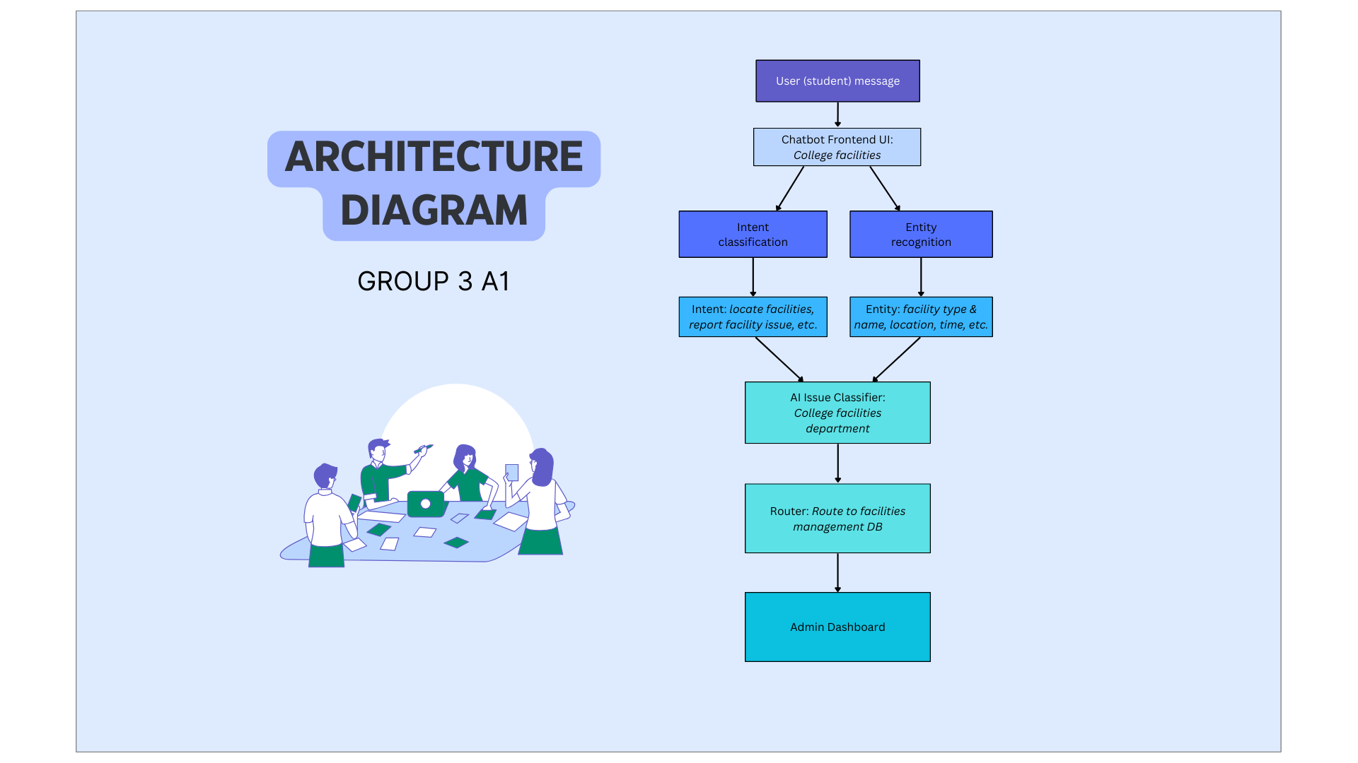

Table 2

*Key components of UTM Campus Assistant Chatbot System Architecture*

|  |  |
| --- | --- |
| **Component** | **Description** |
| User (Student) | End-user interacting with the chatbot either to report a facility issue or ask facility-related information. |
| Chatbot Frontend UI | User interface where students input messages and receive responses. |
| Entity Recognition | AI model that extracts key entities (e.g, facility type, name, location, time) from the user message. |
| Intent Classification | AI model that determines the user’s intent (e.g. “locate facilities”, “report facility issue”) |
| AI Issue Classifier | Classifies the specific type of issue being reported. |
| Facilities Management DB | Backend database that keeps all facility issue reports. |
| Admin Dashboard | Interface for facilities staff/ admins to view, manage, and resolve reported issues. Provides filters, search, and status tracking. |

5.0 Appendix (Survey Form and Response)

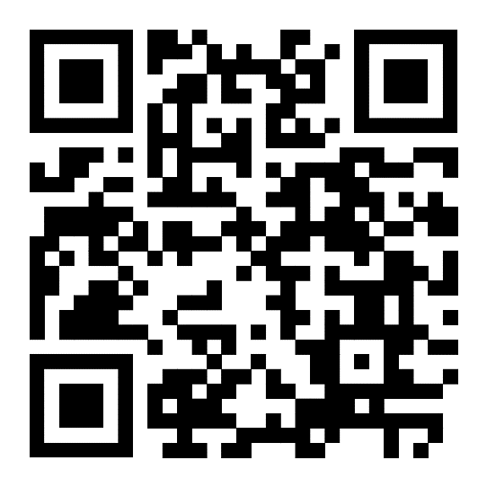

https://forms.gle/bAL1HvgztCuJKUEcA