**Course Code:** MECS 0033

**Course Name:** Artificial Intelligence

**Section:** 52

**Lecturer’s Name:** Dr. Shafaatunnur binti Hasan

**Session/Semester:** 202420252

**Assignment Title:** UTM Campus Assistance Chatbot

**Group:** 3 (College Facilities)

**Member Details**:

|  |  |
| --- | --- |
| **Matrix No.** | **Name** |
| MEC245057 | Tan Zhuang Min |
| MEC245056 | Tan Seng Hooi |
| MEC245046 | Nurul ‘Aini Hamdan |
| MEC245041 | Teng Jiun Wah |

Table of Contents

Table of Contents 2

1.0 Introduction 3

2.0 AI Solution Overview 3

3.0 PEAS Model Representation 4

3.1 (P) Performance Measure 4

3.2 (E) Environment 5

3.3 (A) Actuators/Effectors 7

3.4 (S) Sensors 10

4.0 PEAS Model Diagram 12

5.0 Conclusion 13

1.0 INTRODUCTION

In the Ideate phase of the Design Thinking approach, our primary objective is to generate innovative solutions and create a comprehensive design blueprint for the proposed AI system. The PEAS (Performance measure, Environment, Actuators, Sensors) model serves as a robust and structured framework, enabling us to meticulously define and conceptualize the AI agent's operational parameters. This systematic approach ensures clarity, consistency, and a shared understanding among stakeholders.

This proposal meticulously outlines the formulation of our proposed AI solution utilizing the PEAS model. It includes detailed descriptions for each PEAS property, a comprehensive summary table, and a clear conceptual diagram. Crucially, the AI solution is contextualized by direct reference to the UI design developed in Assignment 2 (A2), allowing us to illustrate each PEAS property with practical and relevant examples from the user interface. This integration ensures that our AI design is not abstract but deeply embedded within the user experience we've already envisioned.

2.0 AI SOLUTION OVERVIEW

The AI solution is strategically engineered to significantly enhance user interaction and automate critical decision-making processes within the proposed UI platform (from A2). Its core objective is to optimize the user experience through a trifecta of intelligent capabilities: smart response generation, perceptive environment sensing, and real-time action execution. This AI will move beyond simple automation to provide proactive, personalized, and efficient interactions, ultimately streamlining workflows and improving user satisfaction.

3.0 PEAS MODEL REPRESENTATION

3.1 (P) Performance Measure

The Performance Measure defines the criteria by which the AI solution's success will be quantitatively and qualitatively evaluated.

3.1.1 Accuracy of AI-Generated Responses

We will measure the percentage of AI-generated responses that are contextually appropriate, factually correct, and directly address the user's intent. For example, we'd track how often the chatbot provides the exact information requested by the user without requiring further clarification. We could implement a scoring system (e.g., 0-5) for each response, with a target average score of 4.5 or higher. To ensure a high level of precision, human evaluators will periodically review a random sample of AI responses against a set of predefined rubrics to validate the automated accuracy metrics.

3.1.2 Response Time Latency

Targeting a response time of less than 1 second is critical for a seamless user experience, especially in real-time conversational interfaces. We will track the average and maximum time taken for the AI to process a user query and display a response in the chatbot. High latency can lead to user frustration and abandonment.

3.1.3 User Satisfaction Rating via Feedback

Beyond objective metrics, user perception is vital. We will integrate mechanisms within the chatbot for users to provide direct feedback on their interactions (e.g., a "Was this helpful?" thumbs up/down button, or a quick rating system after a resolved query). A target satisfaction rate of 85% or higher will indicate successful user adoption and positive sentiment.

3.1.4 Issue Resolution Efficiency

This metric will track the total time taken from a user's initial issue report via the chatbot to the final resolution of that issue. Furthermore, we'll monitor the number of issues that are successfully resolved directly through AI-generated workflows or by AI-facilitated processes. Faster issue resolution directly enhances user satisfaction and minimizes disruption caused by facility problems. The AI's contribution here isn't just about speed but also about ensuring that the right resources are engaged at the right time, leading to more effective and timely problem-solving.

3.1.5 Facility Staff Efficiency

We'll measure the reduction in time that facility staff spend on manual issue management tasks, such as initial categorization, data entry, basic information gathering from users, or re-routing miscategorized tickets. This can be tracked by comparing pre-AI operational times against post-AI times, or by analyzing time saved per issue type. By intelligently categorizing, triaging, and sometimes even resolving issues, the AI directly contributes to a more efficient and productive facility team. Staff can allocate their time more strategically, leading to faster overall issue resolution times and a more streamlined workflow for the entire department.

3.2 (E) Environment

The Environment encapsulates the external conditions, context, and entities with which the AI interacts.

3.2.1 User Devices (Mobile, Desktop, Tablet)

The chatbot is able to operate seamlessly across a variety of devices, each with different screen sizes, input methods (touch vs. keyboard/mouse), and processing capabilities. The A2 UI's responsive design principles directly influence how the AI's outputs are rendered and how inputs are received.

3.2.2 Network Connectivity and Latency Conditions

The performance can be significantly impacted by network conditions. It must be designed to handle varying levels of connectivity, from high-bandwidth Wi-Fi to limited mobile data. This might involve implementing local caching strategies or designing for asynchronous operations to mitigate the impact of latency.

3.2.3 Input Variability (Typed Text, Image Uploads)

The chatbot needs to process diverse input modalities to effectively understand user requests. This means it must handle typed text, which will require robust natural language processing (NLP) to accurately interpret user queries and commands. Additionally, if the A2 UI supports image uploads (e.g., for reporting a broken fixture or a damaged area), the AI will need image recognition capabilities to analyze the visual information and extract relevant details, such as the type of issue or its severity. This dual input capability ensures the AI can gather comprehensive data from users, adapting to how they choose to communicate issues.

3.2.4 Database

This database will hold essential information about each student, such as their name, student ID, dormitory/residence hall, contact information, and academic program. The AI will leverage this to personalize interactions and automatically pre-fill relevant details when a student reports an issue. Concurrently, this database will contain detailed information about all facilities and assets within the institution. Meanwhile, every conversation and reported issue will be logged here. This includes the student's initial report, AI responses, automated actions taken, and the eventual resolution status. This data is vital for the AI to learn, identify recurring problems, and inform future decision-making, improving its accuracy and efficiency over time.

3.3 (A) Actuators/Effectors

Actuators are the mechanisms through which the AI agent influences or communicates changes within its environment.

3.3.1 UI Updates (Displaying Messages, Notifications, Dynamic Content)

The chatbot will dynamically display conversational responses within the chat interface, providing immediate confirmations of issue receipt, current status updates and clear instructions. Furthermore, a personalized Student Dashboard Presentation will be dynamically updated by the AI, offering a comprehensive view of all reported issues, their current status, historical records of past requests, and convenient feedback options, empowering students to track their requests in real-time. Simultaneously, for the Facility Management Team, the AI will actuate changes to their operational interfaces. A real-time Dashboard View will present a comprehensive and intuitive overview of all reported issues, intelligently categorized by type, priority, and location. This dynamic dashboard enables rapid assessment. The AI will also update a Maintenance Schedule Display, visually outlining upcoming and ongoing maintenance tasks, which aids in better planning and efficient resource allocation. To facilitate workflow, the AI will enable Person-in-Charge Assignment through interactive UI components, allowing managers to easily assign or reassign issues to specific maintenance staff or teams. Crucially, Issue Status Tracking will be managed by the AI, providing real-time updates on the progress of each issue from initial report and investigation through repair, resolution, and final closure ensuring transparent monitoring and follow-up across the team.

3.3.2 Notifications

Notifications as pop-up alerts or in-app messages for key events like issue acknowledgment, progress updates, or resolution completion. This ensures students are consistently informed without needing to actively check the app. The system will send Issue Acknowledgment Notifications immediately upon a report's submission, confirming that their facility issue has been received and logged. As the issue progresses, Progress Updates will be sent, informing students when their issue is being reviewed, is actively under repair, or has been resolved. Finally, a Resolution Confirmation notification will be sent, confirming that the reported issue has been addressed, and can include any necessary follow-up instructions or requests for feedback via surveys.

3.3.3 Alerts

The AI also proactively sends Alerts to Facility Management. Priority Alerts are automatically triggered for high-priority or urgent issues, ensuring critical problems are escalated promptly for immediate attention. To maintain efficiency, Due Date Reminders will be sent to maintenance staff and supervisors regarding approaching deadlines or overdue tasks, helping to ensure timely resolution. For ongoing accountability, Follow-Up Reminders will be sent periodically for unresolved issues or when status updates are required. Lastly, the AI can generate and distribute Summary Reports, scheduled alerts containing vital performance metrics, a list of unresolved issues, and an overview of the maintenance backlog, all designed for managerial review and data-driven decision-making.

3.3.3 Generate Facility Issue Reports

The chatbot system can compile and generate detailed facility issue reports automatically, based on the collected data, including issue types, average resolution times, and responsible parties. These reports are Customizable Reports, allowing facility managers to request specific data filtered by time periods, locations, issue severity, or current status, providing robust support for data-driven decision-making. Once generated, these reports can be set up for Report Distribution, automatically sent to relevant stakeholders via email or made easily accessible through the facility management dashboard for continuous monitoring and auditing, enhancing transparency and accountability across the board.

3.3.4 Modifying Database Entries

The AI system ensures all records are current and accurate. This includes initiating Issue Status Updates, where the chatbot automatically changes issue records in the database to reflect their current stage (e.g., moving from 'reported' to 'in-progress' or 'resolved'). It also facilitates Assigning/Reassigning Personnel by directly updating database entries to reflect changes in the staff responsible for specific facility issues. Every interaction, including student feedback and system actions, will be meticulously logged by the AI, ensuring a comprehensive Interaction History is stored in the database for future audit trails and performance analysis. When students submit new reports, the AI will automatically handle Adding New Issue Reports as fresh entries into the database. Lastly, it will enable the Updating of Maintenance Schedules, allowing for modifications to scheduled maintenance dates or tasks based on new inputs or rescheduling requests, ensuring operational plans remain flexible and responsive.

3.4 (S) Sensors

Sensors are the data collection mechanisms that allow the AI to perceive and understand its environment, enabling it to make informed decisions.

3.4.1 User Input Capture (Keyboard Input, Mouse Clicks, Touch Gestures)

These are fundamental for the AI to understand user intentions and actions within the UI. The AI needs to interpret what the user types into text fields via keyboard input, where they click or interact with elements using a mouse, and various gestures on touch-enabled devices such as taps, swipes, and pinches. This diverse range of direct user interactions forms a primary data stream for the AI.

3.4.2 System Logs and Interaction Histories

Comprehensive logging provides invaluable data. The AI can analyze past user interactions, system errors, and workflow completions to identify patterns, understand user behavior, and self-correct over time.

3.4.3 Network and System Health Monitors

To ensure optimal performance, the AI needs to sense the health of the underlying infrastructure. This includes monitoring network latency, server uptime and database response times. This allows the AI to adapt its behavior (e.g., inform the user about delays, retry failed requests).

3.4.4 Environmental Context Data (Date, Location, Profile Data, Device Type)

The AI can leverage contextual information to personalize interactions. For instance, knowing the time of day can influence greetings, location data can inform local recommendations, and user profile data can tailor content and services.

|  |  |  |
| --- | --- | --- |
| **Property** | **Description** | **Relation to Proposed UI** |
| **(P)**  **Performance** | Response accuracy,  Response time,  User Satisfaction,  Issue Resolution Efficiency,  Facility Staff Efficiency | Respond accurately and quickly to queries that bring an enhancing experience. |
| **(E)**  **Environment** | User devices,  Network conditions,  Input methods,  Databases | Adapt to various device types, network connectivity, and handle diverse input formats. |
| **(A)**  **Actuators** | UI updates,  Notifications,  Alerts,  Generate Facility Issue Reports,  Modifying Database Entries | Display responses, trigger workflows, and show alerts/notifications. |
| **(S)**  **Sensors** | User inputs,  System logs,  Network health,  Contextual data | UI collects input, logs interactions, and monitors network statuses. |

4.0 PEAS MODEL DIAGRAM

The diagram visually represents the AI agent within its environment, highlighting the interactions between the PEAS components:

* The Environment represents the dynamic user-system context in which the AI operates.
* Sensors gather user inputs and environmental data.
* The AI agent processes this information based on Performance goals.
* Actuators then act on the environment by updating the UI or backend systems.

Link:

<https://www.canva.com/design/DAGpGFBAd_c/R7GYVVD2Megoy6OPsgB62A/view?utm_content=DAGpGFBAd_c&utm_campaign=designshare&utm_medium=link2&utm_source=uniquelinks&utlId=hf7bfc406a4>

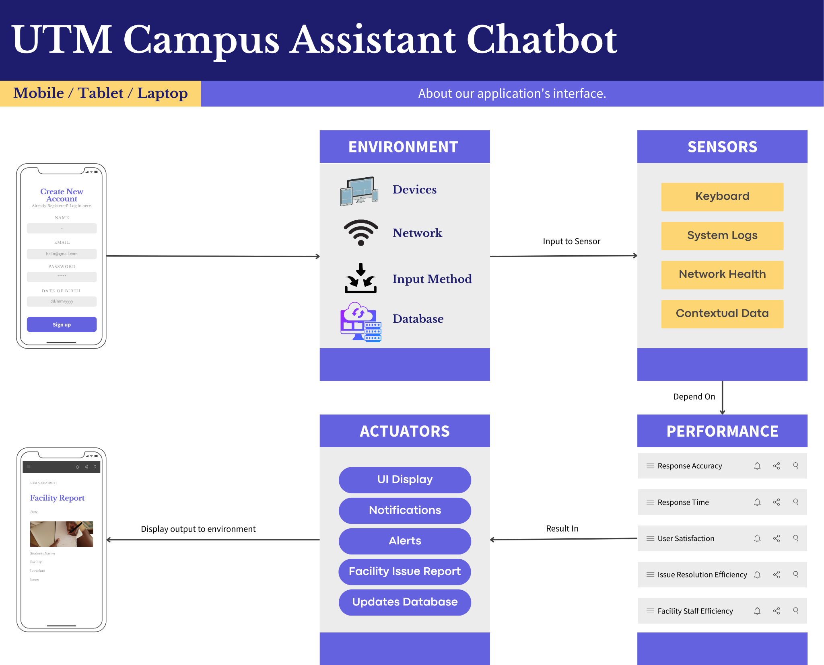

Figure 1: PEAS model diagram

5.0 CONCLUSION

This proposal lays the foundation for designing the AI solution using the PEAS model framework in the Ideate phase. It ensures clear, structured thinking about AI performance, environment, sensors, and actuators, integrated tightly with the user interface conceptualized in Assignment 2. The detailed table and diagram aid communication and further design iterations.