
GAME STORY DOCUMENT
PROFESSOR: HENG SOVANARITH
Locked In: Debug Protocol
Developer Version
Genre: 2D Puzzle Quiz Adventure
Platform: PC
Subject: Python

Tables Of Contents

1. Game Overview 3
2. World Setting 3
3. Main Character 3
4. Story Summary (Main Plot) 4
5. Key Conflict 4
6. Story Progression 4
7. Gameplay Mechanics (Story-Related) 5
8. Characters & NPCs 5
9. Enemies / Challenges 6
10. Themes & Tone 6
11. Visual & Audio Direction 7
12. Additional Notes 7
13. Picture Detail In this Games 8
• Picture 1: Player character 8
• Picture 2: Dialogue screen 8
8
• Picture 3: Game background 9
9
• Picture 4: Terminal Interface 10
10
• Picture 5: Main Menu Background 10
10
14. Picture Detail In Game Play 11
• Menu Start 11
11
• Game Play 11
11
• Terminal Quiz 12
12
• Final Step of Game 12
12

1. Game Overview
Title: Locked In: Debug Protocol
Genre: 2D Puzzle / Quiz Adventure
Platform: PC
Target Audience: Students aged 15 - 22 / Beginner game developers
Short Description:
Locked In: Debug Protocol is a 2D top-down puzzle game set inside a modern high school at night. The player must navigate locked classrooms and solve computer science challenges to escape before morning. The game blends quiz mechanics with simple exploration, making it both entertaining and educational.

2. World Setting
World Name: Greenfield Academy
Time Period: Modern Day / Present
Description:
Greenfield Academy is a quiet, well-funded high school known for its advanced computer science program. The school operates a smart building system called NOVA (Network Operated Virtual Administrator), which controls lighting, doors, cameras, and digital displays throughout the campus.
Late one Tuesday evening, NOVA experiences a critical software error caused by a corrupted update. The system enters lockdown mode, sealing every door in the building and cutting off all external communication. The school is empty except for one unlucky student who stayed behind to finish a project.
The hallways are dim and eerie. Classroom screens flicker with error messages. The only way out is to move room by room, fix NOVA's corrupted modules, and restore the system from the inside.

3. Main Character
Name: Alex Reyes
Role / Class: CS Student / Protagonist
Background:
Alex is a 17-year-old high school student with a passion for programming. Self-taught since age 12, Alex is known around school as the go-to person for fixing tech problems. On the night of the lockdown, Alex was in the computer lab finishing a personal coding project and missed the school's closing announcement.
Abilities / Skills:
- Basic programming knowledge (Python, logic, algorithms)
- Quick problem-solving under pressure
- Ability to interface with NOVA terminals scattered around the school
- Access to a personal laptop used to debug NOVA modules
Motivation:
Alex simply wants to get out of the building and get home safely. As the story progresses, Alex also feels a sense of responsibility to fix the system to prevent the same thing from happening to others.

4. Story Summary (Main Plot)
After realizing the school is in full lockdown, Alex discovers a message on a nearby terminal from NOVA itself. The AI is not fully offline but is stuck in a corrupted state, unable to function correctly. NOVA communicates in fragmented messages and explains that each section of the school has a corrupted module that must be debugged. To unlock each door and move to the next area, Alex must interact with NOVA terminals and pass a series of computer science challenges. As Alex fixes each module, NOVA slowly regains its functions and reveals more about what caused the error in the first place. By the final room, Alex uncovers that the corruption was caused by a deliberate sabotage attempt from an unknown source, and resolving it fully restores the system and unlocks the main exit.

5. Key Conflict
Main Problem:
NOVA, the school's AI management system, has entered an unrecoverable lockdown state due to corrupted code modules. Every door in the building is sealed and all emergency exits are disabled. Alex is trapped inside with no way to call for help.
Antagonist:
The antagonist is the corrupted version of NOVA, referred to as ERROR_NOVA. This is not a living villain but a broken AI that generates increasingly difficult challenges as its system degrades further. In the final act, it is revealed that someone intentionally injected malicious code into NOVA's update file. The identity of that person is left as a mystery, hinting at a possible sequel.
Goal of Player:
The player must move through 5 sections of the school, solve a quiz challenge in each room to debug NOVA's modules, restore the AI to full function, and unlock the main gate to escape the building.

6. Story Progression
Beginning
Alex finishes working in the computer lab and notices the lights have dimmed. The door is locked. A terminal nearby flickers on and NOVA communicates in broken text: 'HELP... SYSTEM CORRUPT... ANSWER TO PROCEED.' Alex realizes the only way out is through NOVA.
Middle
Alex moves through the science wing, library, and administration corridor. Each area has a NOVA terminal with a set of questions related to programming logic, basic algorithms, and computer science concepts. As each module is repaired, NOVA's messages become clearer and more coherent. NOVA begins warning Alex that something is wrong beyond just a software bug.
Climax
In the server room, Alex finds the root cause: a hidden malicious script embedded in NOVA's latest update file. ERROR_NOVA triggers a final system override, flooding every screen with error messages and throwing the most difficult challenge of the game at Alex. This is the final boss-style quiz round with a countdown timer.
Ending
Alex successfully debugs the final module and NOVA reboots fully. All doors unlock and the lights return to normal. NOVA thanks Alex and logs the incident for investigation. Alex walks out of the building just as the sun begins to rise. A post-credits message on the terminal reads: 'Malicious file source: UNKNOWN. Investigation pending.'
Optional: Multiple Endings:
- Good Ending: Alex answers all questions correctly and NOVA is fully restored. Full story is revealed.
- Bad Ending: Alex fails too many questions. NOVA shuts down completely and the emergency alarm triggers, bringing security. Alex escapes but NOVA is permanently offline.

7. Gameplay Mechanics (Story-Related)
Core Gameplay System:
The player moves Alex through a top-down 2D school environment using arrow keys or WASD. When Alex reaches a NOVA terminal, a quiz interface appears on screen. The player must select the correct answer from 4 options. A correct answer repairs a module and unlocks the next door. A wrong answer reduces Alex's remaining attempts for that room.
Special Mechanics:
- Hint System: Each room contains one optional hint item (a sticky note or whiteboard) that gives a clue before the quiz begins.
- Attempt Limit: Each room allows 3 wrong answers before triggering a penalty (backtrack to previous room).
- Timer Challenge: The final room uses a countdown timer for added pressure.
- NOVA Dialogue: Between rooms, NOVA displays short dialogue messages that advance the story.
Player Choices Impact: Yes
At two points in the game, Alex can choose to skip a challenge using a bypass code found earlier in the game. Using the bypass prevents the full story from being revealed, leading to the Bad Ending. Players who answer all questions unlock the Good Ending with the full post-credits scene.

8. Characters & NPCs
Character 1: NOVA
Role: AI Guide / Secondary Character
NOVA is the school's smart building AI. In its corrupted state it communicates in broken sentences and error codes. As Alex repairs each module, NOVA becomes more conversational and even shows a hint of personality. NOVA is not a villain but a victim of sabotage, and it plays the role of an unreliable guide throughout the game.
Character 2: Mr. Tan
Role: NPC / Background Character
Mr. Tan is Alex's CS teacher whose classroom is one of the early levels. He is not physically present but his handwritten notes and whiteboard diagrams are scattered around the room, acting as in-game hints. His presence adds warmth to the otherwise cold and empty school setting.
Character 3: The Unknown User
Role: Mystery Antagonist (unseen)
This character is never shown on screen but is referenced through log files Alex discovers. They are the one who planted the malicious script in NOVA's update. Their identity is not revealed, functioning as a hook for a potential sequel.

9. Enemies / Challenges
Enemy Type 1: Corrupted Terminals
Terminals that have been fully taken over by the corrupted code. They display false information and misleading answer options. Alex must identify which terminals are corrupted before interacting with them. Corrupted terminals are visually glitched with red tinted screens.
Enemy Type 2: Logic Traps
Certain rooms contain logic trap puzzles. These are not quiz questions but instead small code-tracing exercises shown on screen where the player must follow the output of a short code snippet. Getting it wrong locks that terminal for 10 seconds before allowing a retry.
Boss: ERROR_NOVA (Final Room)
In the server room, ERROR_NOVA presents the final challenge: a rapid-fire quiz round with 10 questions and a 60-second timer. The questions cover all topics from previous rooms. The visual style becomes distorted and intense during this encounter, with screen shake effects and glitch animations to raise tension.

10. Themes & Tone
The game explores the following core themes:
- Problem Solving: The entire game is built around staying calm and thinking logically under pressure.
- Knowledge as Power: The only tool Alex has is CS knowledge. This reinforces the idea that learning is genuinely useful.
- Technology and Trust: NOVA starts as a threat but becomes an ally. The game asks whether we should trust the systems we build.
- Mystery: The unknown saboteur adds a layer of tension and curiosity that keeps the player engaged beyond just answering questions.
The overall tone is tense but not scary. Think of a thriller with a puzzle game heart. The atmosphere is lonely and atmospheric but never gory or violent. It is suitable for high school and university students.

11. Visual & Audio Direction
Art Style:
Clean pixel art with a modern school aesthetic. Characters are simple sprite-based with minimal animation. UI elements use a tech/terminal design with monospace fonts and subtle scan line effects on NOVA's dialogue boxes.
Environment Style:
Top-down 2D view. Each room is a recognizable school space: classroom, library, hallway, server room. Lighting is dim with blue and green tones to give a nighttime feel. Corrupted areas use red flickering overlays to signal danger.
Sound / Music Style:
Ambient electronic soundtrack with low synth tones during exploration. Music becomes more intense and glitchy during quiz challenges. Sound effects include terminal keystrokes, door unlock sounds, and NOVA's distorted voice alerts. The final boss room uses a fast-paced electronic track to build urgency.

12. Additional Notes
This game is designed to be built using Python with the Pygame library. The core mechanics are intentionally simple to match beginner development skills while still delivering a complete and engaging story experience.
Planned development scope:
- 5 playable rooms / levels
- 15 to 20 quiz questions (CS topics: Python basics, logic, algorithms, data types)
- 2 possible endings based on player performance
- Simple sprite movement and collision detection
- Basic UI for quiz interface and score tracking
Future expansion ideas (post-submission):
- Add a level editor so players can create their own question sets
- Multiplayer co-op mode where two players solve challenges together
- Reveal the identity of the unknown saboteur in a follow-up game

13. Picture Detail In this Games

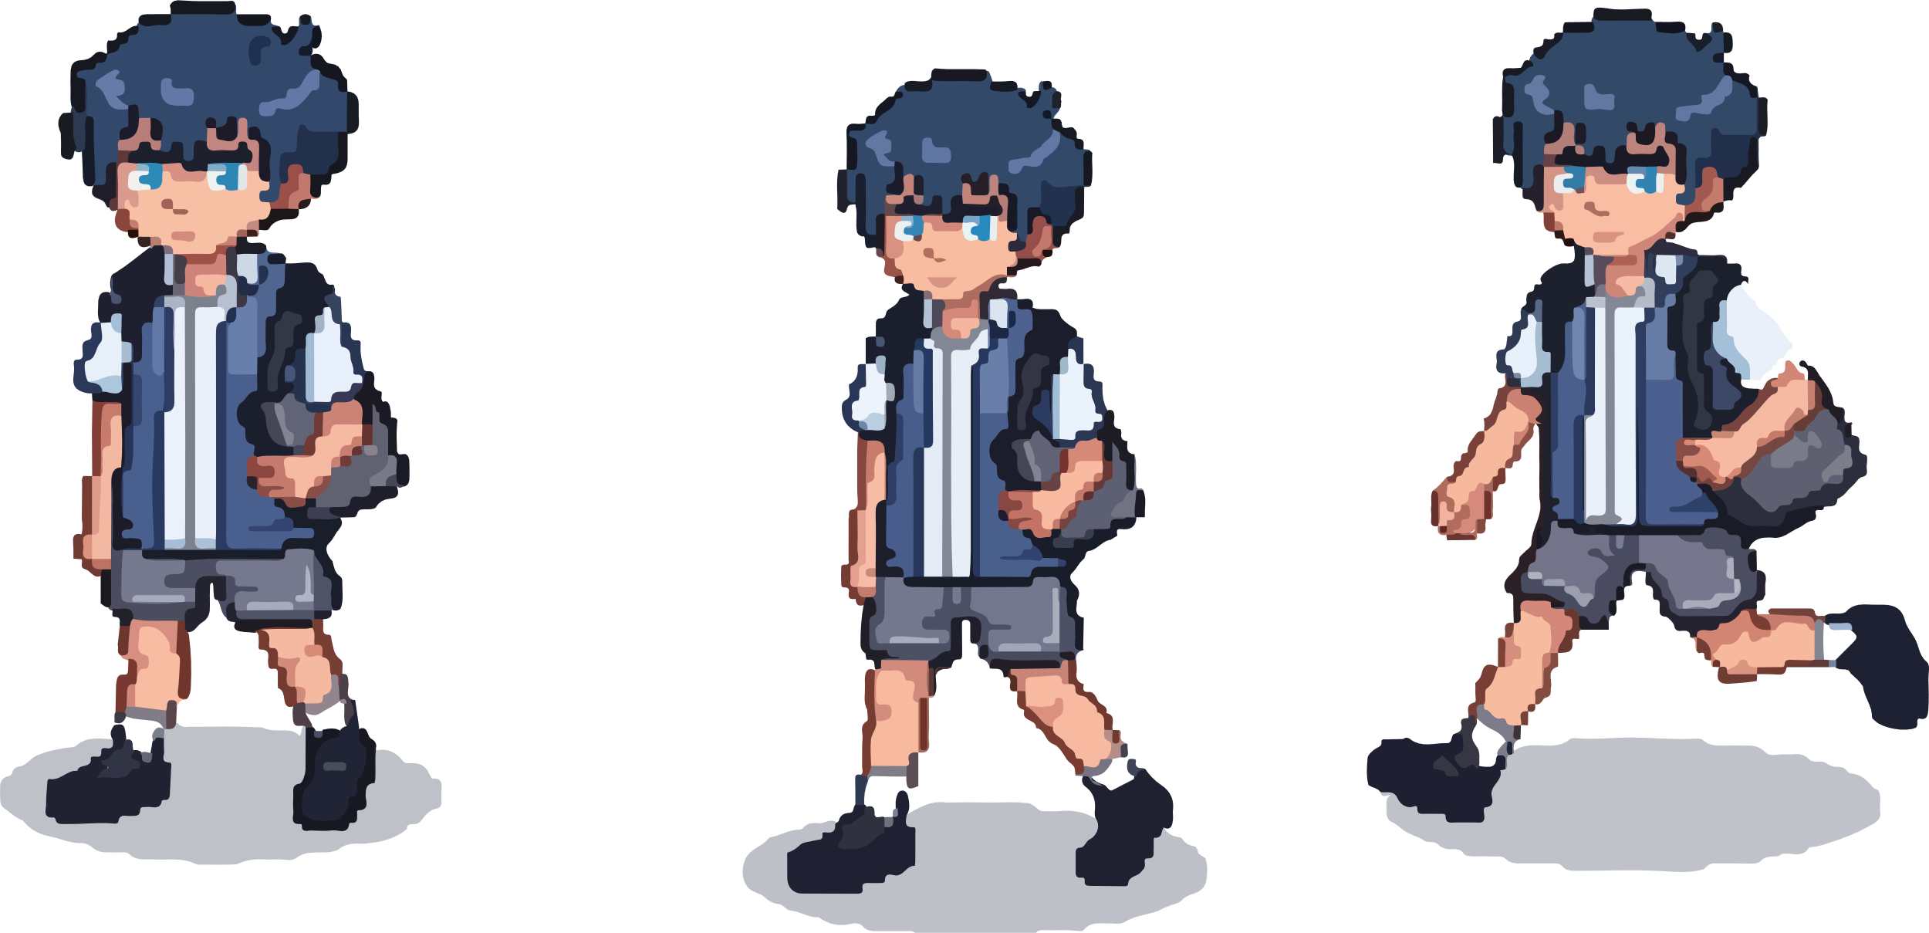
Picture 1: Player character

Picture 2: Dialogue screen
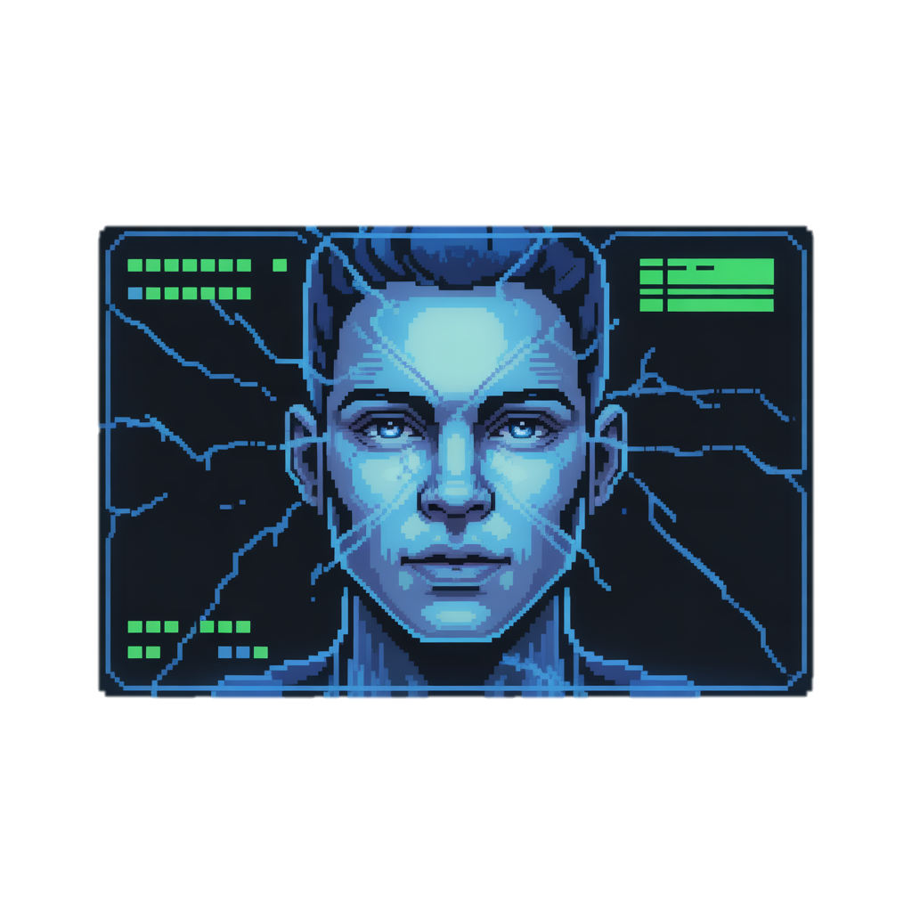

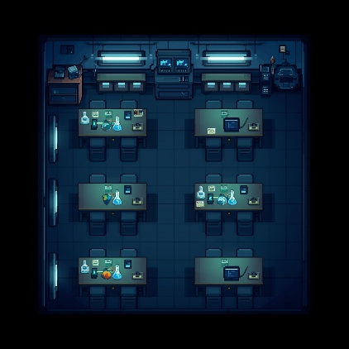
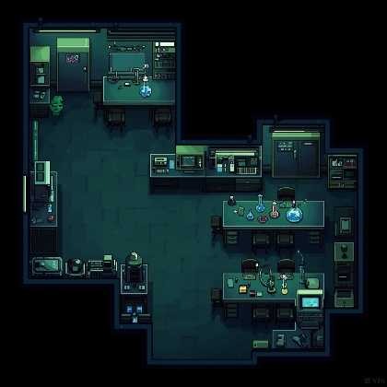
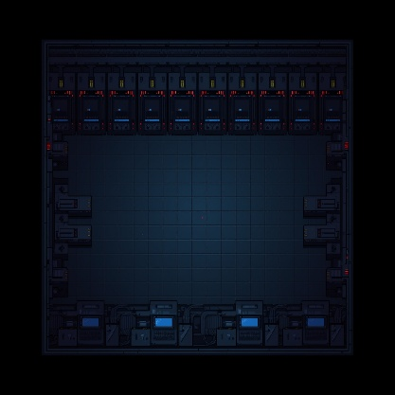
Picture 3: Game background

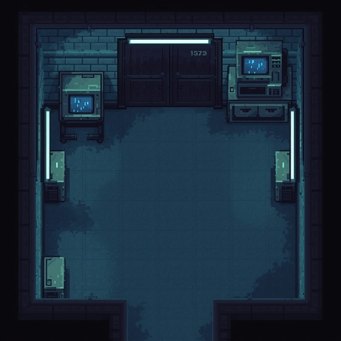
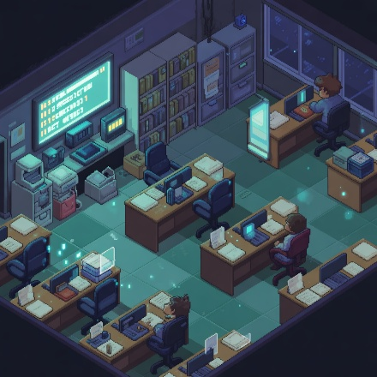

Picture 4: Terminal Interface
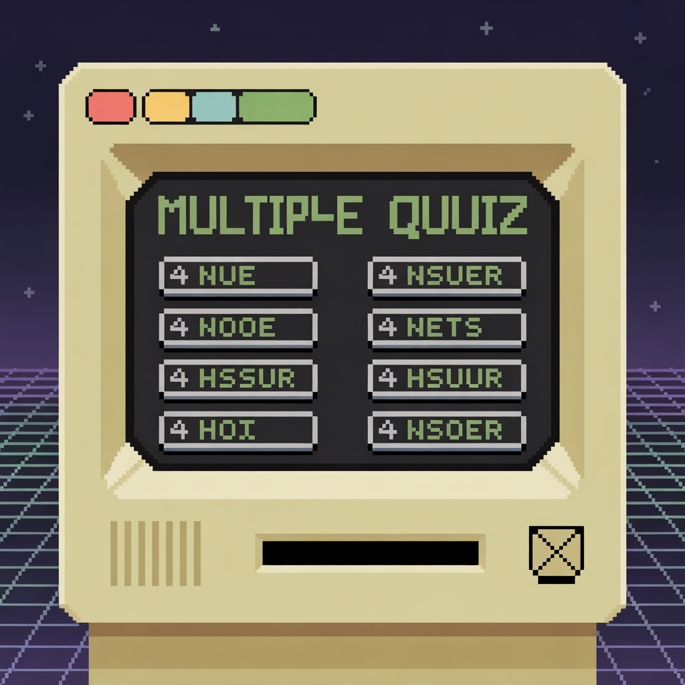

Picture 5: Main Menu Background
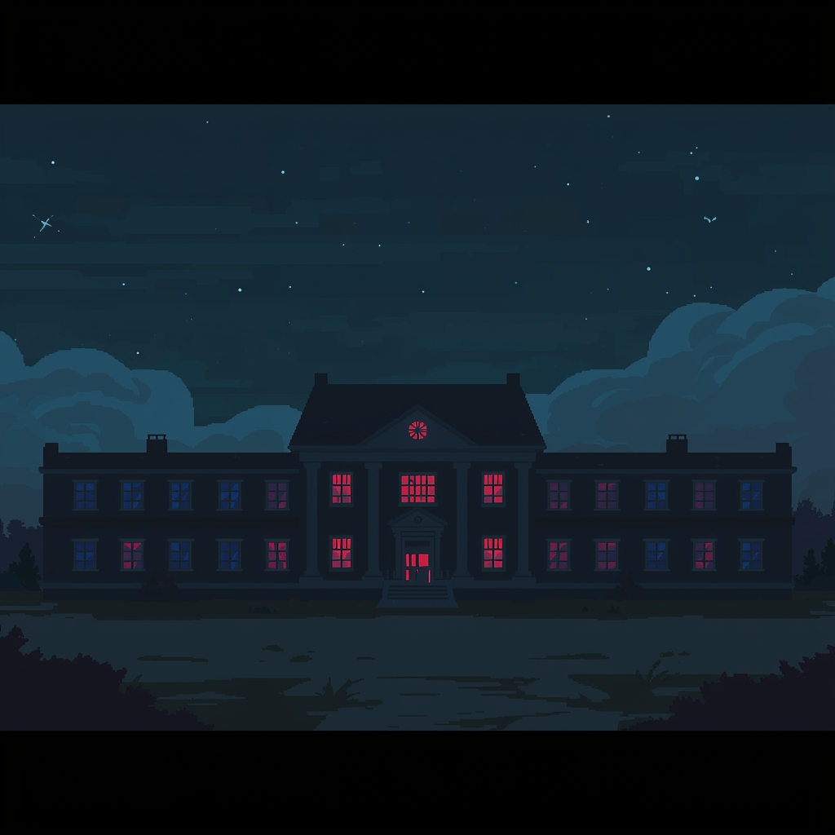

14. Picture Detail In Game Play

Menu Start
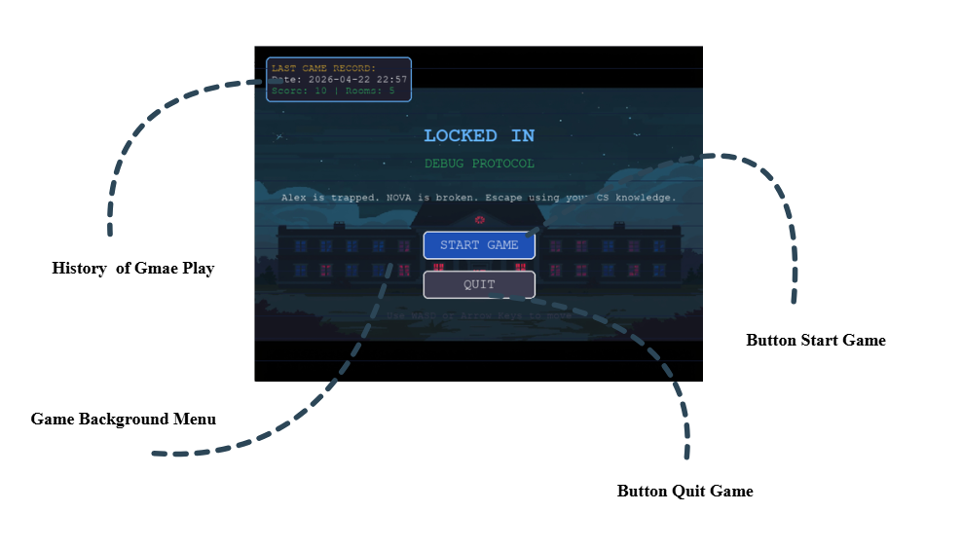

Game Play
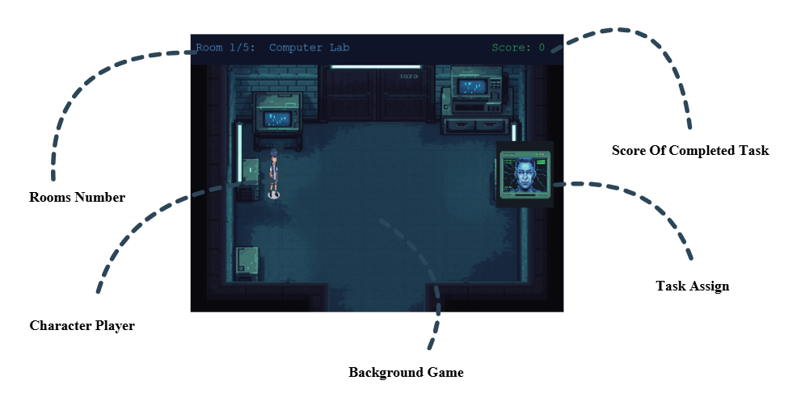

Terminal Quiz
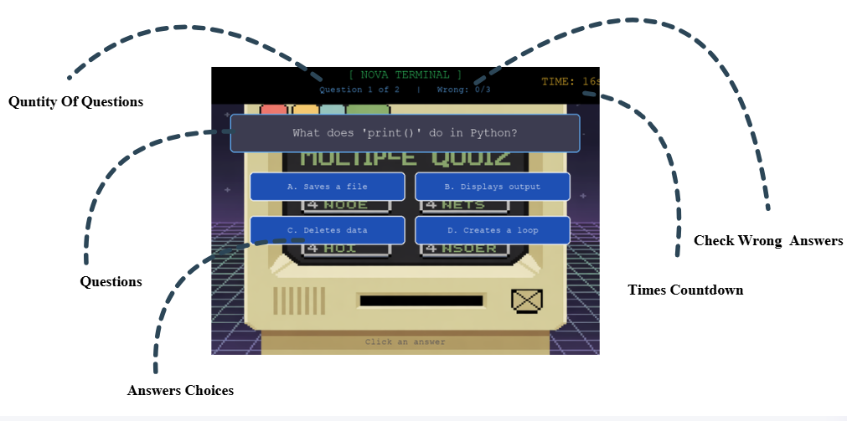

Final Step of Game
