Assignment 1

# Work Breakdown Agreement

Lab 12 Team 4 Group Member:

Seng Wei Han (32229070) Chua Jun Jie (32022425)

|  |  |  |  |
| --- | --- | --- | --- |
| Tasks | Due Date | Person In Charge | Status |
| [Design Req 2](https://www.notion.so/Design-Req-2-d6ebb90ba0264b7f93aa1c4d884c0d69) | 7th April 2022 | Seng Wei Han |  |
| [Design Req 4](https://www.notion.so/Design-Req-4-8ea8c299d04641ed92d51547836ed9c9) | 7th April 2022 | Chua Jun Jie |  |
| [Design Req 1,3,5,7](https://www.notion.so/Design-Req-1-3-5-7-27ac4ef5c1084798ae4f77fd4a52723e) | 7th April 2022 | Chua Jun Jie/Seng Wei Han |  |
| [Review each other’s diagram](https://www.notion.so/Review-each-other-s-diagram-c747bf4edca649d09255808bdde23ca8) | 10th April 2022 | Chua Jun Jie/Seng Wei Han |  |
| [Design Rationale](https://www.notion.so/Design-Rationale-c26f2e024e314c6496afd0bd1d83d642) | 10th April 2022 | Chua Jun Jie/ Seng Wei Han |  |

I (Chua Jun Jie) accept this WBA.

I (Seng Wei Han) accept this WBA.

# Requirements

**REQ1: Let it grow!** 🌳

## Design Implementation

(The screenshot shown above is the UML designed for requirement 1)

### Tree Class:

1. The purpose of making the Tree class to be an abstract class is because we knew that we will not

instantiate the Tree class in any of our code. Such implementation helped us to achieve abstraction.

1. From requirement 1 of the assignment, it is stated that a Tree has three stages and each stage has a unique spawning ability. On the other hand, each spawning stage will also have additional characteristics, for instance each sprout has 10% chance to spawn Goomba. Therefore, instead of doing all the spawning in one Tree class which will cause the Tree class to be so called the God class, I have decided to split the classes into 3 small new classes namely Sprout , Sapling and Mature and make it inherit the Tree class. In each of these new subclasses, it will have their own responsibility so that this design will adhere to the Single Responsibility Principle (SRP). On the other hand, I have also planned to declare an abstract method called tick in Tree class so that any subclasses that inherits the Tree class will need to implement the tick method. By doing this way,

we can prevent too many if-else statements in one Tree class so that it will not violate the second principle which is the Open-closed Principle.

1. Since sprout, sapling and mature are the 3 stages that a tree can experience, meaning to say the 3 classes will have the same characteristics for instance, having the same method implementation for the following method :



Thus, it’s a better idea to implement those method in the Tree class and allow the other 3 new classes(Sprout, Sapling and Mature) to inherit the method from their parent class. By using this implementation, we can ensure that DRY(Don’t Repeat Yourself) Principle will not be violated.

### Relationship:

1. The dependency relationship between Application and the three subclasses of Tree is due to the fact that for each new ground that we created, we will need to add into the FancyGroundFactory constructor.
2. The association relationship between Sprout and Goomba, Sprout and Sapling is due to the fact that each sprout can spawn goomba, so we will need to have Goomba as an attribute in the Sprout class and the same goes for Sprout and Sapling.
3. The association relationship between Sapling and Coin , Sapling and Mature is because the requirement states that a sapling can have a chance to drop a coin and a sapling will grow into a mature tree, therefore we will need to have those attributes in the sapling class.

Since coins are needed, we will also need to create a new class for coins.

# REQ2: Jump Up, Super Star! 🌟

## Design implementation

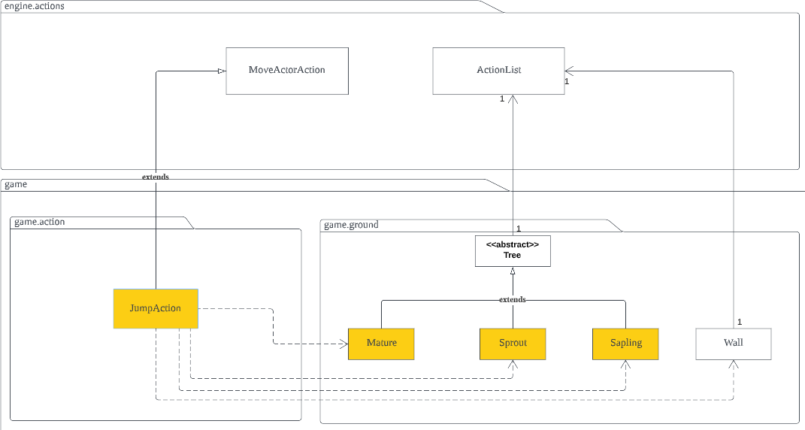

(The screenshot shown above is the UML designed for requirement 2)

### Jump Action:

1. Since requirement 2 is about jumping features, then we definitely need to have a JumpAction class implementation. This JumpAction class will inherit (extends) the moveActorAction. The ground

inside the UML class diagram is basically the ground that does not allow player to enter without using the jump action . Therefore, for each ground that player walked through, we will need to do a checking (if-else statement) inside the execute method in the JumpAction class .The checking needs to be done due to the fact that certain ground does have certain success rate which means if the player failed to jump to that particular ground, it will get inflicted a certain amount of damage by that ground. We need to set an allowable action to the ground that allows the player to use the

jumping action. Since Sapling, Sprout and Mature are inheriting the Tree class, we can just set the allowable actions in Tree class and also for Wall class. This design implementation does satisfy the requirement for the Single Responsibility Principle (SRP) since this class is only responsible for the jumping action of a player . As for the case of the SuperMushroom, we can just check whether a player has the status when it consumes super mushroom, if it does then the player will have a 100% success rate of jumping through those grounds.

### Relationship:

1. The association relationship between Tree and Wall to ActionList is because we need to have an attribute of type ActionList and this attribute will basically add a new instance of Tree class and Wall class to the ActionList in the allowableActions method inside both the Tree and Wall classes.
2. The dependency relationship between JumpAction class and the 4 other ground is due to the checking process inside the execute method where we need to check whether the ground in the

player exit surrounding is one of that four ground , if it is, then it will trigger the jump action in the console to allow the player to jump through that ground.

# REQ3: Enemies

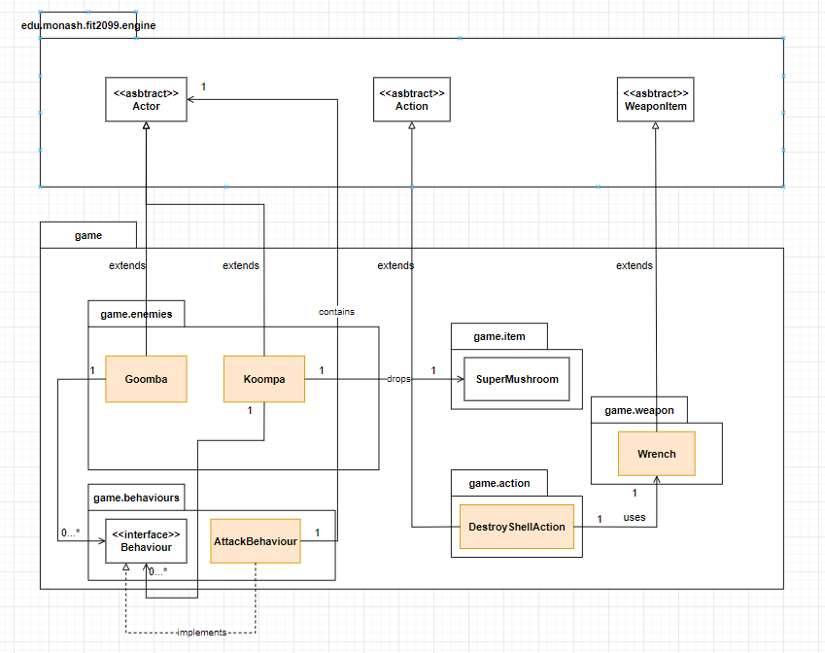

(The screenshot shown above is the UML designed for requirement 3)

## Overview

REQ3 is all about the enemies in this game. There are two enemies in the game, Goomba and Koompa. Each of them has their individual game mechanics that will be implemented in this requirement.

#### Goomba (g)

Starts with 20HP.

Deal 10HP upon every successful attack, has 50% chance to register a successful attack.

Has 10% chance to despawn (removed) from the map in every turn.

**Koompa (K)**

Starts with 100HP.

Deals 30HP on every successful hit, has 50% chance to land a successful hit.

When defeated, Koompa will turn into Dormant state (D), and it stays on the ground and does nothing.

Wrench must be used to destroy the shell (when Koompa is in Dormant state). Wrench deals 50 damage and 80% hit rate.

Destroying the shell drops Super Mushroom.

Once engaged in combat mode (either player attacks the enemy or the other way around), the enemy will follow the player until it is defeated.

## Implementation

#### Goomba

The Goomba class is given already, thus we don’t need to create another class just for the character. So, at first, Goomba’s basic stats will be added to the class as its global attributes

public class Goomba extends Actor {

/*

* CONSTANT 10% chance to be removed from the map
* sets HP attributes
* sets HP per damage, and hit percentage

*/

}

For every turn, Goomba has 10% chance to be removed from the map. Thus, we can implement a method to remove Goomba if Goomba hits the 10% chance.

public void removeGoomba (){

/* if goomba hits the CONSTANT 10% chance created

* goomba is removed from the map.

*/

}

#### Koompa

Since there is no given Koompa class before, we shall create its own dedicated class. Similar to Goomba, Koompa’s basic stats will be declared as a global attribute.

public class Koompa extends Actor {

/*

* sets HP attributes
* sets HP per damage, and hit percentage

*/

}

There is another similar check that is needed to perform if the player manages to defeat the Koompa. If the player defeats Koompa, Koompa will turn into Dormant state. We can put Dormant state in the

Status class, and we implement the Status into the AttackAction as well.

public enum Status {

HOSTILE_TO_ENEMY, // use this status to be considered hostile towards enemy (e.g., to be attacked by enemy) TALL, // use this status to tell that current instance has "grown".

DORMANT // use this status to tell Koompa is in Dormant state

}

Since Koompa has a special state when it is defeated, a special class dedicated to deal with destroying the shell of Koompa.

public class DestroyShellAction extends Action {

/* code goes here

*/

}

Since both Goomba and Koompa are NPCs of the game, they will be using AttackBehaviour class to generate an AttackAction to attack a player.

public class AttackBehaviour implements Behaviour {

//code continues

}

## Justification of Implementations

#### Goomba — Advantages

The implementation method written above uses several design principles, mainly Open-closed Principle (OCP) and Single Responsibility Principle (SRP).

Goomba has its own dedicated class, and it is a subclass of Actor superclass. This is essentially OCP as whatever changes Goomba class has, it will not affect other classes, especially Actor superclass. SRP is used when Goomba’s attack action is placed inside AttackAction class. This is because

AttackAction has one and only one purpose/responsibility only: to create and register the attack action made by one actor to a target.

#### Goomba — Disadvantages

NA

#### Koompa — Advantages

Similar to Goomba’s justification written above, Koompa also uses OCP and SRP while implementing its methods.

Since Koompa has its own special state when defeated (but not killed), we put the status inside the Status enum class so that we can avoid using excessive literals.

**Koompa *— Disadvantages***

NA

# REQ4: Magical Items

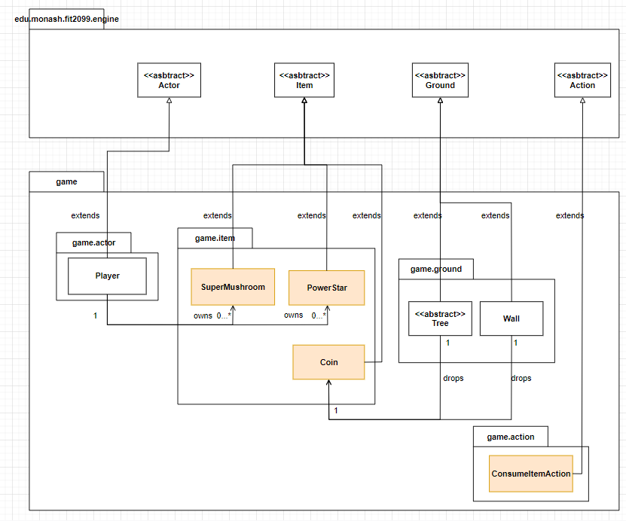

(The screenshot shown above is the UML designed for requirement 4)

## Overview

REQ4 is about adding Magical Items into the game. The items allows the player to consume them and gain extra power and effects so that the player may have an easier time to play the game. There are two Magical Items in the game, they are Super Mushroom and Power Star. Each of them has their own unique abilities that enhances the player experience of playing the game.

#### Super Mushroom (^)

When a player consumes Super Mushroom:

The player max HP is increased by 50 and its current HP is healed to the max. The player’s display character turns to uppercase (m → M).

The player can jump freely with no fall damage and 100% jump success rate.

The effect lasts indefinitely till the player receives any damage (from the enemy). Once the effect wears off, the player’s display character turns back to lowercase (M → m).

#### Power Star (*)

When a player consumes Power Star:

The player does not need to “jump” to higher ground. Instead, the higher ground will be destroyed and turn into dirt.

Destroyed ground drops a Coin (5$).

The player receives immunity and does not take any damage from enemies.

Under the effect of Power Star, a successful attack from the player will always kill the enemy.

Power Star lasts for 10 turns. If within the 10 turns it does not get picked up by a player, it will disappear from the game. If Power Star is picked up by the player, it will last for 10 turns in the player’s inventory, before disappearing from the player’s inventory. When the player consumes Power Star, the effects

written above last for 10 turns only.

## Implementation

#### Super Mushroom

In order to implement Super Mushroom as a Magical Item into the game, a class called

SuperMushroom is created, and it is a subclass of the Item abstract class, as shown below.

public class SuperMushroom extends Item {

/* creates a super constructor since its a subclass

* the implementation continues below

*/

}

Since the SuperMushroom effect lasts for an indefinite time until the player receives damage from enemies, we can utilize the given enum class Status and use it to set the status of the player.

public enum Status {

HOSTILE_TO_ENEMY, // use this status to be considered hostile towards enemy (e.g., to be attacked by enemy) TALL, // use this status to tell that current instance has "grown".

EFFECT_SUPER_MUSHROOM // example, use this status when the player consumes super mushroom

}

We can create a ConsumeItemAction class, and make it a subclass of Action. This class is used for the items to be consumed. Then, we can put an if-condition to check if the item being consumed is a Super Mushroom, if yes, then apply the effects.

public abstract class ConsumeItemAction extends Action {

/*

* if consume SuperMushroom, apply SuperMushroom effects

*

*/

}

The effect last until the player receives damage from the enemies, therefore, we can implement it inside the given AttackBehaviour class because when NPCs attack, they will use this class to generate an

AttackAction instance and remove the effect from the player.

public class AttackAction extends Action {

/*

* ... given code in the class

*/

@Override

public String execute(Actor actor, GameMap map) {

/*

* + given method code ...

*/

/* check if target has EFFECT_SUPER_MUSHROOM

* + if yes, remove the target's status,
  + reset the target's display character to lowerCase
  + deal damage to the target

*/

/*

* + ... code continues below

*/

}

/*

* ... given code in the class

*/

}

Not only that, if the effect hasn’t worn off, the player can jump to any place with 100% success rate and no fall damage will be taken. We can also implement this in the JumpAction class.

public class JumpAction extends Action {

/*

* some code...

*/

/* a method to check if the actor has EFFECT_SUPER_MUSHROOM

* if yes, the actor jumps with 100% success rate
* and does not take any fall damage

*/

}

#### Power Star

In order to implement Power Star class, we would do exactly the same as to how we implemented Super Mushroom.

public class PowerStar extends Item {

/* creates a super constructor since its a subclass

* the implementation continues below

*/

}

Likewise, when a Power Star is consumed, a status will be granted to the player. Unlike the status for Super Mushroom, the status for Power Mushroom must be displayed in the console.

public enum Status {

HOSTILE_TO_ENEMY, // use this status to be considered hostile towards enemy (e.g., to be attacked by enemy) TALL, // use this status to tell that current instance has "grown".

EFFECT_SUPER_MUSHROOM, // example, use this status when the player consumes super mushroom IMMUNITY //example, use this status when the player consumes power star

}

A similar consume class will also be implemented.

public class ConsumePowerStar extends ConsumeItem {

/*

* if consume SuperMushroom, apply SuperMushroom effects
* else, apply Power star effects

*/

}

We can utilize the special status effect to grants the subsequent special effects to the player. For example, under the special effect, each successful attack made by the player is an instant kill to the enemies.

public class AttackAction extends Action {

/*

* ... given code in the class

*/

@Override

public String execute(Actor actor, GameMap map) {

/*

* + given method code ...

*/

/* check if actor has IMMUNITY status, if yes

* + actor damage to target = a very large number,
  + deal damage to the target
  + else, do normal damage target

*/

/*

* + checks if target has IMMUNITY status
  + if yes (that means the target is the actor), actor takes 0 damage
  + else, continue Super Mushroom code above

*/

/*

* ... code continues below

*/

}

/*

* ... given code in the class

*/

}

Furthermore, we can use this status effect to make the jump effect as well. For example:

public class JumpAction extends Action {

/*

* some code..

*/

/* special check for IMMUNITY status

* if yes, actor does not need to jump, move normally to the tile
* sets the ground to dirt, then drop the coin on the ground

*/

}

While high ground will be destroyed and convert to dirt, and drops a coin.

public class Coin extends Item {

/*

* some code...

*/

/* special method for IMMUNITY status

* drops the coin on the ground

*/

}

## Justification of Implementations

#### Super Mushroom — Advantages

The implementation method written above uses several design principles, mainly Open-closed Principle (OCP) and Single Responsibility Principle (SRP).

OCP is used when the SuperMushroom class is created and it is a subclass of the abstract class Item. This way, SuperMushroom will have its dedicated class, thus its own changes will not affect other classes.

Not only that, ConsumeSuperMushroom is a subclass of the ConsumeAction. This also follows the idea of OCP while implementing.SRP is used when the player attacks any enemies after consuming a Super Mushroom. Since

AttackAction class is given, it shall only be used as one single action only. We create an if-statement to check if the player has the effect status, if yes, the player’s attack action is modified.

This if-statement is not and shouldn’t be placed in the SuperMushroom class because it’s an AttackAction, therefore it should be grouped and placed within the AttackAction class.

The special effect when consuming a Super Mushroom is placed inside the given enum special class. This prevents excessive use of literals, which will make the code extra messy.

#### Super Mushroom — Disadvantages

NA

#### Power Star — Advantages

Similar to the advantages of the implementation method of Super Mushroom, OCP and SRP design principles are also used when implementing Power Star item. OCP is used when a dedicated

PowerStar class is created, and also ConsumePowerStar subclass is created, and SRP is also used when the attack action is modified and placed inside AttackAction class, with similar reasoning written

above. The special effect of Power Star is also created with the same reason written on the Justification of implementation of Super Mushroom.

#### Power Star — Disadvantages

NA

# REQ5: Trading 💰

## Design Implementation

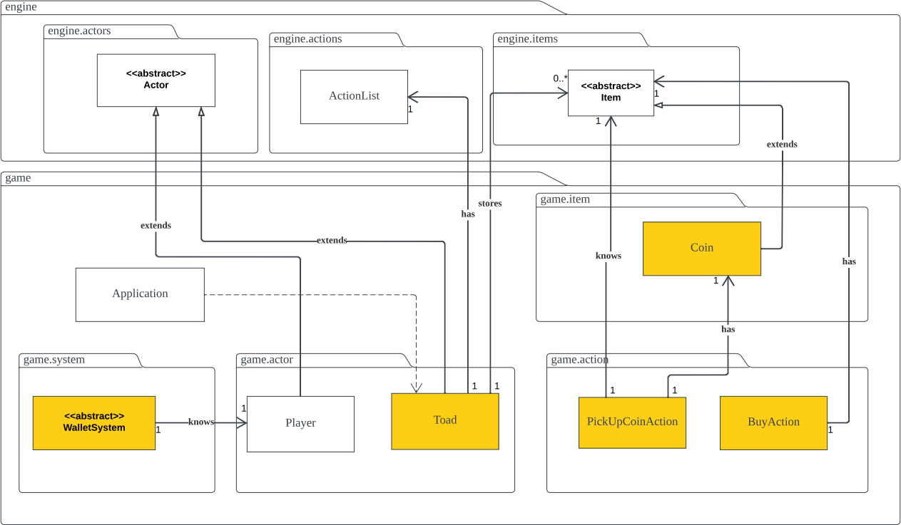

(The screenshot shown above is the UML designed for requirement 5)

### Toad:

1. A friendly actor which serves a purpose of selling items to the player.
2. Since Toad is selling the 3 items (Wrench, Super Mushroom and Power Star) , therefore instead of creating 3 separates arrayList that stores each of those items, I have decided to create a HashMap that stores the items that the Toad is currently selling together with the price of the items. By doing so, we are adhering to the Dependency Inversion Principle and also the Liskov Substitution

Principle.

1. Toad will also add an instance of BuyAction into its allowableActions method so that when a player approaches the toad in the gameMap, they can use the BuyAction to buy the items that the toad currently has , provided that the player has sufficient wallet balance.

### PickUpCoin:

1. An action that a player can take when encountering a coin on the ground.
2. I have decided to create this PickUpCoinAction class instead of using the default PickUpItemAction implemented in the engine class is due to the fact that the PickUpItemAction in engine will basically stores the item that is picked up into the player’s inventory. However, this is not the case for coin

items. Instead of storing them into the inventory , I will add the values of the coin into the player’s wallet balance.

### BuyAction:

1. An action that a player can take to buy items from Toad.
2. Inside the execute method of the BuyAction class, it will check whether the player’s wallet balance is sufficient to buy those items from Toad , if it does then the item will be added into the player’s

inventory and the wallet balance will be deducted. However, if the player’s wallet balance is insufficient then a message will be printed in the console.

### WalletSystem:

1. The purpose of creating a WalletSystem class is to allow us to keep track of the player’s balance as well as allow us to add to player’s balance when the player collected some coins and also to allow the player’s balance to be deducted from the wallet when the player is buying items from the Toad.
2. This class is declared as abstract because we will not create any instance of type WalletSystem. This helps to achieve abstraction.

### Relationship:

1. Dependency relationship between Application and Toad is because we need to create a new instance of Toad and add it into the gameMap.
2. Association relationship between Toad and ActionList is because we need to add a new BuyAction instance to the ActionList in the Toad’s allowableActions method.
3. Association relationship between Toad and Item is because we need to have a HashMap that stores Item instances together with the cost of the item.
4. Association relationship between BuyAction and Item is because we will have an Item attribute

which needs to be initialised in the BuyAction constructor so that player can know which items are available for them to buy from the Toad.

1. Association relationship between WalletSystem and Player is to ensure that each wallet can only belong to that particular player.
2. Association relationship between PickUpCoinAction and Item is because we need to have an attribute of type Item which needs to be initialised in the PickUpCoinAction constructor . This item argument will be passed when the Coin class adds the PickUpCoinAction instance into the addAction method.
3. Association relationship between PickUpCoinAction and Coin is because we need to extract the value of the coin so that we can pass the coin value to the addWalletValue method in the

PickUpCoinAction’s execute method so that we can increase the wallet balance of the player when the coin is picked up.

# REQ7: Reset Game

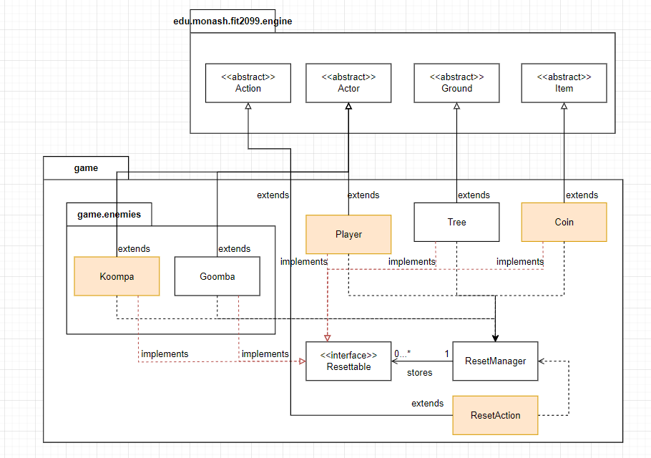

(The screenshot above shows the UML class diagram for requirement 7)

## Overview

The player sometimes wish to reset the game. The game can only be reset once every game. If the game is reset, the following will happen:

Trees have 50% chance to be converted back to dirt. All enemies are killed.

Player status is reset. (remove Super Mushroom/Power Star)

Player’s HP is healed back to maximum.

All coins are removed from the ground. (Super Mushroom and Power Star may stay)

## Implementation

There are two classes given already in the game package, Resettable interface and ResetManager. We can use these classes to implement resetting the game.

We can start making the classes that are required to be reset implements Resettable interface. This is because Resettable interface has its own way to keep track of which class needs to be reset. For example:

public class Tree extends Ground implements Resettable {

//code continues

}

Then, we can overwrite the methods implemented so that when it runs, it will reset the classes to its respective status.

There is a run() method in ResetManager class. We can put the reset methods inside the run() method, thus when we run the run() method, all the classes needed to be reset will be reset together through just one method call.

public void run(){

/*

* runs all the instances's reset method

*/

}

A ResetAction class is created to execute the run() method.

public class ResetAction extends Action{

// runs the ResetManager run() method

}

## Justification of Implementations

#### Advantages

The reason why we implements Resettable interface on the required classes is because the classes

implemented the interface will automatically be “recorded” inside ResetManager class. This allows the classes to be grouped together and therefore be reset together once and for all. This utilizes Single

Responsibility Principle (SRP), Open-closed Principle (OCP) and Interface Segregation Principle (ISP).

Using these principles allow us to create and modify classes without affecting other classes. Moreover, using interface for implementation allows us to not creating the same method over and over again in other classes as we can just overwrite the method coded in the interface.

***Disadvantages***

NA

# UML Class Diagrams

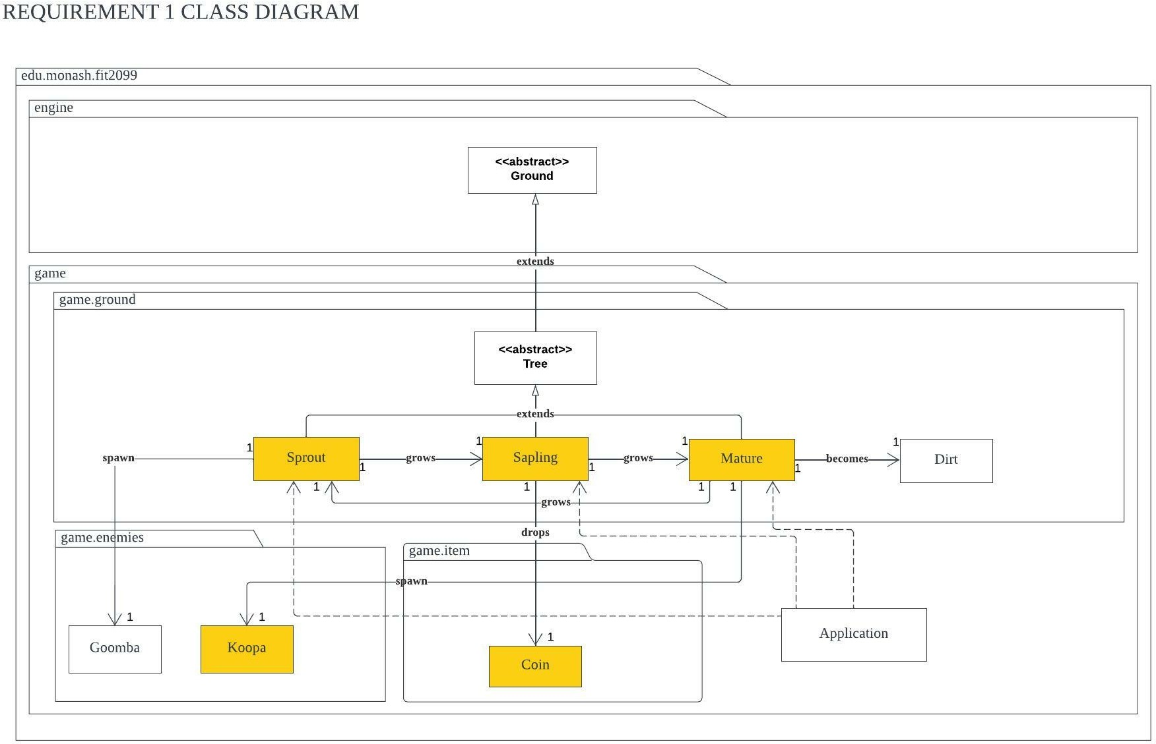

Requirement 1 Class Diagram

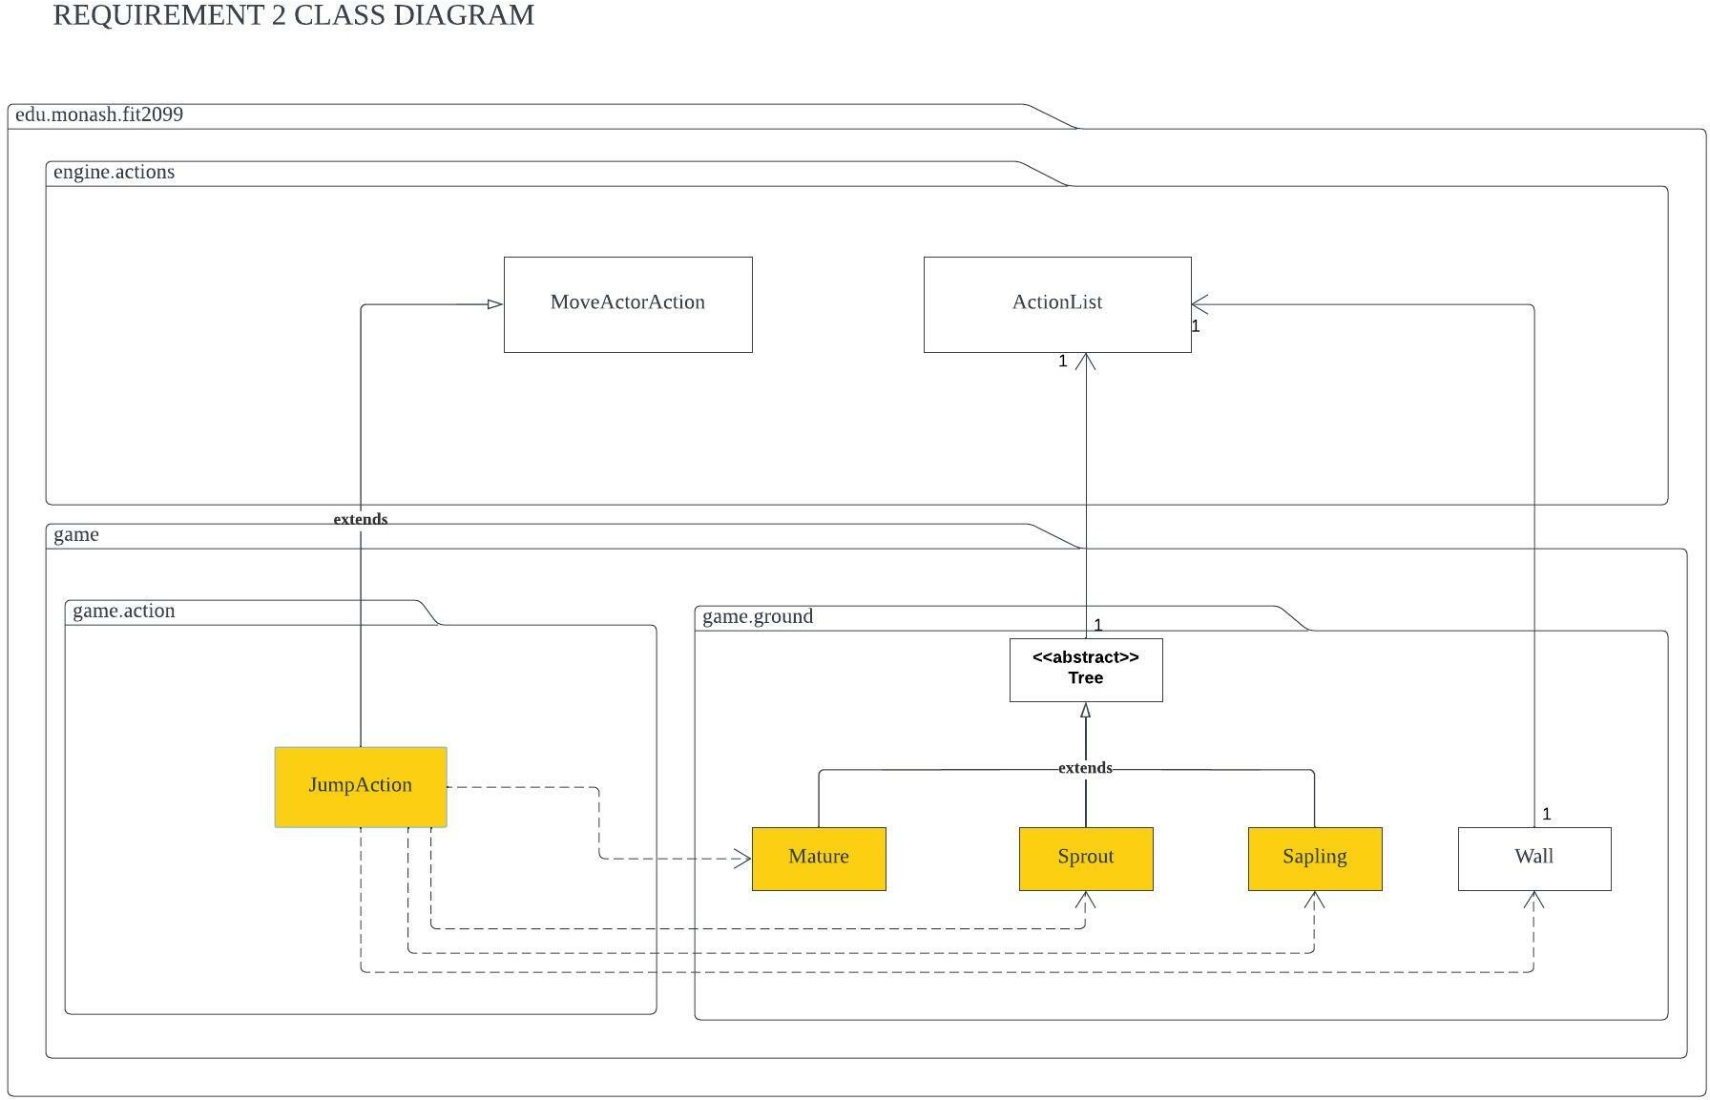

Requirement 2 Class Diagram

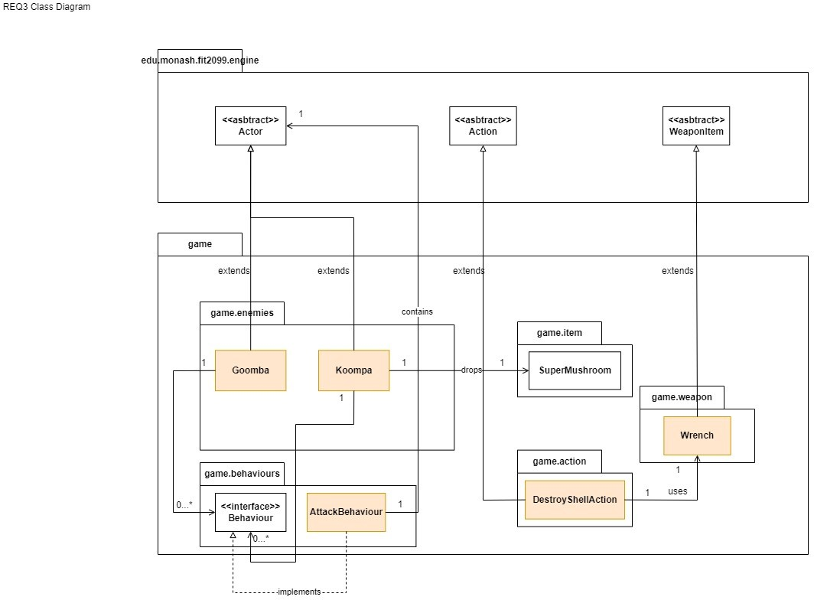

Requirement 3 Class Diagram

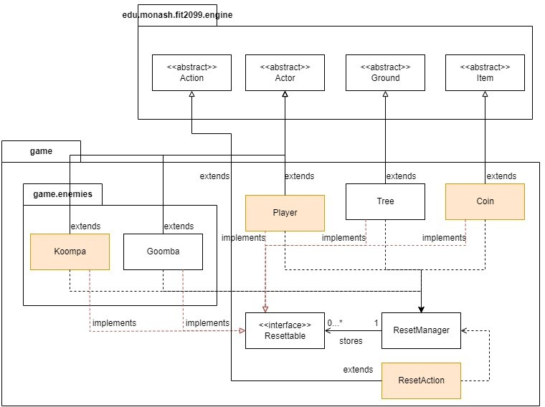

Requirement 4 Class Diagram

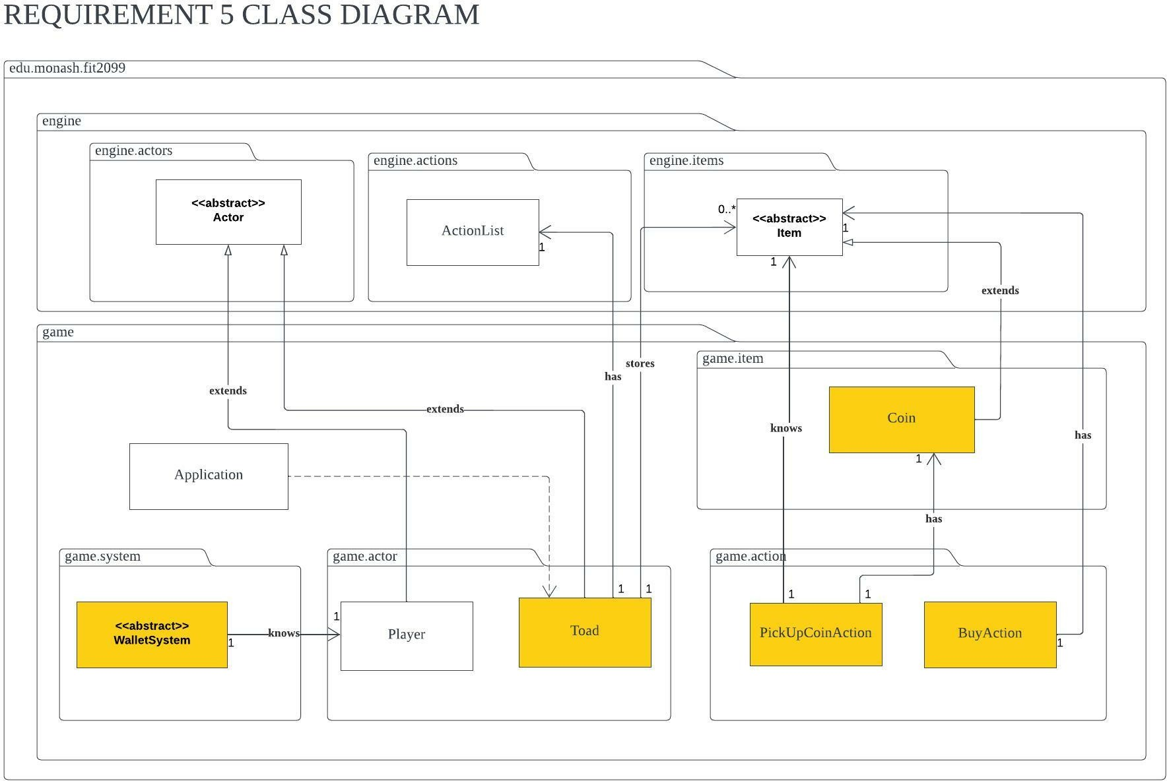

Requirement 5 Class Diagram

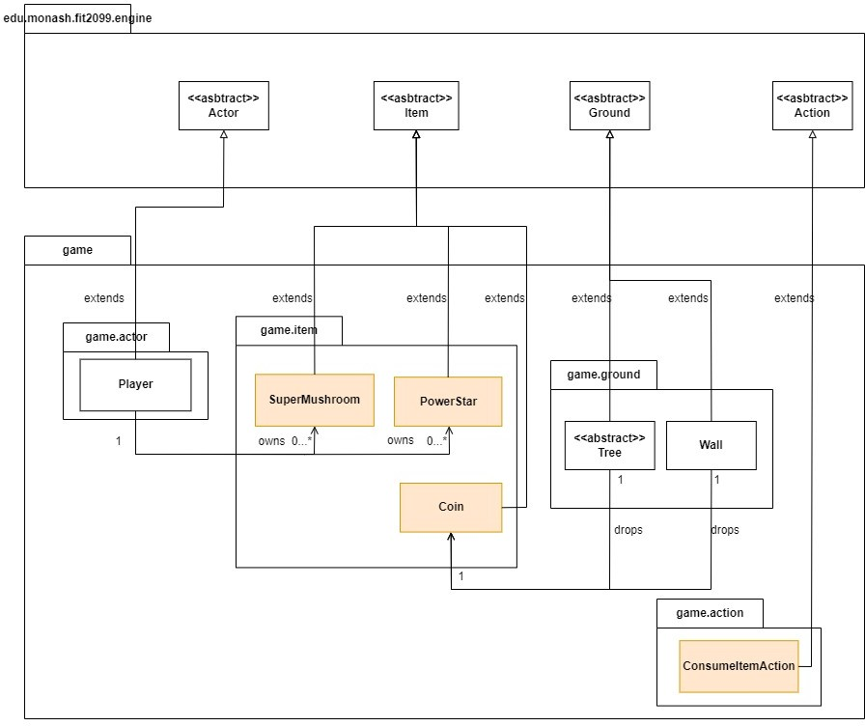

Requirement 7 Class Diagram

# Interaction Diagrams

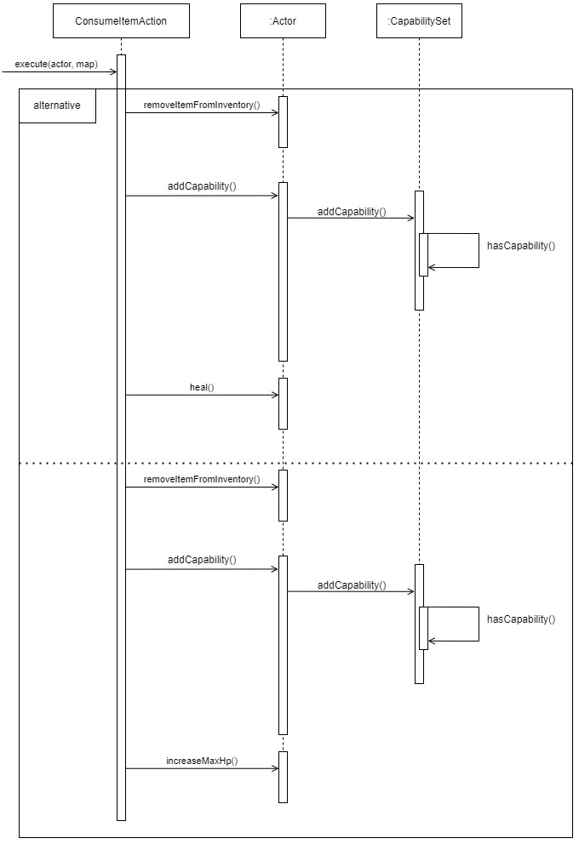

Sequence Diagram for ConsumeItemAction

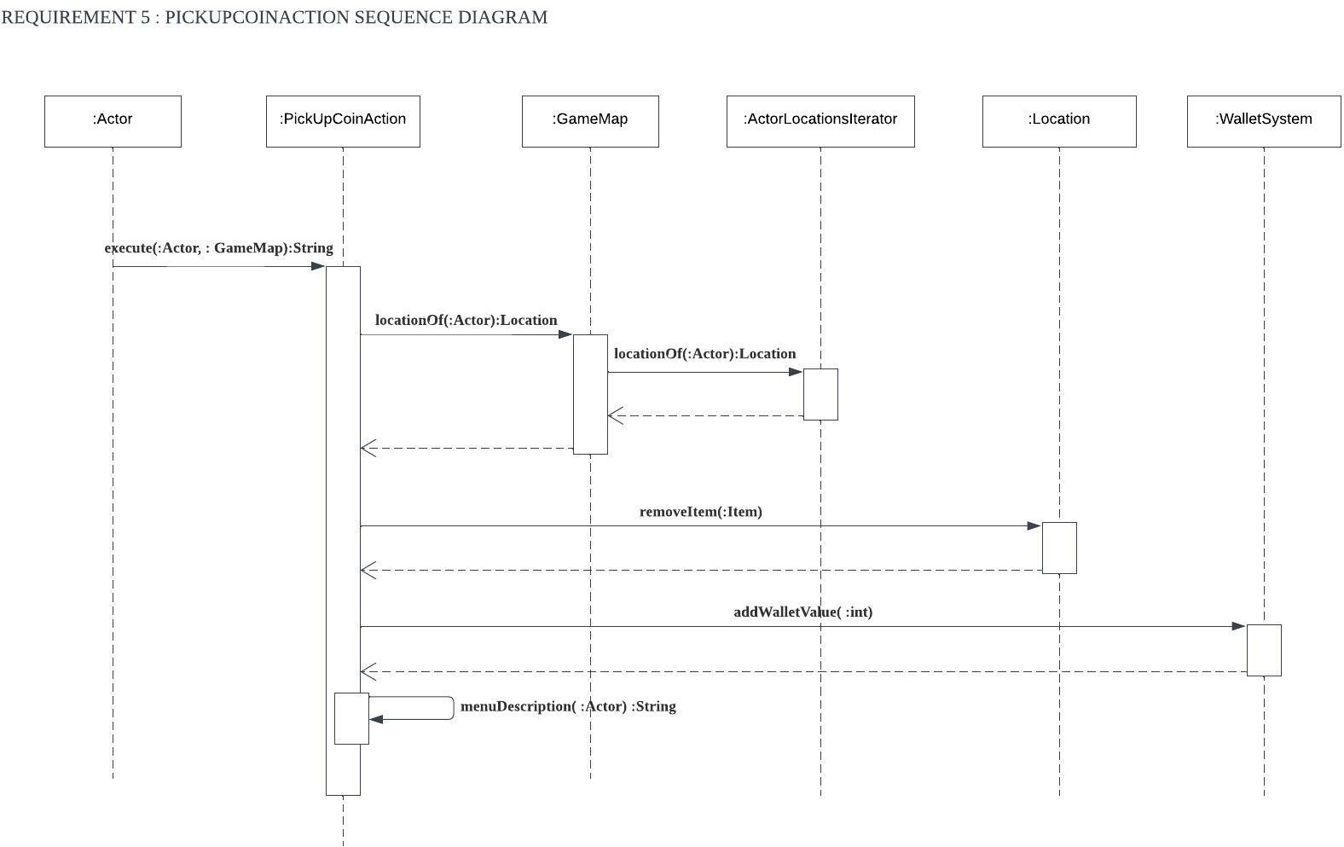

Sequence Diagram for PickUpCoinAction