Senhub PRTG Ekara sensor
Deployment guide

Release 1.0.1.4
June 28, 2024

Notice
The information contained in this document is believed to be accurate in all respects but is not warranted by Sensor Factory Corporation.
The information is subject to change without notice and should not be construed in any way as a commitment by Sensor Factory or any of its affiliates or subsidiaries. Sensor Factory and its affiliates and subsidiaries assume no responsibility for any errors or omissions in this document. Revisions of this document or new editions of it may be issued to incorporate such changes.

No part of this document can be reproduced or transmitted in any form or by any means - electronic or mechanical - for any purpose without written permission from Sensor Factory.

Trademarks
Senhub, Hibouvision and Sensor Factory logo are trademarks of Sensor Factory SAS Corporation.
Ekara and IP-Label are trademarks of IP-Label SA Corporation
PRTG and Paessler are trademarks of Paessler AG Corporation.
Windows and Microsoft are trademarks of Microsoft Corporation.
Other product names mentioned in this document may be trademarks of their respective companies and are hereby acknowledged.

© Copyright 2023, Sensor Factory SAS Corporation
All rights reserved
Senhub PRTG Ekara sensor — On premise deployments
Release 1.0.1.4 - June 28, 2024

Content

1. Introduction 4
Version compatibility table 4
Good to know 5
2. Deployment of the sensor 6
2.1. Getting sensor ZIP file 6
2.2. First Execution 7
2.3. Setting up the license key 8
3. Setting up your sensor 9
3.1. Before starting 9
Best practices 10
Ekara credentials 10
3.2. Parameters 10
Parameters tab 10
3.3. Example 1: Application metrics 11
3.4. Example 2: Scenario metrics 14
4. Logging and debug 16

Introduction
The Senhub PRTG Ekara sensor is an on premise version of the Senhub Ekara cloud connector customized for PRTG users.
It allows you to collect data from the Ekara solution whether it is hosted by IP-Label or on an on premise platform deployed on your own IT infrastructure.

The specifications and capacity of this sensor are strictly identical to the cloud version.

Deployment of the Senhub PRTG Ekara Sensor requires the use of the EXE/Script Advanced Sensor on a PRTG device, regardless of the device and its IP.

You can refer to the PRTG manual to plan your deployment with this reference: https://www.paessler.com/manuals/prtg/exe_script_advanced_sensor

The use of the Senhub PRTG Ekara sensor requires a license key issued by the Senhub sales team. Reading and following this guide will help you to easily deploy this sensor.

Version compatibility table

IP Label regularly improves and enriches the Ekara solution. If necessary, the APIs of the solution are also modified. The Senhub PRTG Ekara connector relies on the Ekara APIs to collect metrics, so it is necessary to make sure that the executable used on your PRTG platform is compatible with the new version of Ekara before considering any update. The risk is that the collection of metrics will not work until the Senhub PRTG Ekara connector is updated to the new version.

To know your executable version you can type the following command in a windows console:

senhub_prtg_ekara.exe -about

Senhub PRTG ekara version | Ekara version
v1.0.1.0 | v2.41.0
v1.0.1.3 | v2.41.0
v1.0.1.4 | v2.41.0

Good to know

- PRTG is not known for its compliance with special characters. We therefore recommend that you do not use special or accented characters in your application, scenario or step names.
- After creating a new scenario and starting to monitor your application, retrieving data from Ekara using its APIs can take half an hour to an hour depending on how often the scenario is run.

Deployment of the sensor

Getting sensor ZIP file

The first step is to get senhub_prtg_ekara.zip from your Senhub contact.

This archive contains 2 files: senhub_prtg_ekara.exe and sfs_ekara_status.ovl.

The exe file must be placed in the Custom/Exe folder of the PRTG probe from which you want to query your Ekara platform.

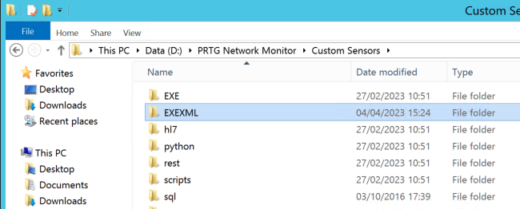

Custom/EXE folder

The .ovl file is a definition file that helps translate the scenario status code into a human readable status. This file should be placed in the lookups/custom folder of your PRTG Core folder.

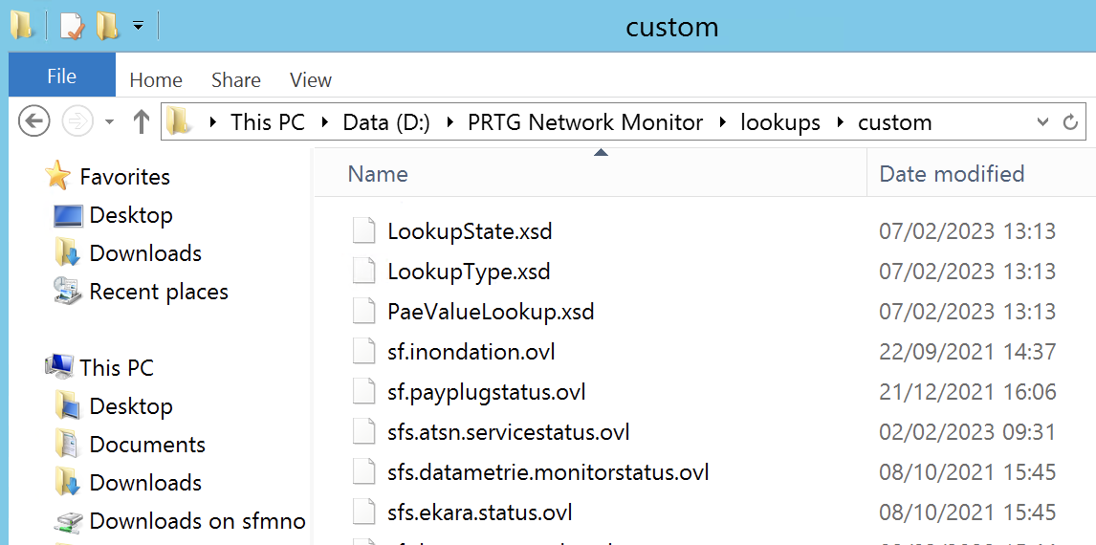
.ovl folder

First Execution

Open a console and change directory to your Custom/Exe folder.

Launch senhub_prtg_ekara.exe without any parameter.

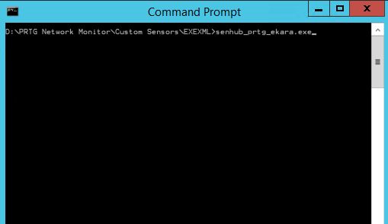

First execution will create a new file: senhub_prtg_ekara.ini: the file contains all parameters that can be used to request the Ekara solution, your license infos and logging configuration if needed.

Setting up the license key
Once the first execution is done, the .ini file contains a unique license server identifier (license_server_id) that will be used to generate your license key.

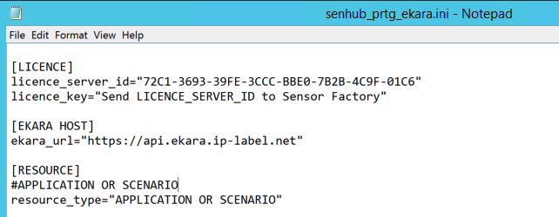

Just send it by email to contact@senhub.io with "[SENHUB LICENSE]" in the subject line and you will receive your license key very shortly.

After receiving your license, you can save it in the license_key parameter of the .ini file and start using your sensor.

Setting up your sensor

Before starting
There are two ways to configure your request to your Ekara platform: the .ini file and runtime parameters.

The first one is to save parameters in the .ini file. Using this way will allow you to omit all registered parameters in your PRTG request. Those parameters will be used by default.

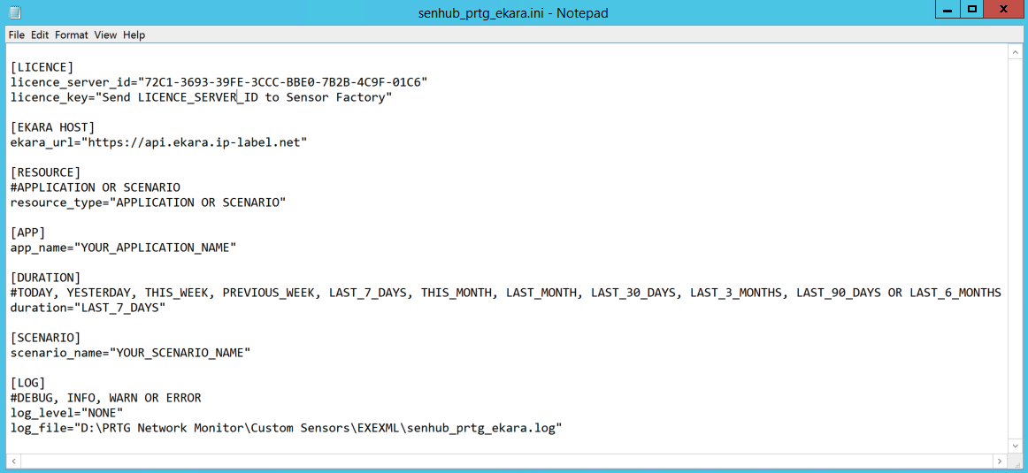

But you can always override them when you call the sensor exe file with the runtime parameters.

Example:

D:\PRTG Network Monitor\Custom Sensors\EXEXML>senhub_prtg_ekara.exe -ekara_url “https://api.ekara.myownekarahost.com”


It will force the sensor to query api.ekara.myownekarahost.com instead of api.ekara.ip-label.net host.

Best practices
Unless you only have an application and/or scenario to request, only the license, Ekara host and log section should be set in the .ini file.

Ekara credentials
To access the Ekara APIs, it is necessary to authenticate to the Ekara host using two parameters: an email address and a password. For security reasons, those credentials cannot be stored in the .ini file and will always be runtime parameters. They can be stored securely using the "placeholder" function of PRTG.

Parameters
As seen before, the identification and authentication information must be passed on the command line and cannot be stored in the .ini file.

Example of query:

senhub_prtg_ekara.exe -ekara_url “https://<your ekara host address>” -ekara_email “<your email account>” -ekara_password “<your account password” -resource_type “[APPLICATION] or [SCENARIO]” -app_name “<your application name>” -duration “[Refer to the table of parameters]” -scenario_name “your scenario name”


Parameters tab

Parameter | Description | Value
about | Returns the server id, the subscribed maintenance end date and the version of the Senhub PRTG Ekara connector.
ekara_url | By default, it is recommended to set up this parameter into the .ini file. But you can override this parameter if you need to request a different Ekara host. | Expected format is:  https://<your ekara host address>
ekara_email | This is the email account requested to login into Ekara solution.
ekara_password | This is the password of your Ekara account.
resource_type | There are 2 types of resources for which we can collect metrics. | APPLICATION or SCENARIO
app_name | This parameter is always mandatory and allows to retrieve the metrics for the specified application. | Collected from your Ekara console interface
duration | Application metrics are calculated on a time basis by Ekara. By default, the metrics are calculated over the last 7 rolling days. | TODAY,  YESTERDAY,  THIS_WEEK,  PREVIOUS_WEEK,  LAST_7_DAYS,  THIS_MONTH,  LAST_MONTH,  LAST_30_DAYS,  LAST_3_MONTHS,  LAST_90_DAYS OR LAST_6_MONTHS
scenario_name | Required if you select SCENARIO as resource_type. | Collected from your Ekara console interface

Example 1: Application metrics

The first step is to get the application name from your Ekara platform.

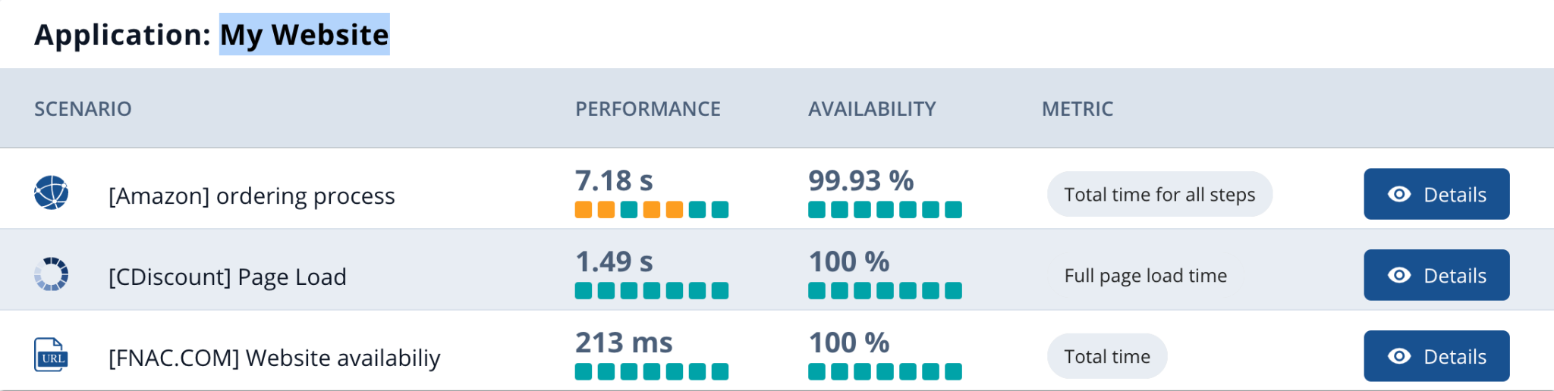

In this example our application is called “My Website”.

Here is the command line to request this resource.

senhub_prtg_ekara.exe -ekara_email “<your email account>” -ekara_password “<your account password” -resource_type “APPLICATION” -app_name “My Website” -duration “LAST_7_DAYS”


In the PRTG console, you can create an "EXE/Script Advanced" sensor with the following parameters:

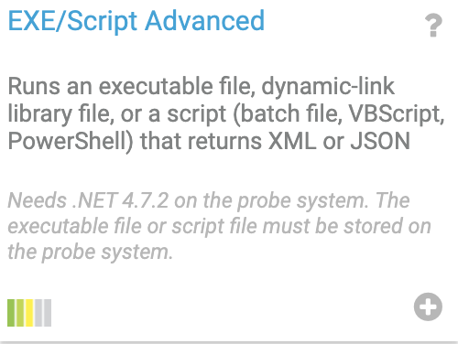

PRTG custom script sensor

We recommend using the PRTG placeholders to store your credentials securely.

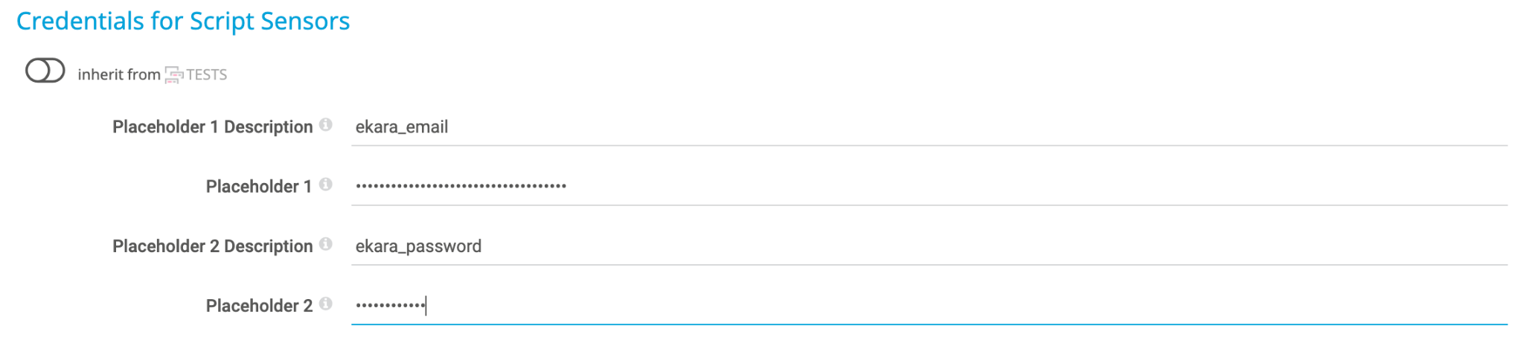

This can be configured in the device settings tab.

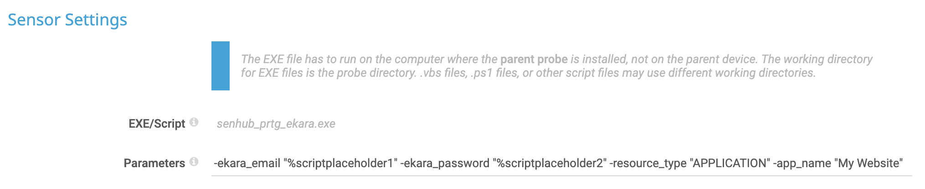

Sensor settings

Here is the rendering in PRTG:

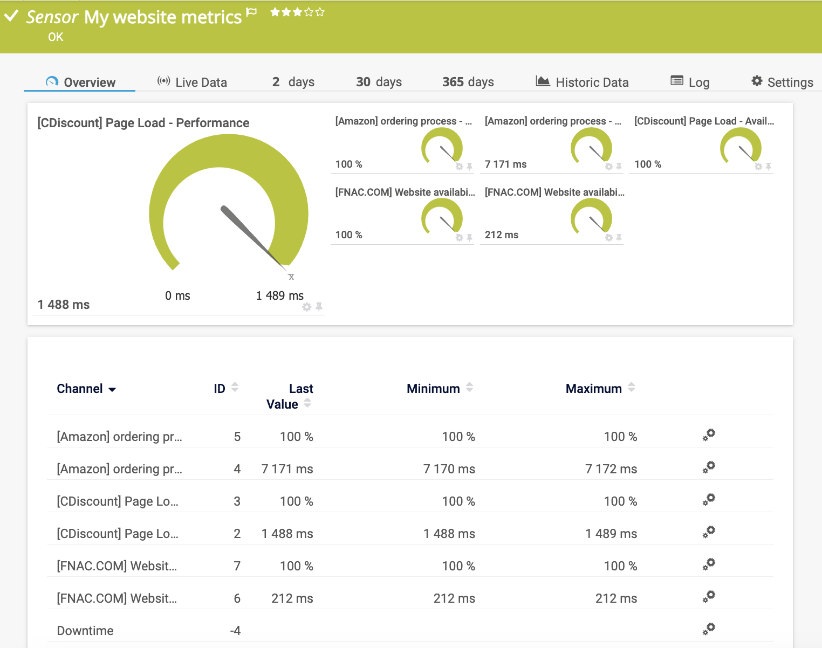

Example 2: Scenario metrics

First, when you want to retrieve metrics for a specific scenario, you must fill in the resource_type entry with "SCENARIO" in your query.

Next you need to precise a scenario name in the scenario_name entry.

Depending on the type of scenario, you will get the corresponding metrics.

As a reminder, a scenario can be of type "Total time for all steps", "Full page load time" or "Total time".

As in example 1, the first step is to retrieve the information from your Ekara console: the name of the application and the name of the scenario.

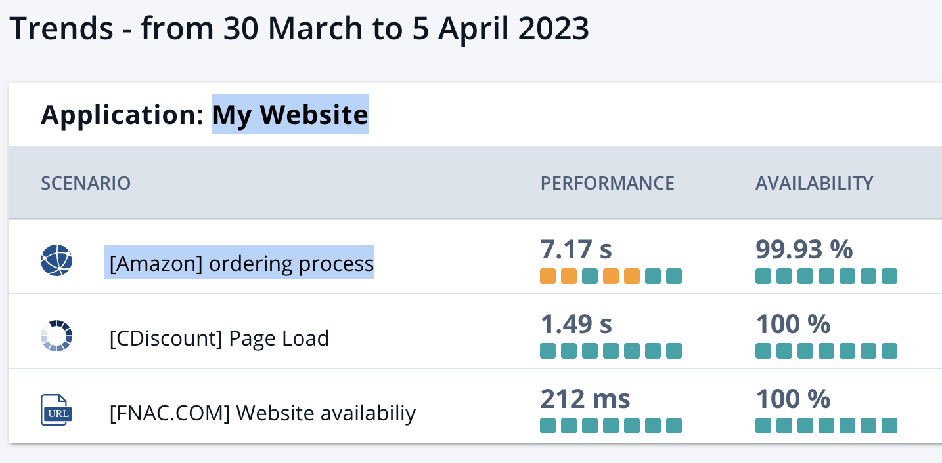

In this example our application is called “My Website” and the scenario “[Amazon] ordering process”

Here is the command line to request this resource.

senhub_prtg_ekara.exe -ekara_email “<your email account>” -ekara_password “<your account password” -resource_type “SCENARIO” -app_name “My Website” -scenario_name ”[Amazon] ordering process”

Please note that the duration parameter is not necessary because this query retrieves the metrics for the last execution of the scenario.

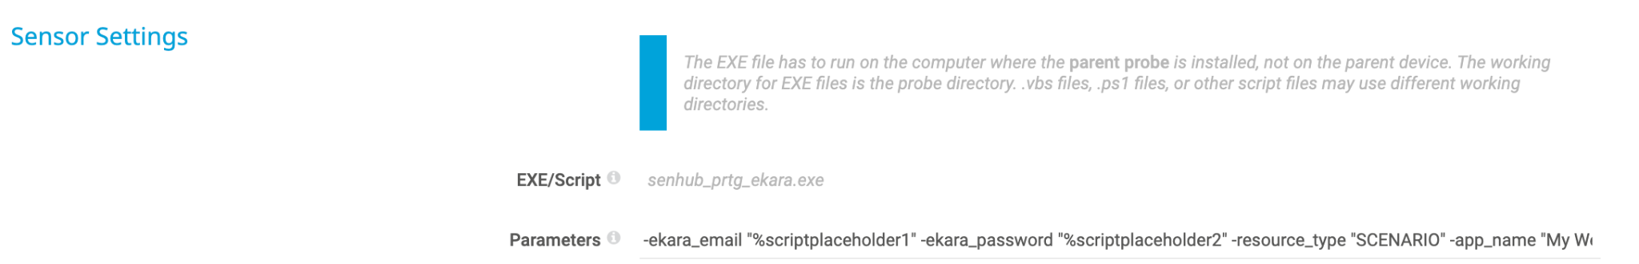
Sensor settings

Here is the rendering in PRTG:

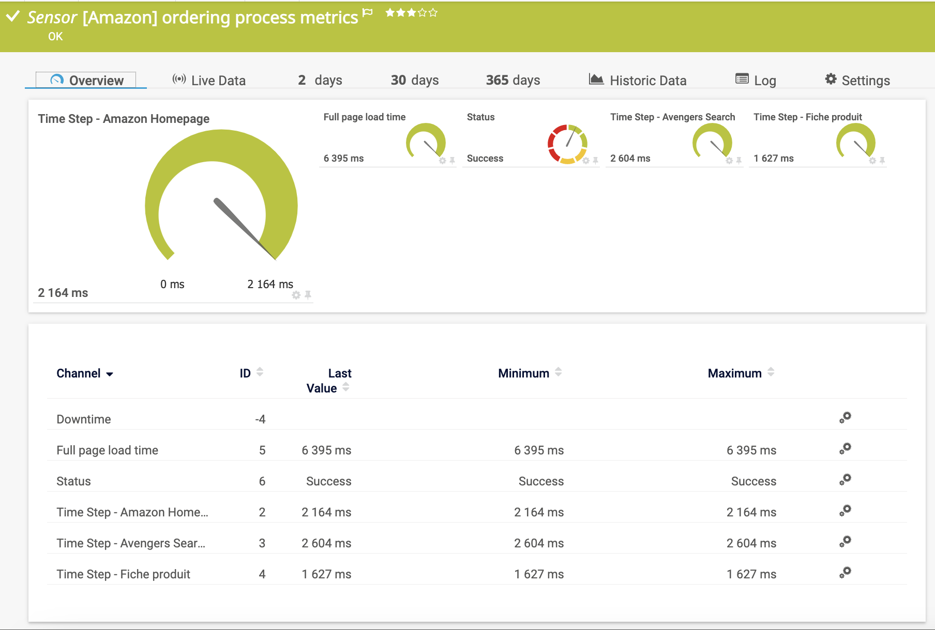
Scenario metrics in PRTG

Logging and debug
The sensor exe file can record traces of its executions in a log file to help you troubleshoot metrics recovery.

In the .ini file, logs can be enabled by changing the "log_level" parameter.

By default, the log file is created in the same folder of the .exe file. You can change its path with the “log_file” parameter.

The sensor controls the rotation of its own log. Only 5 log files of 1 MB can be generated. The current log file is always the one without a number in its filename extension.

Very important: The DEBUG level reveals the entire execution context, with all parameters and ekara platform response. So only use this mode knowingly, disable it as soon as your problem is solved and delete the log file so that nobody can reuse those informations.

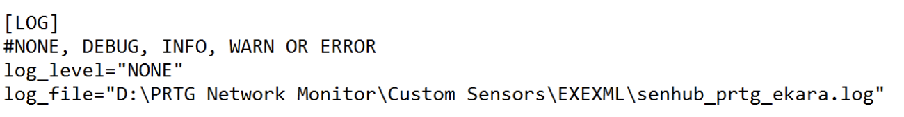
Log section

- End of document -

