**Documentation**

**Gamification**

**Application**

**-**

**Senila Constantin**

**Student**

**Faculty of Automations and Computer Science**

**Computer Science Department - 4th year**

1. **Introduction**

The application can be used by iOS users and each users must have different accounts. After creating an account, the user will log in the application and can propose or solve quests.

1. **Features**

For this project I made a gamification application in which you can connect through the application an create an account, but this only possible from Postman since the view part for registration is not done. The user is shown the number of badge, tokens and his ranking. A user cand add a quest provided that the numbers of tokens that quest has is at least the number of tokens available on his account. For each quest added by the user, the number of tokens that the added quest has will be deducted from his account. For each quest added, the user receives from the number of badges and tokens from that quest. The ranking part is taken according to the number of badges owned by each user, the user with the largest number of being on 1st.

Fig. 1. Database diagram

1. **Interface**

Bellow are the application screens:

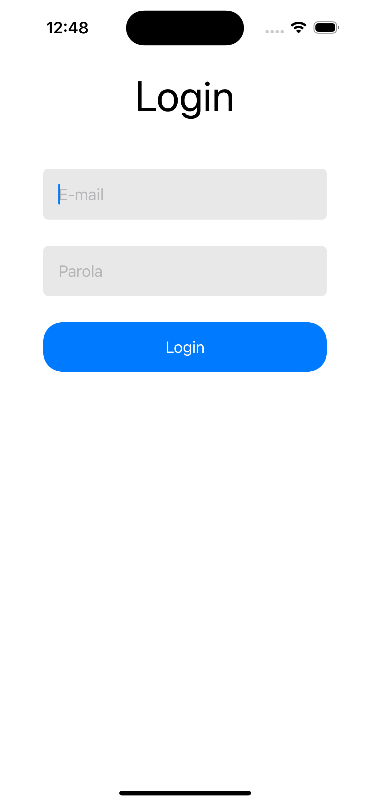

1. **Technologies used**

The implement this application I use the Java backend part with Spring where I implemented the security part and the application functionalities. I used PostgreSQL for the database where I stored the user data and quests. For the frontend side I used Swift where I implemented an application available for Apple phones and iPads.