You have to add the dataset in Data folder like this.
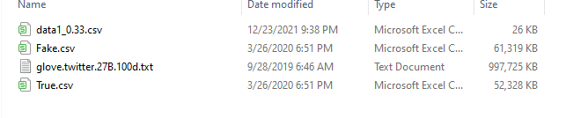
Fake.csv and True.csv can download from https://www.kaggle.com/clmentbisaillon/fake-and-real-news-dataset.
And the glove.twitter.27b.100d.txt can download from https://www.kaggle.com/bertcarremans/glovetwitter27b100dtxt.
And the data1_0.33.csv are given.
After add these files in Data folder, you can run two jupyter file Question1.ipynb and Question2.ipynb

