Question 1. NLP
- Train Model with L2 Regularization
In this question, we have used the Fake and Real news dataset which given https://www.kaggle.com/clmentbisaillon/fake-and-real-news-dataset.
First, we have to import required libraries and dataset. This dataset hase two class ‘Real’ and ‘Fake’. The first five records for each class are given Figure 1 and Figure 2.

Figure 1. Five records of real class

Figure 2. Five records of fake class
Since the train ML model takes long time, it is recommended to use GPU. Hence, check the GPU by tf.test.gpu_device_name().
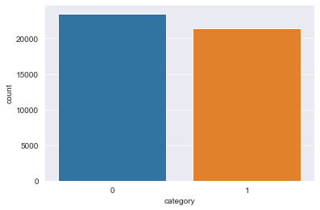
Figure 3. Number of records each class
Figure 3 shows the number of records for each class. From this figure, we can see that the are alomst same records for each class and we can apply ML without any SMOTE.
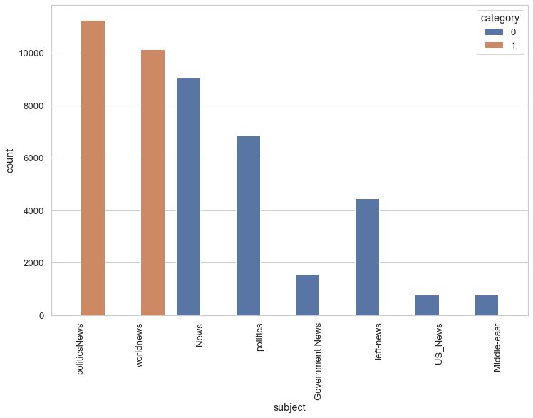
Figure 4. Counter for each subject
Figure 4 shows the number of subject. This category doesn’t use for this project only for visualization.
Each record have two useful catecory title and text. Since our goal is to build the model classify the records to real and fake, we have combined these two categories and remove other unuseful categories such as subject, date.
Now, we have to split the dataset for train and test.
df_train, df_test = train_test_split(df,random_state = 0)

df_train is the dataset for training and df_test is the datast for test. The information of eah dataset are given Figure 5. There are 33673 records in trainin dataset and 11225 records in test dataset.
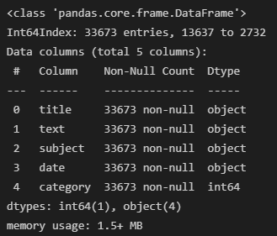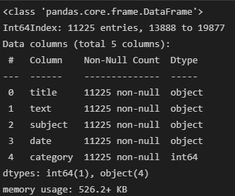
- b)
Figure 5. The infomations of train and test datsaet
Following the guidence, we have to use the pre-trained embedding layer(https://www.kaggle.com/bertcarremans/glovetwitter27b100dtxt). This dataset contain 100-dimensional word embeddings of tweets.
NLP need to vectorize doc, hence we have converted text to vectors. Now we can build the model using converted train and test dataset.
First we have to build the model with at least three hidden layers. To select the best units of hidden layers and learning rate, we have prepared some combinations and calculate the performance for test dataset.

Table 1. Test Accuracies for various parameters
No | Number of Units in Layer1 | Number of Units in Layer2 | Learing Rate | Accuracy(%)
1 | 128 | 64 | 0.05 | 60.097
2 | 128 | 64 | 0.01 | 72.901
3 | 64 | 32 | 0.05 | 90.477
4 | 64 | 32 | 0.01 | 96.703

Table 1 shows the test accuracies for various combination of hyperparameters. From this table, (64, 32, 0.01) are selected as the best hyperparamters. The model build using this hyperparameters are given bellow.
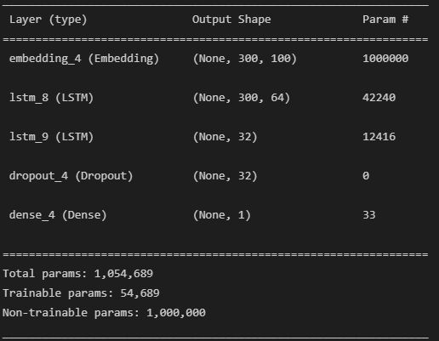
Figure 6. Summarization of selected best model
The training and test accuracies of selected model are 99.15% and 99% respectively. The model trained with 5 epochs and Figure 7 shows the training , validation accruacies and losses.
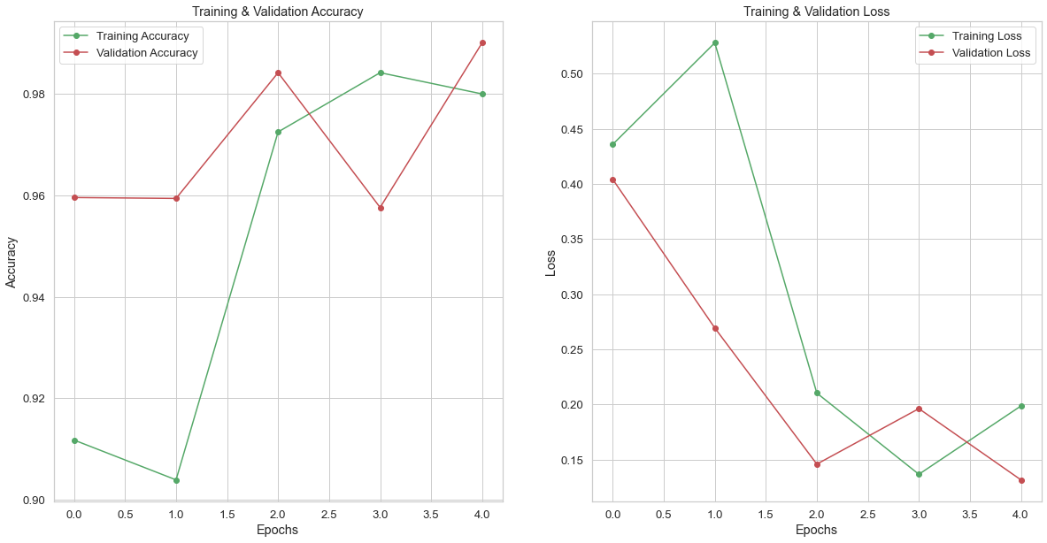
Figure 7. Training and Validation Accuracy and Loss
Figure 8 shows the confusion matrix of selected model. From this, we can compute the precision, recall, F1-score and supposr.

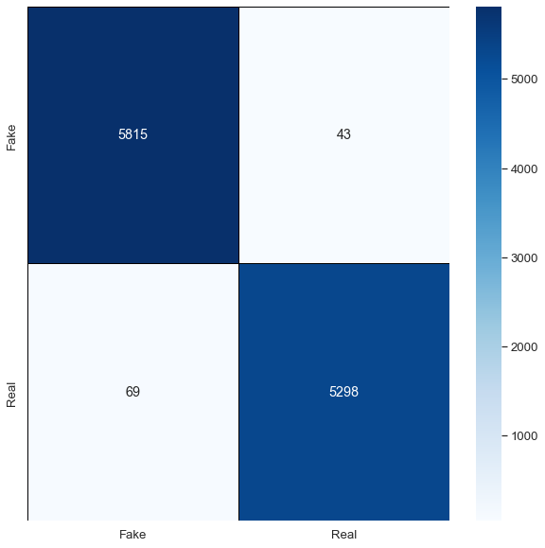
Figure 8. Confusion Matrix of Seleted Model
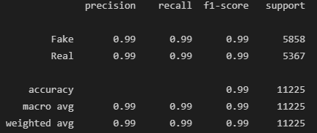
Figure 9. Classification Report
- Train Model without regularization
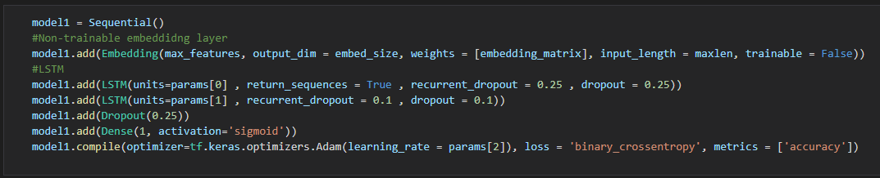
The training and test accuracy of the model without regularization are 99.94% and 99.77%. The same hyperparameters are used with first model.
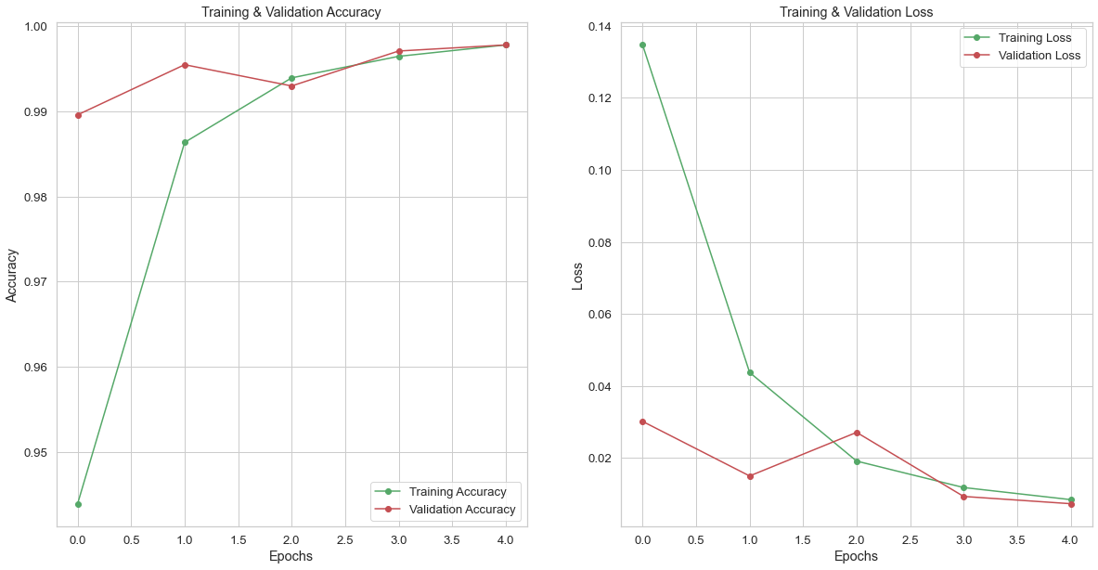
Figure 10. Training, Test Accuracy and Loss of the Model without Regularization
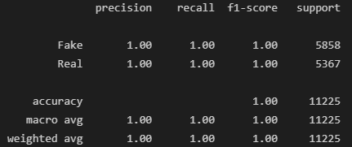
Figure 11. Classification Report of the Model without Regularization
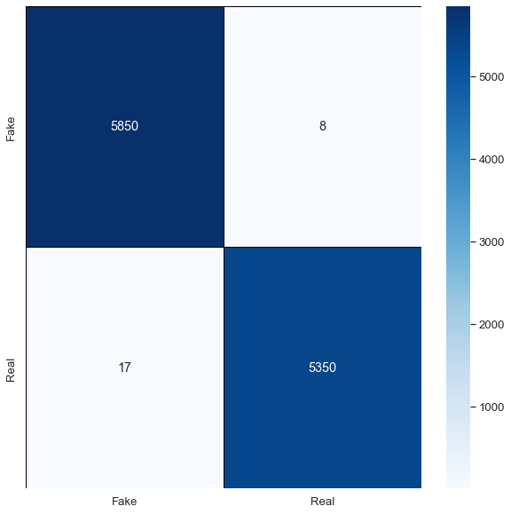
Figre 12. Confusion Matrix of the Model without Regularization
- Train the model with change the position and value of dropout layer
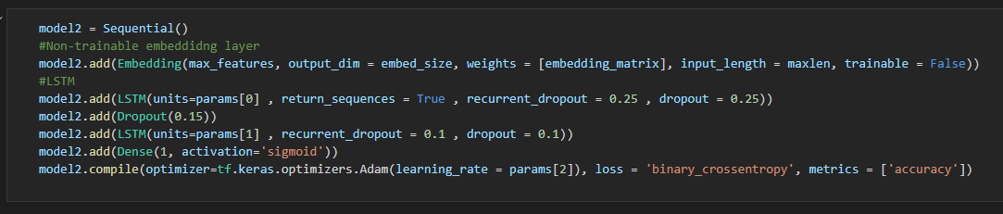
The training and test accuracy of the model without regularization are 99.91% and 99.72%. The same hyperparameters are used with first model.
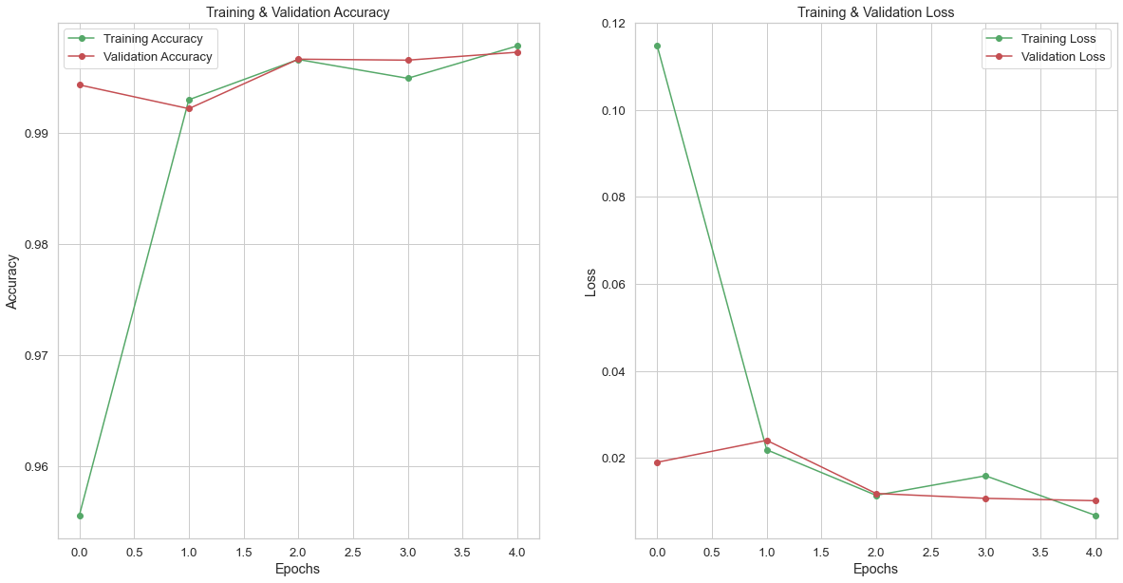
Figure 13. Training, Test Accuracy and Loss of the Model with Different Dropout Position and Value
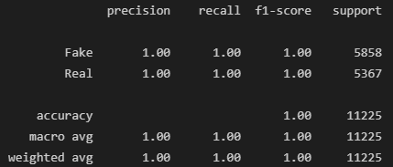
Figure 14. Classification Report of the Model of the Model with Different Dropout Position and Value

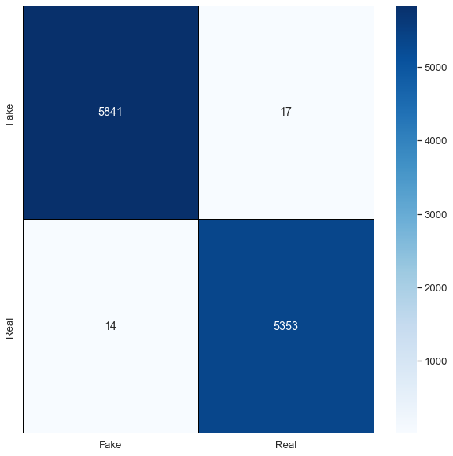
Figre 15. Confusion Matrix of the Model of the Model with Different Dropout Position and Value
- Compare Models

Table 2. Accuraceies of Models
Model | Train Accuracy | Test Accuracy
Model with Regularization | 99.153626 | 99.002224
Model without Regularization | 99.943572 | 99.777281
Model with Different Dropout Poistion and Value | 99.910909 | 99.723828

Table 2 shows the accuracies of three models. As we can see easily, the training and test accuracies are over 99% and three models are well fit the given dataset. The model without regularizaion has the highest train and test accuracies. These three model used the same hyperparameters (64, 32, 0.01).
Question 2. Build Model with Simple Dataset
Dataset: data1_0.33.csv
First, we have to load the dataset. This dataset have two features and two classes.
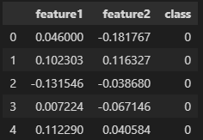
Figure 16. Five records of dataset
Figure 17 shows the number of records for each class. From this figure, we can see that the are alomst same records for each class and we can apply ML without any SMOTE.

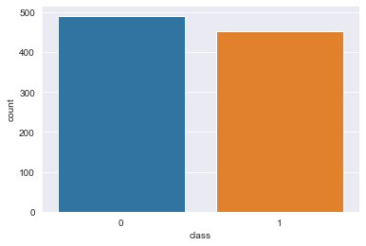
Figure 17. Number of records for each class
Now, we have split the dataset as training and test with proportion 70% vs 30%.
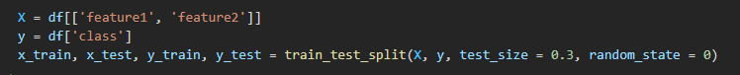
To build the model, we have pre-defined the hyperparameters like below:
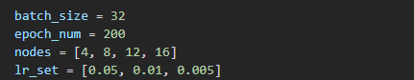
We have set the various number of nodes and learning rate to find the best hyperparameters.
- Single Hidden Layer Model
In this section, we have built the single hidden layer model for given dataset. To find the best hyperparameters we have pre-defined the various number of nodes and learning rate, then calculate the test accuracy and select the hyperparameters given highest test accuracy.
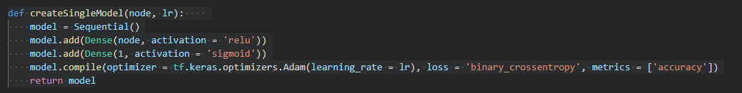
Figure 18. Single Hidden Layer Model
Where node is the units of hidden layers and lr is the learning rate of the model. The test accuracies are given table 3.
Table 3. Test accuracy with various hyperparameters
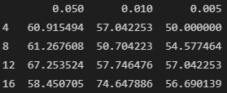
Table3 shows that the test accuracy is the highest when the number of units is 16 and learning rate is 0.01. Hence, we use these values to build model.
Figure 19. Summarizaion of selected model
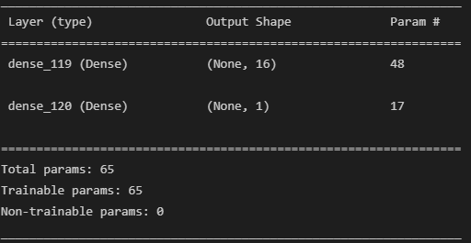
The training and test accuray of selected model are 75% and 72.63%. It shows that single hidden layer model did’t fit well.
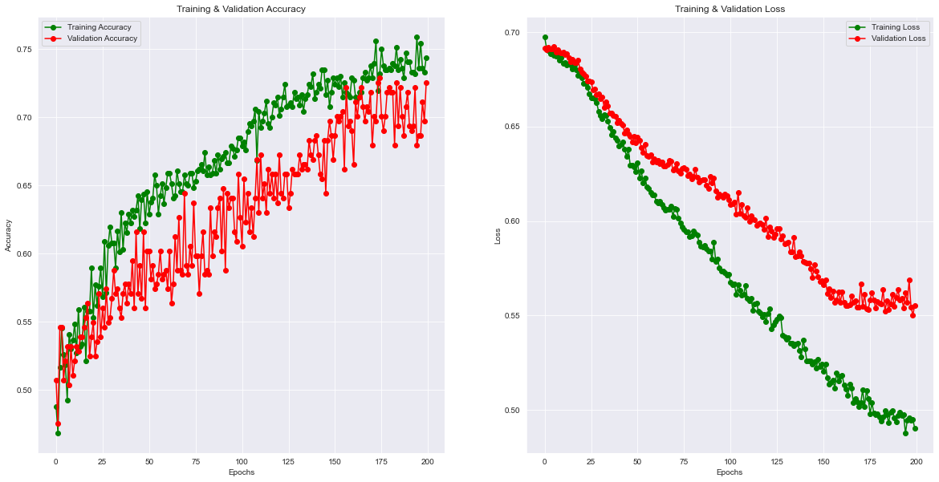
Figure 20. Training, Test Accuray and Loss
Figure 20 shows the accuray and loss of training and test following epochs. The losses are decrease, but the training and test accuracy are around in 75%. Figure 21 shows the confusion matrix of single hidden layer model.
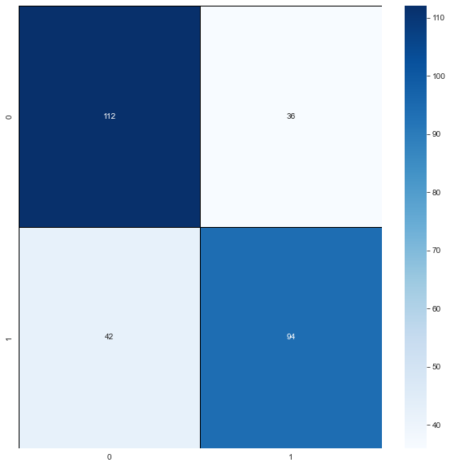
Figure 21. Confusion Matrix of Single Hidden Layer Model

- Double Hidden Layers Model
In this section, we have built the double hidden layer model for given dataset. To find the best hyperparameters we have pre-defined the various number of nodes and learning rate, then calculate the test accuracy and select the hyperparameters given highest test accuracy.
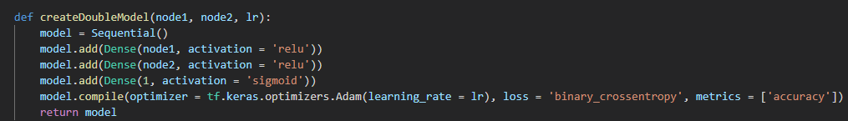
Figure 22. Double Hidden Layers Model
Where node1 and node2 are units of hidden layers and lr is the learning rate of the model. The test accuracies are given table 4.
Table 4. Test accuracy with various hyperparameters
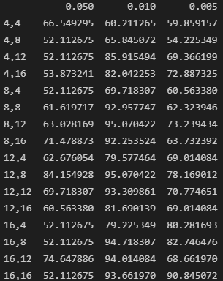
Table4 shows that the test accuracy is the highest when the number of units is 12, 8 and learning rate is 0.01. Hence, we use these values to build model.
Figure 23. Summarizaion of selected model
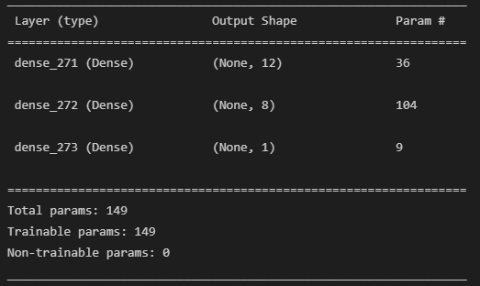
The training and test accuray of selected model are 98.33% and 96.13%. It shows that double hidden layers model fit well.
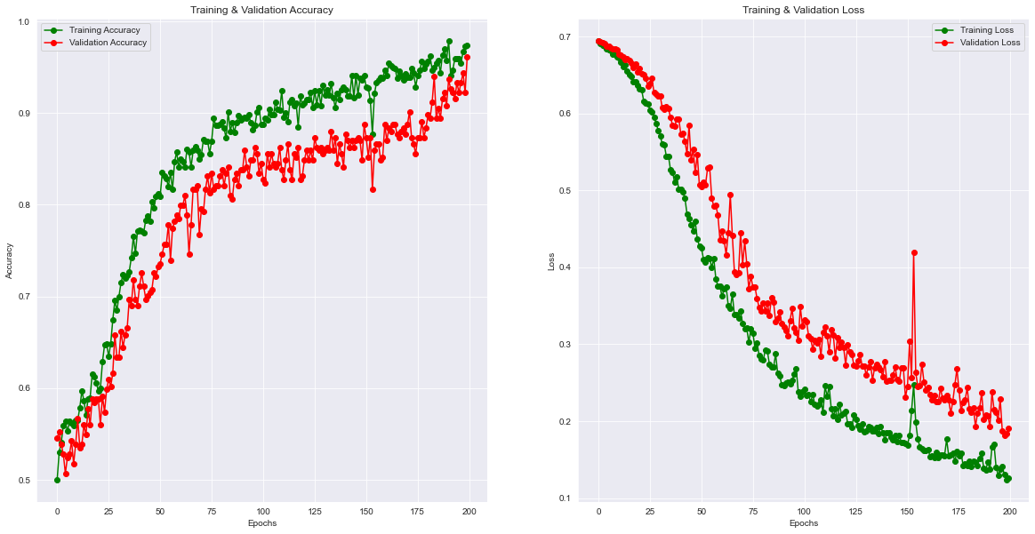
Figure 24. Training, Test Accuray and Loss
Figure 24 shows the accuray and loss of training and test following epochs. The losses are decrease and the training and test accuracy are around in 98%. Figure 25 shows the confusion matrix of single hidden layer model.
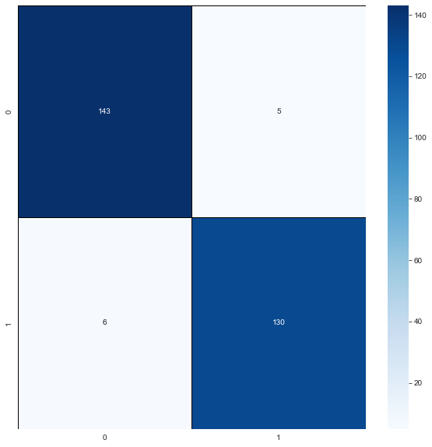
Figure 25. Confusion Matrix of Single Hidden Layer Model
- Minimal Network
Figure 26 shows the visualization of dataset. As we can see easily if we convert this dataset to polar coordinates, we can reduce the dimension. Hence, we add one column ‘dist’.
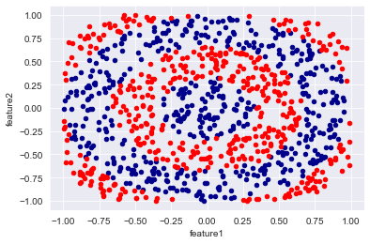
Figure 26. Visualization of Dataset
Figure 27 shows the converted dataset. The ‘dist’ shows the distance form original points.
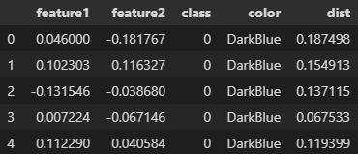
Figure 27. Converted Dataset
Now, we build the single hidden layer model again with dist values. Table 5 shows the test accuracy with various hyperparameters and the best hyperparameters for this dataset is (12, 0.05).
Table 5. Test accuracy with various hyperparameters
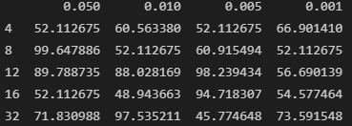
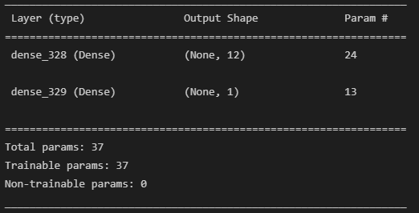
Figure 28. Single Hidden Layer Model with Converted Dataset
The training and test accuracy are 96.97% and 96.13%. As we can see easily, we have got very high accuracy than previous single layer model with used original dataset. It shows that the converting gives the chance to get high accuracy with reducing dimension.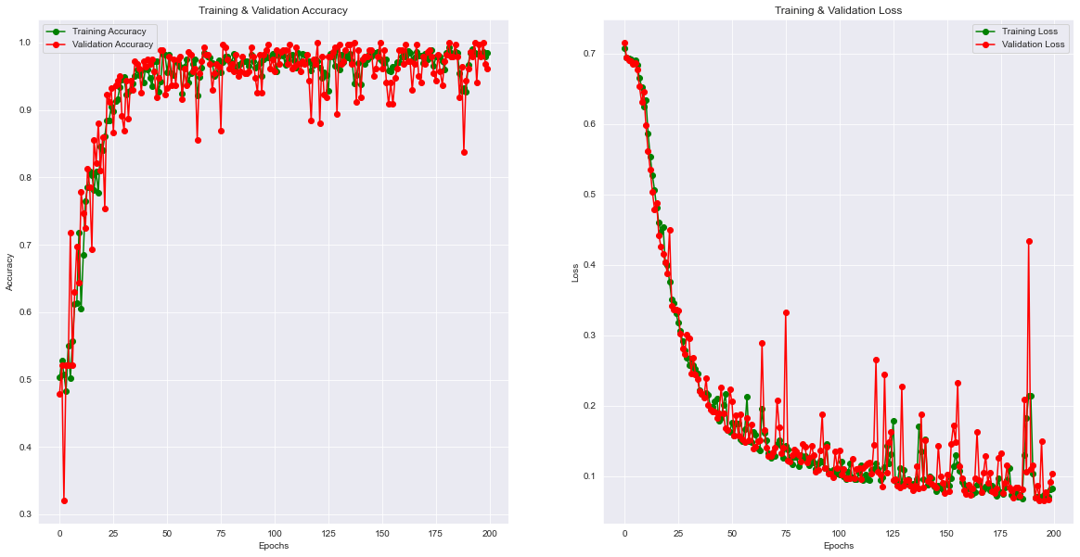
Figure 29. Training, Test Accuracy and Loss
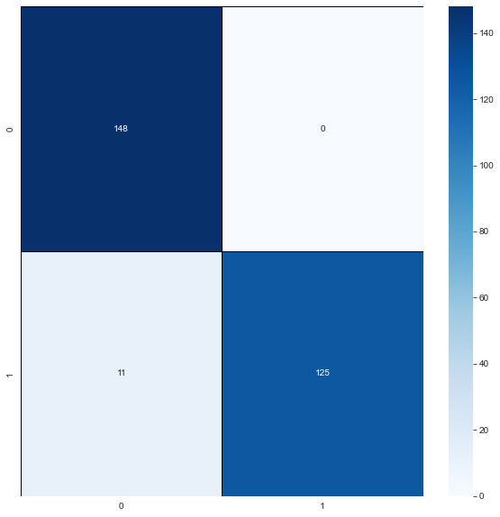
Figure 30. Confusion Matrix of Converted Dataset

