

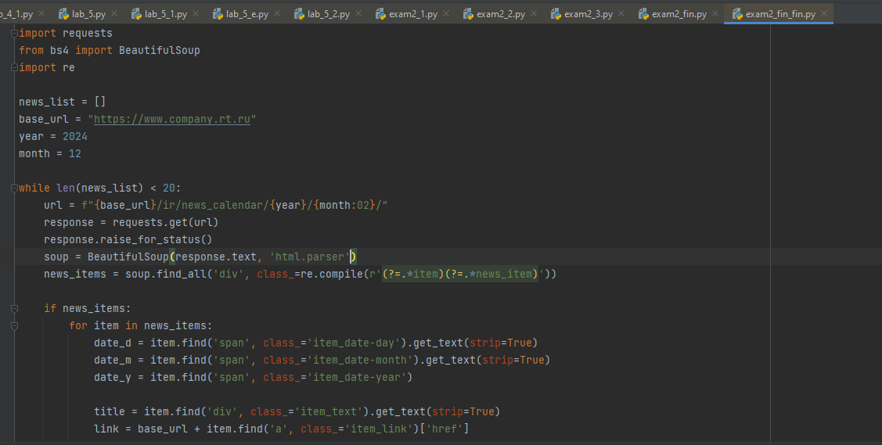

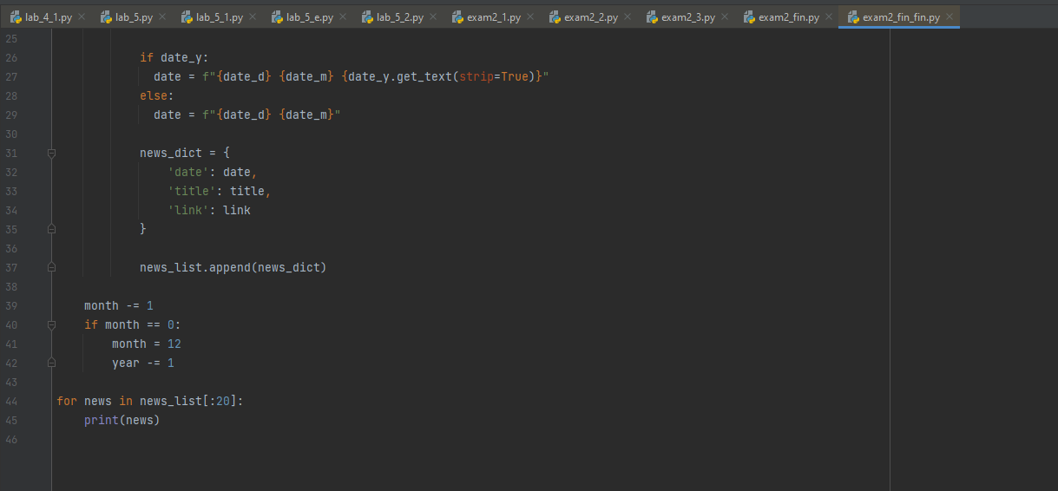

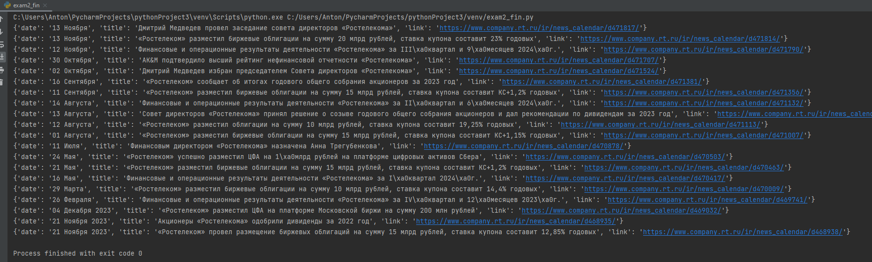

import requests  
from bs4 import BeautifulSoup  
import re  
  
news_list = []  
base_url = "https://www.company.rt.ru"  
year = 2024  
month = 12  
  
while len(news_list) < 20:  
 url = f"{base_url}/ir/news_calendar/{year}/{month:02}/"  
 response = requests.get(url)  
 response.raise_for_status()  
 soup = BeautifulSoup(response.text, 'html.parser')  
 news_items = soup.find_all('div', class_=re.compile(r'(?=.*item)(?=.*news_item)'))  
  
 if news_items:  
 for item in news_items:  
 date_d = item.find('span', class_='item_date-day').get_text(strip=True)  
 date_m = item.find('span', class_='item_date-month').get_text(strip=True)  
 date_y = item.find('span', class_='item_date-year')  
  
 title = item.find('div', class_='item_text').get_text(strip=True)  
 link = base_url + item.find('a', class_='item_link')['href']  
  
 if date_y:  
 date = f"{date_d} {date_m} {date_y.get_text(strip=True)}"  
 else:  
 date = f"{date_d} {date_m}"  
  
 news_dict = {  
 'date': date,  
 'title': title,  
 'link': link  
 }  
  
 news_list.append(news_dict)  
  
 month -= 1  
 if month == 0:  
 month = 12  
 year -= 1  
  
for news in news_list[:20]:  
 print(news)