GUJARAT TECHNOLOGICAL UNIVERSITY

Chandkheda, Ahmedabad Affiliated

 

# Shantilal Shah Engineering College, Bhavnagar

A

Project Report On

## MyPlantInfo

UNDER SUBJECT OF

Design Engineering 2-B

B.E Semester-VI Information Technology

Submitted By:

|  |  |
| --- | --- |
| **Name of Student** | **Enrollment Number** |
| Senjaliya Dhruv | 210430116023 |
| Vasani Vaibhav | 210430116017 |
| Chavda Raviraj | 210430116024 |
| Karkar Harvi | 210430116022 |

Prof. B.K. Borisaniya (Internal Guide)

Pro. (Dr.) M S Shah Head of the Department

Academic year (2023-2024)

## SHANTILAL SHAH ENGINEERING COLLEGE, BHAVNAGAR

**INFORMATION TECHNOLOGY**

## CERTIFICATE

DATE:

This is to certify that the report entitled “**MyPlantInfo**” has been carried out by **Senjaliya Dhruv (210430116023), Vasani Vaibhav(210430116017), Chavda Raviraj(210430116024), Karkar Harvi(210430116022)** under my guidance in fulfilment of the subject Design Engineering 2-B (3160001) of Bachelor of Engineering in INFORMATION TECHNOLOGY (6th Semester) of Gujarat Technological University, Ahmedabad during the academic year 2024.

Internal Guide Head of the Department

Dr. B K Borisaniya Prof. (Dr.) M S Shah

Professor H.O.D. I.T.

I.T Department, I.T Department,

SSGEC, Bhavnagar. SSGEC, Bhavnaga

# Acknowledgement

We are heartily thankful to all faculty members of the department of information technology from SSEC-BHAVNAGAR, for making our project. It is our pleasure to take this opportunity to thank all people who helped us directly or indirectly to prefer this project would have been impossible without their guidance. They all encourages us and trust in our ideas. They were always available for us to give guidance about the project. The disruption about the project and the great advice given by them helped to make this project complete. We are thankful to them pristine and enlightening guidance given to as throughout the semester.

We are especially thankful to our internal guide of project, for their encouragement guidance, understanding and lots of support and trust. Without his help this project would note success. Finally, we thank all persons who directly or indirectly supported us in making this project.

|  |  |  |
| --- | --- | --- |
| **Sr. No** | **Name of Student** | **Enrollment Number** |
| 1 | Senjaliya Dhruv | 210430116023 |
| 2 | Vasani Vaibhav | 210430116017 |
| 3 | Chavda Raviraj | 210430116024 |
| 4 | Karkar Harvi | 210430116022 |

# Abstract

**MyPlantInfo** application that helps to identify plants and provides information such as their origin place, types, uses and medical benefits. User can save their favourite plants in a favourite list for easy reference. And user can also search plants by its name.

# Index

|  |  |  |
| --- | --- | --- |
| **Sr. No.** | **Title** | **Page No.** |
| 1. | Introduction | 7 |
| 2. | AEIOU Canvas | 8 |
| 3. | Mind mapping Canvas | 11 |
| 4. | Empathy Canvas | 13 |
| 5. | Ideation Canvas | 16 |
| 6. | Product Development Canvas | 18 |
| 7. | Learning, Need Matrix | 22 |
| 8. | Use-Case Diagram | 24 |
| 9. | Flowchart | 25 |
| 10. | E-R Diagram | 27 |
| 11. | Sequence Diagram | 29 |
| 12. | Data-Dictionary Table | 30 |
| 13. | Prototype Model | 32 |
| 14. | Experiments and Results | 40 |
| 15. | Conclusion | 48 |
| 16. | References | 49 |

**List of Figure**

|  |  |  |
| --- | --- | --- |
| **Figure no.** | **Figure Name** | **Page No.** |
| 2.1 | AEIOU Canvas | 10 |
| 3.1 | Mind Mapping Canvas | 12 |
| 4.1 | Empathy Canvas | 15 |
| 5.1 | Ideation Canvas | 17 |
| 6.1 | Production Development Canvas | 21 |
| 7.1 | Learning, Need Matrix Canvas | 23 |
| 8.1 | Use-Case Diagram | 24 |
| 9.1 | Flowchart | 25 |
| 10.1 | E-R Diagram | 27 |
| 11.1 | Sequence Diagram | 29 |
| 12.1 | Data-Dictionary Table | 30 |
| 13.1 | Home Module | 32 |
| 13.2 | Camera Module | 33 |
| 13.3 | Identify Module | 34 |
| 13.4 | Upload Module | 35 |
| 13.5 | Search Module | 36 |
| 13.6 | Save Module | 37 |
| 13.7 | Login Module | 38 |
| 13.8 | Signin Module | 39 |
| 14.1 | CNN Classifier | 41 |
| 14.2 | Accuracy and Loss graph | 45 |
| 14.3 | Confusion Matrix | 47 |

# Introduction

Our team has taken a topic of **“MyPlantInfo”** that provide a digital platform for user.

**MyPlantInfo** is a digital tool that can help users identify plants and trees easily and conveniently using their mobile devices. These apps often utilize plant recognition technology and machine learning algorithms to analyses a photo of the plant and provide users with its name, species, and other relevant information. The apps can assist users in recognizing various types of plants, including flowers, fruits, vegetables, and trees, and provide information on their habitat. With the rise of eco-awareness and the popularity of gardening, plant identifier apps have become increasingly popular among nature enthusiasts, gardeners, students, botanist and researchers who want to learn more about plants.

MyPlantInfo app has very useful features such as search, save, upload image from gallery. In search feature user can search plant by its name or species and get detail information on their plants.

In save feature user can save their favourite plant in favourite list. And user can also give name of their favourite list for easy to search their list. Save feature used to save plant information so that user no need to search repeatedly.

Upload image from gallery is very useful feature because user can any time upload image from their gallery and get information. If user cannot able to identify plant using camera so user can get detail through this feature.

When user cannot identify plant due to low quality of image, our app suggests to user that take photo at the right angle and proper distance so that image quality can be improved. Our app provides information like as plant’s origin place, species, scientific name and medical uses. In medical uses, how plant can be used in health and injury. Our app may be limited labels of plant so that user can suggest plant names manually.

# AEIOU Canvas

AEIOU summary canvas contains in 5 Sections:

1. Activity
2. Environment
3. Interaction
4. Object
5. User

### Activities:

* + - Collection Of Information.
      * Collect information from Botany book and reference sites
    - Origins of Plants.
      * Collect Information from Nursery, Gardener and Botanist
    - Medical uses.
      * Collect information from Ayurvedic doctor.

### Environment:

* + - Farm.
      * Farm can be used in many way to collect data on crops and unknow grass.
    - Nursery.
      * Nursery can be used in serval way to collect data on rare graft plant.
    - Hill station.
      * Some common herbs can be found in hill station include thyme, mint, rosemary, oregano and basil.
    - Forest area.
      * A forest area cab be a very useful resource for collect plant data. There are wide variety of plant including trees, shrubs and vine.

### Interaction:

* + - Person and Nursery.
      * Person and nursery may involve requesting permission to take pictures or collect data, and possibly working with the nursery staff to identify specific plants or obtain additional information.
    - Person and Farmer.
      * Person and farmer may involve requesting permission to take pictures or collect data of crops.
    - Person and Botanists.
      * Interaction between person and botanist may involve requesting assistance with plant identification, discussing plant characteristic.

### Objects:

* + - Mobile Phones
      * Our app is design for Android mobile phones, providing user friendly and optimized performance which give great experience.
    - Laptop

### Users:

* + - Student.
* Our app will design in laptop to easy to built in.
* Students are used this app for get information in botany subjects.
  + Botanists.
    - Botanists are used this app in their research.
  + Common people.
    - Common people are used this app for their gardens, to know any plant’s details.

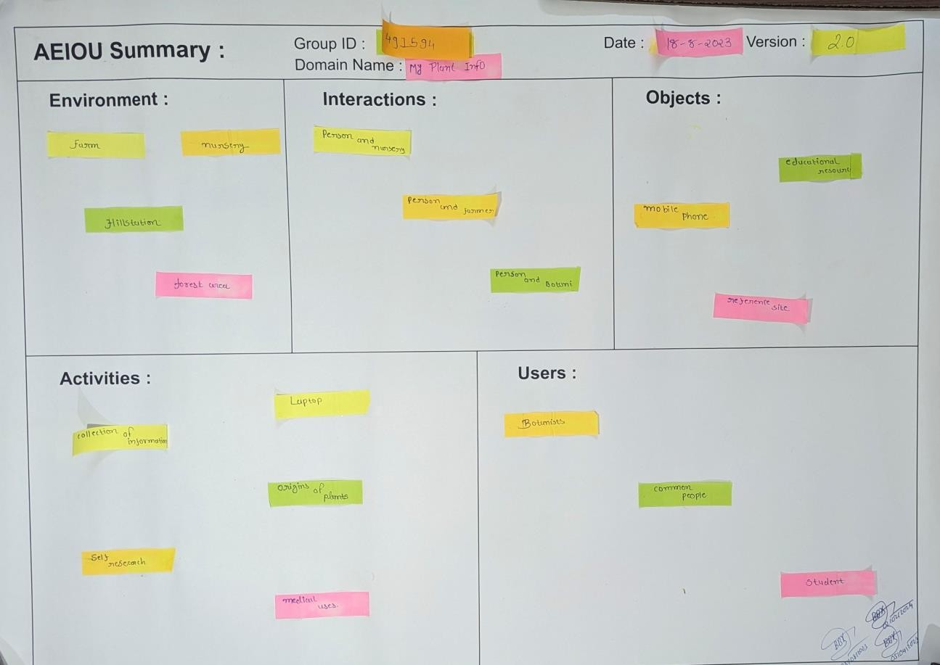

**Fig. 2.1 AEIOU Canvas**

# Mind-Mapping Canvas

1. Identify the main topic: we choose the topic of the mind map and place it in the middle of the canvas. Our idea is identifying the plants, and we gave name of it is MyPlantInfo.
2. Choose relevant categories: We have four main categories, then evenly space them in a circular formation around the main topic of mind map. Our four categories are as following

o Identifying (scan), Uses, Plant origins, Features

1. Choose relevant subcategories: Each main categories have three to four subcategories.
   * Identifying has three subcategories. leaf, vegetable and fruits.
   * Uses has three subcategories. health care, cooking ingredients and food.
   * Plant origins has four subcategories. hill station, forest area, nursery and farm.
   * Features has three subcategories. Search, save information and upload image.
2. Create and node connection: we are created nodes for each category and subcategory. And connect them using lines to show their relationship. we are used dark grey pencil Color and different shapes for nodes and lines to make more visually appealing.

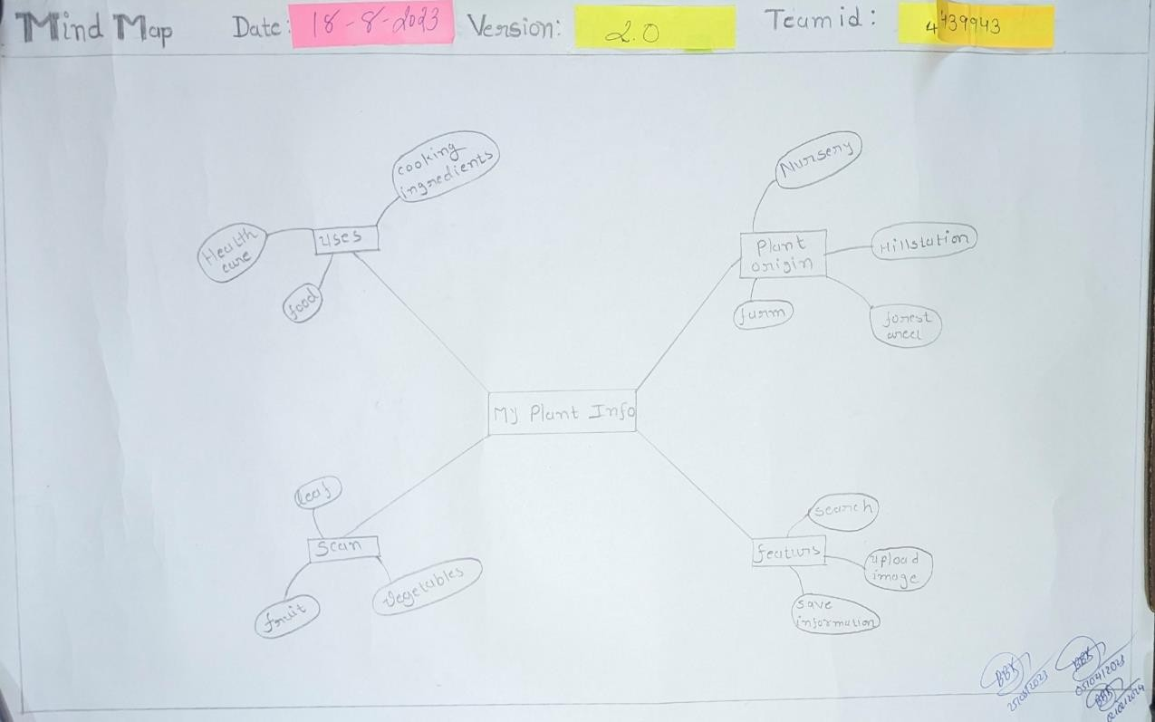

**Fig. 3.1 Mind-Mapping Canvas**

# Empathy Canvas

Empathy canvas contains 4 sections:

1. Users
2. The Stakeholders 3)Activity
3. Happy Stories and Sad Stories

### Users:

* + - Botanist.
      * Botanists are used this app in their research on plant.
    - Student.
      * Students are used this app for get information in botany subjects.
    - Common people.
      * Common people are used this app for their gardens, to know any plant’s detail.

### Stack Holders:

* + - Farmer.
      * Farmers are providing information about crop and some animal feed like grass
    - Nursery.
      * Nurseries are providing information about the bonsai and rare plant’s graft
    - Reference site.
      * With help of reference site, we collect information about tree that don’t belong here

### Activity:

* + - Collection Of Information.
      * Collect data from Botany book and reference sites
    - Origins of Plants.
      * Collect plant origin data from Nursery, Gardener and Botanist
    - Medical uses.
      * For medical uses, collect herb uses data from Ayurvedic doctor.

### Happy Stories and Sad Stories:

**HAPPY**:

A plant lover found a small unknown plant in their garden. They snapped a photo and uploaded it to a plant identifier app. Within seconds, the app identified the plant as a rare and beautiful flower. The plant lover was overjoyed and spent the rest of the day admiring their new addition to the garden.

### SAD:

A gardener excitedly used a plant identifier app to identify a mysterious plant in their garden, hoping it was a rare and valuable species. However, the app identified it as a common weed. Disappointed, the gardener uprooted the plant and threw it away, not realizing it was actually a unique and endangered plant species.

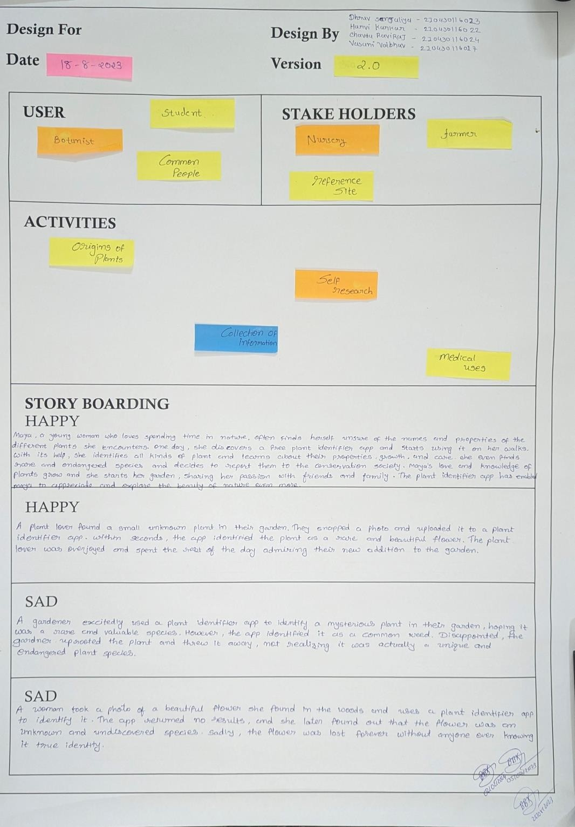

**Fig 4.1 Empathy Canvas**

1. **IDEATION CANVAS**

Ideation canvas contains 4 sections:

1. People
2. Activity
3. Situation
4. Props/Possible solution

### People:

* + - Farmers
      * Farmer are used this app for get information about crops.
    - Students.
      * Students are used this app for get information in botany.
    - Common people.
      * Common people are used this app for their gardens, to know any plant

### Activity:

* + - Collection of information.
      * Collect information from Botany book and reference sites
    - Preprocess dataset of plant.
      * Pre-process the dataset of plant, involves cleaning and organizing the data to ensure that it is accurate and useful.
    - Train machine learning model
      * Training the model on pre-process data set of plant activity, testing the model to ensure that it is accurate and refining the model based on feedback and additional data

### Situation:

* + - Image quality.
      * Image may be blurry or not in perfect angel
    - Language support.
      * Only one language supported in our app.
    - Limited labels of plants.
      * All plants haven’t right name or haven’t any name.

### Props/Possible solution:

* + - Suggest user to capture image at the right distance and resolution.
      * This is solution of blurry image quality problem.
    - We can include language translation feature.
      * This is solution for one language support problem.
    - Suggest manually name of plants.
      * This is the solution for limited labels of plant, here user can give plant name by manually.

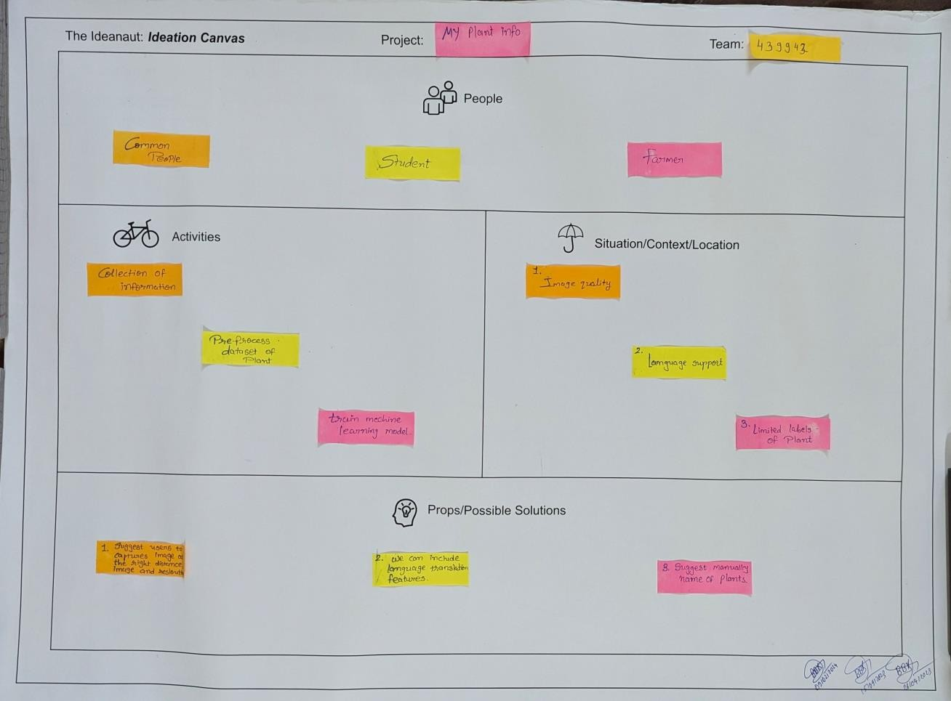

**Fig 5.1 Ideation Canvas**

# PRODUCT DEVELOPMENT CANVAS

Product development canvas is all about how we going to develop our idea in real life situation.

Product Development canvas contains 4 sections:

### Purpose:

* + Helps user to identify plants.

### People:

* Farmers.
* Students.
* Farmer are used this app for get information about crops.
* Students are used this app for get information in botany.
  + Common people.

o Common people are used this app for their gardens, to know any plant

### Product experience:

* Satisfied with our result.
  + Our app provides perfect result as user want, so they are satisfied with our results.
* Easy to use.
  + Our application is easy to use because it’s not hard to understand and not complicated.
* Easy to find app.
  + Our app’s name is very easy to search and remember.

### Product functions:

* Search/Identify plants information.
  + This is a best function of this app, where user can search plant by its name or identify plant.
* Image recognition.
  + Where user can recognize plant image through photo or identify.
* Location of origin.
  + User can get information of plant’s origin place.
* Knowledge sharing function through chat.
  + Where user can share their identified plant or search plant information to another.
* Upload photo from gallery for identify plant.
  + This is very useful function, with help of this function user can upload images through gallery and get information of their desire plant.

### Components:

#### Login module

* + Name
  + Email
  + Password

#### Search module

* + Search plant name.
  + Information.

#### Identify module

* + Identify plant.
  + Upload image.

#### Save model

* + Save information of plant.

### Customer revalidation:

* Application provides detailed information about plant, trees and also save information of their identified plants.
* Useful: - More useful in find location of origin of plants and trees, upload image from gallery is more useful features.

### Reject, redesign retain: -

* Reject
* Retain
* Knowledge sharing function through chat.
  + Users are rejecting this function because they don’t want any chatting platform.
* save information
* location of origins
* Search/Identify plants information.
  + User retain this function because is very useful function.

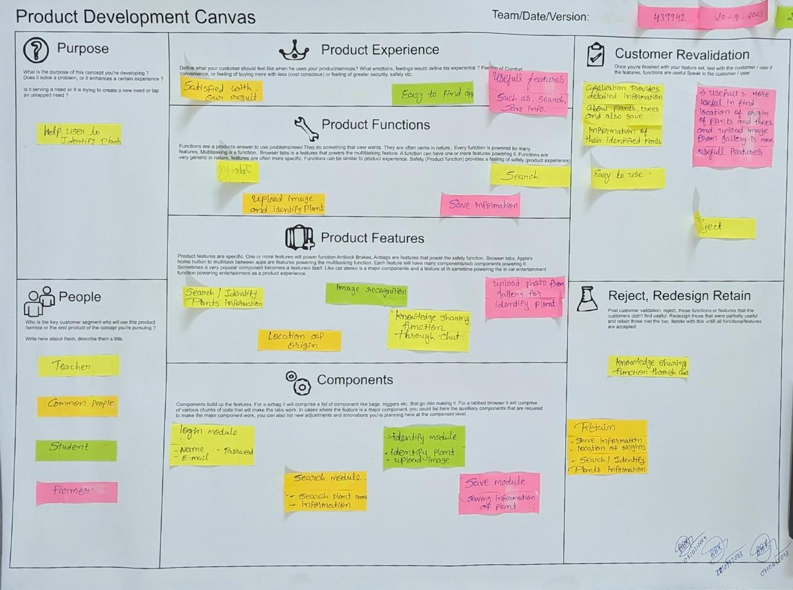

**Fig. 6.1 Product Development Canvas**

# Learning, Need and Matrix

1. The purpose of learning net metrics cost we defined our product concept.
2. Tool/ methods/ theories/ application process involved; During BE II we were learning app design and authentication. During BE III we are learning sorting algorithms, and frontend and backend code and During BE IV we will be learned about Machin learning algorithm which is used in train model for image recognition technology.
3. Applicable standard and design /specification/ principle and experiment: During BE II we were learning database design. During BE III we were learning responsive design and database normalization and During BE IV we will learn about user experience design.
4. Software /simulation/ skill/ mathematical requirement: During BE II we were learning Android studio, firebase and Java. During BE III we are learning database management system, python and C++ during BE IV we will be learning imagerecognition process and data science.
5. Component material’s strength criteria (explosion-varieties/testing requirement): During BE II we were learning Docker during. During B3 III we are learned database server and during BE IV we will be learning Automated testing.

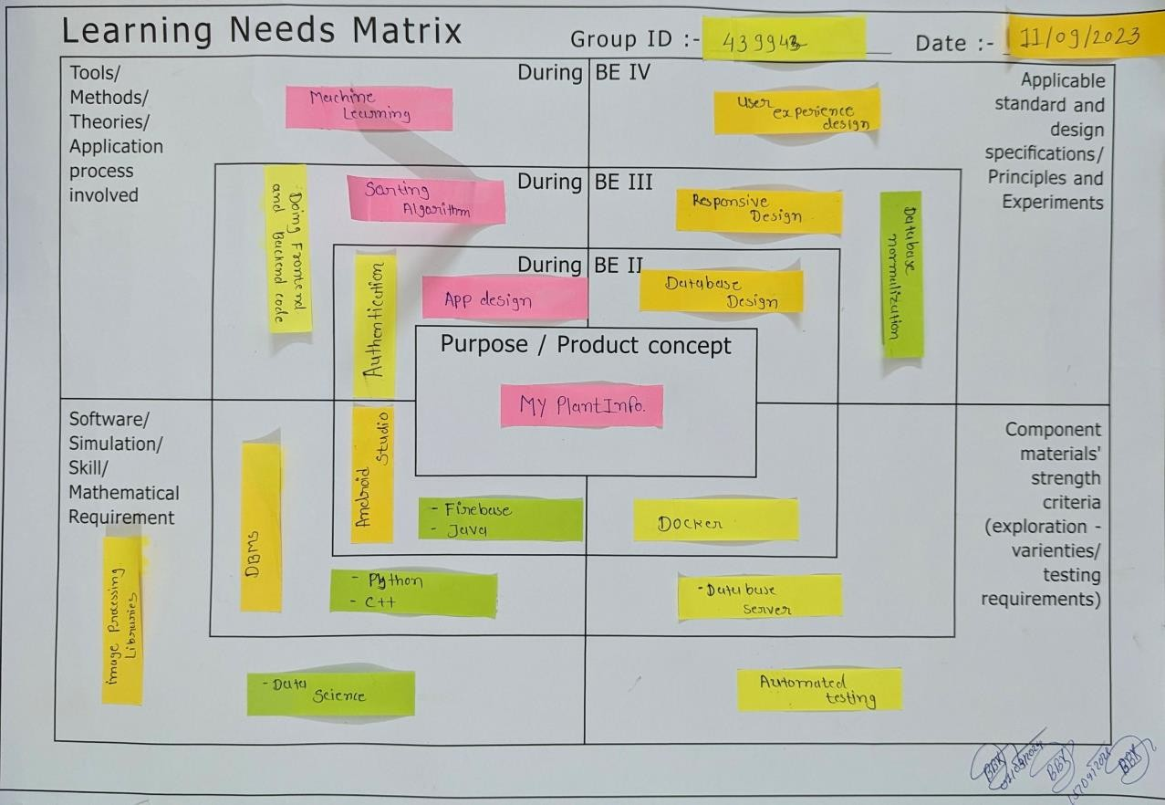

**Fig 7.1 Learning, Need Matrix Canvas**

1. **Use-Case Diagram**

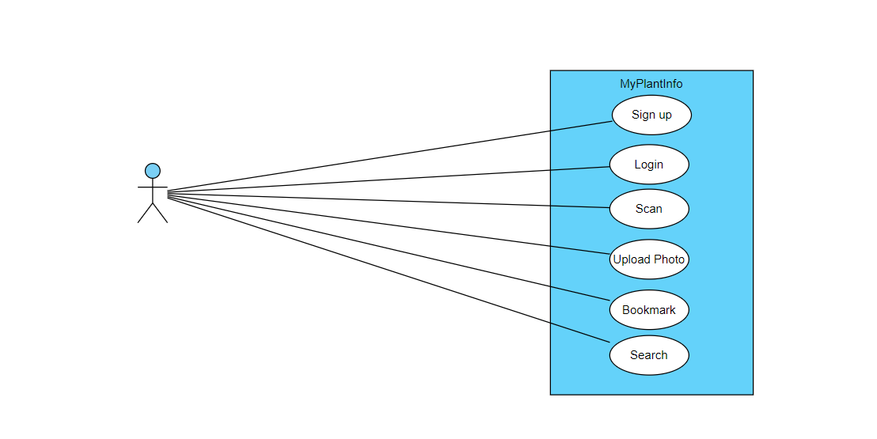

User

**Fig 8.1 Use-Case Diagram**

**Description:**

# As shown in fig 8.1

The image is a data use case diagram for MyPlantInfo application. It includes elements such as ‘Sign up’, ‘Login’, ‘Identify’, ‘Upload Photo’, ‘Bookmark’, and ‘Search’. The diagram features lines connecting these elements, with circles representing key points.

1. **Flowchart**

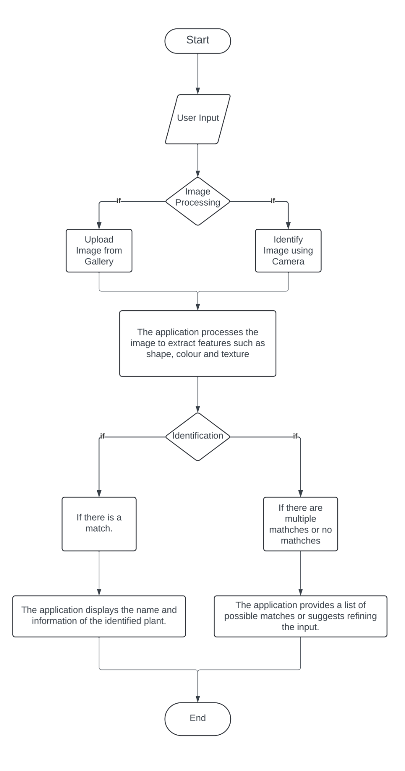

**Fig 9.1 Flowchart**

**Description:**

# As shown in fig 9.1.

1. Start:

* The application starts.

2. User Input:

* User inputs either a photo or description of the plant they want to identify.

3. Image Processing:

* If the user uploads a photo:
* The application processes the image to extract features such as shape, color, and texture.
* If the user provides a description:
* The application analyzes the text to extract relevant information about the plant's characteristics.

4. Database Query:

* The extracted features or description are compared against a database of known plant species.

5. Identification:

* If there is a match:
* The application displays the name and information of the identified plant.
* If there are multiple matches or no matches:
* The application provides a list of possible matches or suggests refining the input.

6. End:

* The process ends, and the user can choose to start a new identification or exit the application.

This is a basic outline and can be expanded upon with additional features such as user feedback, machine learning for improved accuracy, and integration with external databases for more comprehensive plant information.

1. **E-R Diagram**

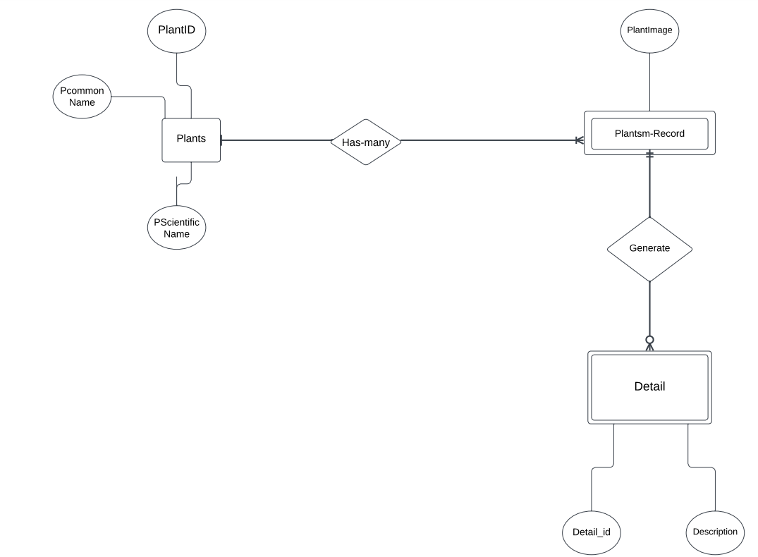

**Fig 10.1 E-R Diagram**

**Description:**

# As shown in fig 10.1.

**1. Entities:**

- **User**: Represents users of the application. It includes attributes such as UserID (primary key), Username, Email, and Password.

- **Plant**: Represents plant information stored in the application. It includes attributes such as PlantID (primary key), Name, ScientificName, and Description.

- **Scan**: Represents the relationship between users and plants scanned by them. It includes attributes such as ScanID (primary key), UserID (foreign key referencing User), PlantID (foreign key referencing Plant).

- **Bookmark**: Represents the relationship between users and plants bookmarked by them. It includes attributes such as BookmarkID (primary key), UserID (foreign key referencing User), and PlantID (foreign key referencing Plant).

- **Upload**: Represents the relationship between users and images uploaded by them for plants. It includes attributes such as UserID (foreign key referencing User), PlantID (foreign key referencing Plant), Image, and UploadDateTime.

- **Search**: Represents the relationship between users and plants searched by them. It includes attributes such as UserID (foreign key referencing User) and PlantID (foreign key referencing Plant).

**2. Relationships:**

- **Scan**: Indicates that users can scan plants, creating a record in the Scan table.

- **Bookmark**: Indicates that users can bookmark plants, creating a record in the Bookmark table.

- **Upload**: Indicates that users can upload images of plants, creating a record in the Upload table.

- **Search**: Indicates that users can search for plants, creating a record in the Search table.

**3. Key Attributes:**

- Attributes like UserID and PlantID serve as primary keys in their respective entities.

- Other attributes like ScanID, BookmarkID, and UploadDateTime also play key roles in identifying and managing records in their associated tables.

Overall, the ER diagram provides a clear visualization of the database structure for the "MyPlantInfo" application, depicting how users interact with plants through various actions such as scanning, bookmarking, uploading images, and searching.

1. **Sequence Diagram**

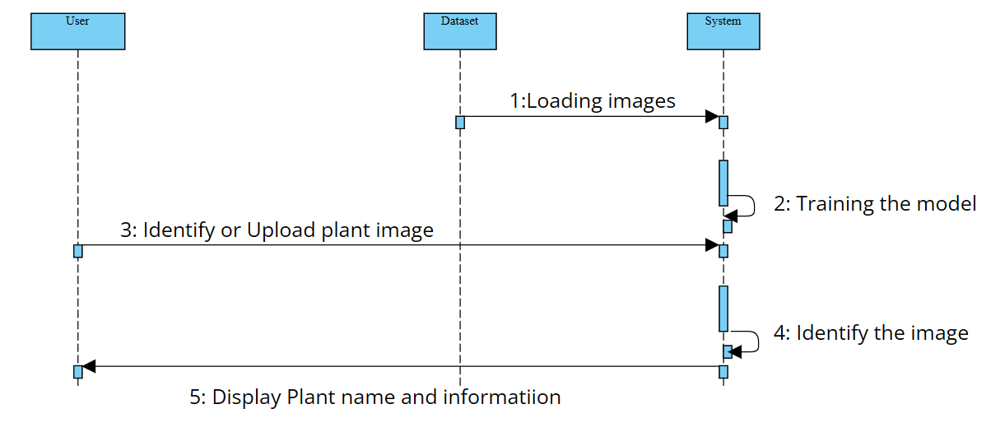

**Fig 11.1 Sequence Diagram**

# Description:

# As shown in fig 11.1.

# Entities and Interactions:

# The diagram depicts three primary entities: User, Dataset, and System.

# Arrows represent interactions between these entities, with each step numbered.

# Process Flow:

# Step 1: The Dataset loads plant images into the System.

# Step 2: Within the System, the model undergoes training to recognize various plant species effectively.

# Step 3: The User interacts with the System, either identifying or uploading plant images for analysis.

# Step 4: The System processes the image, identifying the plant species.

# Step 5: The System provides feedback to the User, displaying both the plant name and relevant information.

# Visual Elements:

# The arrows indicate the directional flow of information or actions taken.

# The diagram visually represents how MyPlantInfo handles user-uploaded or identified plant images using its trained model.

# In summary, MyPlantInfo is a system designed to identify plants based on user-provided images, leveraging a trained model and a dataset of plant images. Users can receive accurate plant names and related information through this interactive process.

1. **Data-Dictionary Table**

**Table 12.1 Data-Dictionary Table**

|  |  |  |  |  |
| --- | --- | --- | --- | --- |
| Field | Attribute | Data Type | Key Type | Description |
| Plant | PlantID | Varchar | Primary | Unique identifier for each plant. |
|  | Name | String |  | Common name of the plant. |
|  | ScientificName | String |  | Scientific name of the plant. |
|  | Description | String |  | Detailed description of the plant. |
| User | UserID | Varchar | Primary | Unique identifier for each user. |
|  | Email | Varchar |  | Email address associated with the user account. |
|  | Password | Text |  | Encrypted password for user account security. |
| Identify | IdentifyID | Varchar | Primary | Unique identifier for each scan action. |
|  | UserID | Varchar | Foreign | Identifier of the user who performed the scan. |
|  | PlantID | Varchar | Foreign | Identifier of the plant being scanned. |
| Bookmark | BookmarkID | Varchar | Primary | Identifier of the plant being bookmarked. |
|  | UserID | Varchar | Foreign | Identifier of the user who created the bookmark. |
|  | PlantID | Varchar | Foreign | Identifier of the plant related to the uploaded image. |
| Upload | UserID | Varchar | Foreign | Identifier of the user uploading the image. |
|  | PlantID | Varchar | Foreign | Identifier of the plant related to the uploaded image. |
|  | Image | Image |  | The image file of the plant uploaded by the user. |
| Search | UserID | Varchar | Foreign | Identifier of the user performing the search. |
|  | PlantID | Varchar | Foreign | Identifier of the plant being searched. |

# Description:

# As shown in table no.12.1:

# Plant Table:

# PlantID: Unique identifier for each plant, stored as a varchar.

# Name: Common name of the plant, stored as a string.

# ScientificName: Scientific name of the plant, stored as a string.

# Description: Detailed description of the plant, stored as a string.

# User Table:

# UserID: Unique identifier for each user, stored as a varchar.

# Email: Email address associated with the user account, stored as varchar.

# Password: Encrypted password for user account security, stored as text.

# Identify Table:

# IdentifyID: Unique identifier for each scan action, stored as a varchar.

# UserID: Identifier of the user who performed the scan, stored as a foreign key referencing the table.

# PlantID: Identifier of the plant being scanned, stored as a foreign key referencing the Plant.

# Bookmark Table:

# BookmarkID: Identifier of the bookmark, stored as a varchar.

# UserID: Identifier of the user who created the bookmark, stored as a foreign key referencing the table.

# PlantID: Identifier of the plant related to the bookmark, stored as a foreign key referencing the table.

# Upload Table:

# UserID: Identifier of the user uploading the image, stored as a foreign key referencing the User table.

# PlantID: Identifier Of the plant related to the upload image, store as a foreign key reference the table

# Image: The image file of the plant uploaded by the user, stored as an image data type.

# Search Table:

# UserID: Identifier of the user performing the search, stored as a foreign key referencing the User.

# PlantID: Identifier of the plant being searched, stored as a foreign key referencing the Plant table.

# Each table serves a specific purpose within the database schema, facilitating operations related to plants, users, scans, bookmarks, image uploads, and searches. The relationships between tables are established through foreign key constraints, ensuring data integrity and consistency.

# Prototype

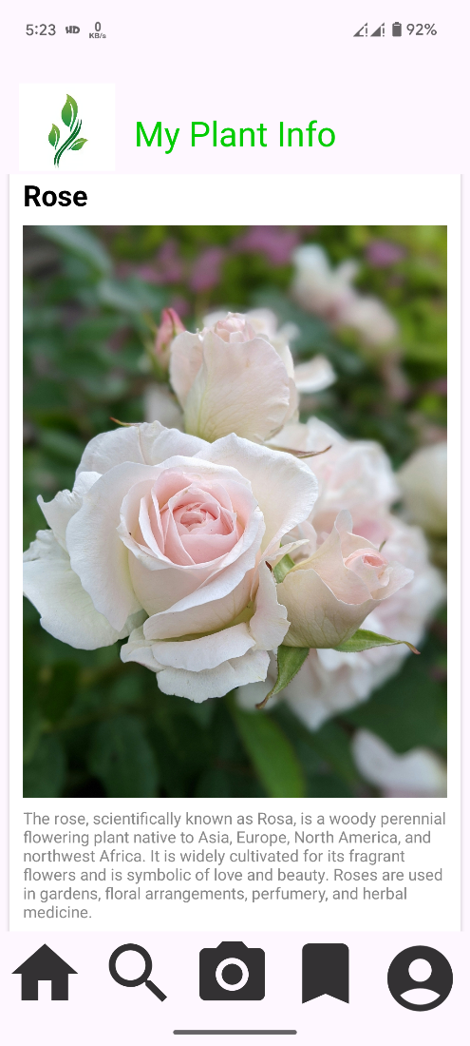

#### Fig. 13.1 Home module

This is the first page when user opens this application.

* In this page random some plants and leave’s details are displayed.
* User can also scroll down and see different types of plants

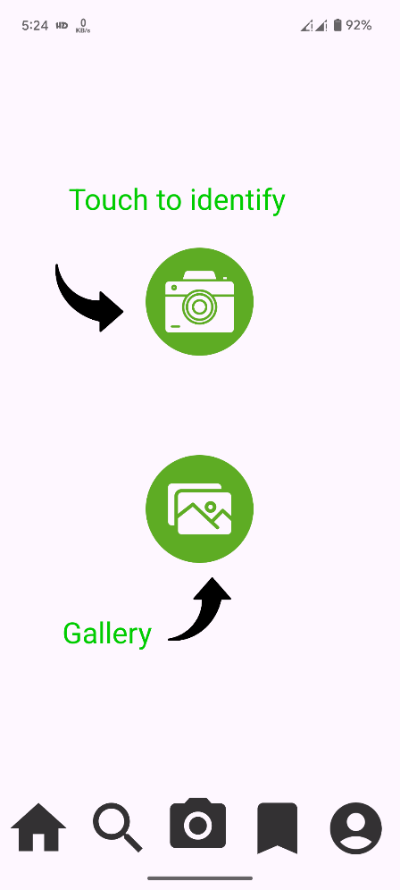

#### Fig. 13.2 Camera module

This is the identifier page

* Here two icons are shown in this page.
* First is camera icon user can touch it and identify any plants.
* Second is gallery icon, user can upload plant image through their gallery and get information about their plant.

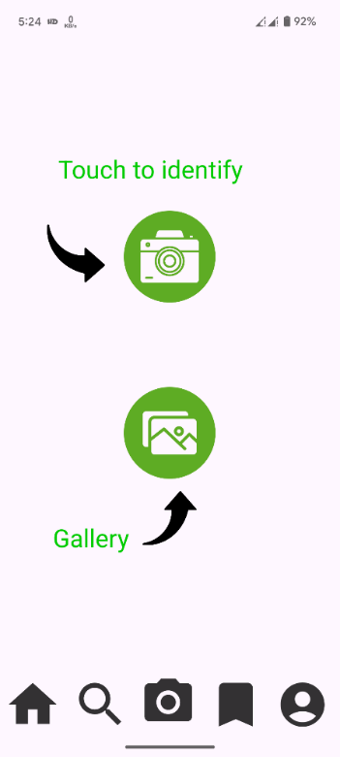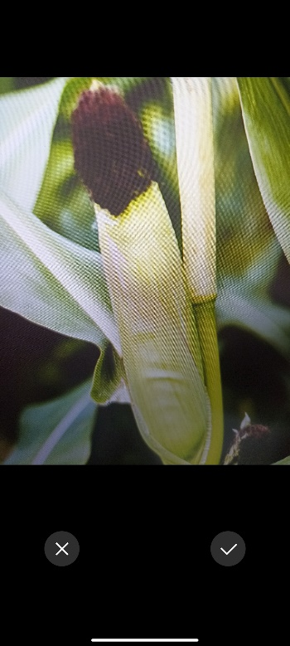

#### Fig 13.3 Identify Module

This is the Camara page of this application.

* In camara page user can start flash light for more lighting, user can also close this page using cross button.
* user can identify plant and get information about it.

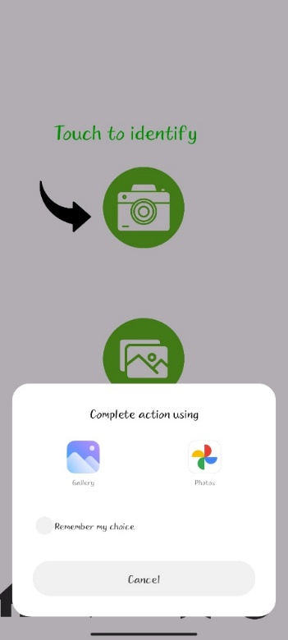

#### Fig 13.4 Upload module

This is the Gallery of this application.

* Here user can select image from gallery for identify plant.
* This is useful for identify some unseen plant from internet.
* User close this page using cross button.

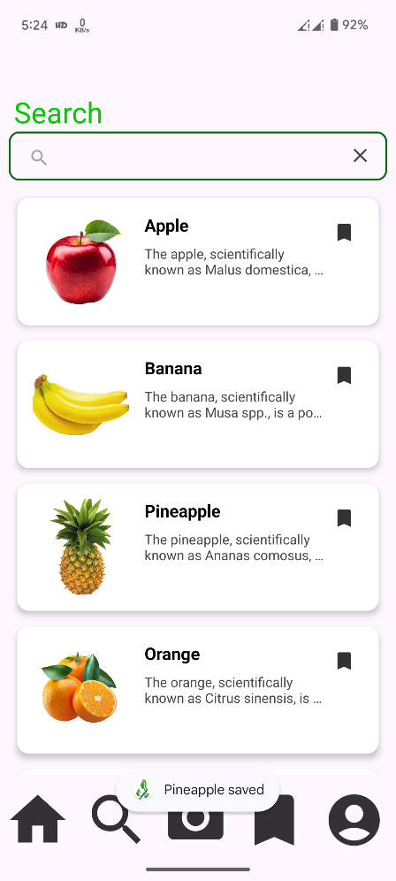

#### Fig 13.5 Search module

This is search page of application

* + If user knew about name of the plant so, user can search plant name in search section. And get detail about that plant.

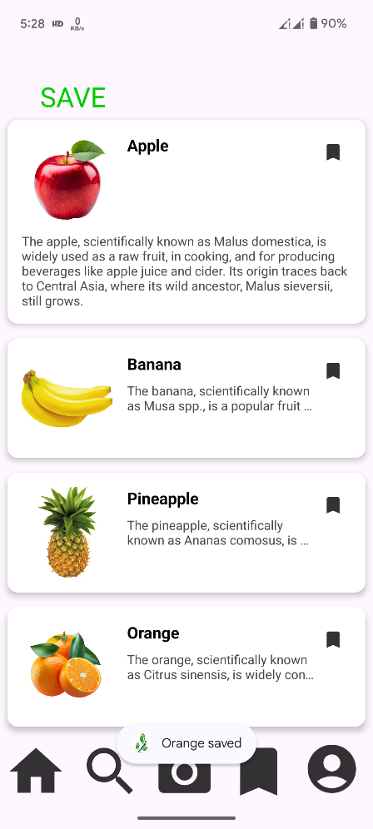

#### Fig 13.6 Save module

This is SAVE page of application,

* User can save their favourite plants in a favourites list for easy reference.
* Here plus icon is given for add new favorite list.
* User can also give name of their list

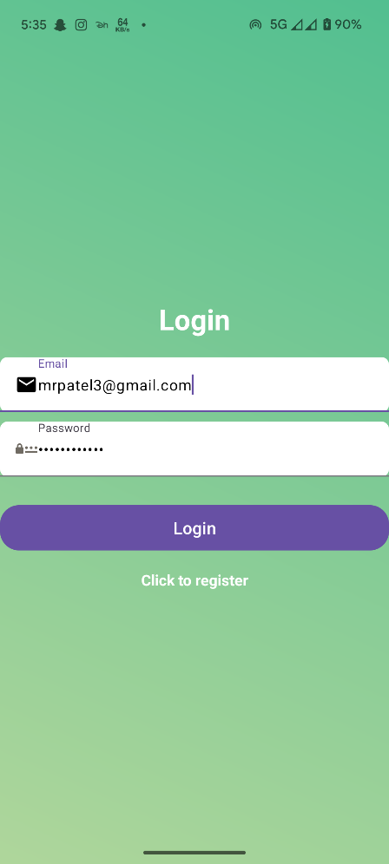

#### Fig 13.7 Log In module

This is PROFILE page of application

* In LOG IN, user can retrieve their old accounts.
* User can Log in via their email and password.

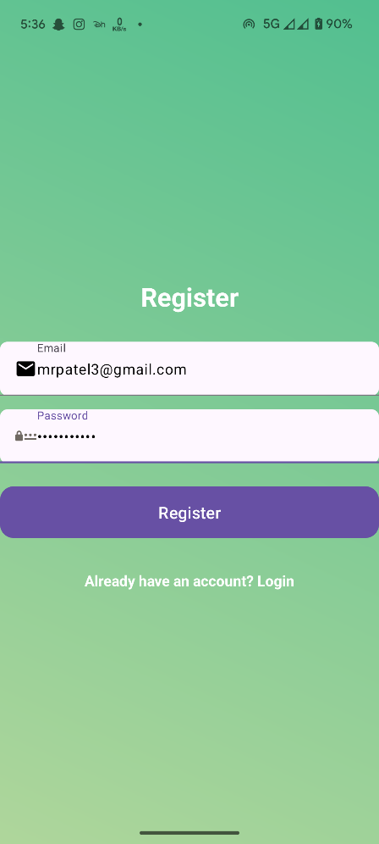

#### Fig 13.8 Sign in module

This is a profile page of application.

* + For sign in, there user can create their account through their name email id and password.

1. **Experiments and Results**
2. **Dataset Details:**

* **Dataset Description:**
* **Total Classes:** The dataset contains images of leaves belonging to 14 different categories or classes. (Apple – 513 images, Blueberry – 467 images, Cherry – 260 images, Corn – 358 images, Grape – 306 images, Orange – 1140 images, Peach – 256 images, Pepper – 336 images, Potato – 89 images, Raspberry – 264 images, Soybean – 576 images, Squash – 574 images, Strawberry – 532 images, Tomato – 540 images).
* **Total Images:** There are 6011 images in the entire dataset.
* **Batch Size:**
* **Batch Size:** Images are processed in batches of 32. This means that during training, validation, and testing, the model will work with 32 images at a time.
* **Dataset Split:**
* **Training and Test Split:** The dataset is divided into training and testing sets with an 80-20 split.
* **Training Set:** 80% of the total images are used for training the model.
* **Test Set:** 20% of the total images are reserved for testing the model.
* **Batch Distribution:**
* **Total Batches:** Given the batch size and the total number of images, there are 188 batches in total (6011 images divided by 32 images per batch).
* **Training Batches:** Out of these 188 batches, 150 are used for training.
  + **Test Batches:** The remaining 38 batches are used for testing and validation.
* **Further Split for Testing and Validation:**
* **Test Set:** The 38 batches set aside for testing are further divided.
  + **Test Batches:** 20 of these batches are used for testing.
  + **Validation Batches:** 18 of these batches are used for validation to fine-tune the model during training.

1. **Classifier:**

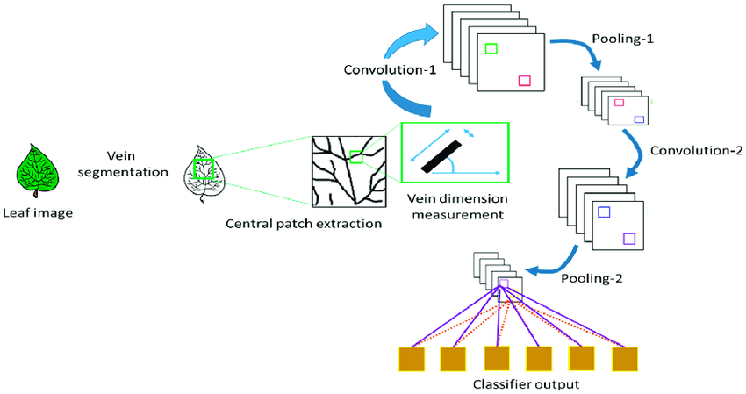

**Fig.14.1 CNN Classifier**

# As shown in fig 14.1.

* **Overview of CNNs:**
* A Convolutional Neural Network (CNN) is a deep learning model primarily utilized for image recognition and classification tasks.
* **Convolutional Layers:**
* CNNs operate by employing specialized layers known as convolutional layers, which extract essential features from input images through a process called convolution.
* Convolution involves sliding a filter matrix across the input image, capturing spatial patterns such as edges and textures.
* **Pooling Layers:**
* CNNs incorporate pooling layers, which down sample feature maps, reducing computational complexity while retaining crucial information.
* **Layer Composition:**
* These networks typically comprise multiple convolutional and pooling layers, followed by fully connected layers responsible for classification.
* **Training and Feature Detection:**
* Throughout training, convolutional layers progressively learn to detect low-level features in early layers, evolving to recognize complex patterns in deeper layers.
* **Enhancement Techniques:**
* Techniques like ReLU activation and dropout are commonly employed to enhance learning and prevent overfitting.
* **Training Methods:**
* CNNs are trained using backpropagation and optimization algorithms such as gradient descent.
* **Transfer Learning:**
* Transfer learning is often utilized by leveraging pre-trained CNNs on large datasets and adapting them to specific tasks with smaller datasets.
* **Impact on Computer Vision:**
* Overall, CNNs have revolutionized computer vision tasks, achieving state-of-the-art performance in image classification, object detection, and various other applications

1. **Experiment Methodology:**

### Training and Validation Data:

* **Total Batches**: There are 188 batches in total, calculated from 6011 images divided by a batch size of 32.
* **Training Batches**: 150 batches are allocated for training.
* **Testing and Validation Batches**: The remaining 38 batches are used for testing and validation.
* **Further Division for Testing and Validation**:
* **Test Batches**: Out of the 38 batches reserved for testing and validation, 20 batches are designated for testing.
* **Validation Batches**: The remaining 18 batches are used for validation, aiding in the fine-tuning of the model during training.
* **Training Over Epochs:**
* **150 Epochs:** The model will go through the entire training dataset (150 batches) 150 times. Each epoch allows the model to learn and adjust its parameters based on the training data. This repeated exposure helps the model to better generalize and improve its performance on unseen data.
* **Layers:**

This is a convolutional neural network (CNN) model built using the Keras Sequential API, primarily for image classification tasks. Let's break down each layer:

#### Preprocessing Layers

* **resize_and_rescale**: This likely refers to preprocessing steps applied to input images, such as resizing them to a specific size and rescaling pixel values to a certain range.

#### Data Augmentation Layer

* **data_augmentation**: This suggests the use of data augmentation techniques, which involve generating additional training data by applying transformations like rotation, flipping, and scaling to existing images. Data augmentation helps improve the model's robustness and generalization

#### Convolutional and Pooling Layers

* **First Convolutional Layer**:
* layers.Conv2D(32,kernel_size=(3,3),activation='relu',input_shape=input_shape) :This is the first convolutional layer with 32 filters of size 3x3, using the ReLU activation function. It takes input images with shape input_shape. Since this is the first layer, it specifies the input shape explicitly.
* **First Max-Pooling Layer**:
* layers.MaxPooling2D((2,2)): This is a max-pooling layer with a pool size of 2x2. Max-pooling reduces the spatial dimensions of the representation and extracts the most important features.
* **Additional Convolutional and Max-Pooling Layers**:
* Similar to the first convolutional layer, there are several more layers, each followed by a max-pooling layer. The number of filters generally increases in deeper layers, as seen here with 64 filters.

#### Flattening Layer

* **Flatten Layer**:
* layers.Flatten(): This layer flattens the output of the previous layer into a one-dimensional vector, preparing it for input into a densely connected neural network.

#### Dense (Fully Connected) Layers

* **First Dense Layer**:
* layers.Dense(64, activation='relu'): This is a fully connected (dense) layer with 64 units and ReLU activation. It learns complex patterns from the flattened features.
* **Output Layer**:
* layers.Dense(n_classes, activation='softmax'): This is the output layer with n_classes units, representing the number of classes in the classification task. It uses the softmax activation function to output class probabilities, indicating the likelihood of each class.

#### Data Split Information

* **Total Batches**: There are 188 batches in total, calculated from 6011 images divided by a batch size of 32.
* **Training Batches**: 150 batches are allocated for training.
* **Testing and Validation Batches**: The remaining 38 batches are used for testing and validation.
* **Further Division for Testing and Validation**:
* **Test Batches**: Out of the 38 batches reserved for testing and validation, 20 batches are designated for testing.
* **Validation Batches**: The remaining 18 batches are used for validation, aiding in the fine-tuning of the model during training.

1. **Result:**

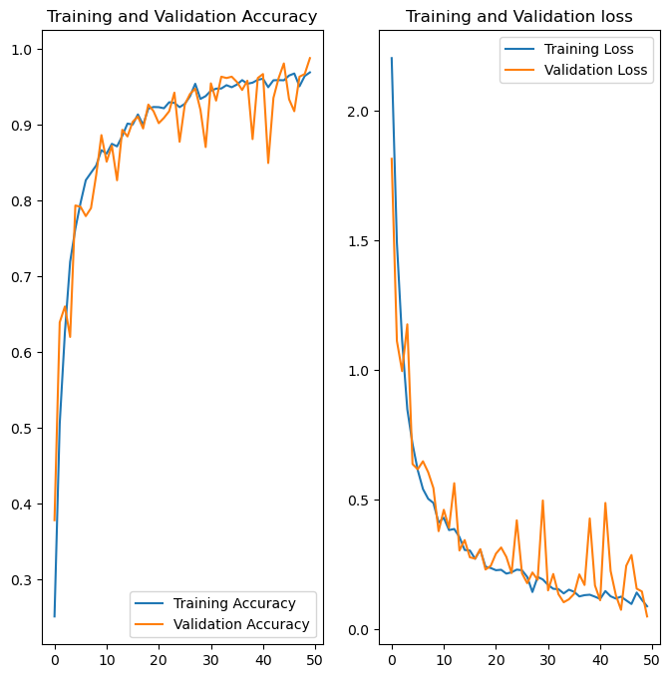 **Fig 14.2 Accuracy and loss Graph**

**Description:**

# As shown in fig 14.2.

This graph displays the performance metrics of a plant identifier application over 50 epochs, illustrating both the training and validation accuracy (left plot) and the training and validation loss (right plot).

### Training and Validation Accuracy (Left Plot)

* **Y-axis**: Accuracy, ranging from 0 to 1.0 (100% accuracy).
* **X-axis**: Epochs, ranging from 0 to 50.
* **Lines**:
* **Blue Line**: Training Accuracy
* **Orange Line**: Validation Accuracy

Both training and validation accuracy start at low values around 0.3 (30%) and steadily increase as the epochs progress. By the end of the training, both accuracies are approaching 1.0 (100%), indicating that the model has learned to identify plants correctly with high accuracy. The slight fluctuations in the validation accuracy suggest some variability in performance on the validation set.

### Training and Validation Loss (Right Plot)

* **Y-axis**: Loss, starting above 2.0 and approaching 0.
* **X-axis**: Epochs, ranging from 0 to 50.
* **Lines**:
* **Blue Line**: Training Loss
* **Orange Line**: Validation Loss

Both training and validation loss start above 2.0 and rapidly decrease within the first 10 epochs, indicating significant learning during the initial phase. The losses continue to decrease and eventually converge to values close to zero by the 50th epoch, suggesting that the model's predictions are becoming more accurate over time. The validation loss exhibits more fluctuations compared to the training loss, reflecting varying model performance on the unseen validation data.

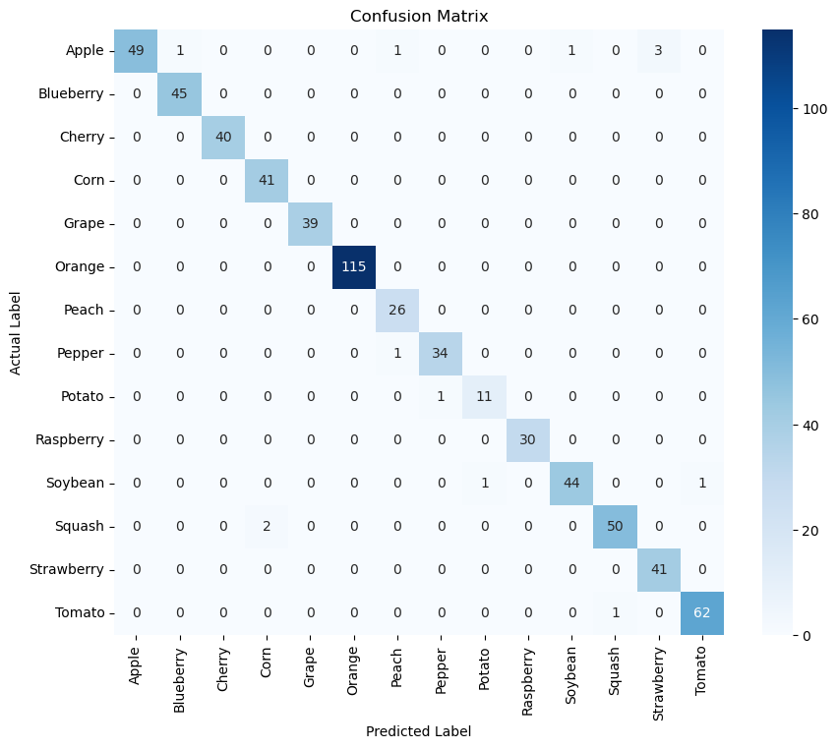 **Fig 14.3 Confusion Matrix**

**Description:**

# As shown in fig 14.3.

* **High Accuracy Classes**:
  + Orange (115), Tomato (62), Squash (50), Soybean (44), Blueberry (45), Strawberry (41), Corn (41), Cherry (40), and Grape (39) show high classification accuracy with minimal misclassifications.
* **Classes with Misclassifications**:
  + Apple has several misclassifications with 1 instance each as Blueberry, Corn, Raspberry, and 3 instances as Tomato.
  + Pepper has 1 misclassification as Potato and vice versa.
  + Soybean has 1 misclassification as Squash.
  + Squash has 2 misclassifications as Corn.

The confusion matrix indicates that the plant identifier application performs well overall, with high accuracy for most classes. The misclassifications are relatively few and concentrated in a small number of classes.

# Conclusion

My planned info application can be a useful tool for people you are interested in identifying large by using machine learning algorithms and image recognition technology the application can accurately identify plants and provide user with information about them the application can be improved by adding more plant species to the data set and refining the algorithms to improve accuracy overall a plant identifier application can help people learn more about the world around them and appreciate the beauty of nature.

# References

* Wikipedia
  + Wikipedia is used to collect plant image from other countries. https://en.m.wikipedia.org/wiki/Plant
* Books Of Botany
  + What name books are you use to collect information of plan characteristic and other relevant detail.
* Online source
  + We are using some online resources such as Google for plant dataset and its information.
* Plant snap
  + Plant snap is a popular plant identifier app that uses machine learning technology to identify plant based on photos taken by user, The app has database overall 6,00,000 plant species and can identify plant from all over the world.