System Description of PLL-Evalboard-Synthesizer

Brendan Bramman, Rich Rademacher, University of Waterloo/IQC

# Introduction

This document describes our Phase-Locked Loop (PLL) frequency synthesizer for generating medium-precision RF carrier wave (CW) signals. The Quantum Ion Trap group at the Institute for Quantum Computing (IQC) uses a series of evaluation boards from Analog Devices and Peregrine Semiconductor to provide a low-cost series of RF drive signals. Custom boards may be designed later if desired. These signals are calibrated to industry standards, not atomic standards, and so are medium-precision. Analog Devices documentation refers to *both* products as ‘microwave’ synthesizer, but in keeping with AMO community convention we delineate Microwave as >10 GHz, while RF is considered all lower frequency carriers.

# System Design

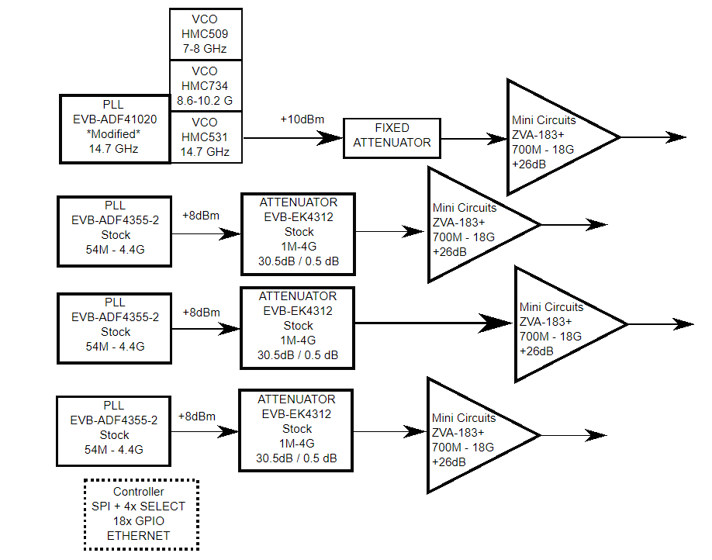

Figure 1 - System Block Diagram

## Oscillator Configuration

The system is designed around a series of Phase-Locked Loop evaluation boards. The ADF-41020 phase locked loop provides microwave carrier, and ADF-4355-2 phase locked loop provides RF carriers. The 4355-2 is wider band, with on-chip voltage-controlled oscillator (VCO). The microwave synthesizer 41020 is narrower band and uses an external VCO.

## Amplitude Control

The RF system is designed with programmable amplitude control. The Peregrine Semiconductor EVB-EK4312 programmable attenuator is used to drive the input amplitude prior to final gain. The microwave synthesizer is not programmable due to lack of suitable evaluation board.

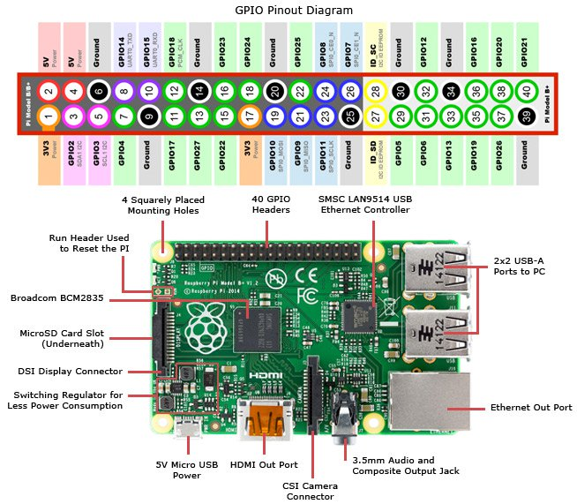

Figure 2: Raspberry Pi 3 Pinout

## Control Processor

The PLL oscillators and attenuators are controlled via a Raspberry Pi 3 control board. The PLL boards and Attenuators are controlled via serial peripheral interface (SPI) bus along with individual general-purpose I/O (GPIO) pins for Latch Enable. A list of GPIOs on the Raspberry Pi’s is shown in figure 2.

## Final Amplifier

The final drive to the appropriate laser modulator (AOM or EOM) is provided by three types of Mini-Circuits amplifiers. MPA-40-40 for RF(1-1000MHz), ZHL4240 for RF(10-4200MHz), and ZVE-3W-183+ for MW(5.9-18GHz). The MPA-40-40 is used for AOMs and lower frequency EOMs, the ZHL4240 is used for medium frequency EOMs, and the ZVE-3W-183+ is used for high frequency EOMs.

# Control Software

The Raspberry Pi 3 provides a Python control program to interface with GPIO lines and SPI. Details are given in a separate document.

# System Design

Next, we’ll talk about the design of our system and how we put it all together.

## Raspberry Pi Interfacing

The Raspberry Pi’s are each used to control up to four PLL or attenuator enclosures. All components are connected to the same SPI lines on the Raspberry Pi (Series or Parallel, it doesn’t matter). It was found that clock lines running to the attenuators tended to sometimes have an overvoltage, so a 500 Ohm resistor was added in series for each clock to attenuator connection. Another overvoltage problem occurred for latch enable to some types of PLLs, so a similar scheme is used between Latch Enable and all devices. For all Raspberry Pi’s, we start connecting the lowest item in enclosures from the lowest numbered available GPIO: 4, 5, 6, 12, 13, 16, 17, 18, 19, 20, 21, 22, 23, 24, 25, 26, 27.

For example: one Pi connected to a three-PLLs enclosure and a three-Attenuators enclosure – The bottom PLL Latch Enable is connected to GPIO 4 and the bottom Attenuator is connected to GPIO 12.

Information for how each Raspberry Pi is connected to the devices can be found in a separate document.

## 200 MHz AOMs

For the less important AOMs which we are just using to switch beams on and off, we just need a non-variable 200 MHz signal. For this purpose, we just use a single ADF4360-8 to produce 200 MHz. We first amplify the signal using a ADL5534 constant amplifier, and then split the signal into multiple RF lines using RF splitters described in another document.

## ~200 MHz AOMs

For some switch AOMs, we would like to have some control over the frequency, such as for the pumping or cooling 493nm lasers. For these, we use separate ADF4355 PLL boards.

## 100-4000 MHz EOMs

For low frequency EOMs, we use ADF4355 PLL boards. These boards have very strong odd harmonics if the frequency is below 800 MHz, so we use Mini-Circuits SLP low pass filters to reduce these signals.

## 6 GHz + EOMs

For high frequency EOMs, we use ADF41020 PLL boards. For these higher frequencies, it is very difficult to find attenuators, so we instead use FW set attenuators from Mini-Circuits.

# Component Enclosures

Each RF component is held in an aluminum enclosure to prevent stray RF from interfering with the boards. On the bottom of each enclosure, a power regulator for the necessary power is placed and the outputs are connected to the power supplies of each board. SPI connections are made through a D-Sub connector. Power is brought in via RCA jacks. For multiple PLLs which are used for similar frequencies or the frequencies are being combined, we put them into the same enclosure. The connection from these enclosures to the Raspberry Pi’s is made via 10-wire ribbon cables wired to D-Sub connectors. This design ensures that all enclosures and Pi’s are their own unit: you can easily pull one item out to work on it.

D-Subs are wired up as follows:

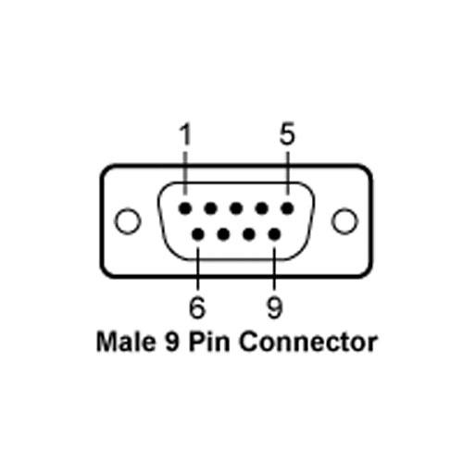

Figure 3: D-Sub Pins

|  |  |
| --- | --- |
| Pin | Connection |
| 1 | SPI Clock |
| 2 | SPI Data |
| 3 | Latch Enable 1 |
| 4 | Latch Enable 2 |
| 5 | Latch Enable 3 |
| 6 | Ground |
| 7 | 5V (ADF41020) |

Table 1: D-Sub Pins

# TTL/Switch Panel

For switching lines on and off, we use a TTL/Switch Panel. The RF Switch used is the ZX80-DR230+ from Mini-Circuits. There are three modes, which are chosen by a DP3T toggle switch on the front: On(Green), TTL(Red), and Off(Off). On mode provides 5V to the control on the RF switch, meaning it always outputs the signal. TTL connects the control to the BNC on the front of the panel. Off disconnects everything and there is no signal out.

# Amplifier Boxes

A set of aluminum enclosures is used to isolate the final amplifiers. DC Apevia CF6025S and CF6015S fans are used to cool the amplifier heat sinks. Power for the amplifiers and fans is provided through RCA jacks on the back. Since the fans require 12V, we use a power regulator attached to the rack mount to provide power.

# System Specifics

Finally, this section describes the components we used and which ones are connected to what other components.

RPi4: x2 ADF41020 PLL boards, x3 ADF4355 PLL boards(one enclosure), and x3 PE4312 attenuator boards(one enclosure). The two ADF41020 boards are completely separate, and the outputs of the three ADF4355 boards are attenuated by to the three PE4312 boards.

RPi3: x3 ADF4355 PLL boards(one enclosure), and x3 PE4312 attenuator boards(one enclosure). The outputs of the three ADF4355 boards are attenuated by to the three PE4312 boards.

RPi2: x3 ADF4355 PLL boards(one enclosure), and x3 PE4312 attenuator boards(one enclosure). The outputs of the three ADF4355 boards are attenuated by to the three PE4312 boards.

RPi1: x1 ADF4360 PLL board, x3 PE4312 attenuator boards(one enclosure). The output of the ADF4360 board is amplified by a ADL5534 board(in an enclosure) and split into several outputs which are fed into the attenuator boards.

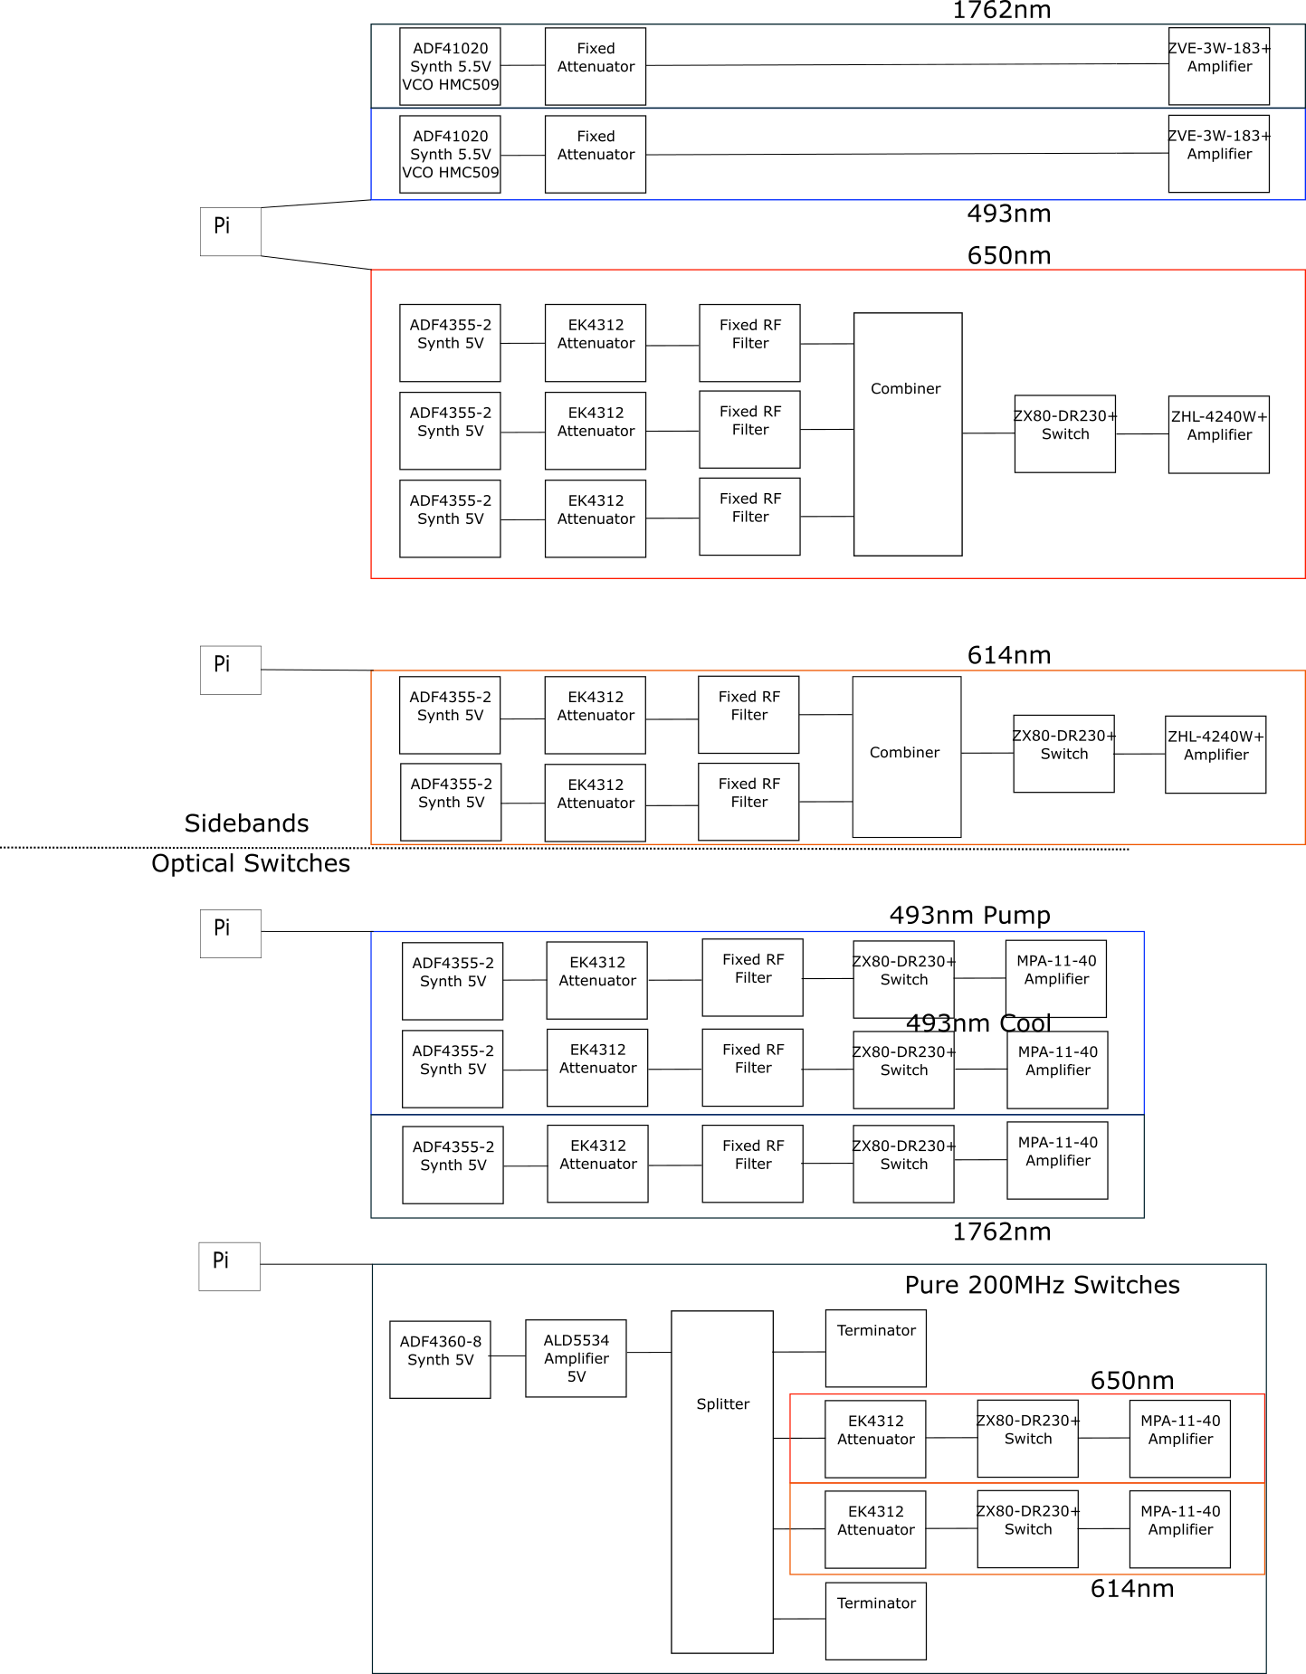

Figure 4: Overall System Diagram