IK141 Struktur Data
Pendahuluan Struktur Data
Tree



Di Susun Oleh :
Deden Ahmad Jamil
2501518

PROGRAM STUDI PENDIDIKAN ILMU KOMPUTER
FAKULTAS PENDIDIKAN MATEMATIKA DAN ILMU PENGETAHUAN ALAM
UNIVERSITAS PENDIDIKAN INDONESIA
22 April 2026
- Implementasi dan Hasil
Implementasi dan Hasil
Screenshot program no 1 C:
Screenshot adt atau struct:
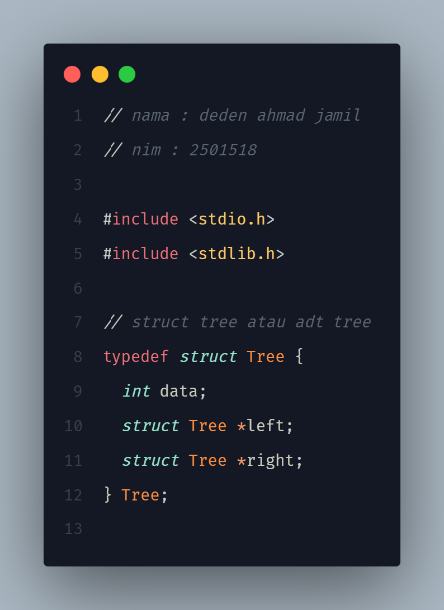
Screenshot createNode:
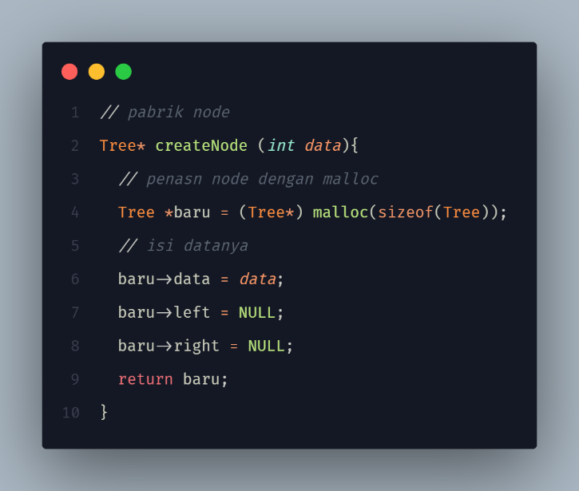

Screenshot insert:
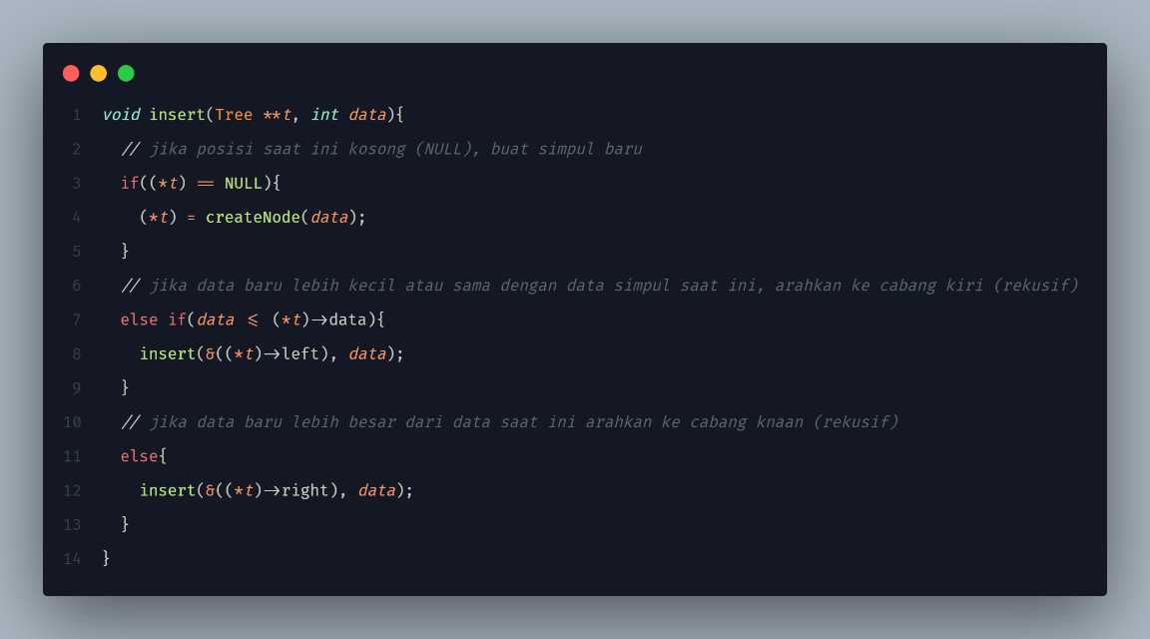
Screenshot inorder:
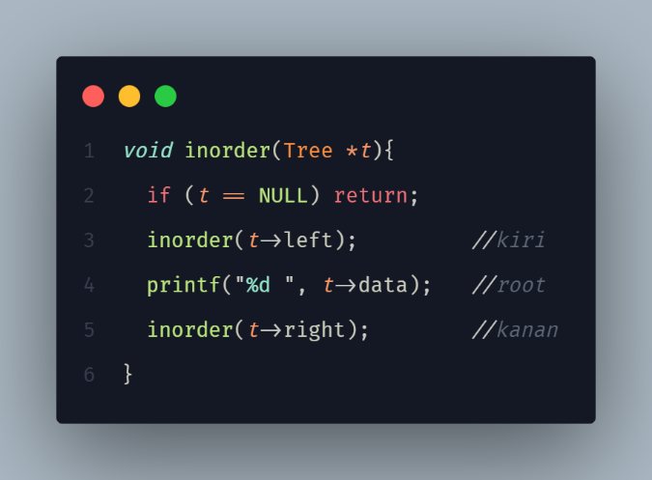
Screenshot preorder:
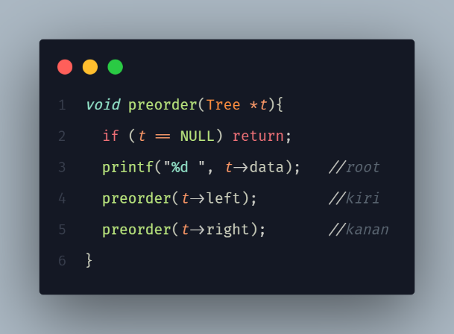

Screenshot postorder:
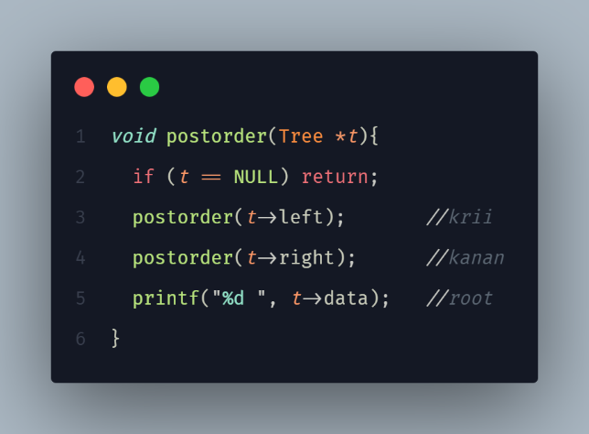
Screenshot main:
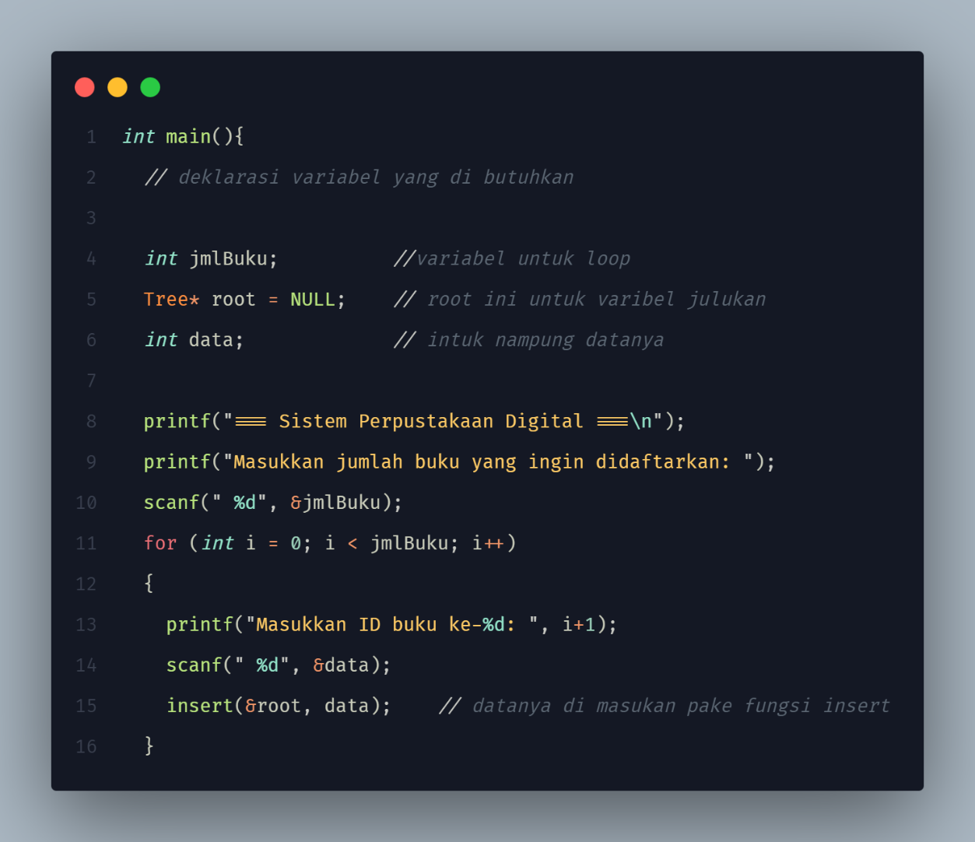

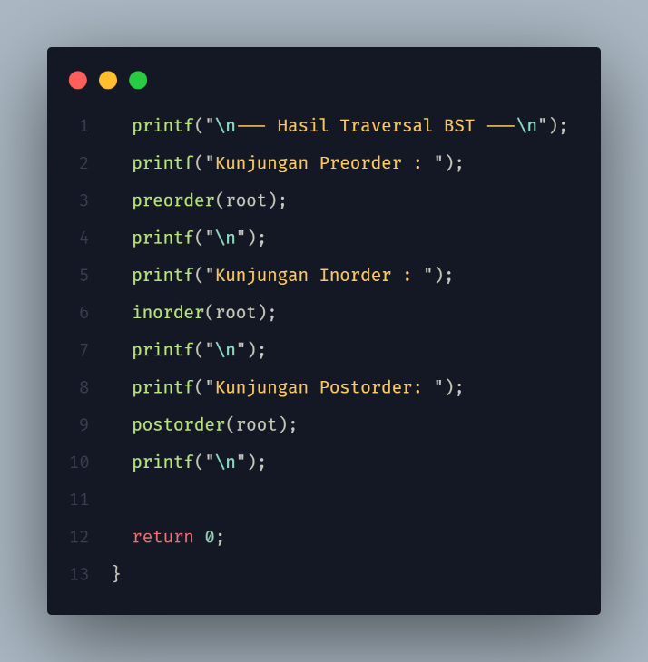
Screenshot output:
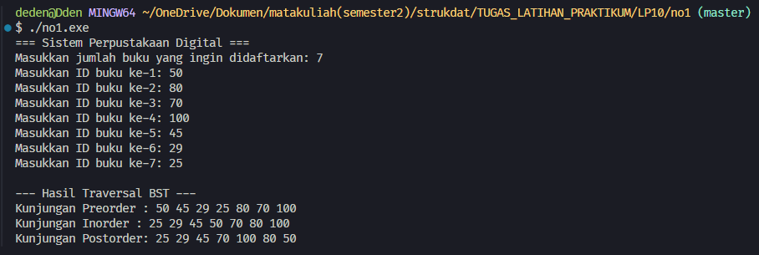

Screenshot program no 2 C:
Screenshot adt atau struct:
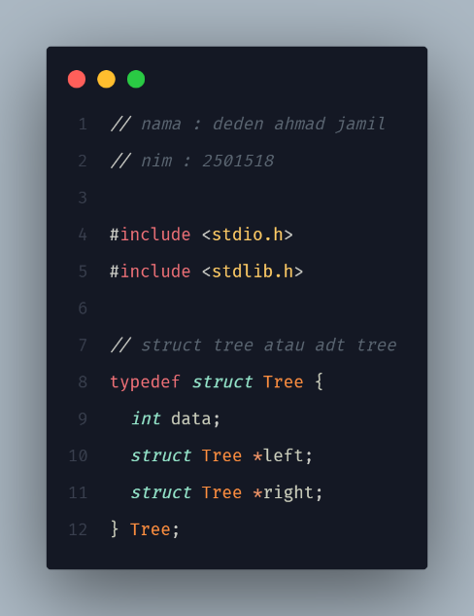
Screenshot createNode:
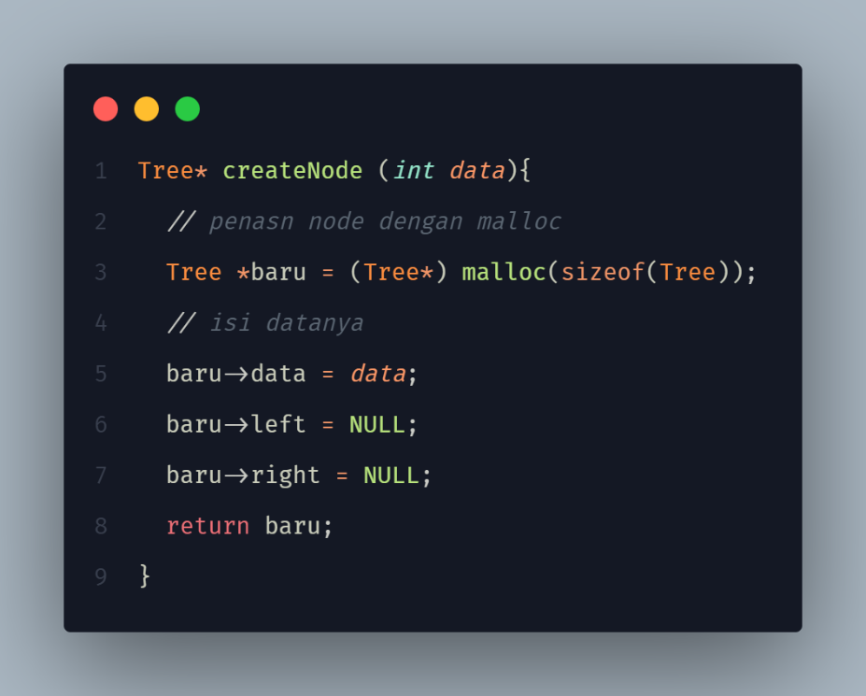

Screenshot insert:
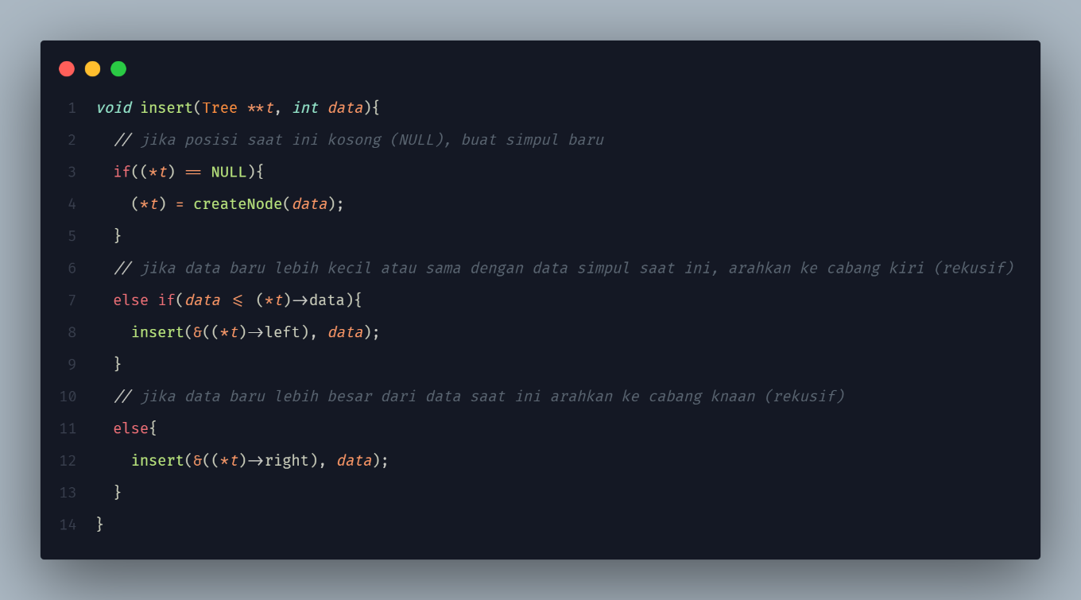
Screenshot search:
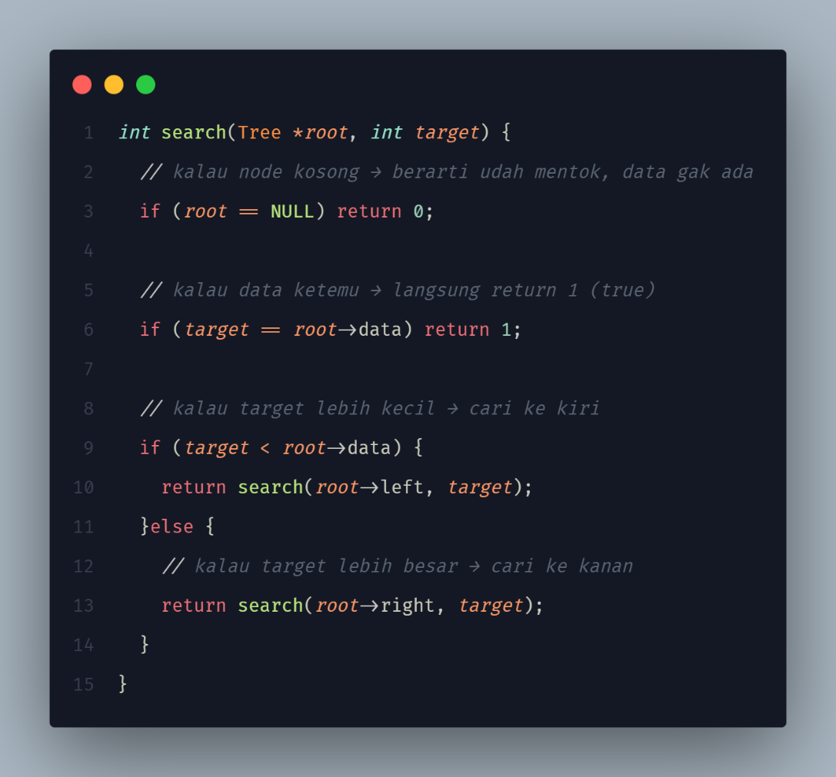
Screenshot main:
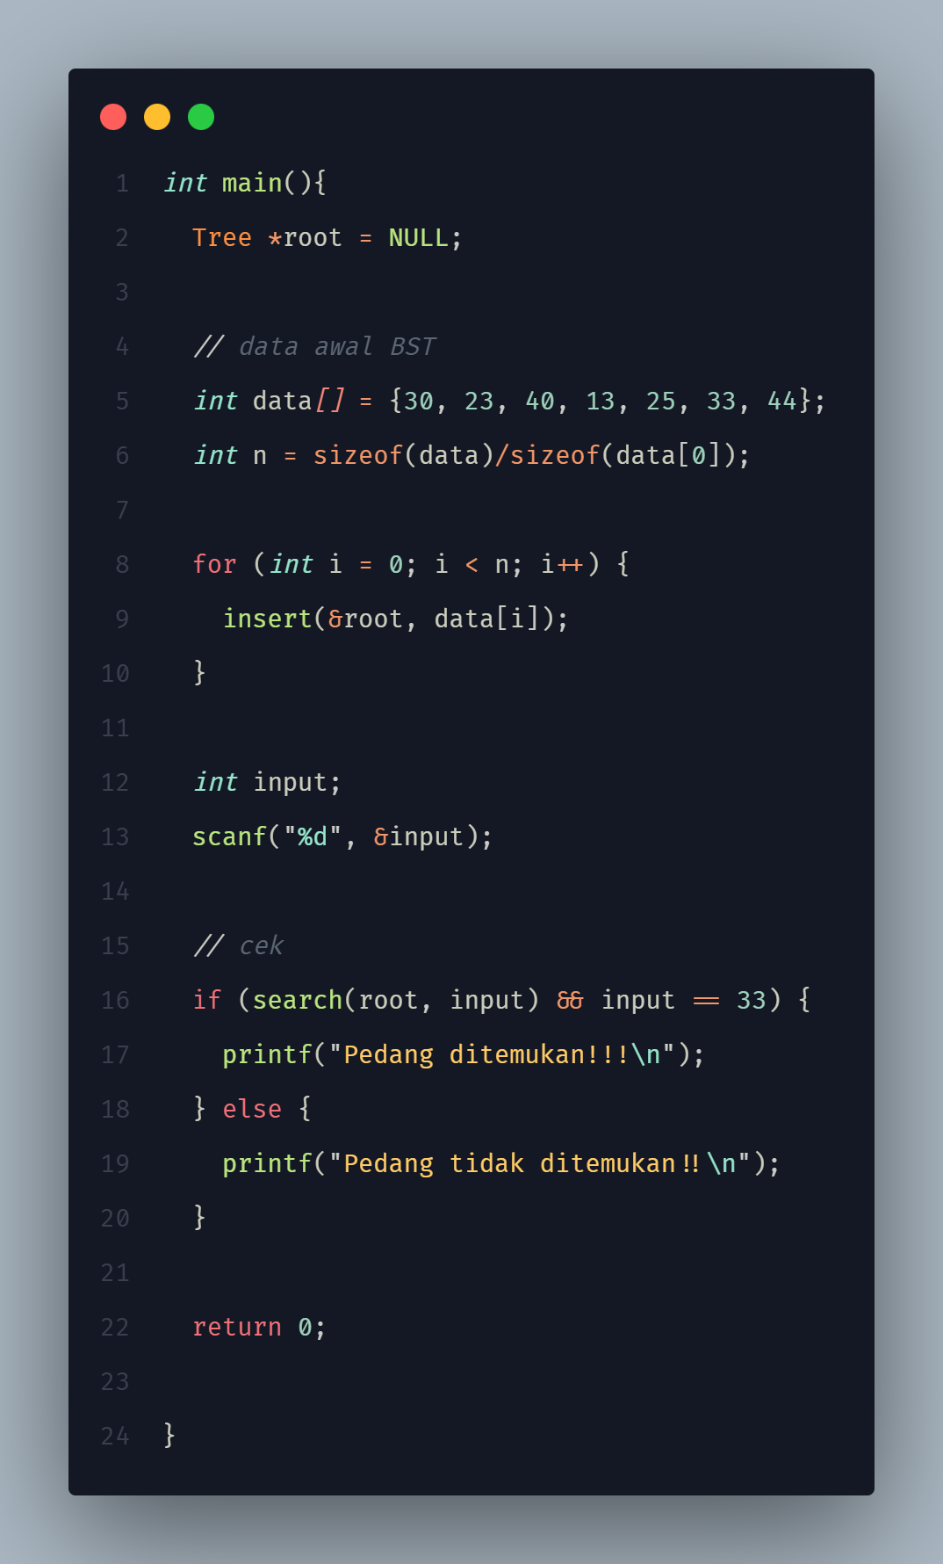

Screenshot output:
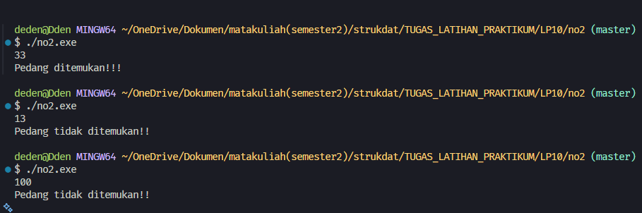
Screenshot program no 3 C:
Screenshot adt atau struct:
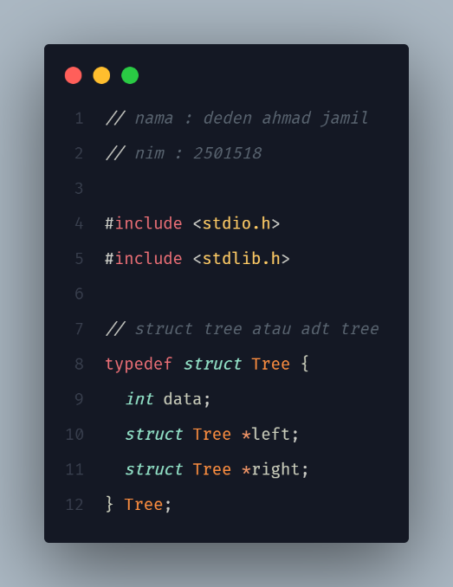
Screenshot create:
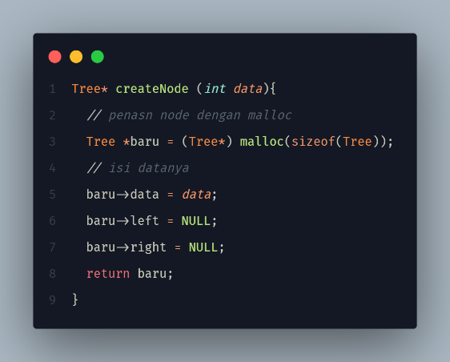
Screenshot insert:
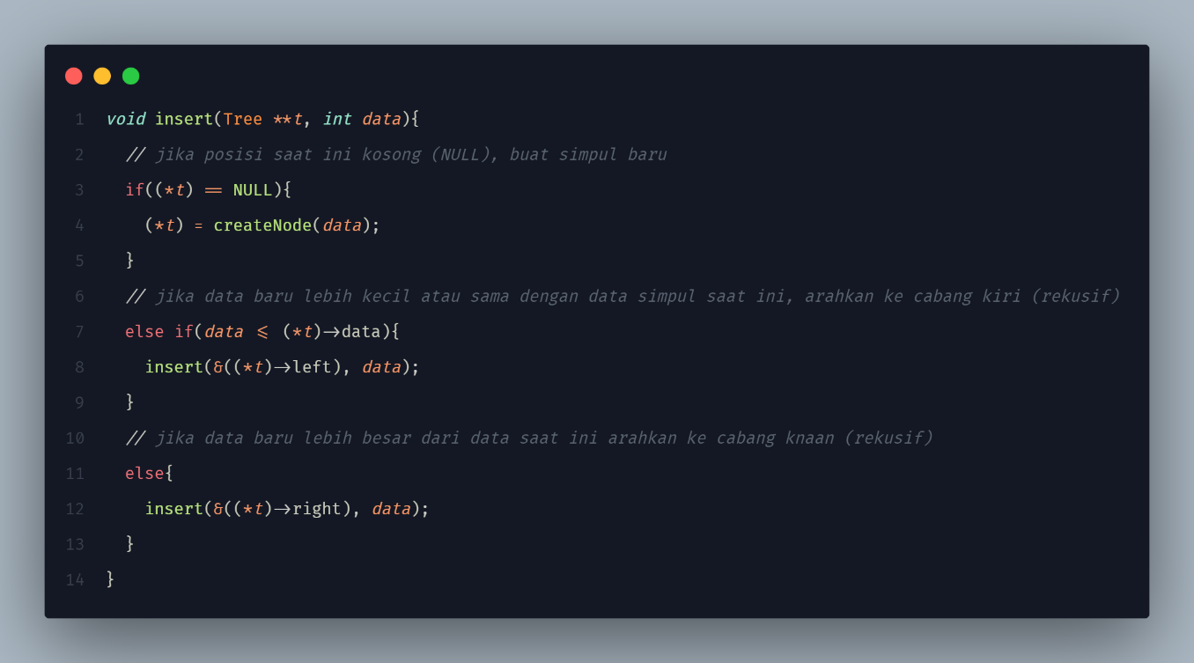

Screenshot searchRute:
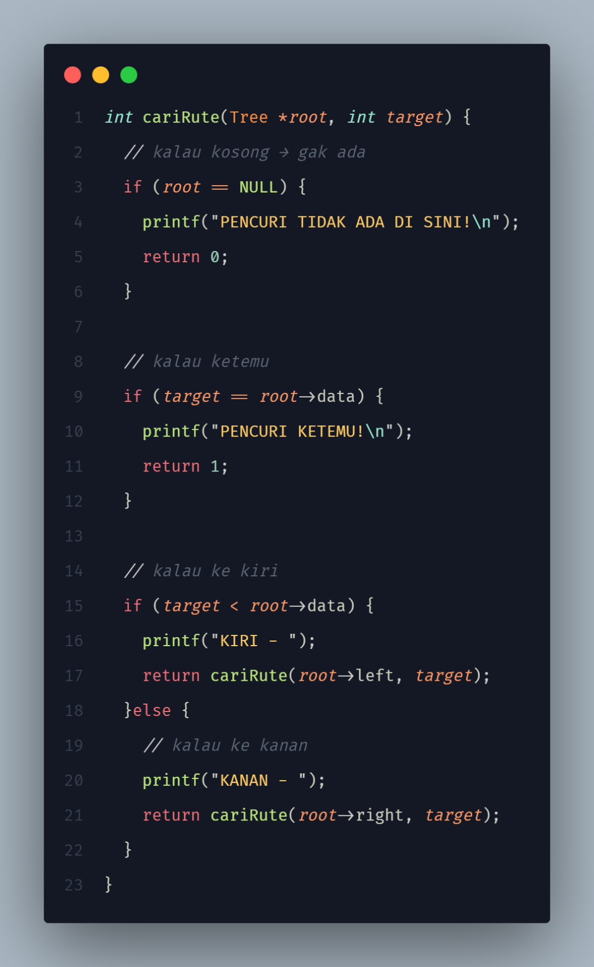

Screenshot main:
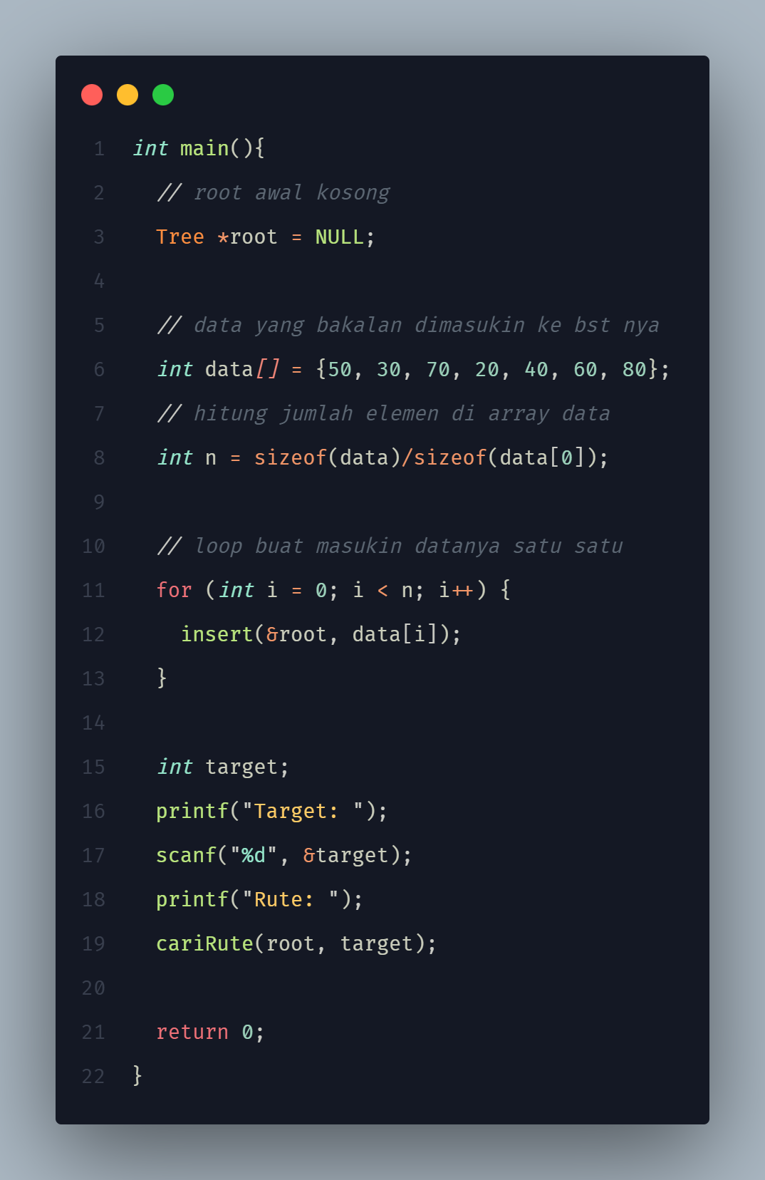

Screenshot output:
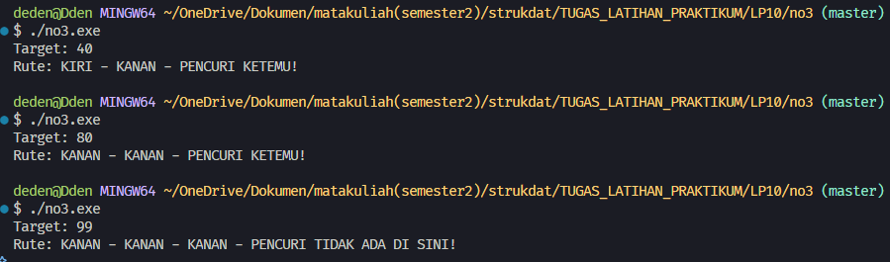
Screenshot program no 4:
Screenshot adt atau struct:
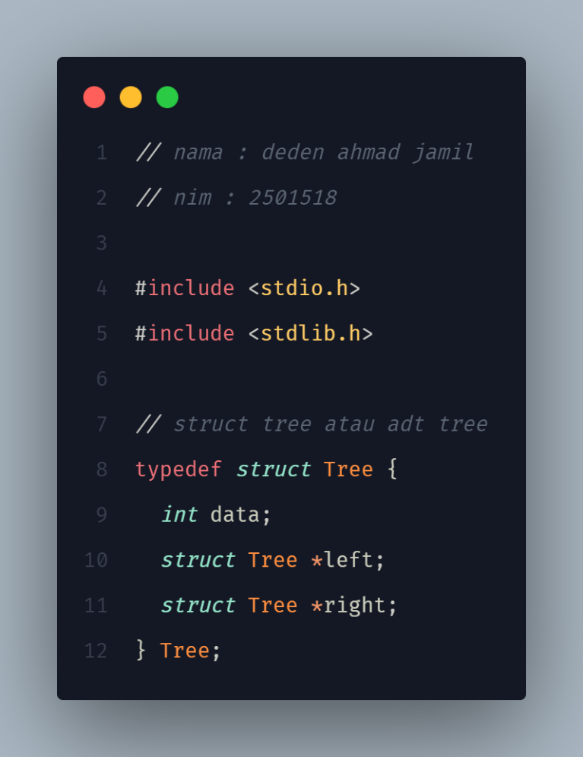

Screenshot create:
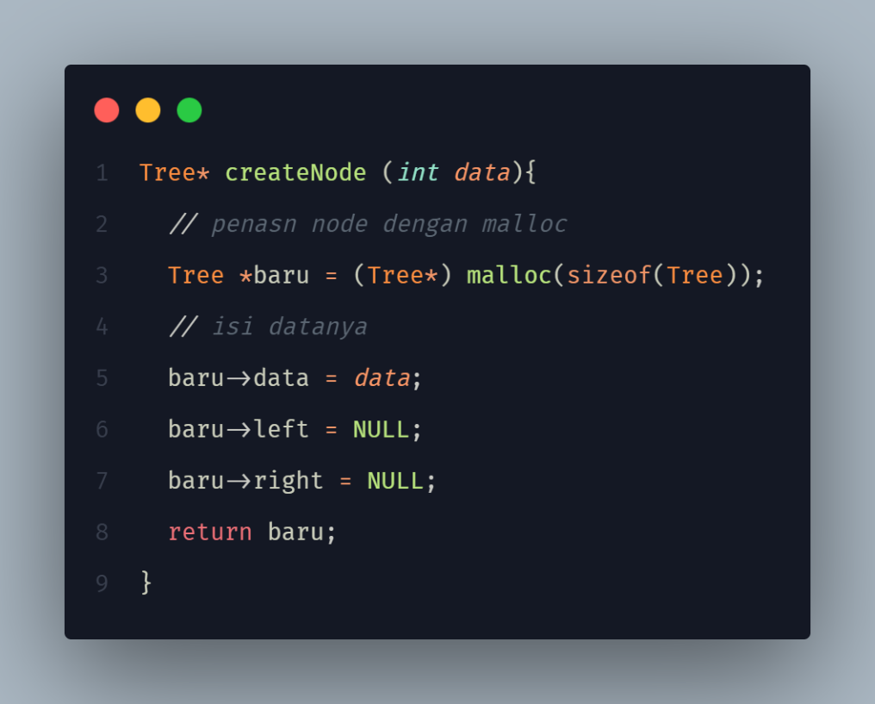
Screenshot insert:
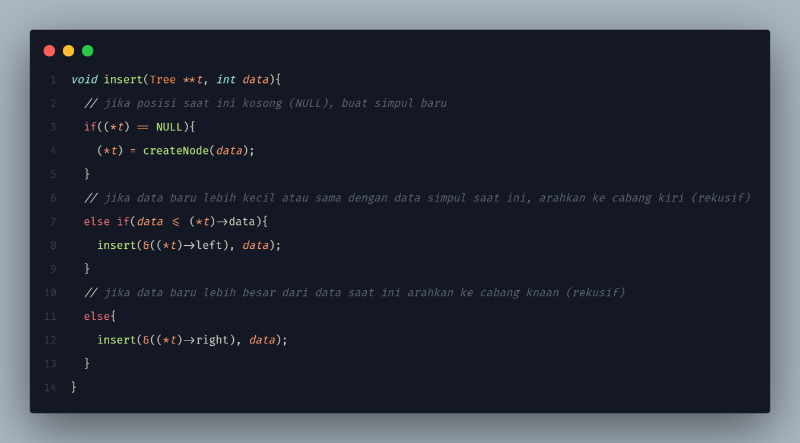

Screenshot inorder dan preorder:
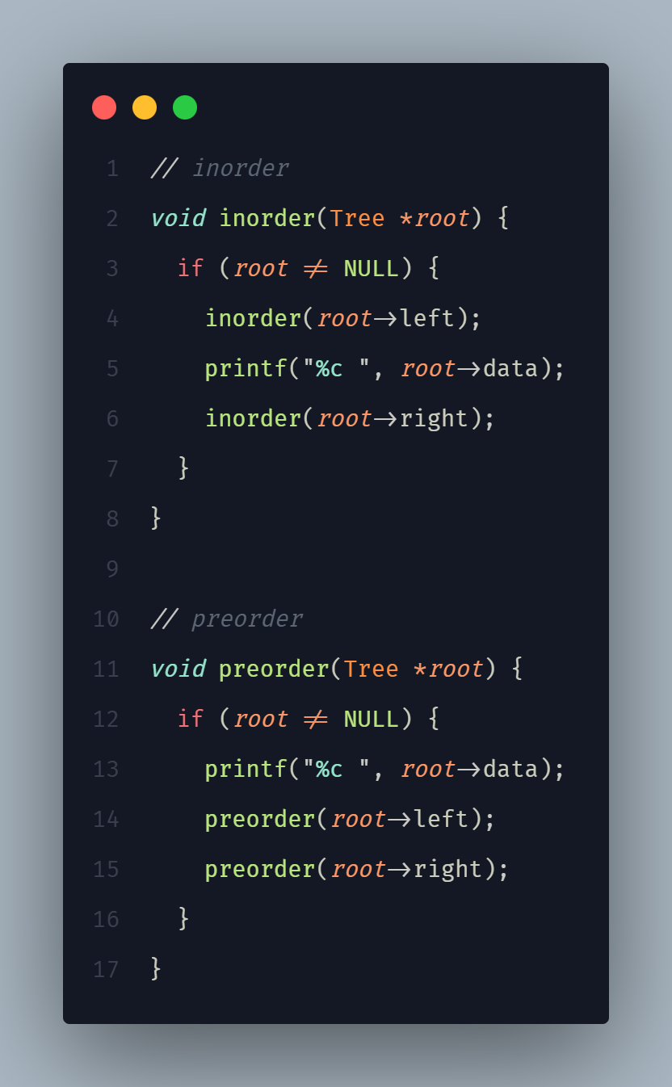

Screenshot search:
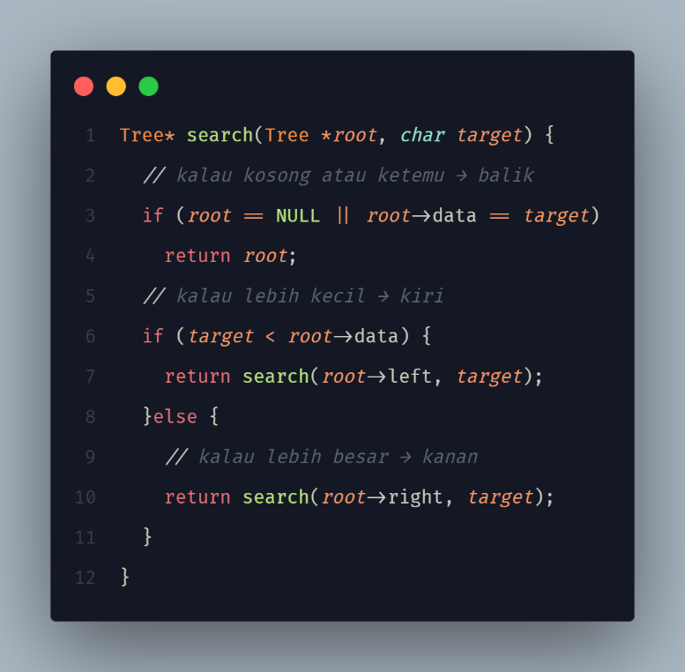
Screenshot delete all dan delete kanan sub:
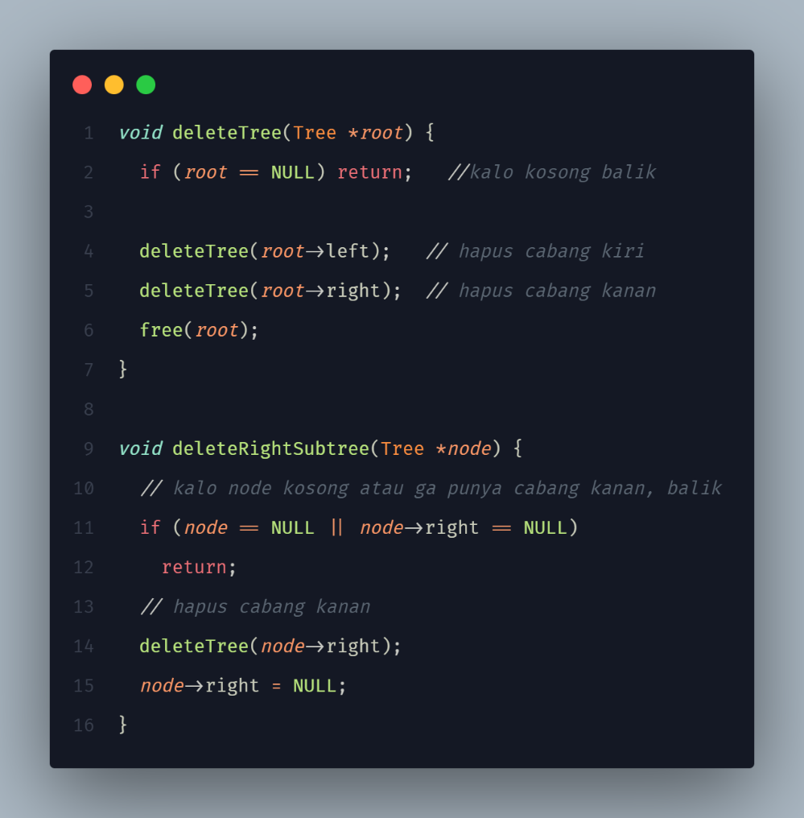
Screenshot main:
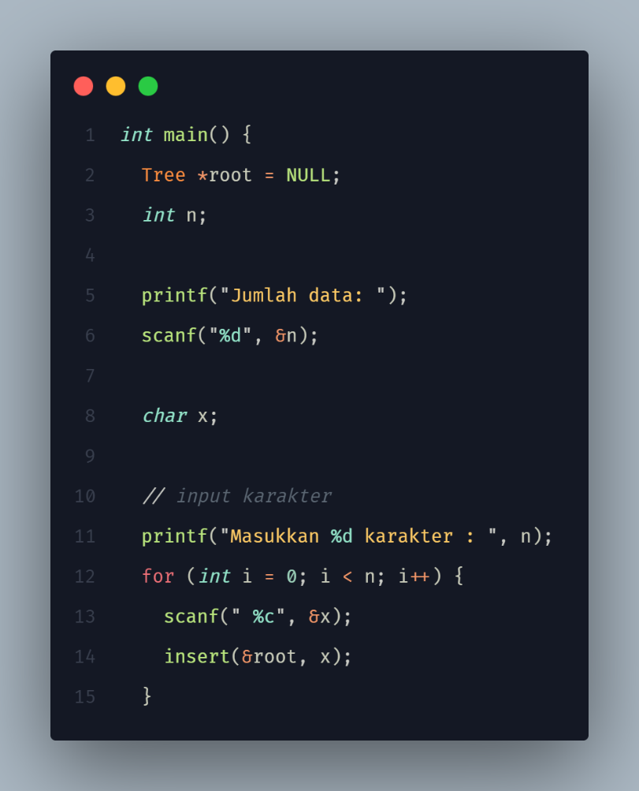
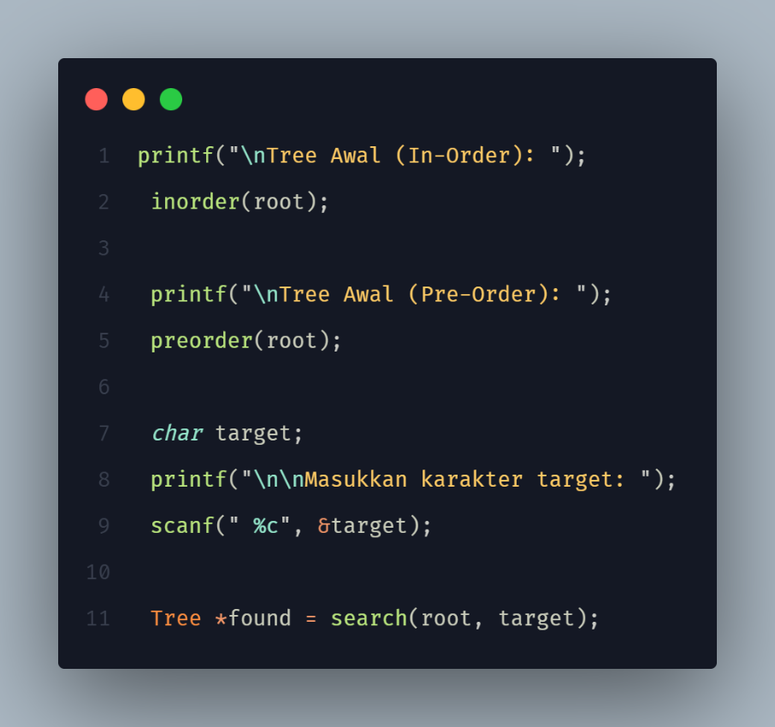
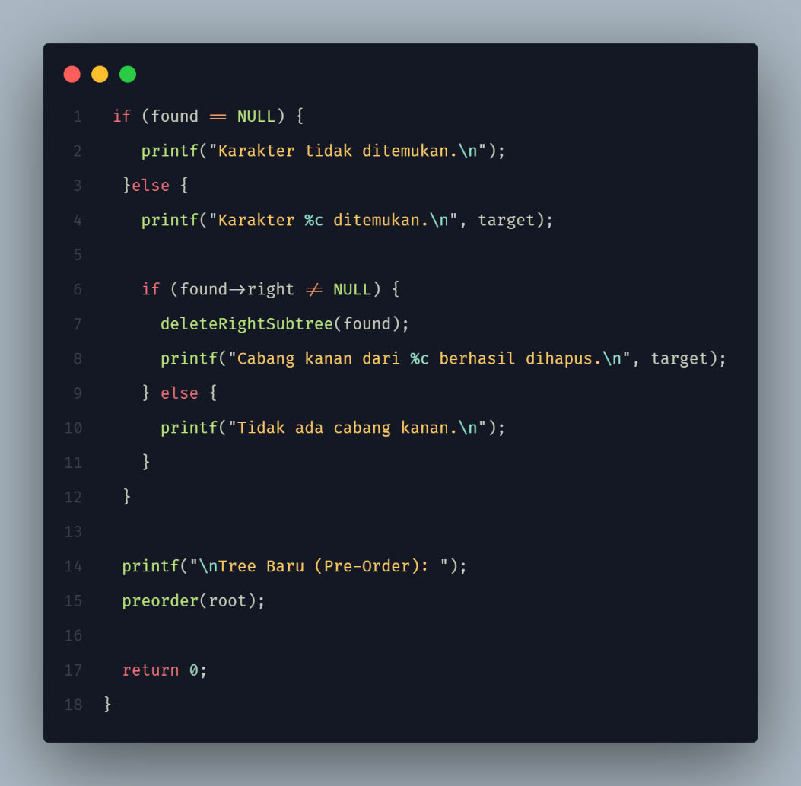
Screenshot output:
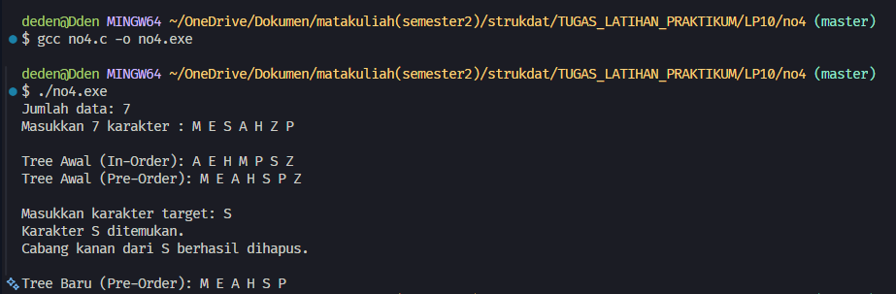

- Kesimpulan
Kesimpulan
-

