Decisions and Justifications
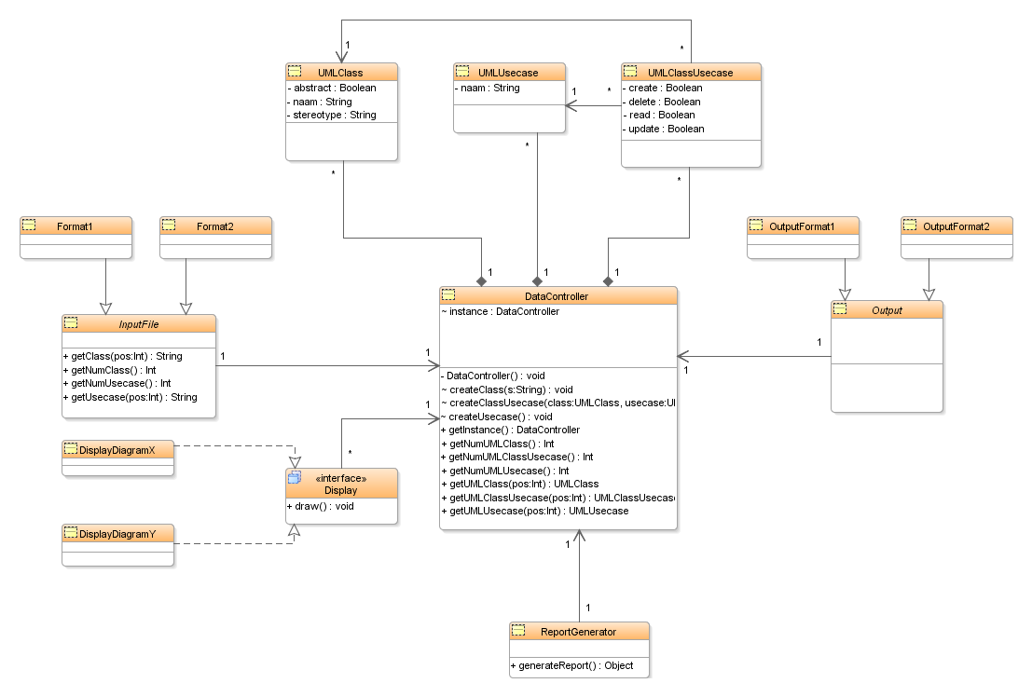
Bram is fucking boss he will make this document.

