Add Linked Web pages to a Node.js Application
1 In your web browser, go to IBM Bluemix™ at https://bluemix.net and LOG IN.
2 On a separate tab in your browser, go to DevOps Services at https://hub.jazz.net/ and SIGN IN.
3 You can either continue with the project you used for Card 3, or start a new project. To continue:
Use My STUFF to find your project of my name | myname-NodeJS_Simple_2, Open the application and EDIT CODE. OR to start a new project: Go to rewillen | NodeJS_Simple_2 , EDIT CODE, and FORK like card 2.
4 Open the views folder, and then Click on indexwithhtml.ejs and copy lines 9-15.
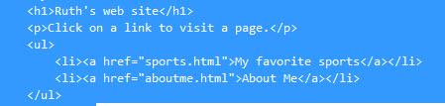
5 Click on index.ejs and paste the content after line 8. Index.ejs should now look like indexwithlinks.ejs.
6 Click on manifest.yml. DEPLOY and use the Manual Deployments page to view your application.
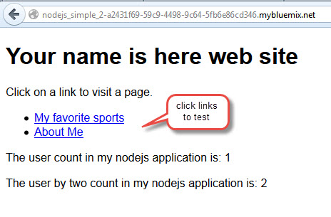
7 Follow the links to My favorite sports and About Me pages
8 Back in DevOps Services, Click on public directory.
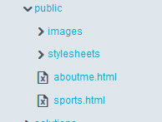
9 Edit the text in aboutme.html.
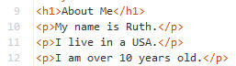

10 Edit the img line in aboutme.html to reference a picture which will be uploaded in the next steps.
11In the public folder, Click on images.
12 Select File, Import, File or zip archive.
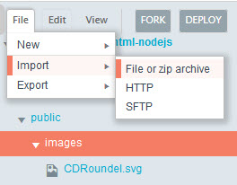
13 Navigate and select your image to upload.
14 Edit sports.html. Insert links to your favorite sports and games.

Step 7. Explore the application from browser
15 Again, click on manifest.yml. Deploy and use the Manual Deployment page to view your application. Check that your image displays and your new links work.
16Experiment with any HTML features that you want. You can complete the My First Website CoderDojo HTML exercises.

