Add HTML to a Node.js Application
1 In your web browser, go to IBM Bluemix™ at https://ace.ng.bluemix.net and LOG IN.
2 On a separate tab in your browser, go to DevOps Services at https://hub.jazz.net/ and SIGN IN.
3 Use EXPLORE to search and find sample application rewillen | coderdojo-html-nodejs, Open the application, EDIT CODE, and FORK like you did on Steps 3-6 on card 2.
4 Deploy the application and follow Routes like you did on card 1. You should see a formatted HMTL page in the browser. Refresh. You should see the count increment.
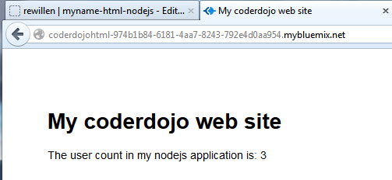
5 Back in DevOps Services, Open the views folder, and then Click on index.ejs to edit the HTML.
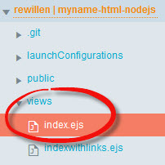
6 Edit the <title> and <h1> tags to say your name <h1>My name web site</h1>
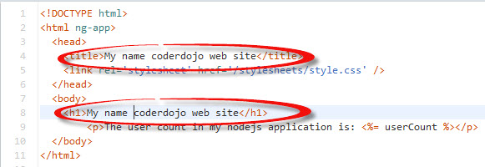
7 Click on app.js. Deploy your application and follow Routes.
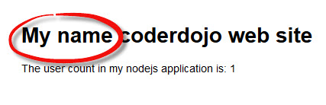
8 Back in DevOps Services, edit app.js. Add a new variable, userbytwo and initialize it to 0.
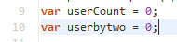
9 Increment userbytwo like this: userbytwo = userbytwo + 2;
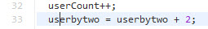
10 Add userbytwo as a variable to pass to the new HMTL page for display by updating line 34 like this: res.render('index', {userCount: userCount, userbytwo: userbytwo}); Your app.get code block should now look like this:
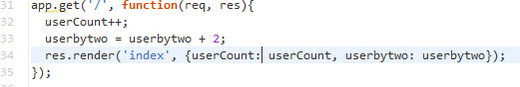
11 Return to the views folder, and then Click on index.ejs
12 Copy and paste line 9. Change usercount to userbytwo to also display your new variable.
13 Click on manifest.yml before deploying. Deploy your application and follow Routes.
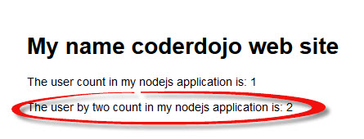

14 Experiment with displaying additional information from your node.js server on the HTML page.

