Add HTML to a Node.js Application
1 In your web browser, go to IBM Bluemix™ at https://ace.ng.bluemix.net and LOG IN.
2 On a separate tab in your browser, go to DevOps Services at https://hub.jazz.net/ and SIGN IN.
3 Open the sample project rewillen | NodeJS_Simple_2, EDIT CODE, and FORK like you did on card 2.
4 DEPLOY the application, follow the link in the green box to “root folder page”, and wait for the Manual Deployment information to display like you did on card 1. Click on NodeJS_Simple_2.
5 You should see a formatted HMTL page in the new browser tab. Hit Refresh in the browser. You should see the count increment.
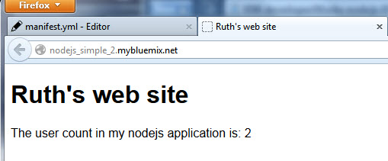
6 Back in DevOps Services, Open the views folder, and then Click on index.ejs to edit the HTML.
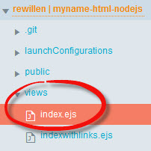
7 Edit the <title> and <h1> tags to say your name <h1>My name web site</h1>
8 Click on app.js. DEPLOY your application and use the Manual Deployment page to see your application. Check that the changes are displayed.
9 Back in DevOps Services, click on app.js. Add a new variable, userbytwo and initialize it to 0.
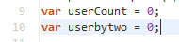
10 Increment userbytwo like this: userbytwo = userbytwo + 2;
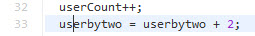
11 Update the render command to add userbytwo as a variable to pass to the HTML page for display like this: res.render('index', {userCount: userCount, userbytwo: userbytwo}); Your app.get code block should now look like this:
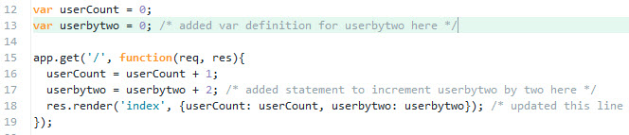

12 Return to the views folder, and then Click on index.ejs
13 Copy and paste line 9. Update the text and change usercount to userbytwo to also display your new variable.

14 Click on manifest.yml before deploying. DEPLOY your application and use the Manual Deployment page to see your application changes.

15 Experiment with displaying additional information from your node.js server on the HTML page.

