Kids Code! Card 1

Create a website using Node.js

1 In your web browser, go to IBM Bluemix at https://ibm.biz/bluemix4kids and Log In.
2 On a separate tab in your browser, go to DevOps Services at https://hub.jazz.net/ and Sign In.
3 Open the sample project rewillen | NodeJS_Simple_2 in your browser.
Note: if you are working from a hardcopy type: https://ibm.biz/nodejs2 or Explore for “rewillen”
4 Click on Fork Project and give it a new name.
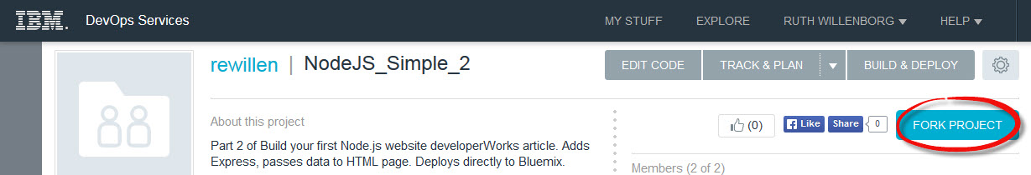
5 Click Edit Code
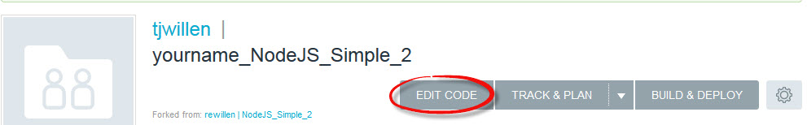
6 Open the views folder, and then Click on index.ejs to edit the HTML.
7 Edit the <title> and <h1> tags to say your name <h1>My name web site</h1>

8 Click on manifest.yml. Deploy the Application. Wait for the deployment to complete and the green box shown in Step 9 to appear.
9 See the Manual Deployment page by following the root folder page link in the green box message.
10 Wait until the Manual Deployment information refreshes on the page, and you see a green success indicator for your deployment.
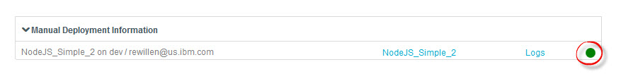
11 Click on the NodeJS_Simple_2 link to view your application.
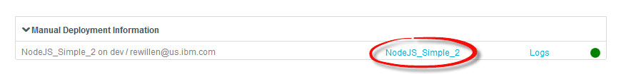
12 A separate browser tab will open with your application. You should see the text you changed.
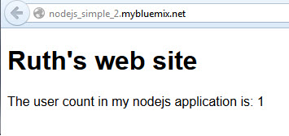
13 Refresh the application in the browser. What happens? The count should increment.
