Kids Code! Card 2

Add Node.js code to your Website

1 In your web browser, go to IBM Bluemix at https://ibm.biz/bluemix4kids and log in.
2 On a separate tab in your browser, go to DevOps Services at https://hub.jazz.net/ and sign in.
3 You can either continue with the project you used for Card 1, or start a new project. To continue:
Use My Stuff to find your project of my name | myname-NodeJS_Simple_2, Open the application and Edit Code
Or, to start a new project, refer to Kids Code! Card 1.
4 Click on app.js to open the node.js application code.
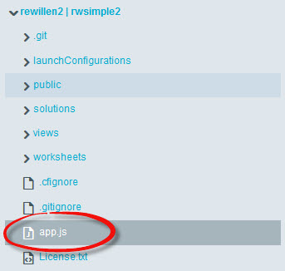
5 Add a new variable, userbytwo and initialize it to 0.
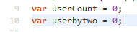
6 Increment userbytwo like this: userbytwo = userbytwo + 2;
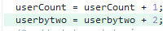
7 Update the render command to add userbytwo as a variable to pass to the HTML page for display like this: res.render('index', {userCount: userCount, userbytwo: userbytwo}); Your app.get code block should now look like this:
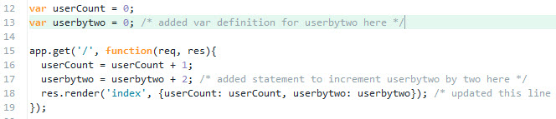
8 Return to the views folder, and then Click on index.ejs
9 Copy and paste line 9. Update the text and change usercount to userbytwo to also display your new variable.
10 Click on manifest.yml before deploying. DEPLOY your application and use the Manual Deployment page to see your application changes. Refresh the application in the browser and watch the counters increase.
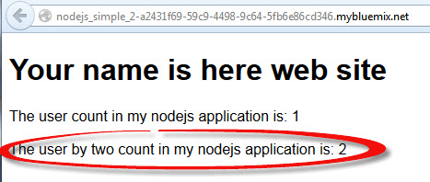
11 Return to the Manual Deployment Information in the root folder page, click on your deployment, and Stop your application.
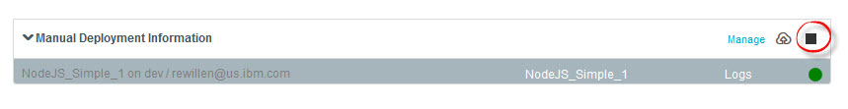
12 Click on your deployment again, and Start your application in BlueMix.
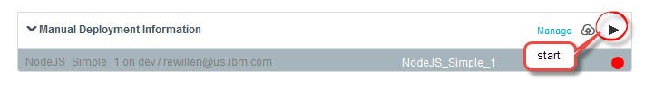
13 Follow the NodeJS_Simple_2 link again to open the application running in a separate tab. * What happens to the count? The count should be reset to 1 visit.

