Kids Code! Card 3

Add Linked Web pages to your Node.js Website

1 In your web browser, go to IBM Bluemix at https://ibm.biz/bluemix4kids and LOG IN.
2 On a separate tab in your browser, go to DevOps Services at https://hub.jazz.net/ and SIGN IN.
3 You can either continue with the project you used for Card 2, or start a new project. To continue:
Use My Stuff to find your project of my name | myname-NodeJS_Simple_2, Open the application and Edit Code.
Or, to start a new project, refer to Kids Code! Card 1.
4 Open the views folder, and then Click on indexwithhtml.ejs and copy lines 9-15.

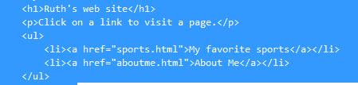
5 Click on index.ejs and paste the content after line 8. Index.ejs should now look like indexwithlinks.ejs.
6 Click on manifest.yml. Deploy and use the Manual Deployments page to view your application.
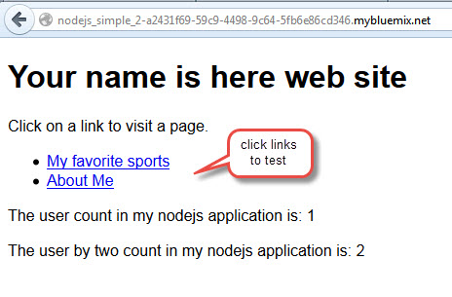
7 Follow the links to My favorite sports and About Me pages
8 Back in the DevOps Services tab, Click on public directory.
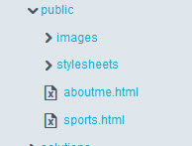
9 Edit the text in aboutme.html.
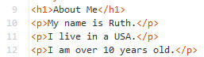

10 Edit the img line in aboutme.html to reference a picture which will be uploaded in the next steps.

11 In the public folder, click on images.

12 Select File, Import, File or zip archive.
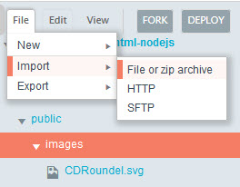

13 Navigate and select your image to upload.
14. Edit sports.html. Insert links to your favorite sports and games.

15 Again, click on manifest.yml. Deploy and use the Manual Deployment page to view your application. Check that your image displays and your new links work.
16 Experiment with any HTML features that you want. You can complete the My First Website CoderDojo HTML exercises.

