## Add HTML to a Node.js Application

1 In your web browser, go to IBM Bluemix™ at https://ace.ng.bluemix.net and LOG IN.

2 On a separate tab in your browser, go to DevOps Services at https://hub.jazz.net/ and SIGN IN.

3 Use EXPLORE to search and find sample application *rewillen | coderdojo-html-nodejs, Open the application, EDIT CODE, and FORK like you did on Steps 3-6 on card 2.*

4 Deploy the application and follow Routes like you did on card 1. You should see a formatted HMTL page in the browser. Refresh. You should see the count increment.

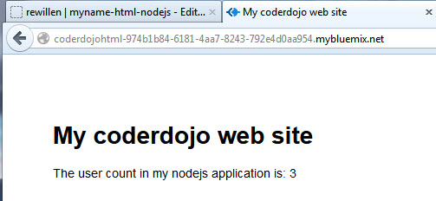5 Back in DevOps Services, Open the views folder, and then Click on index.ejs to edit the HTML.

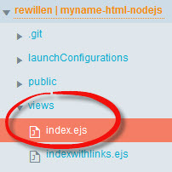

6 Edit the <title> and <h1> tags to say your name <h1>My name web site</h1>

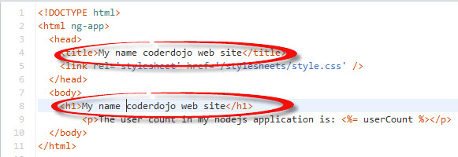

7 Click on app.js. Deploy your application and follow Routes.

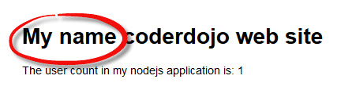

8 Back in DevOps Services, edit app.js. Add a new variable, *userbytwo* and initialize it to 0.



9 Increment *userbytwo* like this: userbytwo = userbytwo + 2;



10 Add userbytwo as a variable to pass to the new HMTL page for display by updating line 34like this*: res.render('index', {userCount: userCount, userbytwo: userbytwo});* Your app.get code block should now look like this:

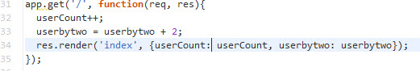

11 Return to the views folder, and then Click on index.ejs

12 Copy and paste line 9. Change usercount to userbytwo to also display your new variable.

**

13 Click on manifest.yml before deploying. Deploy your application and follow Routes.

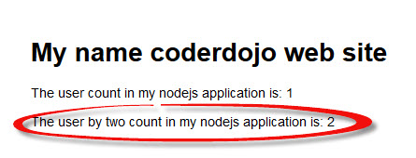

14 Experiment with displaying additional information from your node.js server on the HTML page.