## Add Linked Web pages to a Node.js Application

1 In your web browser, go to IBM Bluemix™ at https://ace.ng.bluemix.net and LOG IN.

2 On a separate tab in your browser, go to DevOps Services at https://hub.jazz.net/ and SIGN IN.

3 To continue using the same project as you used for Card 3:

Use My STUFF to find your code of *my name | myname-coderdojo-html-nodejs, Open the application and EDIT CODE.*

4 OR To start a new project:

Use EXPLORE to search and find sample application *rewillen | coderdojo-html-nodejs, Open the application, EDIT CODE, and FORK like you did on Steps 3-6 on card 2.*

5 Open the views folder, and then Click on indexwithhtml.ejs and copy lines 9-13.

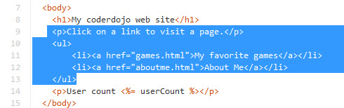

6 Click on index.ejs and paste the content after line 8. Index.ejs should now look like indexwithlinks.ejs.

7 Click on manifest.yml. Deploy and follow Routes.

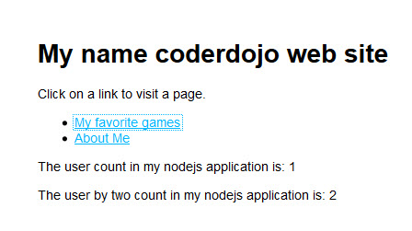

8 Follow the links to My favourite games and About Me

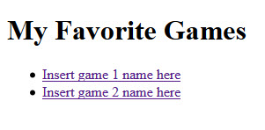

9 Back in DevOps Services, Click on public directory.

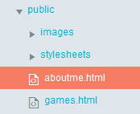

10 Edit the text in aboutme.html.

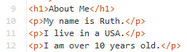

11 Edit the img line in aboutme.html to reference a picture which will be uploaded in the next steps.

**

12 In the public folder, Click on images.

13 Select File, Import, File or zip archive.

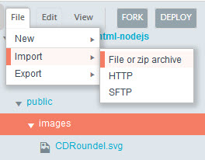

14 Navigate and select your image to upload.

15 Edit games.html. Insert links to your favourite games.



16 Again, click on manifest.yml. Deploy and follow Routes.

17 Experiment with any HTML features that you want. You can complete the My First Website CoderDojo HTML exercises.