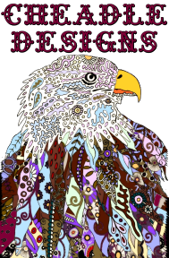

*Mediums and Alternatives*

* l Pouring Mediums (example is Liquitex™ Pouring Medium)
* l PVA/Elmer’s™ Glue (non-archival)
* l PVAc/Bookbinder’s™ Glue (archival)
* l Floetrol™ (flow aid)
* Glazing Mediums
* Gloss Mediums

