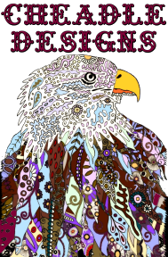

*Other Materials*

* Pouring Cups- 5 oz cups(or larger) for individual colors
* 10 oz. Cups(or larger) for dirty pours
* Jumbo Craft Sticks
* Additives (to aid in “cell” creation)
* Silicone
* Auto Lubricant
* Hair Products that contain Dimethicone
* Heat Source (Embossing Tool, Heat Gun or Butane Torch)
* Plastic Condiment Bottles with Cap
* Painting Knife / Spatula
* Knock down knife (for wide path swiping)
* Trowels - (for skimming and making designs in the paint)
* Pipettes (for adding small amounts of water to mix)
* Paper towels
* Apron
* Latex gloves