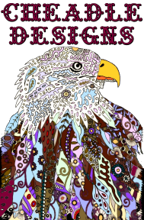

*Substrates*

* canvas (including recycled canvases)
* wood panel/ hardboard/Easy Flow Panels

* wood panel/ hardboard cradled
* Yupo™ paper
* Mixed media paper
* Old cd’s
* Old record albums
* Ceramic tiles
* Rocks and stones
* Old windows
* Furniture
* And More

Please note; Regardless what substrate you choose to paint on I recommend at least two coats of gesso or paint primer be applied [and allowed to dry] prior to any paint pouring.