Seven-Segment Displays

**Introduction**

This program computes a sub circuit of seven-segment LED displays.

**Background**

A seven-segment display is often used on computers, watches, VCRs and many electronic devices to display numbers and some characters. It consists of seven independent lights (light emitting diodes (LEDs)) in an ”8” configuration as shown below in Figure 1. By turning on different segments, you can display different numbers and some letters.

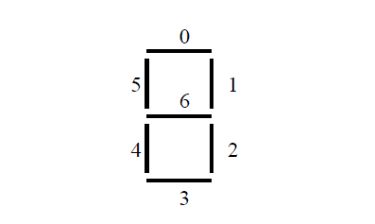

Figure 1: 7-segment Display

The Altera DE1-SoC board has six seven-segment displays (HEX0-HEX5 with HEX5 the one closest to the edge of the board) attached directly to the pins of the Cyclone V FPGA. Figure 1 shows the naming of each segment. See Table 3-9 on Page 27 of the DE1-SoC User Manual

**Simulation**

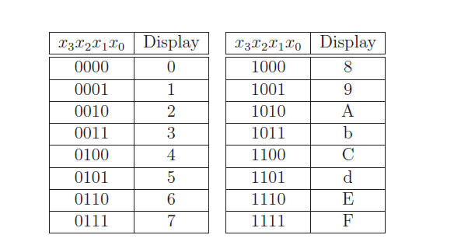

Compile this design for simulation using the Cyclone V FPGA (5CSEMA5F31C6) device and use the following pin assignments:

Connect the inputs to toggle switches SW[9], SW[8], SW[7] and SW[5] and use this component’s outputs to drive HEX5 on the Altera board.

The above table shows the inputs and the corresponding displays on the board.