Simple Image insertion

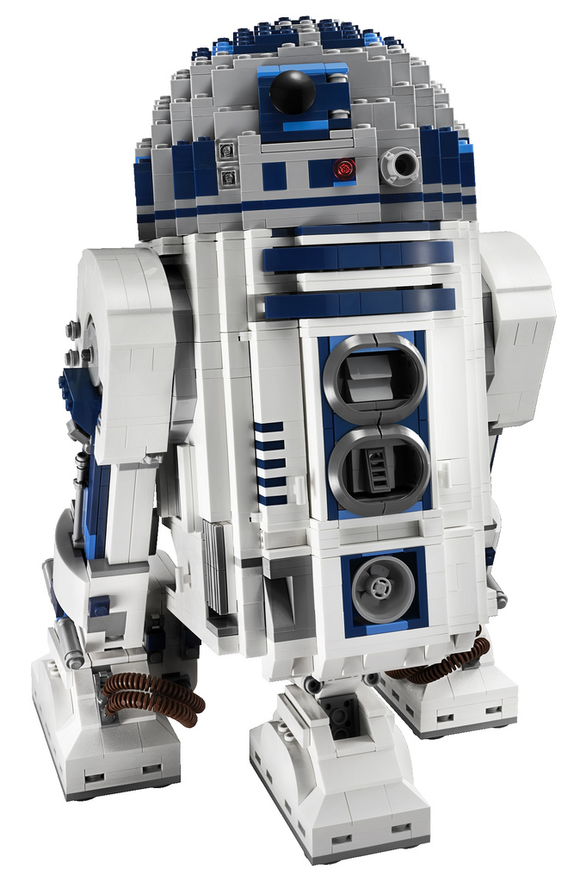

Try to insert image with missing context key



Simple image loop

|  |  |
| --- | --- |
| C-3PO | in items loop |
| R2-D2 | in items loop |
| Darth Vader | in items loop |
| Storm Trooper | in items loop |

Image inside IF construct

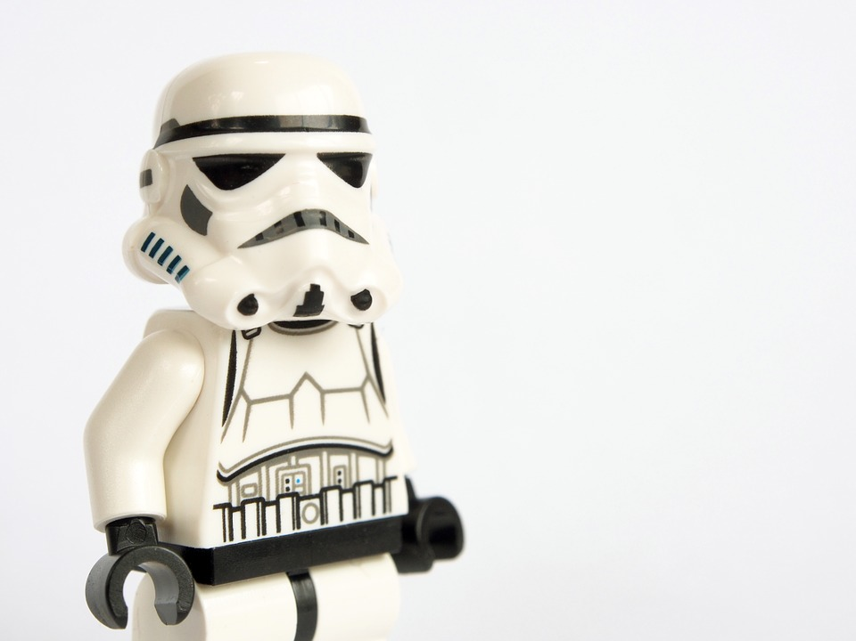

Try to insert image with missing placeholder