SOFTWARE DEVELOPMENT  
DOCUMENTATION  
  
Juan, Quim Joram R.

Core Features:

CORE FEATURES:

• Course Management: Add, edit, and delete courses.

• Student Management: Enroll students, maintain records, and assign grades.

• Faculty Management: Assign faculty to courses and manage their workloads.

• Authentication System: Role-based access for administrators, students, and faculty.

• Grade Management: Record and compute student grades.

• Reporting System: Generate detailed reports on grades, class lists, and faculty loads.

Structure and Branches:  
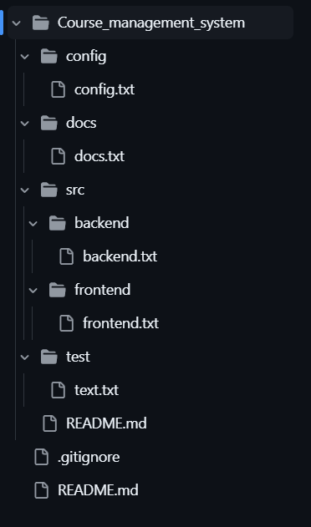

Issues:  
