UbiNavi iSail&iUSV Series User Manual
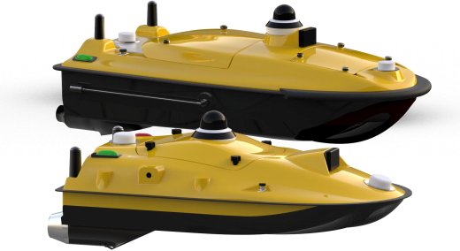
Shanghai Ubiquitous Navigation Co., Ltd
Shanghai UbiNavi Tech Co., Ltd
Headqurter: 11th Floor, Building 6, Lane 308, umin Road, Qingpu District, Shanghai 201702
Branch Factory: No. 528, Mingzhu Road, Qingpu District, Shanghai 201702
www.ubinavi.net marketing@ubinavi.net
+86 17858185283

Manual Revision History
Document No. □UbiNavi-iSail-20260324-V1.3.0
Revision Date | Reviser | Description
2024.09.01 | Leo Zheng | Version 1.0-Initial release. Includes the single-beam bathymetry module only.
2025.08.01 | Wayne  Wang | Version1.1.0.-Updated hardware overview and added descriptions of software functions.
2026.01.20 | John Li | Version 1.2.0.-Expanded the iSail software introduction and hardware overview.
2026.05.05 | Carmen Yu | Version 1.3.0.-Translated the Chinese manual into English
2026.05.28 | Kacy Pan | Version 1.3.0.-Calibration and review of the manual, illustrations.

1

Preface
Purpose of This Manual
Welcome tothe iSail Software User Manual provided by UbiNavi (Shanghai Ubiquitous Navigation Technology Co., Ltd.). This manual applies tothe iUSV series Unmanned Surface Vehicles,
includingthe Tboat10 and the Tboat20. The iSail software supports multiple functional modules, includingthe Control Module, Power Module, Obstacle Avoidance Module, Positioning Module,
Remote Control Module, and Power Supply Module.
If you encounter any issues during operation, please contact UbiNavi Technical Support.
Introduction to the Manual
This manual provides detailed introductions for operating the iSail software used with UbiNavi
iUSV series Unmanned Surface Vehicles. The software supports the automated acquisition,
processing, and analysis of data related to underwater topography, multi-parameter water quality, and specific target objects.
Experience Requirements
Skill Category | Requirements
Computer Operation | Familiar with basic Windows operating system operations, including file management (such as creating, copying, and renaming folders and files), software installation and uninstallation, and the use of basic peripheral devices such as a mouse, keyboard, and USB drive.
Touchscreen Operation | Proficient in using touchscreen gestures such as tapping, dragging, zooming, and long pressing, as iSail primarily operates on hydrographic survey tablets and Android  smartphones.
Technical Document  Comprehension | Able to read and understand technical documents such as this manual and follow written instructions to complete operational procedures step by step.
Background Knowledge
This software is primarily intended for surveying and mapping applications in fields such as offshore survey, inland waterway surveying, and hydrology. Users are recommended to possess one or more of the following areas of background knowledge:
2
□ Basics of Surveying and Mapping Engineering:
o Understanding of fundamental geodetic concepts, including coordinate systems (particularly CGCS2000 and WGS-84), map projection methods, and vertical datums.
o Knowledge of the basic principles of GNSS (Global Navigation Satellite System) positioning, includingthe operating modes and accuracy characteristics of RTK (Real-Time Kinematic) and PPK (Post-Processed Kinematic) technologies.
o Familiarity with basic surveying terminology, such as survey points, survey lines, baud rates, data links, and offset distances.
□ Marine/Hydrographic Surveying Knowledge
o Understanding of the basic principles and workflows of bathymetric surveying, including corrections for tides, sound velocity, and draft correction.
o Ability to read nautical charts or underwater topographic maps and interpret cartographic symbols for isobaths, sounding points, and underwater obstacles.
o (Optional, but highly recommended) Experience with echo sounders or waterborne survey software from other manufacturers.
□ Related Hardware Knowledge
o Understanding of the basic functions and operating principles of commonly used surveying devices, such as GNSS receivers, echo sounders, sound velocity profilers, and inertial
measurement units (IMUs).
o Familiarity with common connection methods between survey equipment and computers or tablets, including serial port, Ethernet, and Bluetooth connections, as well as related network configurations such as IP address and port settings.
Recommended Experience Levels
□ Junior User
o Requirements: Meets the basic operational skill requirements and possesses the relevant professional background knowledge described above.
o Capabilities: Under the guidance of experienced personnel, users can complete equipment
connections, perform basic software configuration, execute simple straight-line survey tasks, and export data.
NOTE: Prior to initial operation, it is recommended to read this manual thoroughly and
perform simulation exercises in a controlled onshore or calm-water environment.
□ Intermediate User
o Requirements: In addition to meeting the requirements for junior users, intermediate users

3
should possess at least three months of practical experience in hydrographic surveying
operations.
o Capabilities: Capable of independently completing the full survey workflow, including project creation, coordinate system configuration, equipment setup and calibration (such as RTK and heave filter configuration), survey line planning, survey execution, real-time data quality monitoring, and preliminary data post-processing.
Able to identify and handle common issues such as equipment connection failure and signal loss.
□ Advanced User
o Requirements: Possesses more than one year of regular experience using iSail or similar hydrographic survey software and has a thorough understanding of system workflows and operational logic.
o Capabilities: Capable of planning and managing complex survey projects, optimizing survey parameters to improve data quality under different operating conditions, and proficiently using advanced software functions such as automatic survey line generation for complex areas and multi-source data fusion processing.
Able to provide technical guidance to team members and efficiently troubleshoot complex
technical issues encountered during field operations.
Disclaimer
These experience requirements provided in this manual are intended as a capability reference for users and
do not constitute mandatory entry thresholds. Users with no prior experience can gradually master the operation of the iSail software through structured training and by studying.
It is strongly recommended that all new users complete adequate simulation exercises and training before initiating any field survey operations.
Safety Warning
Safety is the highest priority. Regardless of experience level, users must be familiar with applicable safety regulations for water-based operations and ensure that safety is consistently prioritized throughout all survey activities.

4
Contact Us
Phone Number | +86 17858185283
Company Name | SHANGHAI UBIQUITOUS NAVIGATION TECHNOLOGY  CO., LTD
Headquarter | 11th Floor, Building 6, Lane 308, Xumin Road, Qingpu District, Shanghai, 201702
Production Center | No. 528, Mingzhu Road, Qingpu District, Shanghai 201702
E-mail | kacy@ubinavi.net
Website | https://www.ubinavi.net/
Customer Support
For all customer service needs, including 24/7 emergency technical support, please contact us via WhatsApp at +86 178 5818 5283, or visit our official website at https://www.ubinavi.net/ and
navigate to the Support section to access and download manuals, firmware updates, software, and other related documentation.
Tips:
囗Caution囗
The content marked as“Caution”indicates important operational instructions that require special attention. Please read carefully before proceeding.
囗! Warning:
The content marked as“Warning”contains critical safety information. Failure to follow or disregard these instructions may result in equipment damage, data loss, system malfunction, or personal injury.
囗Notice:
The content marked as“Notice”provides important information to help users avoid potential issues or highlights additional considerations when using the described functions.

5
Copyright and Legal Notice
This manual and all its contents, including but not limited to text, technical specifications, diagrams, and flowcharts, are the exclusive property of Shanghai Ubiquitous Navigation Technology Co., Ltd. (© UbiNavi 2025).
No part of this manual may be reproduced, distributed, modified, translated, or used for commercial purposes, or incorporated into any other documents or systems in any form (including electronic, mechanical,
photocopying, recording, or otherwise) without prior written authorization from UbiNavi.
This manual and any related software are provided solely for informational purposes for end users. UbiNavi reserves the right to modify or withdraw the content at anytime without prior notice. This manual constitutes
proprietary information of UbiNavi and is protected under the copyright laws of the People’s Republic of China and applicable international treaties.
To the maximum extent permitted by applicable law, this manual is provided “as is”, without warranties of any kind, either express or implied, including but not limited to implied warranties of merchantability, fitness for a particular purpose, or non-infringement. In no event shall UbiNavi be liable for any direct, indirect,
incidental, consequential, or special damages arising out of or in connection with the use of this manual or related products, including but not limited to loss of profits, business interruption, loss of goodwill, or loss of data, even if advised of the possibility of such damages.
Use of this manual and any related products is subject to the applicable End User License Agreement (EULA).
All trademarks, trade names, service marks, and logos mentioned in this document are the property of their respective owners.
Disclaimer
Please read this section carefully before using the iSail software and related products, including but not
limited to hardware, firmware, documentation, and services provided by Shanghai Ubiquitous Navigation Technology Co., Ltd. (hereinafter referred to as“UbiNavi”).
By installing, copying, downloading, accessing, or otherwise using this product, you acknowledge that you have read, understood, and agreed to be bound by the terms of this Disclaimer. If you do not agree to any part of these terms, you must immediately discontinue use of the product and delete or remove it from your system.

6
1. Compliance with Operating Instructions
Users are required to operate the relevant equipment strictly in accordance with the instructions provided in official company documentation, including but not limited to the User Manual and Quick Start Guide.
UbiNavi shall not be liable for any equipment damage, data loss, personal injury, or economic loss arising from failure to follow correct operating procedures, installation requirements, or safety warnings.
Users must ensure that all hardware devices (including but not limited to GNSS receivers, echo sounders,
and tablets) are supplied with power that meets the specified requirements, are installed in a stable environment, and are properly protected against moisture, vibration, and lightning. UbiNavi assumes no liability for any issues arising from improper power supply, unstable installation, inadequate protective
measures, or operation in high-risk environments, including but not limited to severe weather conditions, complex hydrological environments, or areas with significant electromagnetic interference.
2. Survey Data and Measurement Results
Non-Professional User Disclaimer: The data, charts, reports, and other output information generated and
displayed by the iSail software are intended for reference by qualified professionals only and shall not be
used as the sole basis for decision-making. Users are responsible for professionally evaluating and verifying the accuracy, validity, and completeness of all data. The Company shall not be held liable for any
consequences arising from survey, design, construction, or navigation decisions made based on data provided by this software.
Accuracy Limitations: UbiNavi makes every effort to ensure the accuracy and reliability of its products.
However, various factors, including GNSS signal conditions, acoustic measurement signals, environmental
conditions, and system configuration, may affect the accuracy of the final results. UbiNavi makes no warranties or guarantees regarding the absolute accuracy of any measurement data.
Data Backup: Users are responsible for regularly backing up survey projects and data files. UbiNavi
assumes no responsibility for data recovery or any losses resulting from data loss or corruption caused by software malfunctions, hardware failure, operational errors, or other unforeseen circumstances.
3. Software Modification and Third-Party Components
Reverse engineering, decompiling, decrypting, modifying, or otherwise tampering with the iSail software in any form is strictly prohibited. Any unauthorized modification may immediately void all applicable warranty and liability limitation provisions. UbiNavi assumes no liability for compatibility issues, performance
degradation, system instability, or functional failures resulting from the use of third-party software, hardware, or accessories that are not supplied, approved, or officially supported by UbiNavi.

7
4. Service Interruption and Functional Changes
UbiNavi reserves the right to suspend, interrupt, modify, or discontinue certain features or functions of the software at anytime for purposes including, but not limited to, product upgrades, maintenance, or system optimization, without prior notice.
UbiNavi shall not be liable for any inconvenience, data loss, business interruption, or other losses arising from such changes or service interruptions.
5. Force Majeure
UbiNavi shall not be liable for any inability to use the software, data loss, service interruption, or any direct or indirect damages resulting from force majeure events that are unforeseeable, unavoidable, and beyond reasonable control, including but not limited to war, earthquakes, fire, floods, typhoons, epidemics,
government actions, cyberattacks, virus infections, or failures of network service providers.
6. Limitation of Liability
To the maximum extent permitted by applicable law, neither UbiNavi nor its affiliates, employees,
distributors, or agents shall be liable for any indirect, incidental, special, consequential, or punitive damages arising from the use of, or inability to use, this product, including but not limited to loss of profits, business interruption, loss of goodwill, data loss, or other economic losses, even if advised of the possibility of such damages. Under no circumstances shall the total liability of UbiNavi exceed the amount paid by the user for the purchase of this product.
7. Compliance with Laws and Regulations
Users are responsible for ensuring that the use of this software and related equipment complies with all applicable laws, regulations, industry standards, and local requirements, including but not limited to
regulations related to surveying qualifications, data confidentiality, water traffic safety, and environmental
protection. Users shall bear full responsibility for any consequences arising from violations of applicable laws or regulations.
The iSail software and related products provided by UbiNavi are professional tools intended for use by qualified personnel. The effectiveness and accuracy of these products depend on proper operation, configuration, and professional judgment by the user.
Users, and not UbiNavi, assume full responsibility for the operation of the software and equipment, as well as for the interpretation and use of any resulting data or survey results.
Technical Support and Services
For any technical inquiries, please contact Shanghai Ubiquitous Navigation Technology Co., Ltd. by email, tel, whatsapp, wechat, etc. UbiNavi will provide timely technical assistance and respond to your requests as
8
promptly as possible.
Related Information
This manual can be obtained through the following channels:
□ Contact UbiNavi technical support team;
□ Download from the official UbiNavi website.

9
Content
Preface 2
1. INTRODUCTION 11
1.1. USV Overview 12
1.2. Hull Hardware Structure Overview 14
1.3. USV Control System 16
1.3.1 USV Control System 17
1.3.2 USV Power Box 20
1.4. Battery and Charger 21
1.4.1 Battery Configuration 23
1.5. Remote Controller Overview 27
1.6. Remote Controller Operation 29
1.7. Remote Controller Packaging Case 32
2. HARDWARE SETUP AND OPERATION 34
2.1. SIM Card Installation 35
2.2. Remote Controller SIM Card Installation 35
2.3. USV SIM Card Installation Operation 37
2.4. Tboat10 Hardware Operation Procedure 45
2.4.1. Accessory Installation 45
2.4.2. Pre-Launch Procedures 47
2.5. Tboat20 Hardware Operation Procedure 53
2.5.1. Accessory Installation 53
2.5.2. Pre-Launch Procedures 54
2.6. Frequency Pairing 58
2.7. Battery Maintenance Guidelines of USV 62
3. SOFTWARE OVERVIEW 63
3.1. Overview of iSail Software 64
3.2. iSail Software Operating Environment 65
3.3. iSail Software Installation / Uninstallation / Update 66
3.4. iSail Software File Description 68
4. DEVICE CONNECTION 70
4.1. Connecting the USV via 2.4G Mode 71
4.2. Connecting the USV via 4G Mode 73
5. SYSTEM MENU OF ISAIL SOFTWARE 75
5.1. System Menu Entry on iSail Home Screen 76
5.2. iSail User Manual 77
5.3. Version Information 77
5.4. Online Upgrade 77

10
5.5. Device Configuration 80
5.6. Language Switching 81
6. SINGLE-BEAM ECHOSOUNDER SYSTEM 86
6.1. Project Management 87
6.2. New Project 89
6.3. Introduction to Single-beam Bathymetric Survey Coordinate Parameters 91
6.3.1. Ellipsoid 91
6.3.2. Projection 92
6.3.3. Datum Transformation 96
6.3.4. Horizontal Coordinate Transformation 98
6.3.5. Elevation Fitting 100
6.3.6 Correction Parameters 102
6.3.6. Project Parameter Settings 104
6.4. Device Self-Testing 106
6.5. Single-beam Bathymetric Survey Main Interface 111
6.6. Function Parameter Settings 122
6.6.1. Route Planning 122
6.7. Vehicle Control Parameter 138
6.7.5. Record Controlling 141
6.8. Differential Settings 143
6.8.4. USV Information 146
6.8.5. Layer Management 148
6.8.6. Measure Distance 149
6.8.7. Safety Settings 150
6.8.8. Other Settings 153
6.9. Single Beam Bathymetric Data Post-Processing and Export 156
6.9.1. Data Processing View Introduction 156
6.10. Data Settings 168
6.11. Quick Operation Guide for Single Beam Bathymetric Survey 172

11

1.INTRODUCTION
01
This section provides an overview of the Unmanned Surface Vehicle (USV), remote controller, battery, and battery
charger.

11

1.1. USV Overview
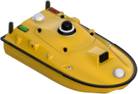 | 
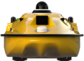 | 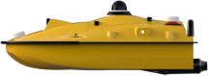
Figure 1.1.1 Views of the Tboat10
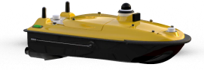 | 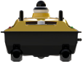
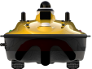 | 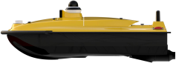
Figure 1.1.2 Views ofthe Tboat20
12
The Tboat10 is a highly integrated platform consisting of a hull, a main control system, a
propulsion system, a millimeter-wave radar module, a GNSS positioning module, a remote control system, and a power supply system.
The Tboat20 is also a highly integrated platform, consisting of a hull, main control system,
propulsion system, millimeter-wave radar module, GNSS positioning module, remote control system, and power supply system.
Capable of covering more than 95% of industry application scenarios in aquatic operations, it integrates multiple core operational functions, including in-situ real-time monitoring of total phosphorus and total nitrogen, high-precision full-coverage bathymetric surveying, accurate hydrological flow measurement, dynamic monitoring of underwater stratigraphy,
and multi-channel synchronized water quality sampling, providing a multi-functional integrated unmanned surface vehicle platform.
The Tboat20 adopts an advanced modular integrated architecture. Its core system consists of a shock-resistant, high-strength hull structure, an intelligent main control module, an
efficient propulsion system, an all-domain intelligent obstacle avoidance module, a
centimeter-level high-precision positioning module, a long-range remote control module, a long-endurance power supply system, and a dedicated payload bay. The payload bay
supports flexible integration of various intelligent payloads, including in-situ analyzers
(total phosphorus and total nitrogen), 6-channel water quality sampling systems, compact multibeam echosounders, Acoustic Doppler Current Profilers (ADCP), and sub-bottom
profilers, thereby further expanding operational scenarios and enhancing measurement accuracy.
The shore-based control system is built around an integrated Android smart remote controller with data transmission capability, featuring high-definition display, intuitive
operation, and real-time data feedback. Combined with the iSail USV control application, which integrates both control and post-processing functions, the system enables full-process
intelligent operation, data acquisition, and post-mission data analysis of the unmanned surface vehicle.
The Tboat10 and Tboat20 are designed for hydrographic surveying, environmental
monitoring, and research applications. Both platforms communicate with the shore-based system via a wireless radio data link.
13

1.2. Hull Hardware Structure Overview
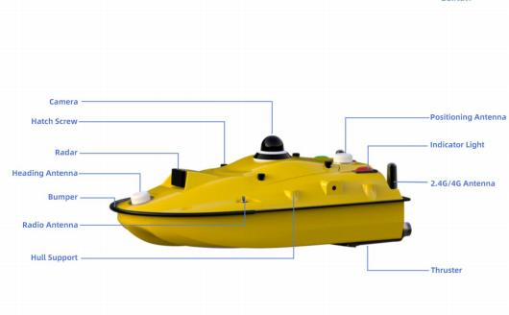
Figure 1.2.1 UbiNavi Tboat10 USV Structure Diagram
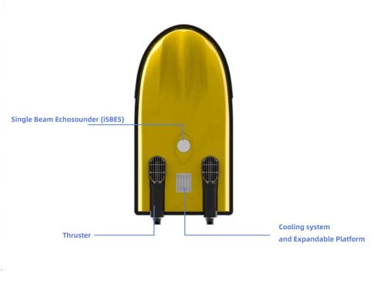
Figure 1.2.2 UbiNavi Tboat10 USV Structure Diagram

14
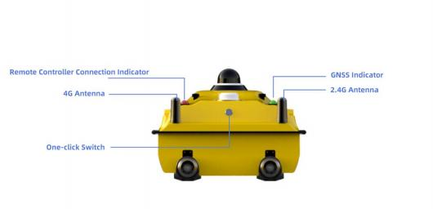
Figure 1.2.3 UbiNavi Tboat10 USV Structure Diagram
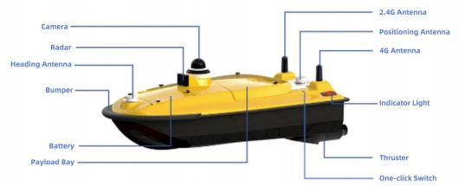
Figure 1.2.4 UbiNavi Tboat20 USV Structure Diagram
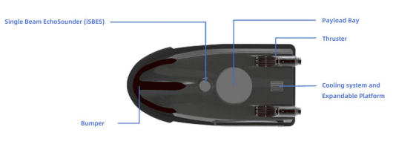
Figure 1.2.5 UbiNavi Tboat20 USV Structure Diagram

15

1.3. USV Control System
All UbiNavi USVs are equiped with two core modules: the USV Control System and the USV Power Box. Both modules share the same core functional architecture, while their
internal configurations are optimized according to the specific characteristics of each USV model to ensure stable and efficient operation.
The installation locations ofthe two modules are shown in the schematic diagram (the USV Control System is located in the upper section, and the USV Power Box is located in the
lower section).
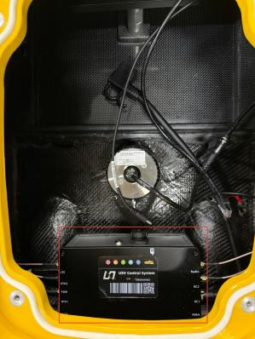
Figure 1.3.1 the Control System of Tboat10

16
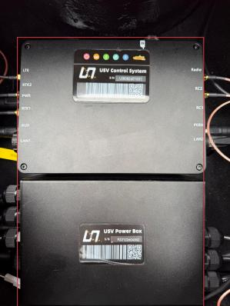
Figure 1.3.2 the Control System and USV Power Box ofTboat20

1.3.1 USV Control System
The USV Control System serves as the core control unit of the USV, responsible for the centralized management of onboard functional modules and external equipment. The system receives control commands from the shore-based remote controller and the iSail App, collects operational and
mission data in realtime, and processes the data to generate corresponding control instructions, ensuring stable and efficient USV operation.
In addition, the USV Control System features data storage and fault feedback functions. It records mission data and provides real-time abnormal status feedback for troubleshooting and maintenance, effectively ensuring operational safety and system reliability.
The USV Control System is also equipped with an indicator light system, which visually displays
equipment operating status through different light indications, improving on-site operation and maintenance efficiency.

17
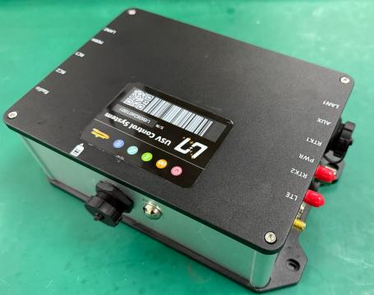
Figure 1.3.1.1 USV Control System
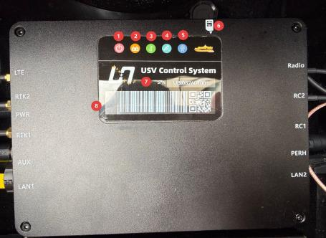
Figure 1.3.1.2 Indicators on USV Control System
1) Power Indicator
A steady indicator light indicates that the equipment is powered on.

18
2) Remote Controller Indicator
A steady light indicates that the remote controller is connected. When pairing is required, press the 2.4G button(refer to Figure 1.3.1.3 , label 2, RC SET); the indicator light will flash rapidly to enter frequency pairing mode.
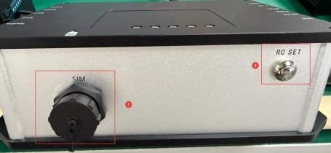
Figure 1.3.1.3 USV Control System
3) Network Indicator(SIM card required)
Flashing indicates that the USV Control System is operating normally on the network; a steady light indicates a network fault.
4) Satellite Indicator
Slow flashing indicates that no satellites are tracked; the number of rapid flashes corresponds to the number of satellites acquired.
5) Radio Indicator
A steady light indicates that the radio is operating normally; flashing indicates that the radio is connecting.
6) SIM Card Installation Guide
Indicates the correct orientation for SIM card installation. (For the SIM card slot location, refer to Figure 1.3.1.3 USV Control System, Label 1, SIM.)
7) USV Serial Number(SN)
A unique identifier assigned to each USV atthe factory.
8) USV Control System Serial Number SN
Factory-assigned unique identifier forthe USV control system.

19

1.3.2 USV Power Box
The USV Power Box serves as the power supply unit forthe USV, providing stable power to all
onboard components, external equipment, and the propulsion system. It ensures reliable power delivery for navigation and mission execution, and supports both power distribution and
communication links across the entire platform.
The USV Power Box is designed for extended endurance and is adaptable to different operational power requirements. It integrates overload protection, short-circuit protection, and voltage
regulation functions. In addition, it provides real-time monitoring of battery level and power supply status, enabling effective mission duration planning.
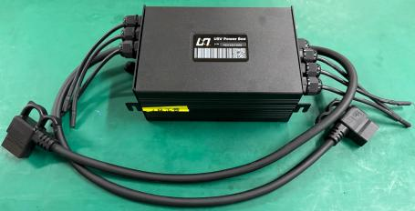
Figure 1.3.2.1 USV Power Box
The labeled position in the figure indicates the serial number (SN) of the USV Power Box, which serves as its unique factory identifier.
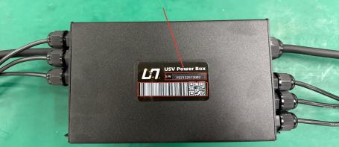
Figure 1.3.2.2 USV Power Box Upper Cover

20

1.4. Battery and Charger
The USV battery system adopts a lightweight design. Each battery unit measures 225 mm × 133 mm × 98 mm □1 mm and features an aluminum alloy housing, with a unit weight of
only 3.7 kg, offering a compact and lightweight structure. The battery utilizes high-performance 21700 cells with a capacity of 25 Ah per unit, enabling continuous
operation of the USV for more than 7 hours at economical cruising speed.
The system employs a dual-battery redundant load-sharing power supply architecture and supports hot-swapping without shutdown, ensuring uninterrupted operation in marine
environments. It is also equipped with a comprehensive BMS (Battery Management
System), providing multiple protection functions including overcurrent, overvoltage, and over-discharge protection, ensuring safe and stable power delivery.
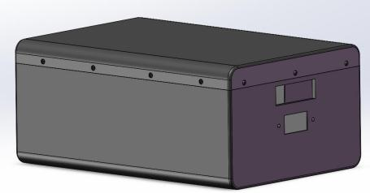
Figure 1.4.1 Battery Structure Diagram

21
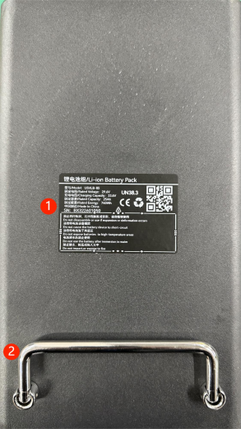
Figure 1.4.2 Battery Top Cover
1) Battery Information Label
Displays key battery parameters, including battery voltage and series cell configuration, for convenient identification and management.
2) Battery Handle
The integrated handle design facilitates convenient battery installation, removal, transportation, and replacement.

22
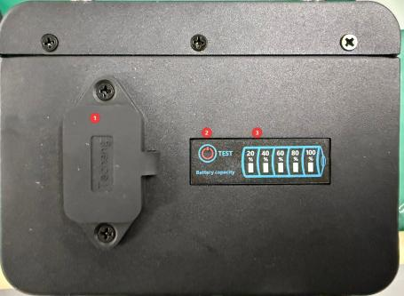
Figure 1.4.3 Battery Side View
1) Power Port
The power port is equipped with a protective cover. When not in use, the cover can be closed to provide dust and water protection.
2) Power Switch
Short press to check the battery level.
3) Battery Level Indicator
The number of illuminated LEDs indicates the remaining battery level.

1.4.1 Battery Configuration
If the battery level indicator is not fully illuminated after the battery has been fully charged, check whether the following settings are configured correctly.
LED Indicator Display Panel Description in Setting Mode:

23
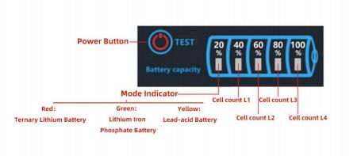
Figure 1.4.4 LED Indicator Display Panel in Setting Mode
Mode Indicator Type | L1 | L2 | L3 | L4 | Series / Voltage
Red (Ternary Lithium Battery)  Green (Lithium Iron Phosphate Battery) | On |  |  |  | 2 Series
 | On |  |  |  | 3 Series
 |  |  | On |  | 4 Series
 |  |  |  | On | 5 Series
 | On |  |  | On | 6 Series
 | On | On | On | On | 7 Series
 |  |  |  |  | 8 Series
Yellow (Lead-acid Battery) | On |  |  |  | 12V
 |  | On |  |  | 24V
Table 1.4.1 LED Indicator Panel in Setting Mode
Function Setting Instruction:
1. Press and hold the TEST button for 2 seconds to enter Setting Mode. The Mode indicator (battery type) will flash, while the Series indicator remains steadily on. Short press the TEST button to select the battery type.
2. After confirming the battery type, press and hold the TEST button for 2 seconds to enter the
Series/Voltage setting interface. The Mode indicator will remain steadily on, and the Series/Voltage indicator will flash.

24
3. Short press the TEST button to set the battery series or voltage. Refer to the table above for available options.
4. Short press the TEST button to set the battery series or voltage. Refer to the table above for available options.
5. In Setting Mode, if no operation is performed within 5 seconds, the system will automatically exit
and return to the normal battery level display.
Caution (Battery type and series are indicated on the battery information label)
Do not exceed the operating voltage. Operation beyond the specified voltage range may damage the product.
This product is available in high-voltage and low-voltage versions. Please select a battery meter that matches the specified voltage range.
Battery Charger
The battery type and number of series cells are indicated on the battery information label.
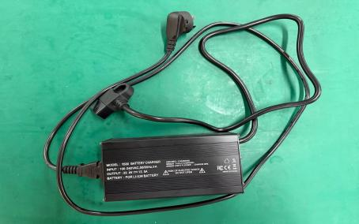
Figure 1.4.5 Battery Charger
Charger Status Description
1. During charging, the charger indicator light turns red, and the cooling fan operates simultaneously.

25
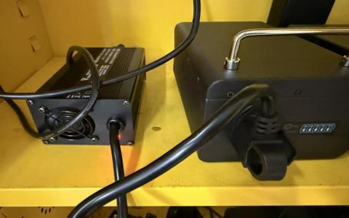
Figure 1.4.6 Battery Charging Status
2. Once the battery is fully charged, the charger indicator light turns green, indicating that charging is complete.
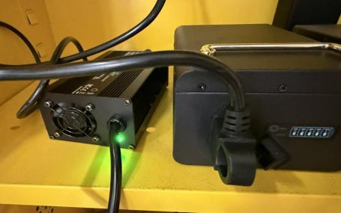
Figure 1.4.7 Battery Fully Charged Status

26

1.5. Remote Controller Overview
1.The G20 remote controller is equipped with a Qualcomm 6 nm octa-core processor and runs Android
13 (64-bit). It features a high-power, high-bandwidth 2.4/5.8 GHz dual-band wireless module, enabling clearer imaging, lower latency, longer transmission range, and enhanced anti-interference performance.
2. It is equipped with a 7-inch 1920 × 1200 high-definition high-brightness display, supporting real-time high-definition video transmission via the integrated camera. A dual-fan cooling system is integrated to ensure stable and efficient operation during extended use.
3. Interfaces include a SIM card slot, USB port, and Type-C port.
4.The device is powered by a high-energy-density lithium-ion battery, providing 6 – 8 hours of operating time on a full charge.
5.The housing is constructed from weather-resistant silicone, matte rubber, and ABS (Acrylonitrile Butadiene Styrene). The G20 features dustproof protection for the main body, control switches, and external interfaces, ensuring stable performance in harsh environments.
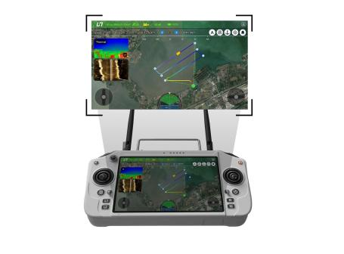
Figure 1.5.1 G20 Remote Controller

27
G20 Remote Controller Specification
Product Model | G20 | Channels |  | 16
Operating Voltage | 4.2V (Built-in Battery) | RF Power |  | 23dBm(CE/FCC)
Frequency Band | 2.4G | Dynamic Frequency Hopping |  | Supported
Dimensions | 277(L)×138(W)×96(H)mm | Weight |  | 1.2kg
Battery Life | 6-8 hours | Battery Capacity |  | 20000mAh
Upgrade | OTA Package/Online Update | Charging Port |  | Type-C
RAM | 4GB | Storage |  | 64GB

28

1.6. Remote Controller Operation
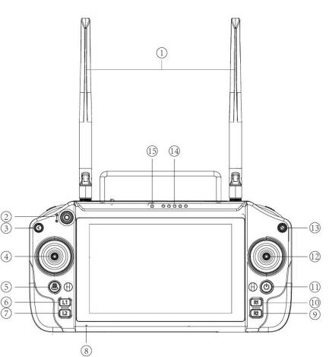
No. | Function | No. | Function
1 | 2.4G Antenna | 9 | USV Information Shortcut  Button (R2)
2 | 3-position Toggle Switch (Forward: Auto / Center:  Hover / Backward: Manual) | 10 | USV Control Parameter Settings  Shortcut Button (R1)
3 | Return Button | 11 | Power Button
4 | Left Joystick (Forward/Backward Control) | 12 | Right Joystick (Left/Right  Control)
5 | Return-to-Home Button | 13 | Data Logging Stop Button
6 | Route Planning Shortcut Button (L1) | 14 | Battery Level Indicator
7 | Safety Settings Shortcut Button(L2) | 15 | Frequency Pairing indicator
8 | Microphone

29
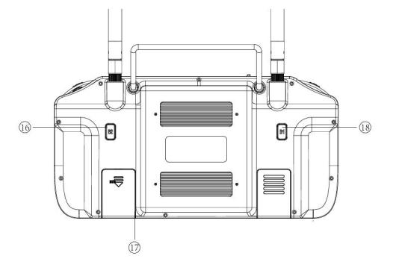
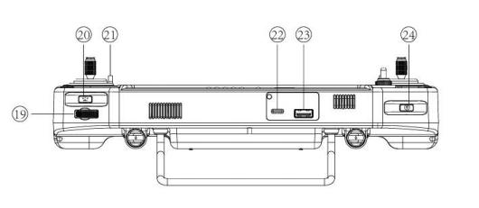
No. | Function | No. | Function
16 | B2 Button (Reserved for more functions) | 21 | Lanyard Attachment  Point
17 | TF Card / SIM Card Slot | 22 | Type-C Port
18 | B1 Button (Reserved for more functions) | 23 | USB Port
19 | Gimbal Camera Left/Right Rotation Control  (Self-centering Wheel) | 24 | Camera Capture  Button
20 | Video Record Button

30
Notes
1. Using Environment
a. Ambient Temperature: -10°C to +45°C
b. Storage Temperature: -20°C to +50°C
c. Relative Humidity: Up to 85% (non-condensing)
d. Atmospheric Pressure: 86 kPa to 106 kPa
Power Supply
a. The G20 Remote Controller is equipped with a built-in rechargeable lithium battery and supports charging via a standard Type-C cable and charger (e.g., USB chargers for
consumer electronics such as mobile phones and cameras).
b. If smoke, unusual odor, or liquid leakage is detected during charging, stop charging immediately and contact our company for service.
c. Do not charge the product in environments where the temperature exceeds 60°C.
d. Always use a certified charger to charge the battery.

31

1.7.Remote Controller Packaging Case
The USV and remote controller are packed using professional protective
packaging materials, with secure wrapping and effective cushioning to protect against vibration, compression, and impact during transportation, ensuring
comprehensive equipment safety. The USV packaging case is equipped with
bottom-mounted wheels, allowing direct rolling movement for easier and more efficient handling and transport.

Figure 1.7.1 Remote Controller Packaging Case

32
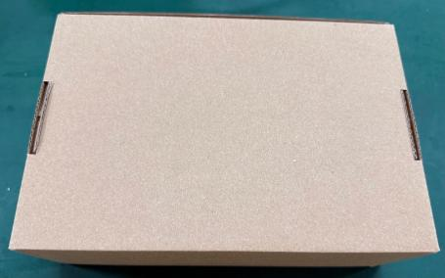
Figure 1.7.2 Battery Charger Packaging Case
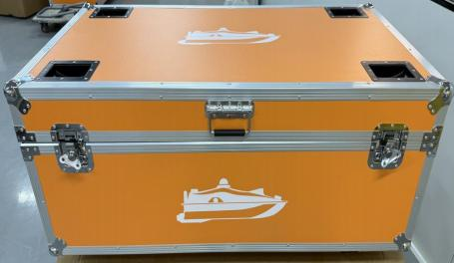
Figure 1.7.3 USV Packaging Case

33
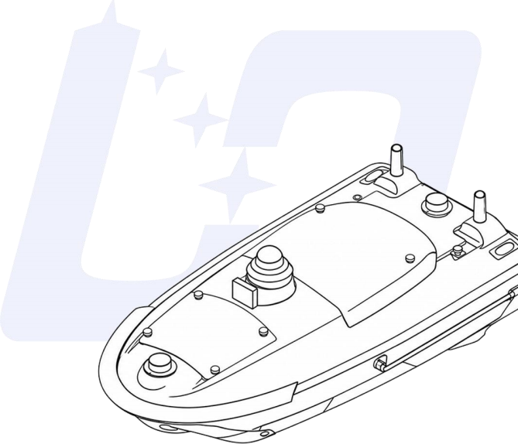

2.HARDWARE SETUP AND OPERATION
This section describes hardware installation, pre-launch preparation procedures, battery operation, and maintenanc4 instructions.

2.1.SIM Card Installation
To ensure stable and efficient USV operation, and to support 4G real-time
video transmission, data communication, and device interconnectivity, both the USV and the remote controller must be connected to a network.
The USV supports network access only through a SIM card installation. The remote controller supports multiple network connection methods, including Wi-Fi connection or SIM card access.

2.2.Remote Controller SIM Card Installation
To enable network access on the remote controller, a SIM card may be installed in addition to connecting via Wi-Fi. Before installation, ensure that the remote controller is powered off. The installation procedure is as follows:
1) Turn the remote controller over to access the rear side. The marked position in the figure indicates the SIM card slot. Pull the protective cover downward in the direction shown to open the slot cover.
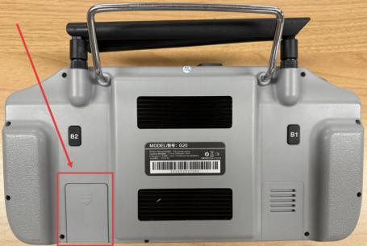
Figure 2.2.1 Remote Controller SIM Card Slot
2) The SIM card orientation is indicated inside the slot. Insert the SIM card strictly according to the indicated direction. When the SIM card is inserted correctly and fully seated, a clear“click”sound will be heard, indicating that the card has been securely locked in place.

35
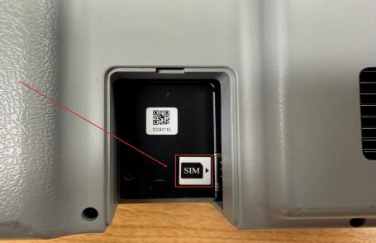
Figure 2.2.2 Remote Controller SIM Card Installation Orientation
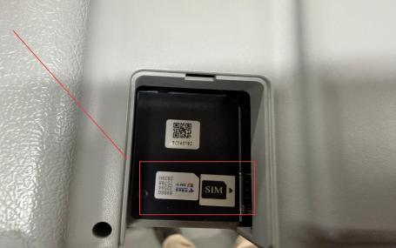
Figure 2.2.3 Remote Controller SIM Card Installation Diagram
3) After installation, close the protective cover and power on the remote controller.

36
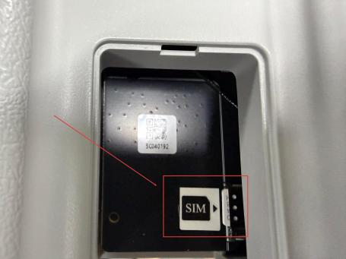
Figure 2.2.4 Remote Controller SIM Card Properly Installed
4) This device does not support SIM card hot swapping. Always power off the remote controller before installing or removing the SIM card. Power on the device only after the operation is completed to avoid equipment damage or network
malfunction.

2.3.USV SIM Card Installation Operation
General Power On/Off Specification (Applicable to UbiNavi Tboat10 and Tboat20)
Power On
Press and hold the One-click Power Switch on the hull. Release the switch when the blue indicator light begins to flash. The system will automatically perform a startup
self-check. Startup is complete when the blue indicator remains steadily on. When the blue indicator remains steadily on, the USV has completed startup.
Power Off
Press and hold the One-click Power Switch on the hull. Release the switch when the indicator light begins to flash. The system will initiate the shutdown process.
Shutdown is complete when the indicator light turns off and the device is fully
37

powered down.
SIM Card Insertion/Removal Precautions
The SIM card supports hot swapping. To ensure system stability, it is recommended to power off the USV and restart the system after SIM card insertion or removal.

2.3.1.Tboat10 SIM Card Installation
1) Press and hold the Power Button to initiate shutdown. Release the button when the indicator light begins to flash. The Tboat10 will complete the shutdown process automatically. The shutdown is complete when the indicator light turns off.
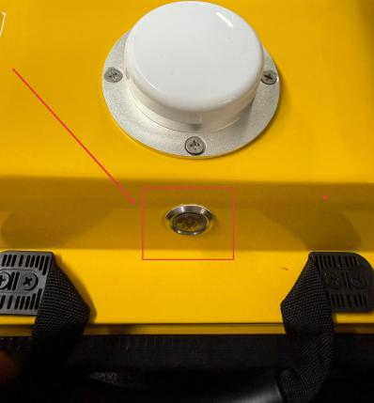
Figure 2.3.1.1 Power Button of Tboat10
2) Loosen the hatch screws in a diagonal sequence and open the top hatch cover. It is recommended to tighten and loosen the hatch screws in a diagonal sequence to ensure uniform force distribution and proper sealing performance.

38
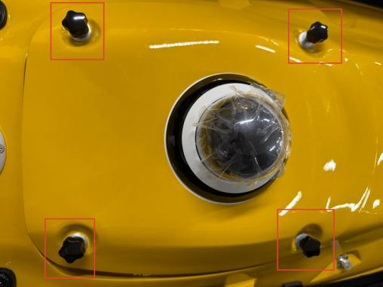
Figure 2.3.1.2 Hatch Screws of Tboat10
3) After opening the hatch cover, disconnect the camera power cable and
communication cable harness to prevent cable strain or damage caused by hatch movement.
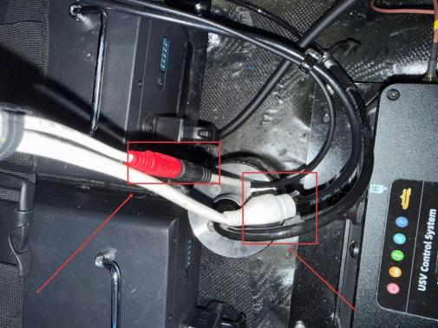
39
Figure 2.3.1.3 Camera Cable Harness of Tboat10
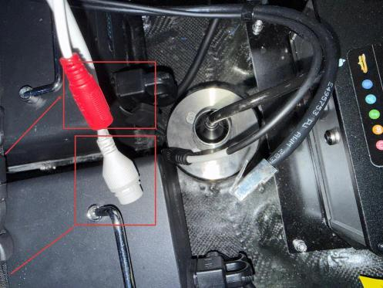
Figure 2.3.1.4 Disconnected Camera Cable Harness of Tboat10
4) Locate the built-in USV Control System inside the compartment. Rotate and open the SIM card protective cover. Insert the SIM card according to the orientation
marking on the housing. A clear“click”sound indicates that the card is properly seated and securely installed.

40
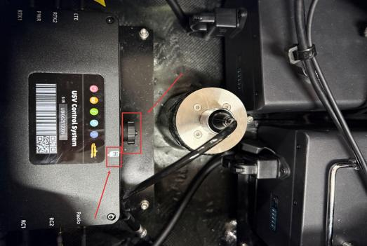
Figure 2.9 Tboat10 USV Control System and SIM Card
5) After SIM card installation is completed, reconnect the camera power cable and communication cable. Close the hatch cover and tighten all hatch screws in a diagonal sequence to ensure uniform force distribution and proper sealing.
6) Press and hold the Power Button to power on the device. Startup is complete when the blue indicator light remains steadily on.

2.3.2. Tboat20 SIM Card Installation
1) Press and hold the Power Button to initiate shutdown. Release the button when the indicator light begins to flash. The Tboat20 will automatically complete the
shutdown process. Shutdown is complete when the indicator light turns off completely.

41
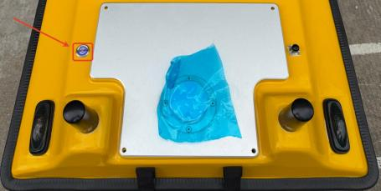
Figure 2.3.2.1 One-click button of Tboat20
2) Loosen the screws to open the Payload Bay cover. Then loosen the rear hatch cover screws in diagonal sequence and open the rear hatch cover.
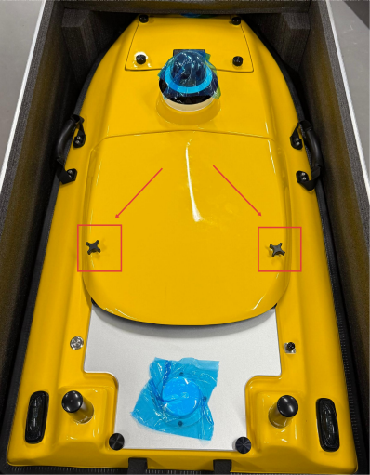
Figure 2.3.2.2 Payload Bay Cover Screws of Tboat20

42
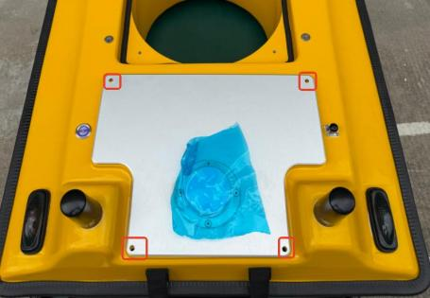
Figure 2.3.2.3 Rear Hatch Cover Screw Location of Tboat20
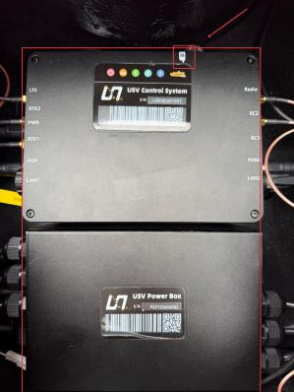
Figure 2.3.2.4 USV Control System and SIM Card Location of Tboat20
3) The SIM card slot structure and insertion orientation are identical for both models. Insert the SIM card strictly according to the orientation marking on the USV Control
System. A clear“click”sound indicates that the card is properly seated.
43
4) After installation, close the rear hatch cover and tighten the screws in a diagonal sequence to ensure proper sealing.
5) Press and hold the Power Button to power on the device. Startup is complete when the blue indicator light remains steadily on.

44

2.4.Tboat10 Hardware Operation Procedure

2.4.1.Accessory Installation
1) After completing SIM card installation, place the battery into the designated
positioning slot inside the battery compartment and ensure that it is properly seated.
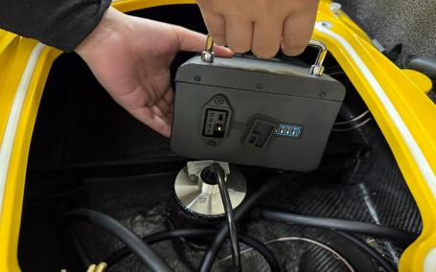
Figure 2.4.1.1 Battery Installation of Tboat10
2) Rotate the battery fixing bracket and tighten the locking mechanism to securely fasten the battery with appropriate clamping force. Then connect the power cable.
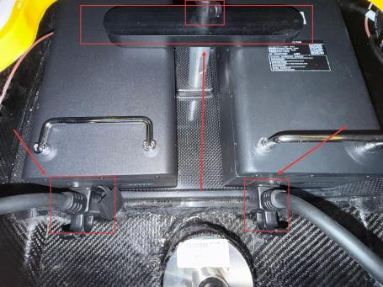
Figure 2.4.1.2 Tboat10 Battery Installed in Place

45
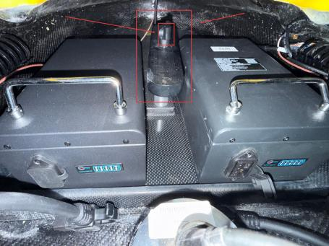
Figure 2.4.1.4 Tboat10 Battery Secured and Power Cable Conne
c
Figure 2.4.1.5 Tboat10 Camera Power and Network Cable

46
3) Close the hatch cover and tighten the Hatch Screws in diagonal sequence to ensure proper sealing.
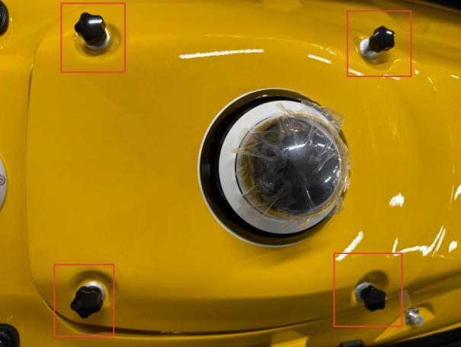
Figure 2.4.1.5 Tboat10 Hatch Cover Installation

2.4.2.Pre-Launch Procedures
1) USV Power On
Press and hold the One-click Switch atthe stern of the USV for approximately 3
seconds. Release the button when the indicator light begins to flash rapidly. After
approximately 10 seconds, the indicator light will remain steadily on, indicating that the USV Control System startup is complete.

47

Figure 2.4.2.1 Tboat10 One-click Switch
2) Press and hold the Power Button to turn on the remote controller.
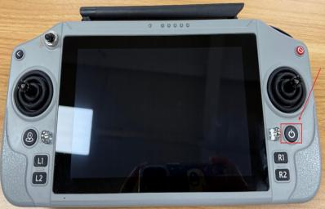
Figure 2.4.2.2 Remote Controller Power Button

48
3) Launch the iSail software, the USV and remote controller are paired before
delivery. After power-on, launch the iSail software and tap the app icon to establish the connection.
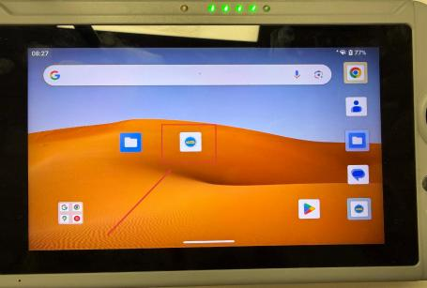
Figure 2.4.2.3 iSail Software
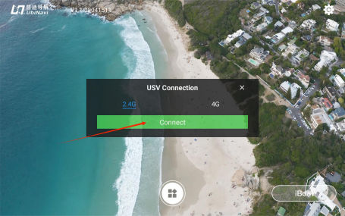
Figure 2.4.2.4 iSail Software Home Screen
4) After a successful connection, the red indicator on the left side of the hull remains steadily on.

49
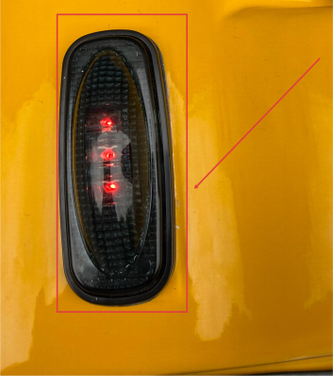
Figure 2.4.2.5 Successful Connection Between USV and Remote Controller
5) Thruster Airflow Direction Test
Use the left and right joysticks on the remote controller to control the thrusters. Manually check whether the airflow direction from each thruster is normal.
6) Startup Self-testing
The left joystick controls the USV's forward and backward movement; the right joystick controls the USV's left and right turning.
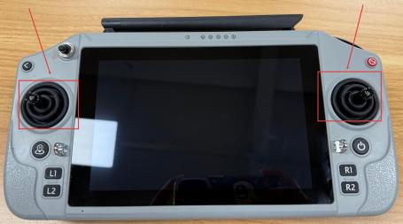
50
Figure 2.4.2.6 Remote Controller Joystick
Push the Left Joystick Forward: Both thrusters should generate airflow backward.
Pull the Left Joystick Backward: Both thrusters should generate airflow forward.
Note: Airflow is directed forward, so you may not feel it if your hand is behind the thruster. This is normal.
Push the Right Joystick Left: The left thruster generates airflow forward; the right thruster
generates airflow backward. You can only feel airflow from the right thruster.
Push the Right Joystick Right: The left thruster generates airflow backward; the right
thruster generates airflow forward. You can only feel airflow from the left thruster.
.
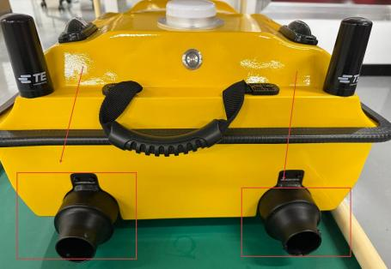
Figure 2.4.2.7 Tboat10 Thrusters
7) Startup Self-testing
After connection, the USV Control System performs an automatic startup self-test. Ensure that all status indicators are normal before operation.

51
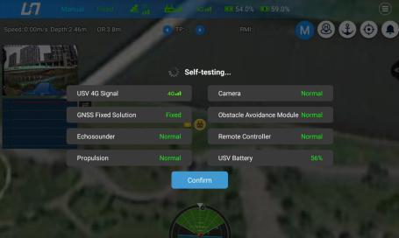
Figure 2.4.2.8 USV Self-Test Normal Status

52

2.5. Tboat20 Hardware Operation Procedure

2.5.1.Accessory Installation
1) After completing SIM card installation, place the battery into the designated positioning slot inside the battery compartment and ensure it is properly seated.
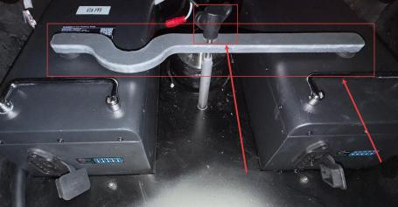
Figure 2.5.1.1 Tboat20 Battery Installation
2) Rotate the battery fixing bracket and tighten the locking mechanism to securely fix the battery in place. Then connect the power cable.
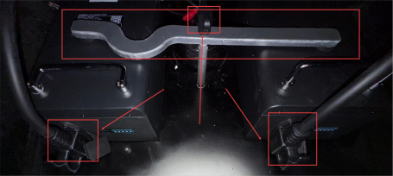
Figure 2.5.1.2 Tboat20 Battery Installation Completed
3) Close the hatch cover and tighten the hatch screws in a diagonal sequence to ensure proper sealing.

53
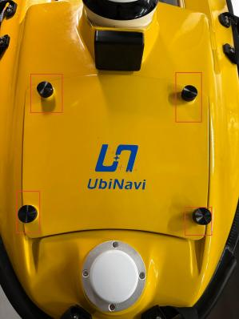
Figure 2.5.1.3 Tboat20 Front Hatch Installation

2.5.2.Pre-Launch Procedures
1) USV Power On
Press and hold the One-click Switch located atthe stern of the USV for approximately 3 seconds. Release the switch when the indicator light flashes rapidly. After
approximately 10 seconds, the indicator light remains steadily on, indicating that the USV Control System startup is complete.
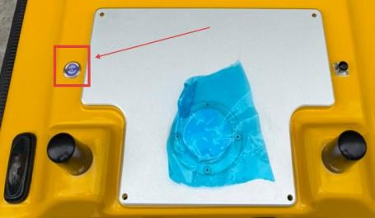

54
Figure 2.5.2.1 One-click Switch of Tboat20
2) Power On the Remote Controller
Press and hold the Power Button to turn on the remote controller.
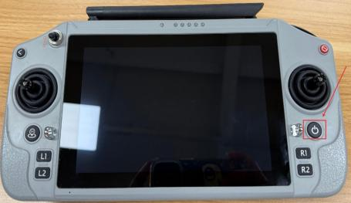
Figure 2.5.2.2 Power Button of Remote Controller
3) Launch the iSail software
The USV and remote controller are pre-paired atthe factory. After power-on, launch the iSail software and tap the app icon to establish the connection.

Figure 2.5.2.3 iSail Software

55
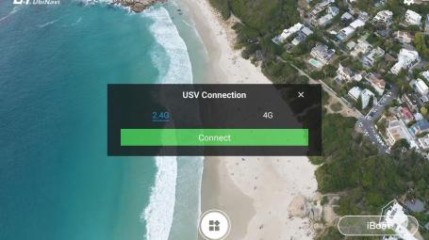
Figure 2.5.2.4 iSail Software Home Screen
4) Connection Successful
After a successful connection, the red indicator on the left side of the hull remains steadily on.
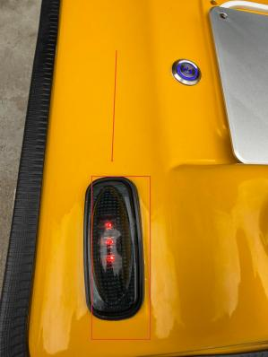
Figure 2.5.2.5 Successful Connection Between USV and Remote Controller
5) Thruster Direction Check

56
The inspection procedure, joystick control rules, and thruster direction verification requirements are identical to those ofthe Tboat10. Refer to the corresponding section above for detailed operating instructions.
6) Startup Self-Test
The startup self-test procedure, inspection standards, and acceptance criteria are
identical to those of the Tboat10. After the software connection is established, the
Tboat20 automatically performs a startup self-test. Ensure that all status indicators are normal before operation.

57

2.6.Frequency Pairing
The USV and the remote controller are paired before delivery. In general, no additional frequency pairing procedure is required.
Note: Frequency Pairing is only required when replacing the remote controller or the USV Control System.
1) Open the Device Tool on the remote controller.
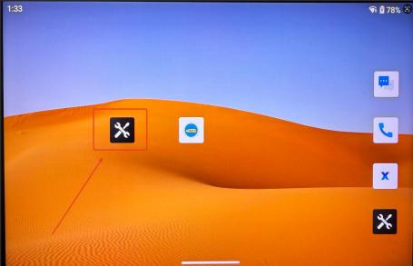
Figure 2.6.1 Remote Controller Device Tool 2) Select System Settings
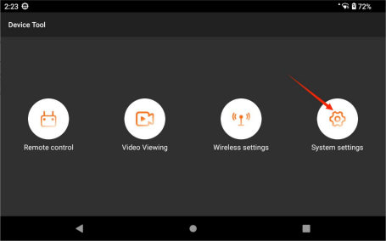

58
Figure 2.6.2 System Settings Selection
3) Select Frequency Settings
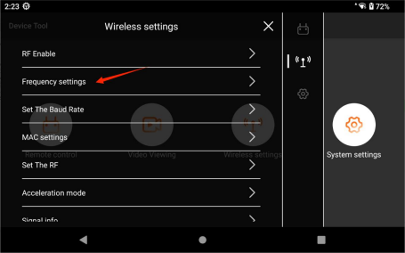
Figure 2.6.3 Frequency Settings Selection
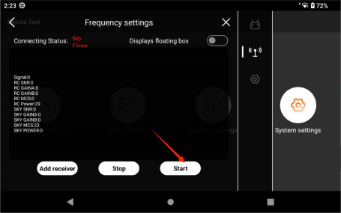
Figure 2.6.4 Start Frequency Pairing
4) Press and hold the Frequency Pairing Button on the USV Control System for approximately 5 seconds (refer to Section 1.3.1 forthe USV Control System) . Release the button when the remote controller indicator on the USV Control System flashes rapidly. The system then enters frequency pairing mode.

59
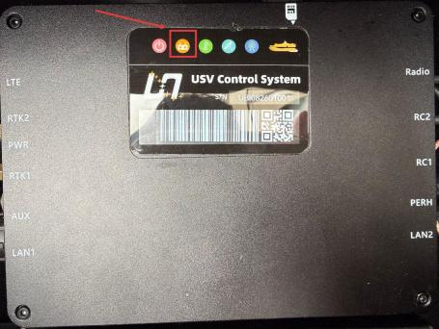
Figure 2.6.5 Remote Controller Indicator on USV Control System
5) On the remote controller, tap START. The interface will display “Frequency Pairing is in progress”.
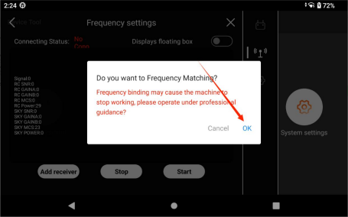
Figure 2.6.6 Confirm Frequency Pairing (Remote Controller)

60
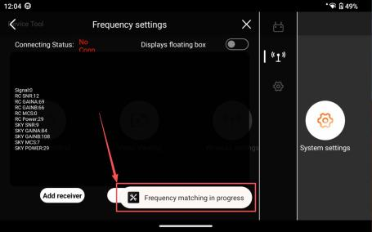
Figure 2.6.7 Frequency Pairing in Progress (Remote Controller)
6) Wait a few seconds until the software indicates “Frequency Pairing success”. The frequency Pairing process is then complete.
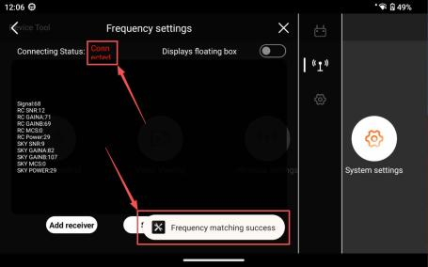
Figure 2.6.8 Frequency Pairing Completed (Remote Controller)
7) Exit the frequency pairing software and return tothe iSail software to resume normal operation of the USV.

61
Troubleshooting:
If frequency pairing is not completed after an extended period, check whether the
remote controller indicator on the USV Control System is functioning properly.
Also ensure that any previously frequency matched remote controller is powered off to prevent signal interference and frequency pairing conflicts.

2.7.Battery Maintenance Guidelines of USV
1) Newly delivered batteries have a state of charge of □30%. Please fully
charge them within two months of receipt;
2) If the battery level indicator shows only one bar, recharge the battery
promptly;
3) A fully charged battery can be stored for up to 6 months. After 6 months of storage, the battery should be recharged in a timely manner.

62
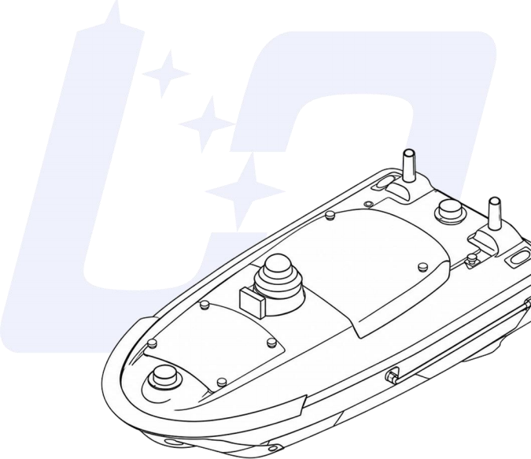

3.SOFTWARE OVERVIEW
This section describes the key features of the iSail software and the minimum system requirements for installation.

63

3.1. Overview of iSail Software
iSail is a USV control and post-processing software independently developed by UbiNavi. It supports multiple measurement modes, enabling autonomous
execution of operational tasks across various application scenarios.
The software provides functions including USV control, route planning, status monitoring, safety alerts, and online upgrades. It adopts an integrated remote
control solution, supporting both 4G communication and data link connections for real-time monitoring and display.
iSail supports integration with multiple external sensors, with data directly displayed in the application, eliminating the need for a separate computer. Its post-processing module supports bathymetric waveform overlay, enabling analysis of depth noise characteristics. Multiple data correction methods are provided to ensure accurate and reliable results.
Designed from a user-centric perspective, iSail aims to deliver high-precision
measurement, intuitive operation, and streamlined workflows for efficient field operations.
囗Notice:
This guide applies to iSail V1.1.0.8.

64
\
Figure 3.1.1 iSail Home Screen

3.2.iSail Software Operating Environment
iSail Software supports the Android operating system only. It is compatible with the G20 remote controller, as well as selected tablets and smartphones running Android 9.0 or above, with a minimum resolution of 1920 × 1080.
Supported devices include USVs, single-beam echosounders (iSBES), and related systems.
Supported languages include Simplified Chinese and English. iSail Software automatically switches language based on the system language settings. If the system language is changed while the application is running, the app must be restarted for the change to take effect.
囗Caution:
Many functions of the software require a mobile network. Network connectivity is also required for USV operation to provide Network RTK services. Please ensure that the product is used in an
environment with stable network availability.

65

3.3.iSail Software Installation / Uninstallation / Update
1) Installation
Copy the iSail Control Application (*.apk) to a local directory on the G20 remote controller.
On the device, open the Downloads folder and tap the iSail installation package to start the installation. Once the installation is complete, the iSail application icon will appear on the home screen.

Figure 3.3.1 iSail Software Icon
2) iSail Software Permissions
To ensure proper operation, the software requires certain permissions, including location and storage access. Floating window permission is also required when using the map
interface.
3) iSail Software Uninstallation and Notes
Uninstallation
Press and hold the iSail software icon and drag it to the uninstall area on the screen.
66
When prompted with “Uninstall this software?”, tap Confirm to uninstall.
Note
Uninstalling the software will remove all associated data, including satellite map
tiles, device connection information, custom server settings, route projects, and all operational data (such as mission records, control parameters, and echosounder parameters).
4) iSail Software Update
When the remote controller is connected to a network, launch the iSail software. If a new version is available on the server, the system will display a pop-up notification based on server configuration.
If the remote controller is not connected to a Wi-Fi network, the system will prompt
whether to proceed with the download. The iSail software is pre-installed on the G20 remote controller by default. If it is not installed, please contact UbiNavi technical
support for installation.
□Caution□
Location permission and location services must be enabled to ensure proper positioning of the remote controller.
Storage permission must be enabled to ensure proper data storage and recording functions.

67

3.4.iSail Software File Description
After installation and use, project files are stored in the following locations:
1) G20 Remote Controller
The project folder can be accessed directly by tapping File Location in the project list.
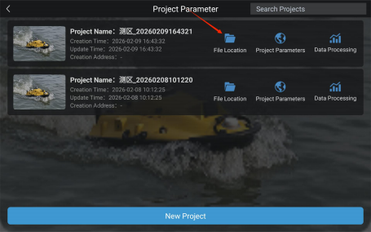
Figure 3.4.1 Accessing Project Files on G20 Remote Controller
2) Other Android Devices
The project folder is located in the following directory:
Android/data/com.ubi.wrc/files/jobs
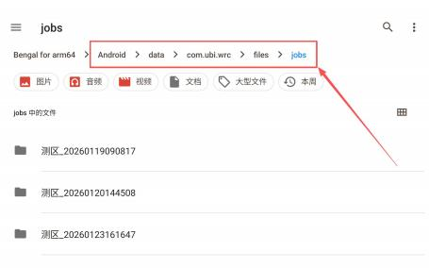
Figure 3.4.2 Project File Location on Other Android Devices

68
3) Project Data
Description of the contents in the project folder.
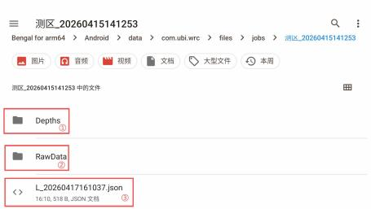
Figure 3.5 Example Project Folder
□Depths Folder: Contains measured depth data collected during surveys. File name format: PS_*.dep
□RawData Folder: Contains raw sonar data collected during surveys. File name format: PS_*.sd
□L_yyyymmddhhmmss.json File: Contains locally saved trajectory data (e.g., L_20260417161037.json).

69

4.DEVICE

CONNECTION
This section describes how to connect the iSail software to the USV, iSBES, and other supported devices.

70

4.1.Connecting the USV via 2.4G Mode
1) Launch iSail and enter the home screen.
2) Select 2.4G as the connection method. The USV and remote controller are factory-configured with frequency pairing by default. Devices delivered as a matched set require no additional
configuration. After the USV is powered on, tap Connect to establish communication directly.
3) If the USV or remote controller is not from the same delivery batch, perform frequency pairing first, then tap Connect to establish communication.
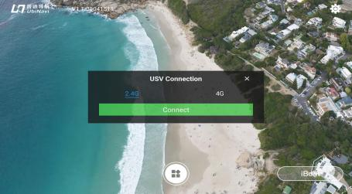
Figure 4.1.1 iSail Software Home Screen
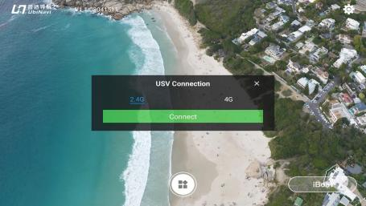
Figure 4.1.2 USV 2 .4G Connection Interface

71
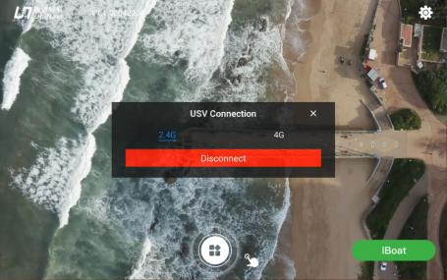
Figure 4.1.3 USV 2.4G Connection Successful

囗Notice:
To use 2.4G connection with the USV, ensure the following requirements are met:
a. The Ethernet function on the G20 remote controller is enabled.
b. The two black rod antennas (2.4G/4G) on the USV are securely installed.
c. It is strongly recommended to position the two antennas on the G20 remote controller vertically upward to ensure optimal signal transmission and reception.
d. Maintain a clear line-of-sight between the USV and the G20 remote controller. Obstructions may cause communication delay or signal degradation.

72

4.2.Connecting the USV via 4G Mode
1) Connect the remote controller to a 4G network by either enabling a mobile hotspot on a
smartphone or inserting a SIM card, ensuring the G20 remote controller has stable internet access.
2) Launch iSail and enter the home screen, then proceed to the USV connection page.
3) Select 4G Network as the connection method. Enter the required Username and Password, and select the corresponding Video Access Mode. After completing the configuration, tap Connect to establish the connection.
4) The Username refers to the SN (serial number) labeled on the USV Control System (refer to Section 1.3.1, Item 7). The default Password is admin123. For Video Access Mode, select International Version.
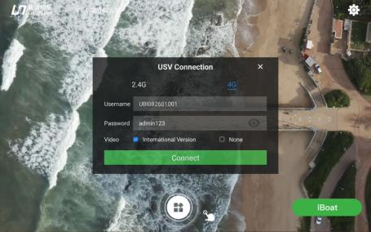
Figure 4.2.1 USV Connection Interface
5) After entering all required information, tap Connect to establish the connection. If connection fails or a timeout message appears, perform the following checks in sequence:
Verify that the username and password are entered correctly, ensure that the SIM card in the USV is properly installed and has available data, and confirm that the remote
controller has a stable network connection.
After completing all checks, tap Connect again to retry the connection.

73
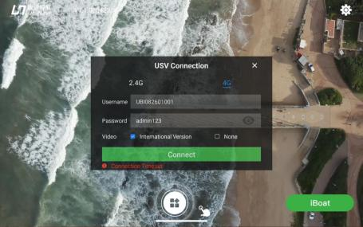
Figure 4.2.2 USV 4G Connection Timeout Message

74

5.SYSTEM MENU OF ISAIL

SOFTWARE
This section describes the system menu of the iSail
software.

75

5.1.System Menu Entry on iSail Home Screen
The gear icon located in the upper-right corner ofthe iSail home screen serves as the entry to the system menu (refer to Figure 5.1.1). Tap this icon to open the full system menu (refer to Figure 5.1.2), which provides access to functions such as User Manual, Version
Information, Online Upgrade, Device Configuration, and Language Settings. The details of each module are described below.
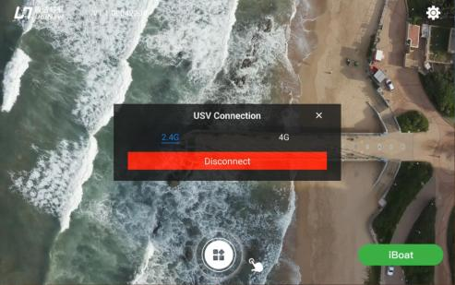
Figure 5.1.1 System Menu Entry Icon on Home Screen
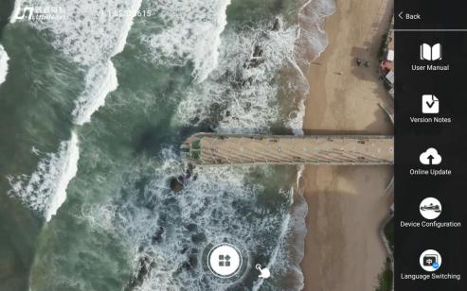
Figure 5.1.2 System Menu Screen
76

5.2.iSail User Manual
The User Manual provides standard operating procedures and technical instructions for the iSail software. It enables users to quickly access operating procedures and precautions for each functional module, supporting operators in performing tasks in a compliant and correct manner.
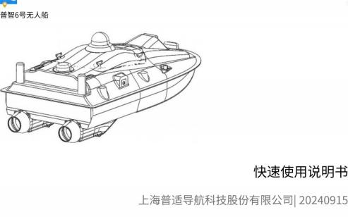
Figure 5.2.1 User Manual Interface

5.3.Version Information
Tap this option to view the current software version, update logs, and optimization details, allowing users to track version status and feature changes.

5.4.Online Upgrade
The Online Upgrade module is the unified version management interface for both the iSail software and the USV firmware. It supports version detection, status display, and one-click upgrade. The main instructions are as follows:

77
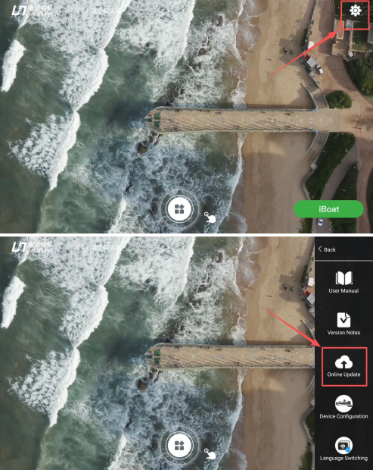

78
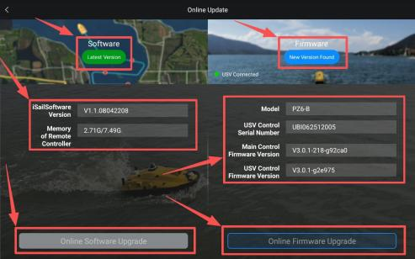
Figure 5.4.1 Online Upgrade Interface
1) Upgrade Modules Overview
The Software module is responsible for version management ofthe iSail on the remote controller, while the Firmware module is responsible for version management of the USV firmware. A stable communication link between the USV and the remote controller must be established before starting the upgrade process.
2) Version-Based Upgrade Button Status Control
The system automatically controls the button states based on version detection results. When the currently installed iSail software (on the remote controller) or the USV firmware is already the
latest stable version, the corresponding Software Upgrade / Firmware Upgrade button will be
disabled (grayed out) and cannot be selected.
When a new official version is available, the corresponding button will be enabled(highlighted in blue) and becomes selectable, allowing a one-tap online upgrade to obtain the latest features and performance improvements.
3) Upgrade Verification Information Display Interface
The interface synchronously displays all verification information required for the upgrade. The left panel shows the iSail software version on the remote controller, as well as the remote controller
storage status (used/total capacity). The right panel displays the USV model, USV Control System SN, host firmware version, and USV Control System firmware version.

79
This information provides the basis for compatibility verification and device identity authentication prior to the upgrade, helping to mitigate potential upgrade risks and ensuring a safe and compliant process.

5.5.Device Configuration
Tap the Device Configuration in the system menu to access the USV device configuration
management interface. This interface serves as a unified entry point for configuring onboard sensors. Operators can enable or disable specific sensors based on the equipment actually installed on the USV. Upon completion of the configuration, corresponding operational
tasks can be initiated to ensure proper data acquisition and execution of mission workflows.
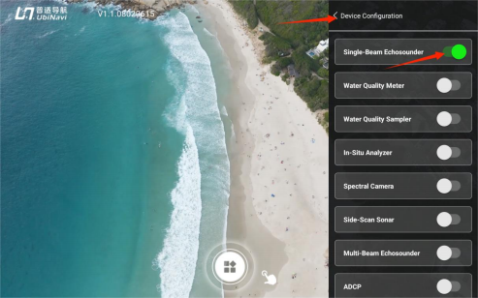
Figure 5 .5.1Device Configuration Interface
The interface displays a list of all supported onboard sensors and devices, including iSBES, Multiparameter Water Quality Sondes, Water Samplers, In-situ Analyzers, Spectral
Cameras, Side-scan Sonar, Multi-beam Echosounder, ADCP, AI Camera, Thermal Imaging Cameras, Underwater Camera, and Triple cameras.
Each device is equipped with an independent toggle switch:
a. Switch (On)–Green: Indicates that the device is enabled. The corresponding data acquisition function will be activated during mission execution.
b. Switch (Off)–Gray: Indicates that the device is disabled. The corresponding function will not be executed during missions.

80
Operational Note:
Please ensure that only devices actually installed on the USV are enabled. Do not enable
any uninstalled devices. This helps prevent operational errors and ensures data integrity and mission reliability.

5.6.Language Switching
The software language automatically synchronizes with the system language of the remote controller. Currently supported languages include Chinese, English, Russian, and Spanish.
1) Tap the System Settings icon to enter the System Settings page.
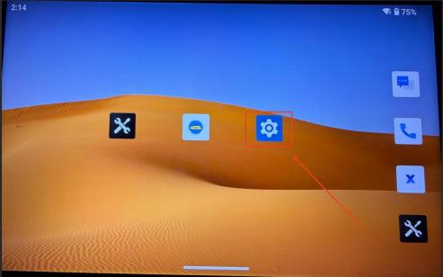
Figure 5.6.1 Settings Interface
2) Scroll to the bottom of the page and access System Settings.

81
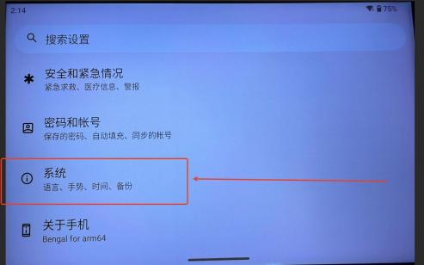
Figure 5.6.2 System Button in the System Settings Page 3) Find and select the Language & Input settings option.
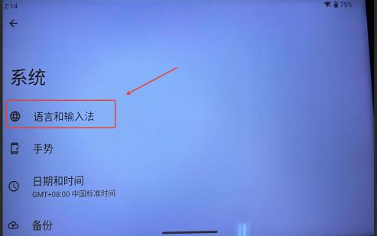
Figure 5.6.3 Language and Input Settings

82
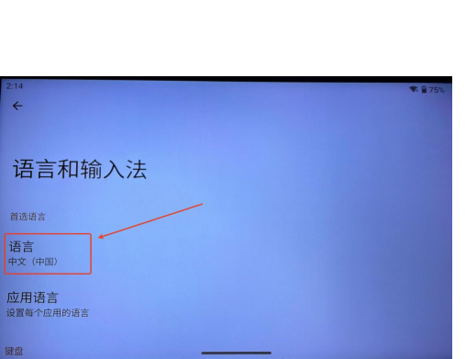
Figure 5.6.4 Language Settings
4) Tap Add Language and select the desired language from the language list to complete the setup.
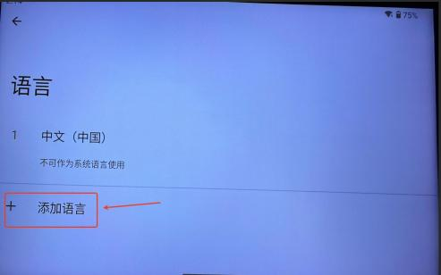
Figure 5.6.5 Language Addition

83
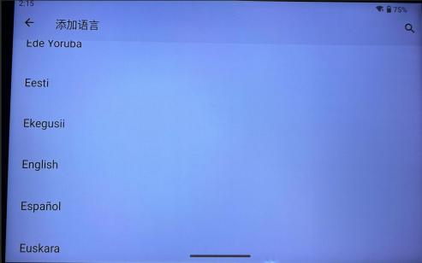
Figure 5.6.6 Language Selection
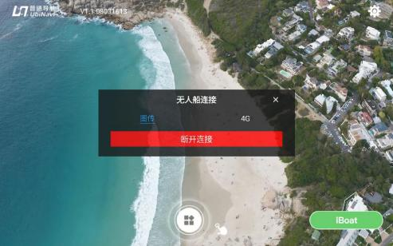
Figure 5.6.7 Chinese Interface Page

84
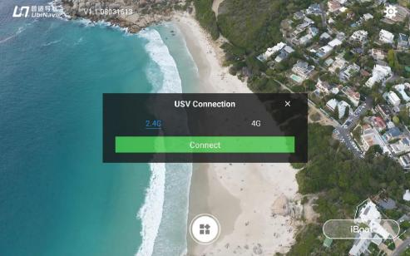
Figure 5.6.8 English Interface Page

85

6.SINGLE-BEAM

ECHOSOUNDER SYSTEM
This chapter describes the specific functions of the
iSBES in the iSail software.

86

6.1.Project Management
After successfully connecting to the USV, tap the function entry atthe bottom of the home
screen to access the Project Management interface. This interface displays all created projects in a list view.
Each project entry includes the Project Name, Creation Time, Update Time, and Creation Address (operation site). Tap any project entry to open the corresponding route task, allow operation resumption or detail review.
Three function buttons are provided on the right side of each project entry, supporting different operations:
□ File Location: Open the project file directory.
□ Project Parameters: View or edit core project settings, including the coordinate system.
□ Data Processing: Access the bathymetric data post-processing workflow.
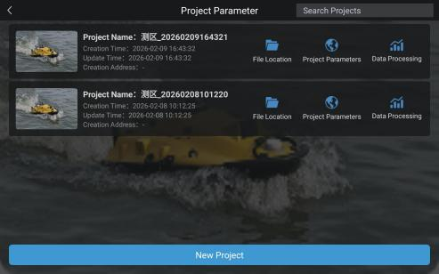
Figure 6.1.1 Project Management List
Press and hold a project entry to delete it from the Project Management list.

87
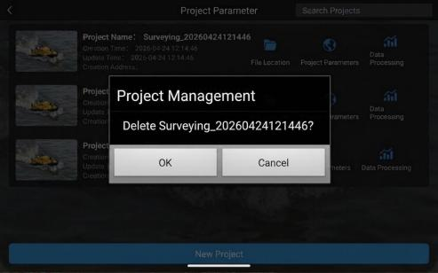
Figure 6.1.2 Deleting a Project from the Project Management List
To locate a specific project, enter its name in the search box. The search function supports retrieval of associated information.
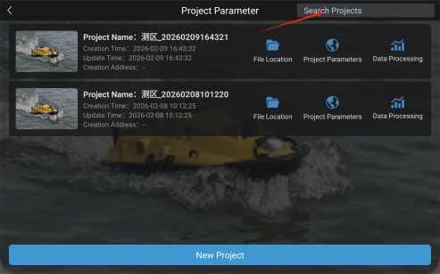
Figure 6.1.3 Project Search in the Project Management List

88

6.2.New Project
The following steps describe how to create a new single-beam bathymetric surveying project.
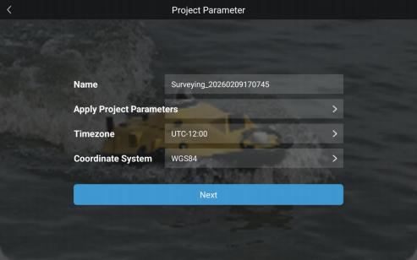
Figure 6.2.1 New Project Establishment
1) Name
The project name can be edited. The default format is SurveyArea_yyyymmdd_hhmmss.
2) Apply Project Parameters
Tap to select and apply parameters from a previous project template.
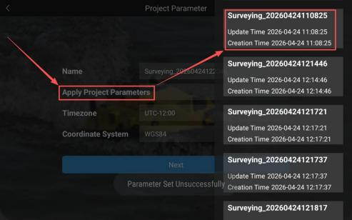
89
Figure 6.2.2 Selecting a Project Template for New Project
3) Select the appropriate time zone according to the operation area to ensure accurate time.
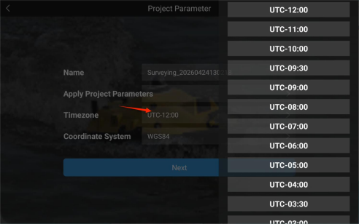
Figure 6.2.3 Selecting the Time Zone in New Project
4) Coordinate System
Select a commonly used coordinate system.
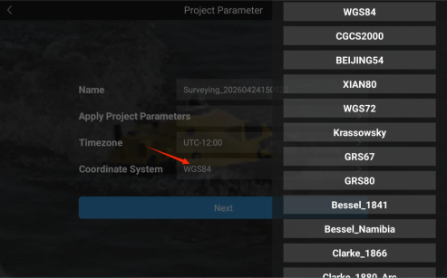
Figure 6.7 Selecting Coordinate System in New Project

90

6.3.Introduction to Single-beam Bathymetric Survey Coordinate Parameters

6.3.1.Ellipsoid
The ellipsoid refers to the target ellipsoid used in the project. An appropriate ellipsoid can be selected from the drop-down list based on project requirements.
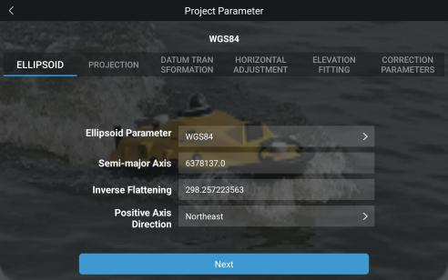
Figure 6.3.1.1 Coordinate System Parameters — Ellipsoid
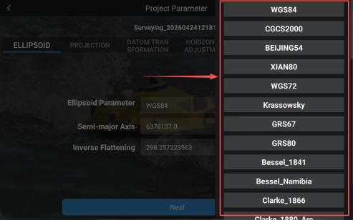
Figure 6.3.1.2 Ellipsoid Type Selection
91

6.3.2.Projection
Select a projection method from the drop-down list and configure relevant projection parameters, including the Central Meridian, Latitude of Origin, Scale Factor, False Easting, False Northing, and Projection Height.
Projection parameters define the transformation from a geodetic coordinate system to a projected coordinate system. Different projection methods result in different planar coordinates. Common methods include Gauss-Krüger 3-degree zone, Gauss-Krüger 6-degree zone, custom Gauss-Krüger, and Mercator projection.
Projection Methods
1) Gauss-Krüger 3-Degree Zone
This method uses a conformal transverse cylindrical projection. Starting from 1 ° 30 □ east
longitude, the Earth is divided into 3-degree longitudinal zones. Surface points are projected onto a cylinder transverse to the central meridian and then developed into a planar coordinate system.
2) Gauss-Krüger 6-Degree Zone
This method also uses a conformal transverse cylindrical projection. Starting from the
Greenwich meridian, the Earth is divided into 6° longitudinal zones. The projection principle is similar to that of the 3° zone projection, with the primary difference being the zone width.
3) Custom Gauss-Krüger Projection
Based on the Gauss-Krüger projection, projection parameters such as central meridian and zone width can be customized according to project requirements to satisfy specific regional or
application accuracy requirements.
4) Mercator Projection
This method uses a normal conformal cylindrical projection. A cylinder is assumed to be
tangent or secant to the Earth's surface. Under conformal conditions, the graticule is projected onto the cylindrical surface, which is then unfolded into a planar coordinate system.
Zoning Methods and Coverage
1) Gauss-Krüger 3-Degree Zone
The globe is divided into 120 zones, with 60 zones in each hemisphere.
92
In the Eastern Hemisphere, zones are numbered from 1 to 60, and the central meridian is
calculated as:
L□ = 3° × n (Eastern Hemisphere)
In the Western Hemisphere, zones are also numbered from 1 to 60, and the central meridian is calculated as:
L□ = 360° −3° × n (Western Hemisphere)
2) Gauss-Krüger 6-Degree Zone
The globe is divided into 60 zones. The globe is divided into 60 projection zones. In the
Eastern Hemisphere, the first zone spans from 0°Eto 6°E, with a central meridian of 3°E.
Zones are numbered from 1 to 30. The central meridian is calculated as:
L□ = (6n −3)° (Eastern Hemisphere)
In the Western Hemisphere, zones are also numbered from 1 to 60, and the central meridian is calculated as:
L□ = 360° −(6n −3)° (Western Hemisphere)
3) Custom Gauss-Krüger Projection
The zoning method and coverage are determined by user-defined parameters and do not follow a fixed zoning scheme.
4) Mercator Projection
The Mercator projection commonly divides the world into 60 projection zones, each spanning 6 degrees of longitude. Zones are consecutively numbered from 1 to 60, starting between 180°W and 174°W and increasing eastward.
Projection Distortion Characteristics
1) Gauss-Krüger 3-Degree Zone
The scale factor along the central meridian is 1, while the scale factor at all other locations is
greater than 1. Along the same meridian, distortion increases as latitude decreases, reaching its maximum atthe equator. Along the same parallel, distortion increases with distance from the central meridian and reaches its maximum atthe edge of the projection zone.
2) Gauss-Krüger 6-Degree Zone
93
The distortion characteristics are generally similar to those of the 3-degree zone. However, due to the wider projection zone, distortion near the zone boundaries is relatively larger.
3) Custom Gauss-Krüger Projection
Distortion characteristics depend on the user-defined projection parameters. When the selected central meridian is close to the area of interest, distortion is relatively small; otherwise,
distortion increases as the distance from the central meridian grows.
4) Mercator Projection
The Mercator projection preserves angles and local shapes without angular distortion, but
introduces significant length and area distortion. Distortion is zero along the standard parallel and increases progressively toward the poles. This projection maintains equal scale in all
directions at a given point, thereby preserving correct directional relationships and relative
positional accuracy.
Application Scope and Scenarios
1) Gauss-Krüger 3-Degree Zone
Suitable for large-scale topographic mapping, such as topographic maps at a scale of
1:10,000, and urban construction coordinate systems, where high positional accuracy is
required.
2) Gauss-Krüger 6-Degree Zone
Applicable to small and medium-scale mapping, such as topographic maps at a scale of
1:250,000, meeting the requirements of general topographic surveying and geographic
information display.
3) Custom Gauss-Krüger
Suitable for regions or projects with special requirements for projection accuracy, such as high-precision engineering surveys and mapping in areas with complex terrain or special geographic conditions.
4) Mercator Projection
Widely used for nautical and aeronautical charts. Nautical charts at scales of 1:250,000 and smaller commonly adopt the Mercator Projection. Among them, standard bathymetric charts
(1:50,000, 1:250,000, and 1:1,000,000) use a unified standard parallel of 30 ° , while
non-standard-scale charts use the mean latitude of the mapping area as the standard parallel. In addition, the Mercator Projection is also widely applied in small-scale online mapping
94
services, such as Google Maps.
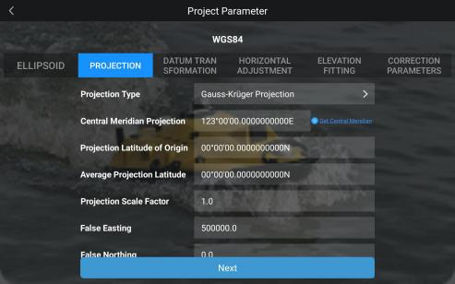
Figure 6.3.2.1Coordinate System Parameters — Projection
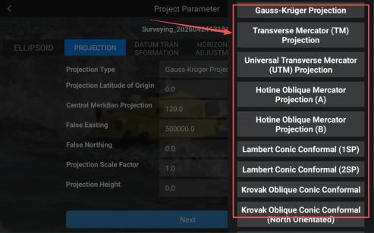
Figure 6.3.2.2 Projection Type Selection
囗Notice
In the new version of iSail software, a “Get Central Meridian”function has been added to the Central Meridian input field. When satellite signals are available and the RTK is in a fixed or valid positioning state, this function
95
can automatically obtain the local central meridian corresponding to the device’s current location.

6.3.3.Datum Transformation
In the transformation model, the system provides the following options: 7 Parameters, 3 Parameters (Helmert), and 7 Parameters (Helmert).
Datum transformation completes the transformation from the source ellipsoid geocentric rectangular coordinate system to the local ellipsoid geocentric rectangular coordinate system. The commonly used transformation methods are 3 Parameters (Helmert) or 7 Parameters.
The 3 Parameters (Helmert) for datum transformation, i.e., three translation parameters, are used
to describe the difference between two different coordinate datums. Using these three parameters, coordinate points can be transformed from one coordinate system to another. This method does not account for rotation or scale and performs only translational shifts of the coordinates. It includes the following three parameters:
1) Three Translation Parameters囗
□X: Translation along the X-axis
□Y: Translation along the Y-axis
□Z: Translation along the Z-axis
These parameters represent the coordinate differences between the origins ofthe two coordinate systems.
The 7 Parameters (Bursa-Wolf) is a mathematical model used to transform geographic positions
between different coordinate systems, widely applied in Geographic Information Systems (GIS), navigation systems, surveying engineering, and other fields. It includes the following seven
parameters:
2) Three Translation Parameters:
□X: Translation along the X-axis
□Y: Translation along the Y-axis
□Z: Translation along the Z-axis
These parameters represent the coordinate differences between the origins ofthe two coordinate systems.

96
3) Three Rotation Parameters:
□□: Rotation angle around the X-axis
□□: Rotation angle around theY-axis
□□: Rotation angle around the Z-axis
By sequentially rotating the three coordinate axes by specified angles, the XYZ axes of the two geocentric rectangular coordinate systems can be aligned.
4) One Scale Factor:
K: The ratio of the length of the same line segment in two spatial coordinate systems is used to
account for scale differences between them. The value of K is typically very close to 1.
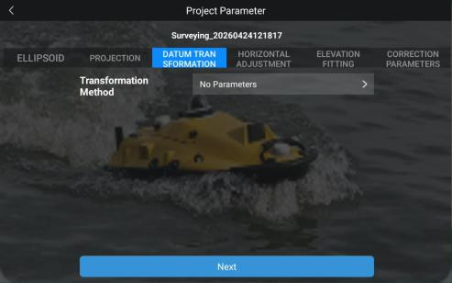
Figure 6.3.3.1 Coordinate System Parameters — Datum Transformation

97
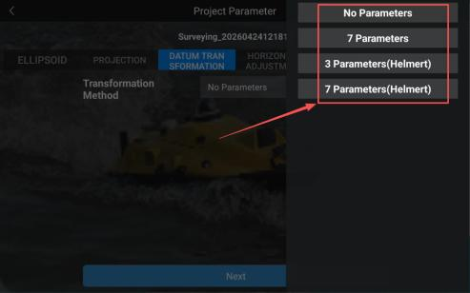
Figure 6.3.3.2 Datum Transformation Method Selection

6.3.4.Horizontal Coordinate Transformation
The transformation model for horizontal coordinate transformation can be set to the standard four-parameter model.
Horizontal coordinate transformation parameters are used to convert coordinates from a projected planar coordinate system based on a source ellipsoid to a local planar coordinate system based on a target ellipsoid. Common transformation methods include the four-parameter model and the TGO method.
The four-parameter planar transformation is a method used to transform coordinates between two two-dimensional Cartesian coordinate systems. It is widely applied in Geographic Information
Systems (GIS) and surveying and mapping engineering to enable coordinate transformation
between different map projections or reference systems. The four-parameter model is suitable for spatial coordinate transformation in small survey areas. Compared with the seven-parameter
transformation, its advantage is that only two common control points are required for parameter estimation, making it simple and easy to implement.
1) Two Translation Parameters:
□X: Translation along the X-axis
□Y: Translation along the Y-axis

98
These parameters represent the coordinate offset between the origins ofthe two planar coordinate systems.
2) One Rotation Parameter:
□: Rotation angle.
By rotating by this angle, the X and Y axes of the two coordinate systems can be aligned.
3) One Scale Factor:
K: The length ratio of the same line segment within the two coordinate systems, enabling proportional scale transformation. Typically, the K value is nearly equal to 1.
囗Caution
It should be noted that different manufacturers may adopt different calculation models for the four-parameter transformation. When comparing coordinates, both devices must use the same model and identical
transformation parameters to ensure consistency.
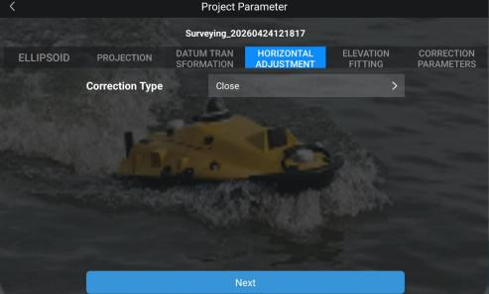
Figure 6.3.4.1 Horizontal Coordinate Transformation (Four Parameters)

99
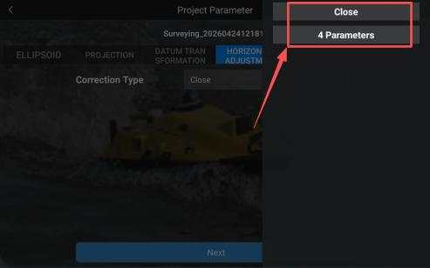
Figure 6.3.4.2 Horizontal Coordinate Transformation Method Selection

6.3.5.Elevation Fitting
Elevation fitting refers to the correction of elevation data through model-based adjustments. It is typically used in combination with horizontal transformation parameters. Common elevation fitting methods include plane fitting and surface fitting.
1) Plane Fitting
Plane fitting for elevation correction is a local elevation adjustment model. It assumes that elevation residuals within the survey area follow a planar linear trend. Elevation errors are considered to vary linearly with planar coordinates (X, Y), while local geoid undulation and terrain variation are not considered. The mathematical model is expressed as:
□h = a□ + a□X + a□Y
The model includes three fitting parameters:
a□: global vertical offset
a□: east-west gradient
a□: north-south gradient
At least two known leveling control points are required to solve the model. However, industry practice recommends using no fewer than three well-distributed control points to ensure stable and reliable results.

100
This model features a simple structure, fast computation, and strong robustness. It requires only a small number of control points for parameter estimation. Within small survey areas, it
provides high accuracy without introducing significant distortion. It is also relatively
insensitive to individual control point errors, as a single erroneous point has limited impact on the overall solution.
However, its limitation is that it cannot compensate for local geoid undulations. As the survey area increases, cumulative elevation errors become more pronounced, particularly atthe
boundaries. Therefore, this method is suitable for small-scale, relatively flat survey areas.
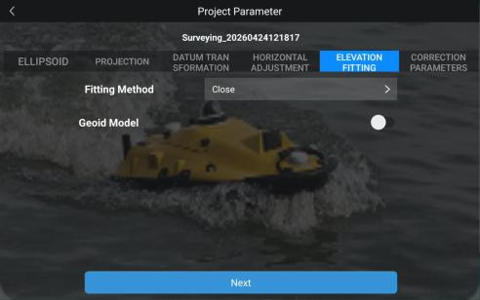
Figure 6.3.5.1 Coordinate System Parameters — Elevation Plane Fitting
2) Surface Fitting
Surface fitting refers to the process of generating an optimal fitted parabolic surface based on
elevation anomalies at multiple leveling control points. It is suitable for areas with significant elevation variations and can more accurately model complex terrain. This method is appropriate for survey regions with pronounced topographic relief.
However, it imposes higher requirements on the initial input data. If the fitting quality is poor, it may lead to divergence of elevation correction values within the working area. At least six control points are required for surface fitting.
The model is expressed as:

101
H□use□ = a + bX + cY + dX□ + eXY + fY□
where H□use□ represents the applied elevation, X and Y are planar coordinates, and a, b, c, d, e, and f are the fitting parameters.
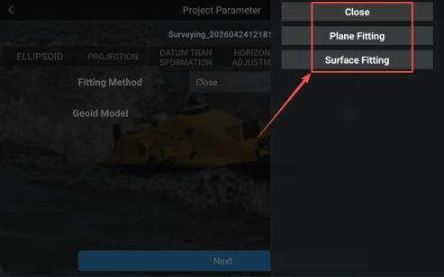
Figure 6.3.5.2 Coordinate System Parameters — Elevation Fitting Method Selection
3) Geoid Model
The GGF (Geoid Grid File) geoid model is a method used for elevation fitting. It improves the accuracy of GPS elevation measurement by establishing a geoid model. This model uses known geodetic height and leveling height data, generating a high-precision geoid grid file through
mathematical fitting methods, thereby achieving accurate elevation transformation.

6.3.6 Correction Parameters
Correction parameters refer to the parameters used to transform points from one coordinate system to another during the coordinate transformation process. These parameters primarily describe the
positional offsets between the origins of two coordinate systems. Specifically, the coordinate translation parameters include the following:
1) X-axis Translation Parameter (ΔX)
Represents the translation offset along the X-axis, typically expressed in meters.
Used to compensate for the positional difference between two coordinate systems inthe X-axis direction.
102
2) Y-axis Translation Parameter (ΔY)
Represents the translation offset along the Y-axis, typically expressed in meters.
Used to compensate for the positional difference between two coordinate systems in theY-axis direction.
3) Z-axis Translation Parameter (ΔZ)
Represents the translation offset along the Z-axis, typically expressed in meters.
Used to compensate for the positional difference between two coordinate systems in the Z-axis direction.

Figure 6.3.5.3 Coordinate System Parameters — Correction Parameters

103

6.3.6.Project Parameter Settings
During the operation of the Single Beam Bathymetric Survey page, if the coordinate system needs to be changed, the current survey workflow must first be exited and reinitialized.
1) Tap the back entry in the upper left corner of the page to return to the Project Management interface.
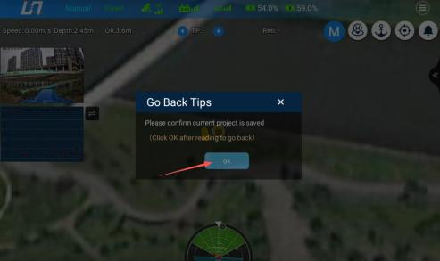
Figure 6.3.6.1 Returning to the Home Screen
2) Select the target project, and tap Project Parameters to enter the parameter settings page.
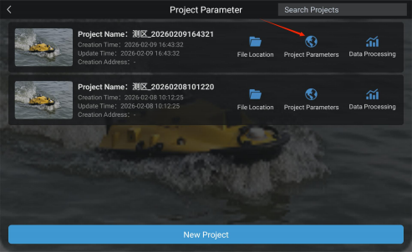
Figure 6.3.6.2 Project Parameter Settings Page

104
3) Modify the coordinate system and related parameters. After confirming that all settings are
correct, tap Next.
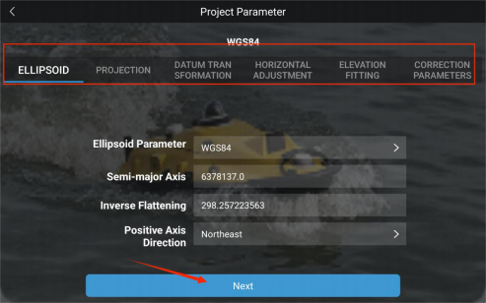
Figure 6.3.6.3 Project Parameter Settings Details Page
4) The system will automatically perform a device self-check. After the self-check is passed, it will proceed to the main operation interface, completing the coordinate system parameter update and resuming the operation workflow.

105

6.4.Device Self-Testing
After the USV is successfully connected to the software, tap the designated function entry at the bottom of the interface (as indicated in the figure) to create a new project or open an
existing project.
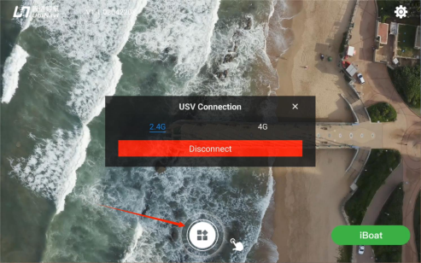
Figure 6.4.1 Project Creation / Historical Project Page after Successful USV Connection
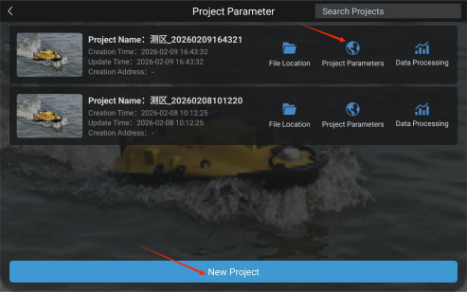
Figure 6.4.2 Project Creation / Historical Project Page
For a new project, after completing parameter the full configuration and verification of the six coordinate system modules — Ellipsoid, Projection, Datum Transformation, Horizontal Adjustment, Elevation Fitting, and Correction Parameters —tap Next. The system will then automatically initiate the USV device self-testing procedure.
106
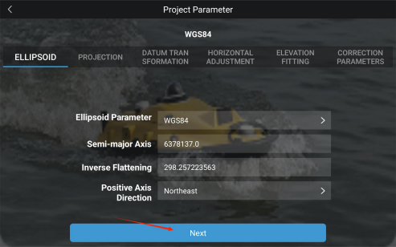
Figure 6.4.3 New Project Parameter Settings
For an existing project, the system directly enters the device self-check interface and display the full device information of the connected USV.
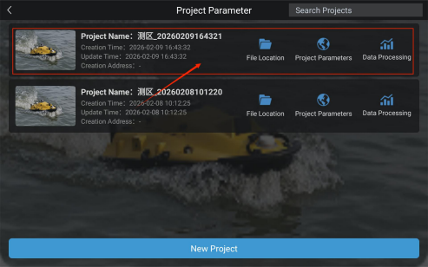
Figure 6.4.4 Historical Projects

107
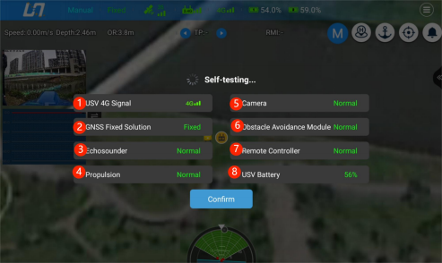
Figure 6.4.5 USV Self-check Information Page
1) USV 4G Network Signal
High signal strength (3 bars): Green;
Medium signal strength (2 bars): Yellow;
Low signal strength (1 bar): Red.
2) GNSS Solution Status
Single Point: White;
Float: Yellow;
Fixed: Green.
3) Echosounder
Normal: Green;
Abnormal: Red.
4) Propulsion System
Normal: Green;
Abnormal: Red.
5) Camera
Normal: Green;
108
Abnormal: Red.
6) Obstacle Avoidance Module
Normal: Green;
Abnormal: Red.
7) Remote Controller
Normal: Green;
Abnormal: Red.
8) USV Battery Level
Displays real-time battery level of the USV. Status bar color coding Green: 61–100%; Yellow: 21–60%; Red: 0–20%.
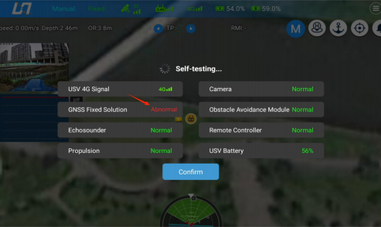
Figure 6.4.6 USV Fault Display
1. USV Self-check
After a successful connection to the USV, the system will perform a self-check of onboard
components. The results are displayed as green (Normal) or red (Warning). If any warning
appears, follow the prompts to troubleshoot the corresponding device.
2. View Device Information
After the USV self-check process is completed, tap Confirm on the interface to acknowledge the results.
109
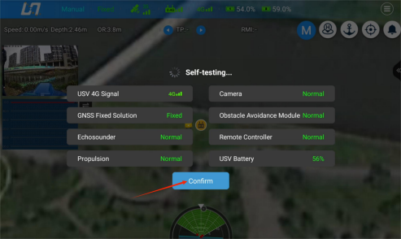
Figure 6.4.7 Confirm Page after USV Self-check Completion

110

6.5.Single-beam Bathymetric Survey Main Interface
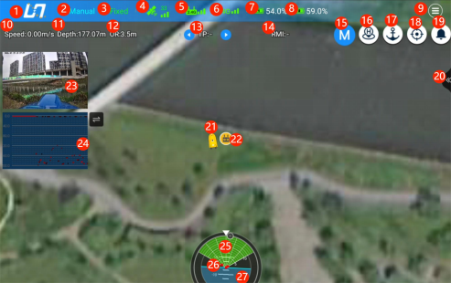
Figure 6.5.1 Function Buttons on Single-Beam Bathymetric Survey Page
1) Return to Project Management
Tap the button in the upper-left corner to return to the Project Management page. When exiting, the system will prompt a data save dialog.

Figure 6.5.1 Go Back Tips

111
2) Navigation Mode
The interface displays the current navigation control mode of the USV in real time, intuitively presenting the real-time operation control status of the USV. Supported modes include
Automatic Operation, Automatic Return, Auto Hover, Auto Obstacle Avoidance, and Manual Mode.
3) Positioning Status
The interface displays the GNSS positioning solution status of the USV in real time, classified into three levels: Single, Float, and Fixed. The Fixed solution provides the highest surveying
accuracy, followed by Float, while Single represents basic positioning accuracy, ensuring
reliable coordinate accuracy for bathymetric operations. The specifications of each status are as follows:
Single
Standard satellite positioning with an accuracy of approximately 1 – 10 m, used for rough
positioning reference only.
Float
Differential corrections are partially converged, with an accuracy of approximately 0.3–1 m,
higher than Single.
Fixed
RTK high-precision positioning with a horizontal accuracy of up to □ 2 cm, meeting
professional hydrographic surveying requirements.
4) Satellite Status
Displays the number of tracked satellites and signal quality atthe USV end in realtime. The
value represents the total number of currently locked satellites. The greater the number of
satellites and the more stable the signal, the higher the positioning accuracy.
Red: No satellites are tracked, no valid positioning.
Yellow: Satellites are tracked, the differential signal is converging, and positioning accuracy is
moderate.
Green: Normal satellite tracking, stable positioning signal. The interface normally displays the
current number of satellites.
5) Remote Controller Status

112
Displays the connection status and signal strength between the remote controller and the USV. Full signal bars indicate stable communication. If the signal is weak, adjust the operation
position promptly to avoid communication interruption.
Red: Poor communication signal; unstable connection; high risk of disconnection.
Yellow: Moderate signal; communication available but with weak interference resistance.
Green: Good and stable signal; meets operational requirements.
6) USV Control Network Status
Displays the connection status and signal strength of the 4G / video transmission network atthe USV end, ensuring the stability of remote control, video transmission, and bathymetric data
transmission. Network abnormalities will affect command delivery and data acquisition.
Red: No 4G network signal, network disconnected, preventing remote communication and data
transmission.
Yellow: Weak network signal with significant transmission delay; remote functions are limited.
Green: Stable 4G network signal, enabling normal data and video transmission.
7) Battery 1 Status
Displays the remaining battery percentage of USV Battery 1 in realtime.
8) Battery 2 Status
Displays the remaining battery percentage of USV Battery 2 in realtime.
Battery Status
Red: Critically low battery level; a low-battery alarm is triggered, and immediate return for charging is required.
Yellow: Low battery level with limited remaining endurance; return planning is recommended.
Green: Sufficient battery level; normal operation of all mission tasks is supported.
9) Function Settings
Tap this button to expand the Function Settings menu, which integrates core functions
including Route Planning, USV Control Parameters, Echosounder Control, Recording Control, Differential Settings, USV Information, Layer Management, Safety Settings, and Other
Settings, providing a unified configuration entry for the entire workflow.

113
10) Navigation Speed
Displays the current navigation speed of the USV in realtime (unit: m/s), used for monitoring the navigation status of the USV.
11) Water Depth
Displays the underwater depth value atthe current position of the USV in realtime, acquired by the single-beam echosounder (iSBES).
12) Hover/Cancel Hover Toggle
One-touch control to place the USV into in-situ hover (station-keeping) mode. Tap again to cancel hover and the USV will automatically switch to Manual mode.
13) Target Point
Displays the number of the next target point that the USV is about to navigate to. Tap the left and right arrows to manually switch between points. In autonomous operation mode, the USV will prioritize navigating through preconfigured points in sequence.
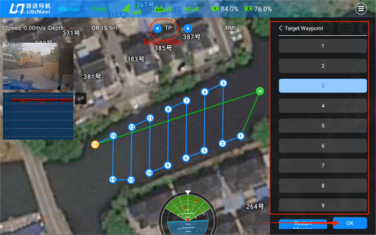
Figure 6.5.2 Target Point
14) Remaining Distance
Displays the total remaining distance of the current USV mission route in real time (unit: km). This data is calculated only in Auto mode.

114
15) Auto / Manual
One-touch toggle forthe USV navigation control mode:
Manual Mode: The USV is directly controlled via the remote controller joystick or the
software virtual joystick, with full manual operation throughout.
Auto Mode: The USV navigates autonomously along the pre-set route.
16) Return to Home/ Cancel Return to Home
Tap to initiate USV return to the preset Home point. During the return process, tap again to
cancel the return to home mode at anytime.
17) Hover / Cancel Hover Toggle
3-position Toggle Switch to command the USV to enter in-situ hover (station-keeping) mode, or to exit hover mode.
18) Auto Center
Tap this button to automatically center the map view centered on the current position of the USV, keeping the USV in the center of the view. When the button remains highlighted in blue, the Auto Center function is enabled. Tap again to cancel Auto Center function.

115
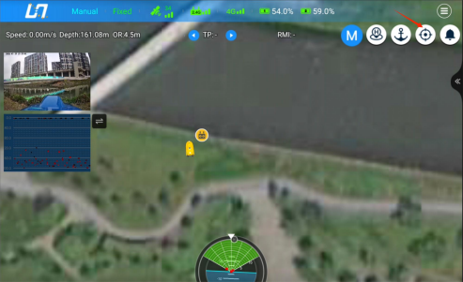
Figure 6.5.3 Auto Center
19) Notification Center
Various real-time prompts from the waypoint system (such as“Caution: Shoal”,“Low Battery Warning”, and“Communication Error”) will automatically pop up on the interface. Temporary notifications will automatically disappear after 5 seconds by default. All historical messages are archived in the notification list. Tap the bell icon to view the complete message history, and tap again to close the list.
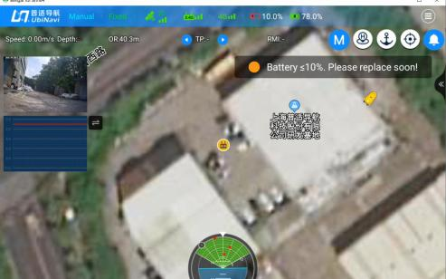
Figure 6.5.4 Real-Time Notifications

116
20) Echosounder Slide-out Button
Tap this button to expand or collapse the echosounder shortcut control panel for quick access to
bathymetric operation functions. After expanding the panel, tap the Activate Sonar and Depth Data Recording buttons in sequence to start underwater depth sounding operations.
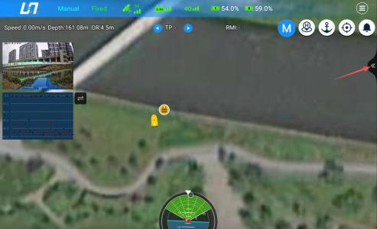
Figure 6.5.5 Echosounder Slide-out Button
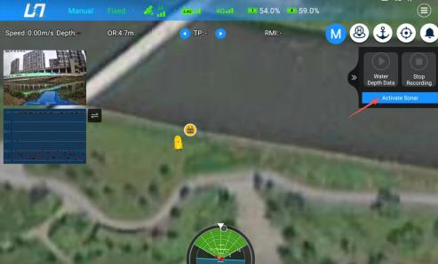
Figure 6.5.6 Sonar Control

117
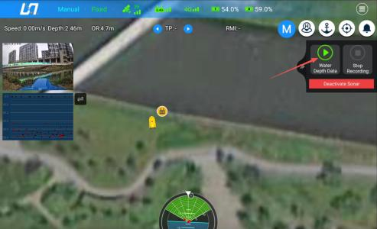
Figure 6.5.7 Start Water Depth Data Recording
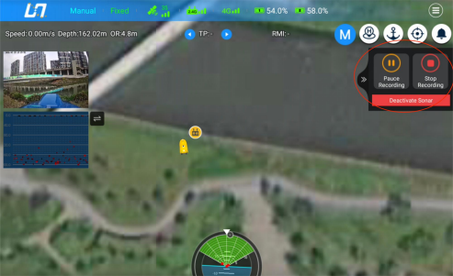
Figure 6.5.8 Pause and Stop Water Depth Data Recording
If the single-beam echosounder function is not required, tap the Deactivate Sonar button to
turn off the sonar.
Notice: Do not operate the sonar for extended periods out of water, as this may damage the
equipment.
21) USV Position Indicator
Displays the current location of the USV in realtime on the satellite imagery basemap.
22) Remote Controller Position Marker
118
Displays the current location of the operator device in real time on the satellite imagery
basemap. By default, this marker indicates the location of the remote controller. When the USV is connected through the iSail App, the marker displays the real-time location of the connected mobile device.
23) Camera Video Feed
Displays the real-time HD video feed transmitted from the onboard camera, providing a clear view of the operating environment ahead of the USV.
24) Camera View Entry
On the main operation interface, tap the camera video window in the upper-left corner to enter the camera view and receive the real-time HD video feed from the USV.
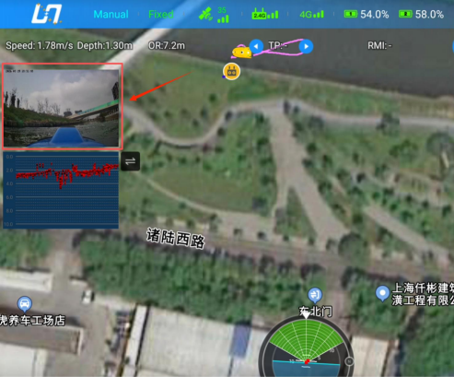
Figure 6.5.9 Camera Control Entry
25) Split-Screen View
Tap the camera video window in the upper-left corner to enter split-screen mode. In this view, the satellite imagery basemap is displayed on the left, while the main camera feed is displayed on the right, enabling simultaneous monitoring of the surrounding environment and the USV status.
119
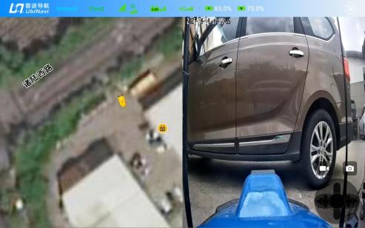
Figure 6.5.10 Split-Screen Display
26) Full-Screen View
Tap the video feed window on the right again to enter full-screen mode.
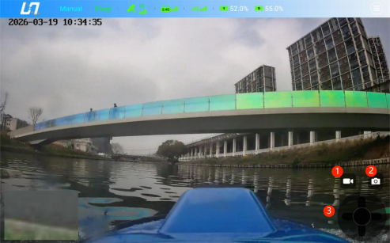
Figure 6.5.11Full-Screen Display
27) Camera View Function Buttons
Video Recording: Starts video recording and local storage of the camera feed, supporting
full-process operation recording for compliance review, troubleshooting, and operation playback.
Snapshot Capture: Captures and stores a single high-resolution image of the current location for
project archiving, operation traceability, and result presentation.

120
Gimbal Control Joystick: Provides remote control of the camera gimbal. The joystick supports
continuous adjustment of the gimbal pitch andyaw angles, enabling comprehensive monitoring of the USV surroundings.
28) Echosounder Waveform View
Displays the real-time echo waveform of the single-beam echosounder, allowing operators to
monitor echosounder performance, verify depth data accuracy, and identify abnormal measurements, bottom terrain variations, and potential interference signals.
The waveform is displayed only when sonar transmission is enabled and depth data recording is
active. When waveform display is disabled, the interface automatically switches to loop playback mode.
Figure 6.5.12 Echosounder Display
29) Obstacle Information Display
Displays real-time information on surrounding obstacles, including their positions, distances, and bearings relative to the USV.
30) USV Detailed Information
Tap the center of the circular panel to quickly view detailed information of the USV.
31) USV Attitude Display
Displays the real-time attitude information of the USV, including heading, roll, and pitch.

121

6.6.Function Parameter Settings
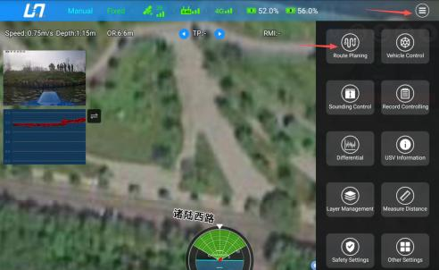

6.6.1.Route Planning
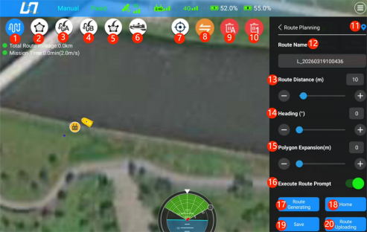
Figure 6.6.1.1 Single-Beam Bathymetric Survey Route Planning Function Buttons
1) Manual Route Planning
Enter Route Planning. By default, the system enters Waypoint Planning mode. Tap the
satellite imagery basemap to create custom waypoints. The system automatically generates the navigation route and heading based on the waypoint sequence, enabling quick creation of

122
custom survey routes.
2) Multi-Waypoint Planning
Tap this button to enter the survey area drawing mode.
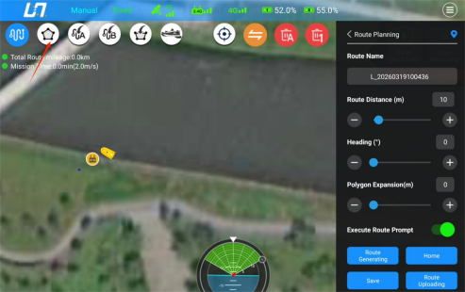
Figure 6.6.1.2 Multi-Waypoint Planning Setting
Tap the map to add boundary points sequentially. A minimum of three points is required to
define a survey area. Once three points have been added, the system automatically generates a triangular survey area boundary. Additional vertices can then be added by tapping the map, and the boundary will automatically extend to form a custom polygon survey area.
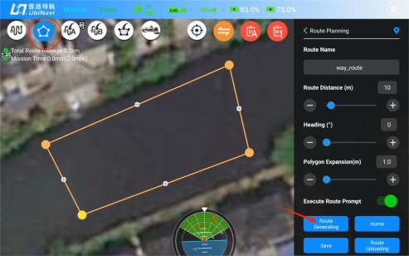
Figure 6.6.1.3 Completed Multi-Waypoint Planning

123
After the survey area boundary has been defined, tap the Generate Route button. The system automatically generates a set of parallel survey lines covering the entire polygon survey area, meeting the requirements of large-area bathymetric survey operations.
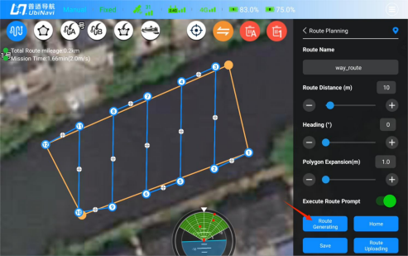
Figure 6.6.1.4 Multi-Waypoint Survey Routes
3) Route Download
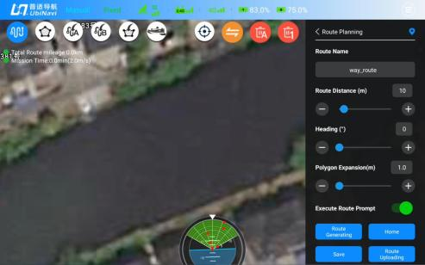
Figure 6.6.1.5 Route Import (No Route Loaded)
Tap this button to download routes previously uploaded to the USV Control System into the software.

124
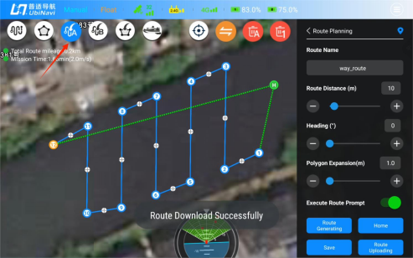
Figure 6.6.1.6 Download Route Successfully
4) Load Local Route History

Figure 6.6.1.7 No Route Loaded
Load historical route configuration files stored in the remote controller’s local storage.

125
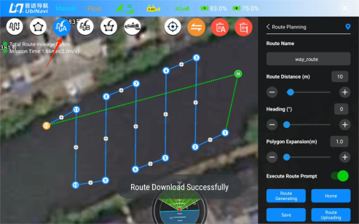
Figure 6.6.1.8 Route Download Successfully
Select the route file to be imported (for instructions on saving historical routes, refer to Item 19).
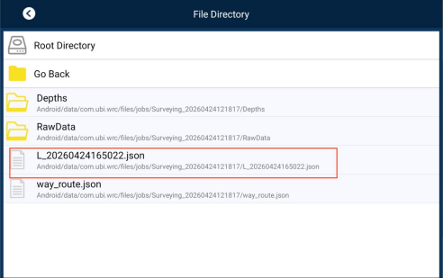
Figure 6.6.1.8 File Selection

126
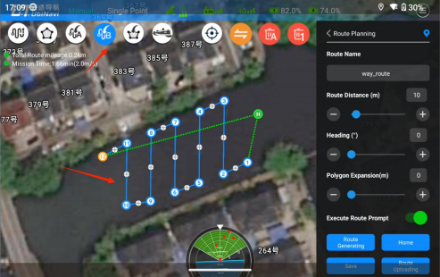
Figure 6.6.1.9 Route Generation
5) External Vector Area Import
Supports importing survey area boundary vector files in KML and DXF formats. Operation
routes are automatically generated based on the imported external boundary, enabling seamless reuse of existing survey data.

Figure 6.6.1.10 No Boundary Imported

127
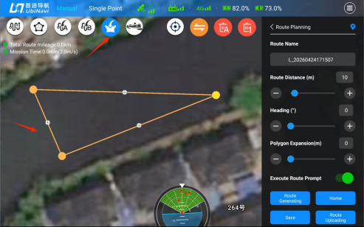
Figure 6.6.1.11 Boundary Imported
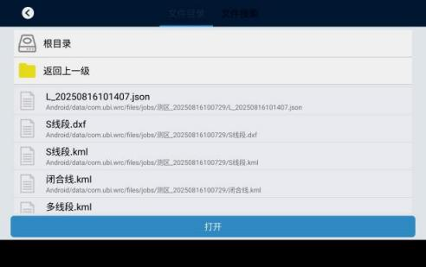
Figure 6.6.1.12 Select the Boundary Line File to Import

128
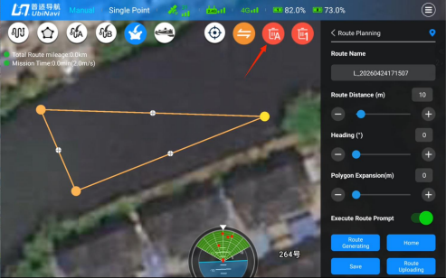
Figure 6.6.1.13 Delete Boundary
6) Add Waypoint at Current USV Position
When the USV is connected and in route editing mode, tap this button to create a waypoint at the current USV position.
7) USV Real-Time Positioning
One-click focus on the current GNSS position of the USV.
8) Waypoint Sequence Adjustment
Adjust the order of planned waypointsto reconstruct the USV navigation path.
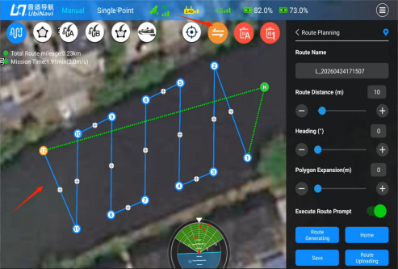

129
Figure 6.6.1.14 Waypoint Order Swapping (Before)
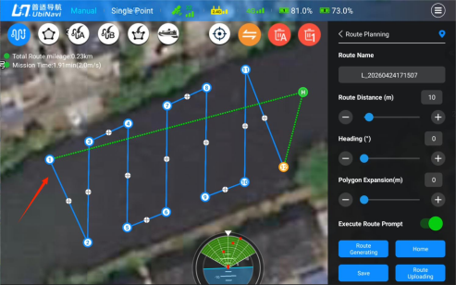
Figure 6.6.1.15 Waypoint Order Swapping (After)
9) Clear All Waypoints
Tap to clear all planned waypoints (mission waypoints / multi-boundary vertices) and reset the route planning state.
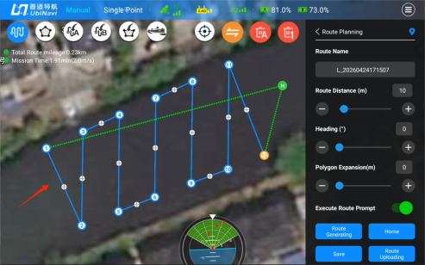
Figure 6.6.1.16 Waypoints Before Clearing

130
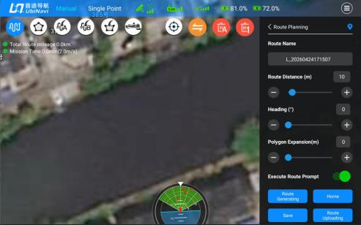
Figure 6.6.1.17 Waypoints After Clearing
10) Delete Single Waypoint
Select a waypoint on the map, or a boundary point in boundary drawing mode. The selected point will be highlighted with a yellow outer ring. Tap this button to delete the point.
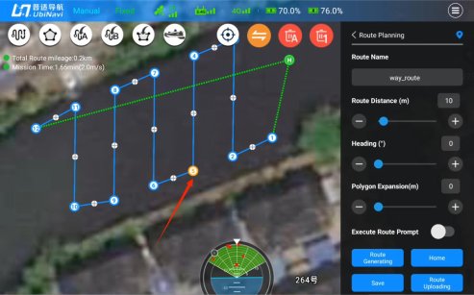
Figure 6.6.1.18 Single Waypoint Deletion
11) Waypoint Information
Displays detailed information for all planned waypoints. The system lists waypoints in the

131
order they were created and displays the waypoint ID, latitude and longitude coordinates, and other key geographic parameters. Waypoints can also be deleted from this interface.
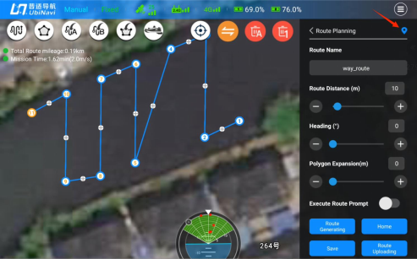
Figure 6.6.1.19 Waypoint Planning View
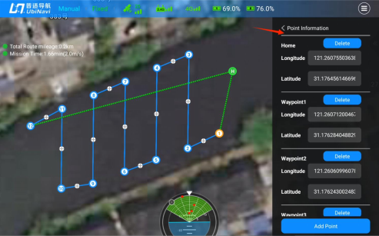
Figure 6.6.1.20 Waypoint Information View
12) Route Name
The unique identifier of a route task. The system automatically generates a route name using a timestamp in the format L_yyyymmddhhmmssto ensure uniqueness. Custom route names are also supported.

132
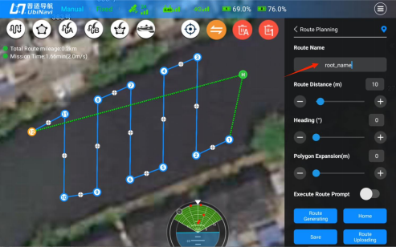
Figure 6.6.1.21 Custom Route Name
13) Route Distance (m)
This parameter is used to control the generation of parallel routes within a polygon survey area. It defines the distance between adjacent survey lines (unit: m) and supports continuous
adjustment via the slider. This parameter is available only after the polygon survey area has been created and the routes have been generated.
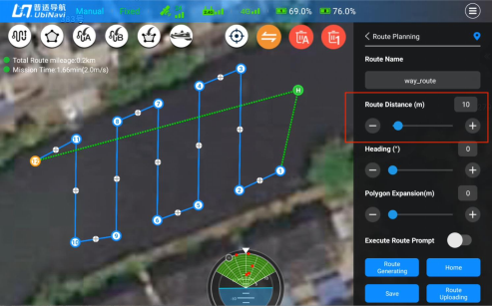
Figure 6.6.1.22 Route Distance Setting
14) Route Heading Angle

133
This parameter controls the orientation of parallel routes within a polygon survey area and defines their overall direction (unit: °). A value of 0° represents true north, with angles increasing clockwise to 360° . Continuous adjustment within the range of 0°–360° is
supported via the slider.
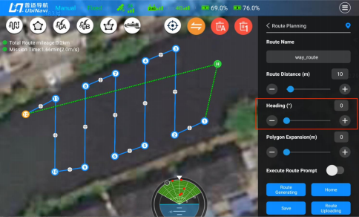
Figure 6.6.1.23 Route Heading Angle Settings
15) Boundary Expansion
A boundary safety margin parameter used to define the outward expansion distance of the boundary line (unit: m), providing additional coverage and a safety buffer around the survey area.
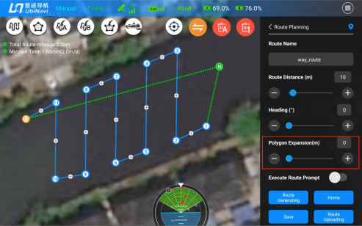

134
Figure 6.6.1.24 Boundary Expansion Settings
16) Route Execution Notification
An auxiliary operation monitoring feature. When enabled, the system provides real-time status notifications during route upload and execution.
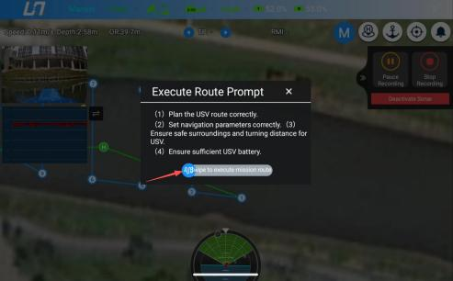
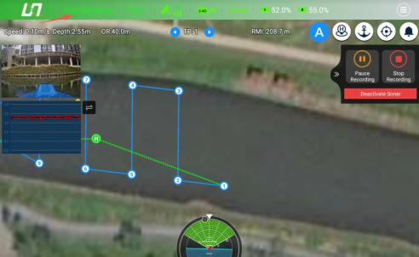
Figure 6.6.1.25 Route Execution Notification

135
17) Route Generation
Automatically generates parallel operation routes based on the defined survey area boundary, enabling efficient route planning for large-scale survey areas.
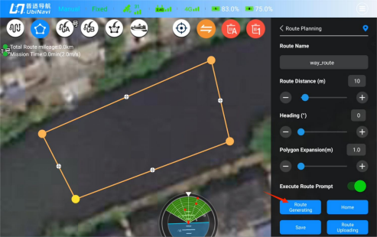
Figure 6.6.1.26 Boundary-Based Survey Area Planning
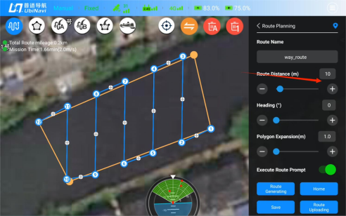
Figure 6.6.1.29 Route Generation
18) Home Point Setting
When in route editing mode, tap this button to enable Home Point setting. Then tap the desired location on the map to create a Home Point. A Home Point must be configured before a route can be uploaded.

136
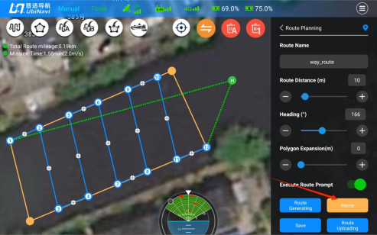
Figure 6.6.1.30 Home Point Setting
19) Save Route
Tap this button to save the currently planned route to local storage.
20) Route Task Upload
Uploads the planned route task to the USV control system and initiates autonomous navigation. During operation, the system automatically acquires and stores single-beam bathymetric data, enabling underwater terrain surveying.

137

6.7.Vehicle Control Parameter
The Vehicle Control Parameter Settings interface provides a range of configurable
parameters to meet different operational requirements. The functions of each parameter are described below.
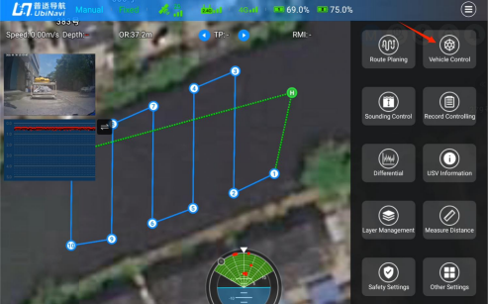
□6.70 □□□□□□Figure 6.7.1 Vehicle Control
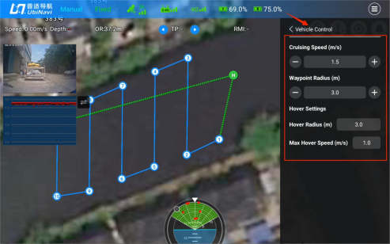
Figure 6.7.2 Vehicle Control Parameter Settings

6.7.1.Vehicle Control Parameter Settings
The following navigation control parameters have been optimized and configured atthe factory. Non-professional users are advised not to modify these parameters unless necessary. Improper
138
adjustments may result in abnormal vessel behavior, route deviations, or other unintended operational issues.
1) Cruise Speed (m/s)
This parameter is used to set the cruise speed of the USV during autonomous navigation. The cruise speed refers to the Speed Over Ground (SOG). The value can be adjusted by tapping the +/- buttons or by entering a value directly. Tap Set to apply the new setting.
2) Waypoint Radius (m)
This parameter defines the waypoint acceptance radius used by the USV during autonomous navigation. It also affects the turning radius when the USV passes route turning points. A larger value results in a larger turning radius and smoother maneuvering through turns. The value can be adjusted by tapping the +/- buttons or by entering a value directly. Tap Set to apply the new setting. (Range: 1–7 m)
3) Hover Radius (m)
Defines the allowable offset radius centered on the target point while the USV is operating in hover mode. The USV may freely adjust its position within this range.
Unit: m
Range: 1–5 m
4) Maximum Hover Speed (m/s)
This parameter defines the maximum movement speed of the USV while operating in Hover Mode (unit: m/s). It limits the vessel's speed when correcting position deviations, compensating for currents, or responding to environmental changes.
Range: 0.1–7 m/s

6.7.2.Echosounder Settings
Configure echosounder parameters, including sound velocity, range, gain, and depth filtering. All parameter changes take effect immediately. The resulting waveform variations can be observed in real time in the upper-left corner of the map interface.

139
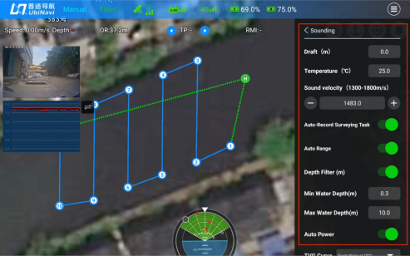
Figure 6.7.3 Echosounder Settings
1) Draft (m)
Draft is the vertical distance from the water surface to the lowest point of the hull when the
USV is afloat. This parameter is used to compensate depth measurements and calculate
elevation data. The draft value is model-specific and should be configured according to the
USV type. The default draft value for both the UbiNavi Tboat10 and UbiNavi Tboat20 is 0.10
m.

6.7.3.Sound Velocity Settings
1) Sound Velocity (m/s)
The sound velocity value can be entered manually or calculated automatically based on the
water temperature.
2) Temperature (囗)
This parameter is used to estimate the sound velocity atthe transducer depth based on the
measured water temperature, providing a reference for depth measurement correction.

6.7.4.Sonar Settings
1) Automatic Measurement Recording
When enabled, the system automatically starts acquiring and recording depth data during route execution.
2) Range

140
When enabled, the system automatically starts acquiring and recording depth data during route execution.
3) Transmit Power
Controls the transmission power of the acoustic signals emitted by the sonar. Both automatic and manual adjustment modes are supported. Higher transmit power is recommended for
deep-water or high-turbidity environments, while lower transmit power is recommended for shallow or clear-water conditions to minimize clutter caused by excessive signal strength.
4) Depth Filtering
When enabled, the minimum and maximum depths for bottom detection can be configured to filter depth measurements outside the specified range. After modifying the parameters, tap Set to apply the settings.
5) TGV Curve
The Time Varied Gain (TGV) curve is used to compensate for acoustic signal attenuation
during underwater propagation. It helps normalize echo amplitudes across different water
depths, improving bottom target detection and enhancing the stability of depth measurements. Users can select the appropriate TGV curve according to local water conditions.
6) Pulse Width
Defines the transmission duration of a single acoustic pulse. Both automatic and manual
configuration modes are supported. A narrower pulse width provides higher depth resolution and is suitable for detailed shallow-water surveys, while a wider pulse width offers greater
penetration capability and is better suited for deep-water or high-turbidity environments.

6.7.5.Record Controlling
Used to configure the recording parameters for single-beam bathymetric data in iSail. Real-time depth measurements are automatically recorded and stored according to the current recording
configuration.

141
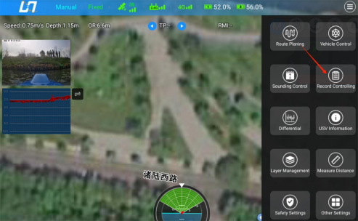
Figure 6.7.5.1 Record Controlling Selection
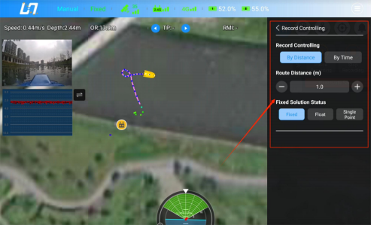
Figure 6.7.5.2 Record Controlling

6.7.6.Record Controlling
Recording can be configured in either By Distance or By Time mode.
By Distance: When set to 1 m, one depth point is recorded to the .dep file for every distance interval of at least 1 m.
By Time: When set to 0.1 s, the system records 10 depth points per second to the .dep file.
142
The minimum supported recording interval is 0.1 s in By Time mode and 0.5 m in By Distance mode.

6.7.6.1. Fixed Solution Filter
1) Select Fixed: Records only Fixed solution and inertial navigation solution data.
2) Select Float: Records only Fixed, Float, and inertial navigation solution data.
3) Select Single Point: Records all data (Fixed, Float, inertial navigation, Single Point).

6.8.Differential Settings
This section describes the functions available in the Differential Settings interface, including CORS login, radio configuration, and remote controller network settings.
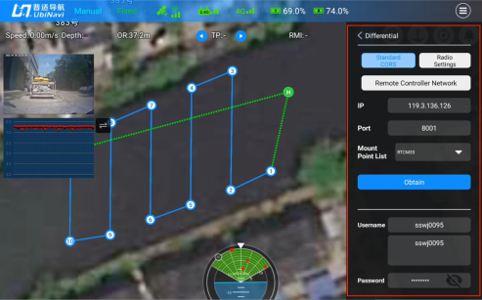
Figure 6.8.1 Differential Settings Page

6.8.1.CORS Login
Users who require network RTK correction services can configure the connection through the CORS Login interface.
Prerequisites:
The remote controller must be connected to the Internet.
The USV Control System must have a SIM card installed and be connected to a cellular network.
Procedure:

143
1. Enter the IP Address and Port Number.
2. Tap Get Source List to retrieve the available correction sources.
3. After the source list has been loaded, enter the Username and Password.
4. Tap Loginto establish the CORS correction service connection.
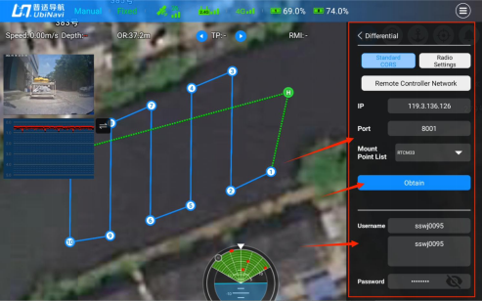
Figure 6.8.1.1 Standard CORS Login
IP Address: The IP address of the CORS reference station server used to specify the correction
data service server.
Port: The communication port number of the CORS server. It must match the server
configuration to ensure proper data communication.
Mount Point List: Used to select the desired correction data source (Mount Point). Different
mount points may correspond to different coordinate reference systems, data formats, or service coverage areas.

6.8.2.Radio Settings
This module provides radio-based RTK positioning forthe USV and is intended for field operations in areas without cellular network coverage. By establishing a wireless communication link with a
radio-equipped base station, the system receives RTK correction data to achieve centimeter-level positioning accuracy.

144
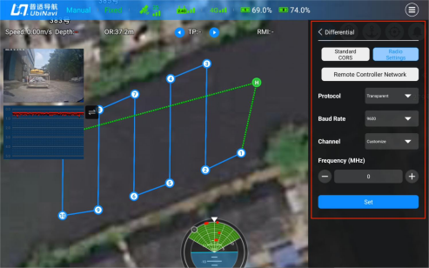
Figure 6.8.2.1 Radio Settings
1) Protocol
Defines the communication protocol used by the radio communication link.
2) Baud Rate
The serial communication rate parameter (unit: bps) that defines the radio data transmission speed. This value must match the baud rate configured on the base station radio to ensure
proper communication.
3) Channel
Used to configure the operating channel of the radio. Supports both custom frequency input and preset channel selection to meet frequency management requirements in different operating areas and minimize co-channel interference.
4) Communication Frequency (MHz)
The carrier operating frequency of the radio (unit: MHz) is a key physical-layer parameter of the differential communication link. It must match the transmission frequency of the base
station radio to ensure stable establishment of the differential data link.
5) Setting
After parameter configuration is completed, tap this button to apply the settings.

145

6.8.3.Remote Controller Network
In the Differential Settings interface, enter the Remote Controller Network module. Input the IP address and port number, tap Get Source List, wait for the source list to load, then enter the username and password, and finally tap Loginto establish the connection.
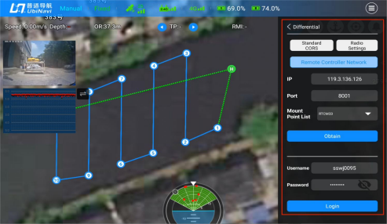
Figure 6.8.3.1Remote Controller Network

6.8.4.USV Information
The USV Information module provides a centralized view of key system status information,
including GNSS positioning, navigation attitude, vessel model, battery status, navigation status,
echosounder status, propulsion status, and 4G connectivity status, enabling real-time monitoring of equipment health and operational conditions.

146
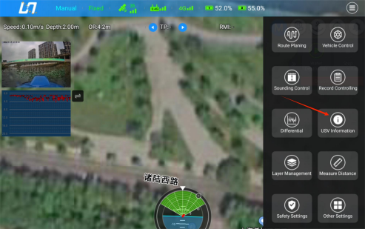
Figure 6.8.4.1 USV Information
Quick Access: Tap the compass icon at the bottom of the software main interface to access this
page.
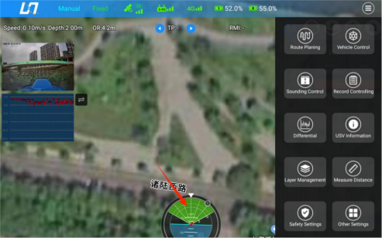
Figure 6.8.4.2 USV Information Quick Access

147
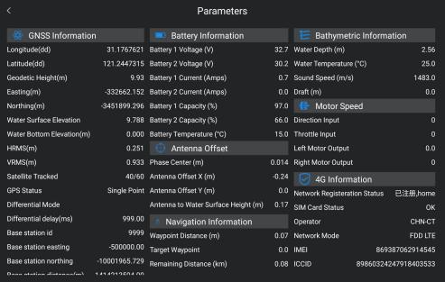
Figure 6.8.4.3 USV Information

6.8.5.Layer Management
The Layer Management module includes the measurement point layer and the boundary line layer. Tap a corresponding layer to quickly toggle its visibility. The right-side panel also supports
importing measurement point and boundary line layer data.
4
Figure 6.8.5.1 Layer Management (1)

148
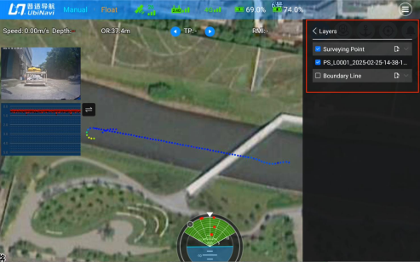
Figure 6.8.5.1 Layer Management (2)

6.8.6.Measure Distance
The Measure Distance function allows users to select any two points on the satellite imagery base map. The system automatically calculates and displays the straight-line distance and azimuth
between the two points.
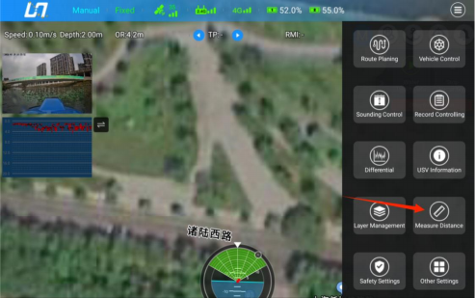
Figure 6.8.6.1 the Access of Measure Distance
149
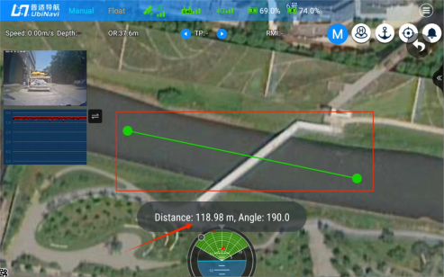
Figure 6.8.6.2 Measure Distance Results

6.8.7.Safety Settings

150
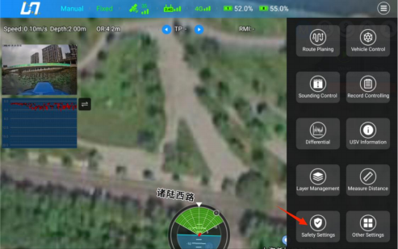
Figure 6.8.7.1 the Access of Safety Settings
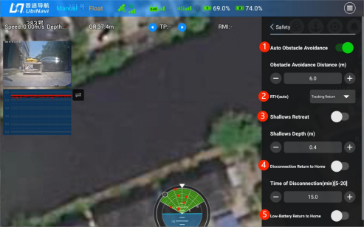
Figure 6.8.7.2 Safety Settings Interface
1) Auto Obstacle Avoidance
The active obstacle avoidance function switch. When enabled, the USV uses millimeter-wave radar to detect obstacles ahead during route execution and automatically plans a bypass path. After obstacle avoidance is completed, the USV returns to the original route. The Obstacle
Avoidance Distance (m) defines the safety threshold for the minimum allowable distance
between the USV and obstacles. It is recommended to keep this value at its default setting.
2) Return-to-Home Mode Configuration
151
Defines the return path logic of the USV. Two modes are available:
Return-to-Home (Straight)
Uses a straight line from the current position to the Home point as the return path. This mode provides the highest efficiency and is suitable for open and unobstructed survey areas.
Return-to-Home (Track Back)
Retraces the completed operation route back to the Home point. This mode helps avoid
unknown obstacles and is suitable for complex or obstacle-dense environments.
3) Shallow Water Avoidance
The active anti-grounding function switch. When enabled, if the echosounder detects that the
water depth falls below the configured Shallow Water Depth (m) threshold, the USV will
automatically brake and reverse for approximately 6 seconds to prevent grounding or bottom contact. This parameter defines the minimum safe water depth for triggering avoidance
behavior and should be configured according to the minimum navigable depth of the survey area.
4) Communication Loss Return-to-Home
The communication loss failsafe function. When enabled, if the 2.4G control link between the remote controller and the USV is lost, the system starts a countdown based on the configured Link Loss Timeout (min) (range: 5–20 min). Once the timeout expires, the return-to-home procedure is automatically triggered to ensure safe recovery of the USV in the event of
communication loss. This parameter defines the waiting duration before triggering failsafe
return and can be adjusted according to operational conditions to avoid false activation.
5) Low-Battery Return to Home
The power safety protection function. When enabled, if the USV battery level falls below the preset threshold of 15%, the system automatically triggers the return-to-home command to ensure the USV safely returns to the Home point before battery depletion.

152

6.8.8.Other Settings
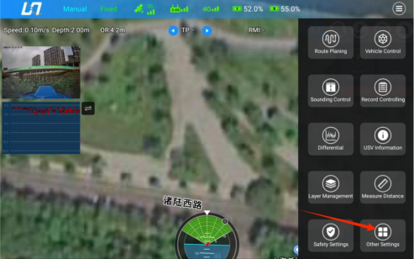
Figure 6.8.8.1Other Settings
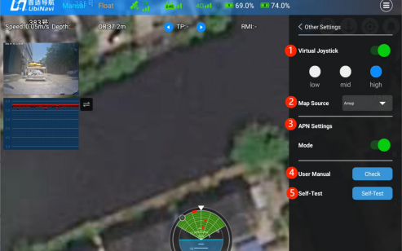
Figure 6.8.8.2 Other Settings Overview
1) Virtual Joystick
The physical joystick on the remote controller is the primary input for manual USV operation: the left joystick controls forward and backward movement, while the right joystick controls left and right steering.
The device features a built-in virtual joystick on the touchscreen, which serves as an alternative manual control interface to the physical joystick. The display of the virtual joystick is

153
controlled by the corresponding enable/disable switch.
The system supports three speed modes (Low / Mid / High). Switching between modes adjusts the USV thruster output speed, enabling adaptation to different operating conditions and
providing precise speed control.
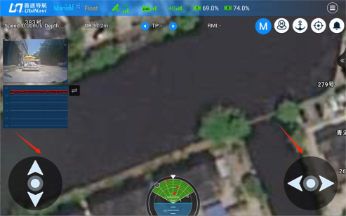
Figure 6.8.8.3 Virtual Joystick Settings
2) Map Source
Provides a multi-source satellite imagery base map switching function, allowing users to switch between Amap and Google Maps.
3) APN Settings
APN refers to the dedicated underlying network access configuration for the 4G communication module of the USV Control System. It is used to define and customize operator network access rules and to standardize the dial-up behavior of the onboard 4G module. This configuration serves as the foundational network setting for all USV communication services, including remote data transmission, CORS differential positioning data reception, and real-time vessel status uploading.
Prerequisites: A cellular data SIM card provided by a network operator must be installed in
the USV Control System. This configuration applies only to the onboard 4G module and
operates independently of the remote controller or mobile app’s local network connection.

154
Figure 6.8.8.4 APN Settings
1. APN
The operator network access point name, which is the core identifier for the 4G module to dial up and connect to the network. The software defaults to cmnet. Users can manually modify it to the official standard access address corresponding to the operator of the onboard SIM card.
2. Username
The account credential for operator APN dedicated line access. The exclusive access account provided by the operator must be entered.
3. Password
The authentication key associated with the APN username, used to complete the network access authentication process.
4. Authentication Type
The authentication method used for 4G network access. The default option is None (no authentication mode).
None: Standard public network mode used by most commercial mobile data SIM cards. No
username or password is required, and the device can directly access the internet.
Optional authentication protocols (PAP / CHAP): Used only for operator private networks or industry-specific data SIM cards to perform network access authentication.
5. User Manual
Provides access to the official software documentation, allowing operators to view operating procedures and user instructions in real time.
6. Self-Test
A standardized system self-test function performed before USV operation. Tap to view the
current self-test status and the status of all onboard subsystems.
155

6.9.Single Beam Bathymetric Data Post-Processing and Export
Project Management Interface
On the Project Management interface, tap the Data Processing button of the corresponding project to enter the data processing module.
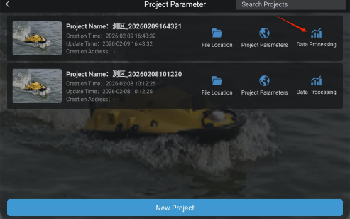
Figure 6.9.1 Project Management List

6.9.1.Data Processing View Introduction
In the data processing window, depth points from the current survey line are overlaid on the satellite imagery base map in the left map view. The right-side information panel displays depth points, echo data, and water surface elevation.

156
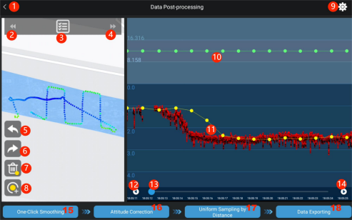
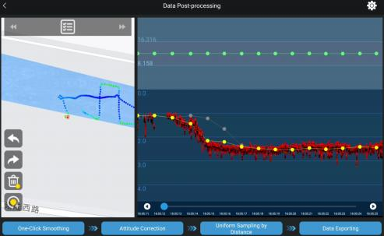
Figure 6.9.1.1Data Processing Main Page
1) Return to Project Management
Tap this button to exit the current data processing interface and return to the project management page.
2) Previous Survey Line
Tap to switch to the previous survey line within the current project.
3) Survey Line Selection
Tap to expand the list of all recorded survey line within the current project. Select a target survey line to switch quickly.

157
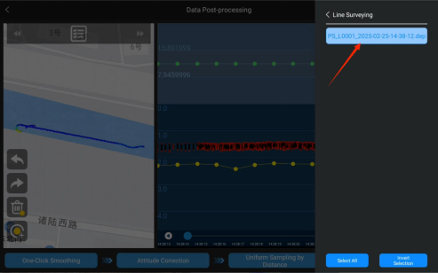
Figure 6.9.1.2 Survey Line Selection
4) Next Survey Line
Tap to switch to the next survey line within the current project.
5) Undo
Reverts the most recent editing action. Multiple consecutive undo operations are supported.
6) Redo
Restores the most recently undone action. Multiple consecutive redo operations are supported.
7) Delete
Tap to activate deletion mode. Select a target point in the waveform view to delete it.
Deletion effect description: Green water surface elevation points will be removed, and yellow depth points will be displayed in a grayed-out state.

158
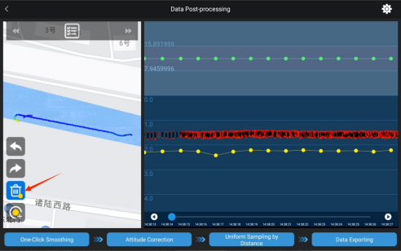
Figure 6.9.1.3 Deletion Mode Activated
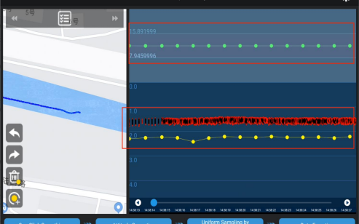
Figure 6.9.1.4 Data Processing Page after Deletion
8) Insert Point
Tap this button to insert a depth point between two existing depth points. The inserted point is generated using linear interpolation based on the coordinates and depth values of the two
surrounding points, and is displayed in yellow.

159
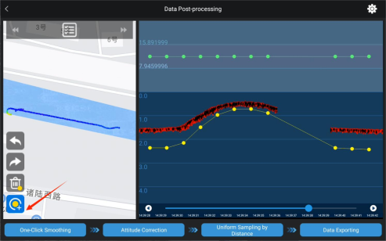
Figure 6.9.1.5 Insert Point Mode Activated
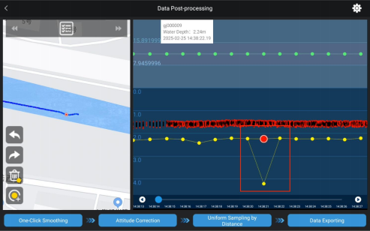
Figure 6.9.1.6 Data Processing Page After Insert Point Mode
Note: Delete Mode and Insert Point Mode are mutually exclusive and cannot be enabled at the same
time.
9) Data Settings
Tap to enter the post-processing parameter configuration interface, where project parameters, echosounder settings, sampling settings, tide correction, and interface settings can be
configured.
10) Water Surface Elevation Point (Green Point)

160
The green point represents a water surface elevation point and displays the corresponding water surface elevation value. It is used for tide correction and vertical datum transformation of
bathymetric data.
Long-press the green point to view detailed information, including point name, water surface elevation value, and acquisition time. Meanwhile, a red control point will be automatically
generated atthe location of the corresponding yellow depth point.
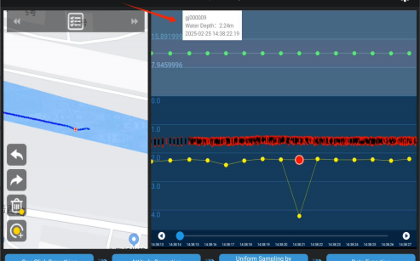
Figure 6.9.1.7 Long-Press on Green Point
11) Bathymetric Data Point (Yellow Point + Red Echo)
The yellow point represents the depth point measured by the USV single-beam echosounder, while the red curve represents the echosounder echo signal. The yellow point corresponds to the real-time measured depth value, and the red echo is used to validate the accuracy of the bathymetric data.
Long-press the yellow point to view detailed information, including point ID, depth value, and acquisition time. Meanwhile, the left-side map will automatically locate and highlight the
corresponding point position.

161
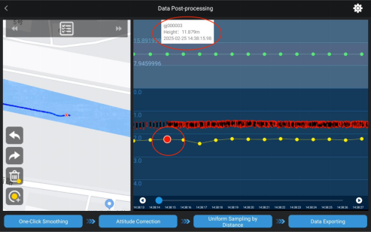
Figure 6.9.1.8 Long-Press Red Point
After a long press, a red control point is generated. This control point represents the original depth value of the current bathymetric point. The yellow point can be dragged vertically to
manually adjust the depth value of the corresponding point.
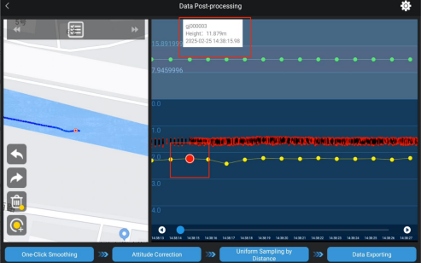
Figure 6.9.1.9 Depth Information Editing
12) Scroll Left
Tap to scroll left and quickly browse earlier bathymetric data in the waveform view.
13) Progress Bar
Drag the progress bar to quickly navigate to a specific time position along the survey line.
162
14) Scroll Right
Tap to scroll right and quickly browse subsequent bathymetric data in the waveform view.
15) One-Click Smoothing
After tapping, the system automatically executes an intelligent smoothing algorithm that adjusts abnormal depth points to align with the echo signal curve, removing anomalies caused by water flow, noise, or interference, and improving overall bathymetric data quality.
After smoothing is completed, all outlier yellow depth points will be automatically displayed in a grayed-out state.
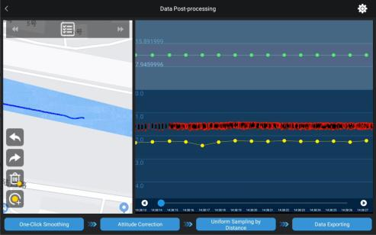
Figure 6.9.1.10 Post-Processing Interface
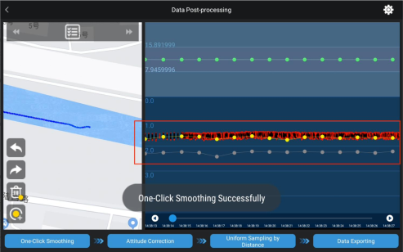
163
Figure 6.9.1.11 One-Click Smoothing Result
16) Attitude Correction
Performs attitude correction on bathymetric data based on roll and pitch measurements collected by the USV’s IMU (Inertial Measurement Unit). It compensates for depth measurement errors caused by vessel tilt and motion, ensuring improved accuracy and reliability of bathymetric data.
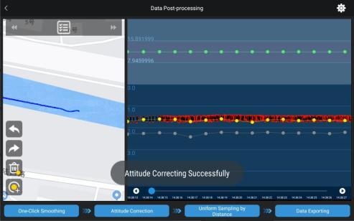
Figure 6.9.1.12 Attitude Correction
17) Uniform Distance Sampling
Tap to resample bathymetric data based on a predefined sampling mode (e.g., uniform distance or uniform time), in order to standardize sampling density and optimize data structure. For
details on sampling mode selection, sampling interval, and other related parameters, refer to Section 6.8.2.3 Sampling Settings.
When Uniform Distance Sampling is executed, corresponding red sampling lines will be
generated in the waveform view in realtime.

164
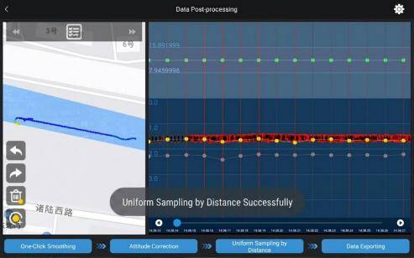
Figure 6.9.1.13 Uniform Distance Sampling
18) Data Export
Select the corresponding survey line. Enable the File Merge and Save Header options as needed, then select the file type and export format. Tap Confirm to export the processed bathymetric data as a standard file. Supported formats include TXT, CSV, DAT, and DXF.
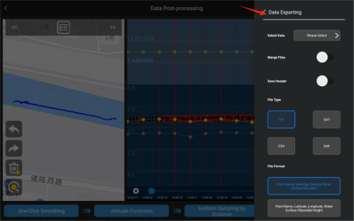
Figure 6.9.1.14 Survey Line Options (File Merge / Save Header / File Type)

165
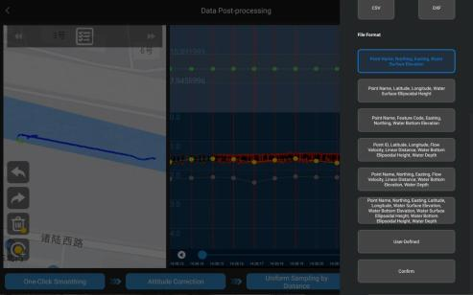
Figure 6.9.1.15 File Format Selection
To customize the export file format, tap the Custom button to enter the custom file format configuration interface. Select the required parameters and tap Confirm to complete the configuration.
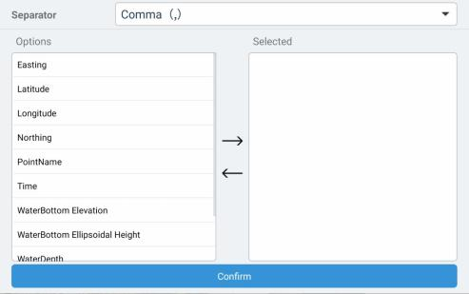
Figure 6.9.1.16 Custom File Format Configuration
After the export is completed, the system displays a pop-up window showing the local storage path of the exported data. The file can be located using this path.

166
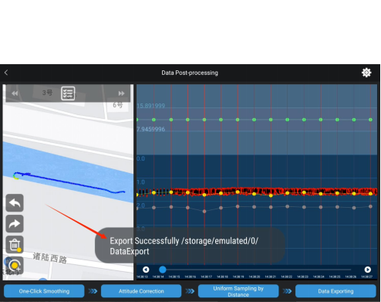
Figure 6.9.1.17 Data Export Success

167

6.10. Data Settings
Tap the Data Settings button in the upper-right corner to view parameter configurations for Project Parameters, Echosounder Settings, Sampling Settings, Tide Correction, and
Interface Settings.
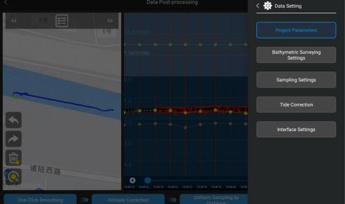
Figure 6.10.1 Data Settings Page

6.10.1.Project Parameters
The basic parameters of the current operation project can be modified and configured.
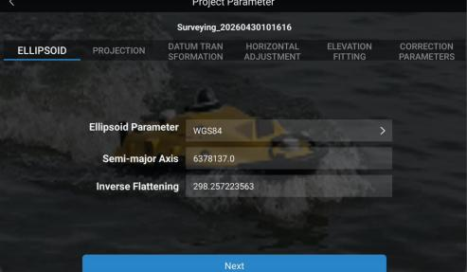
Figure 6.10.1.1 Project Parameters Interface

6.10.2. Sounding Settings
This function is used to modify the echosounder draft (m) and sound velocity (m/s), correcting
168
parameters to eliminate bathymetric systematic errors.
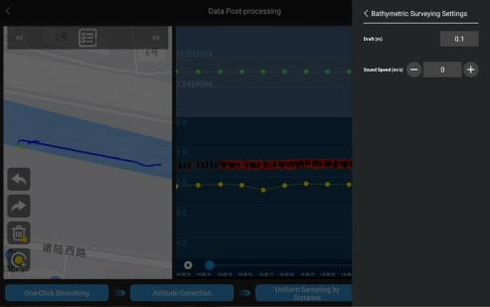
Figure 6.10.2.1 Echosounder Settings Page

6.10.3.Sampling Settings
Uniform-interval sampling performs data thinning on raw bathymetric measurements based on a user-defined Sampling Interval (m). The sampling rules are as follows:
By Distance: Extracts data points at fixed intervals. The distance between adjacent points is not less
than the defined sampling interval.
Deepest: Within each sampling interval, the point with the maximum depth value is selected as the
valid sample.
Shallowest: Within each sampling interval, the point with the minimum depth value is selected as
the valid sample.
Mean Value: Each interval is defined based on the sampling interval, and the arithmetic mean of
all depth values within the interval is used as the sampled depth value. The spacing between sampling points is not less than the preset interval.

169
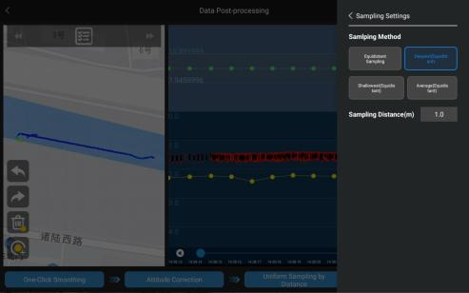
Figure 6.10.3.1 Sampling Settings

6.10.4.Tide Correction
Used to import a tide file in .tid format. The time range of the tide file must fully cover the
acquisition period of the bathymetric data. After import, the system applies water level data from the tide file to perform tide correction, ensuring a consistent vertical datum for bathymetric
measurements.
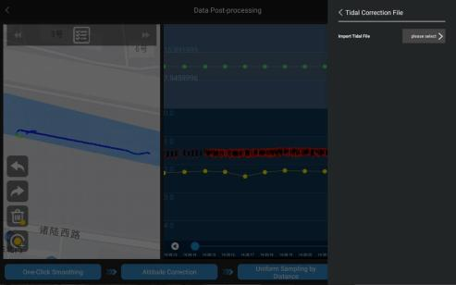
Figure 6.10.4.1 Tide Correction

170

6.10.5.Interface Settings
Used to optimize the view display. Users can configure the vertical axis depth interval (m) and
horizontal axis time interval (s). The horizontal axis time range can also be expanded while keeping the time interval unchanged to prevent excessive data density that may affect point selection.
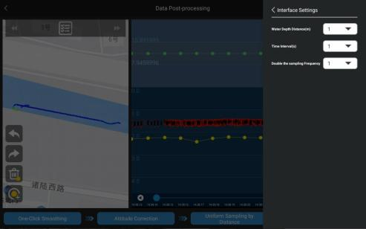
Figure 6.115 Interface Settings

171

6.11. Quick Operation Guide for Single Beam Bathymetric Survey
The steps for performing a quick single beam bathymetric survey are as follows:
1. Power on the USV and the G20 remote controller. Wait 1–2 minutes for system initialization. Under normal conditions, the USV and remote controller will automatically complete pairing, accompanied by a buzzer sound from the USV.
2. Tap Connect. Once the connection is successfully established, the red indicator light on the left side of the USV will remain steady on. Then operate the remote controller joystick to verify that the thrusters are functioning properly.
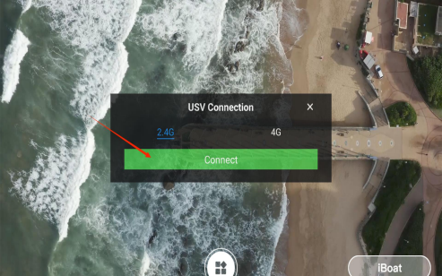
Figure 6.11.1 Initial Connection Page of iSail
3. On the home screen, tap the Settings icon in the upper-right corner to enter the Device
Configuration interface. Locate the Single-Beam Echosounder option and turn on the corresponding switch (green indicates enabled) to activate the echosounder.

172
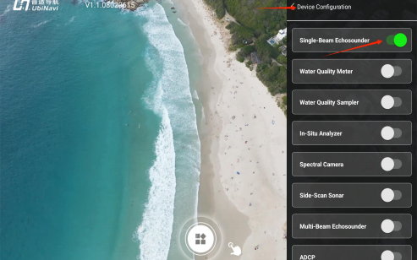
Figure 6.11.2 iSail Software Device Configuration
4. Tap the function entry atthe bottom of the interface to open the Project Management module. This module is used to manage projects and displays basic information for all existing projects, such as project name and creation time. Tap New Project to create a new project.
=
Figure 6.11.2 iSail Home Screen (Connected)

173
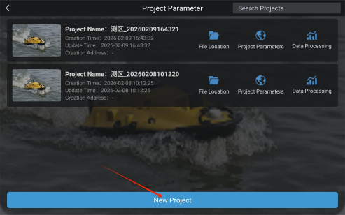
Figure 6.11.3 New Project in the Project Management Interface
5. On the Project Initialization page, configure the Project Name, Template Project (allows reuse
of configuration parameters from an existing project to improve operational efficiency; skip this
option if no existing project is available), Time Zone, and Coordinate System.
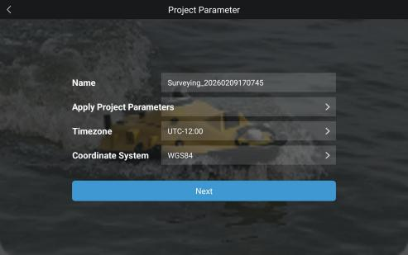
Figure 6.11.4 New Project Page
6. The Coordinate System Configuration supports complete configuration of Ellipsoid, Projection, Datum Transformation, Horizontal Adjustment, Elevation Fitting, and Correction Parameters.
Standard ellipsoid parameters associated with the selected coordinate system are loaded by default and can be customized according to operational requirements.

174
7. After all parameters have been configured, tap Next. The system will automatically perform a
USV self-test. Once the self-test is successfully completed, the system will enter the main operation control interface.

Figure 6.11.5 Parameter Configuration Page
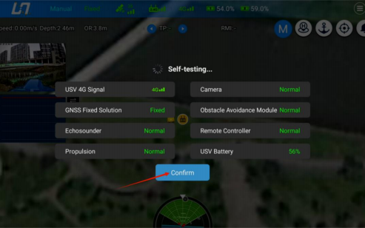
Figure 6.11.6 Device Self-testing Page
8. Return to the main interface and enter the Route Planning module. Planthe survey route
according to the survey area and enable the Route Execution Prompt function. After confirming that the planned route is correct, tap Upload Route to send the mission. Finally, slide the confirmation button to start autonomous route execution.

175
During navigation, the USV will automatically record bathymetric data to complete the underwater topographic survey.
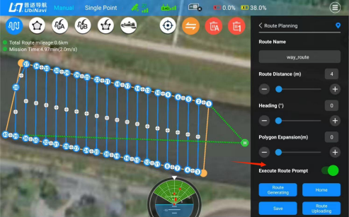
Figure 6.11.7 Route Planning Interface

Figure 6.11.8 Route Execution Interface
9. After all survey operations have been completed, promptly deactivate the sonar system to prevent unnecessary operation and the generation of redundant data.

176
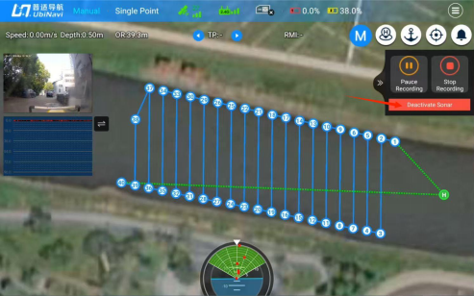
Figure 6.11.9 Sonar Deactivate Interface
10. Return to the Project Management interface and tap the Data Processing button for the
desired project to enter the data processing interface.
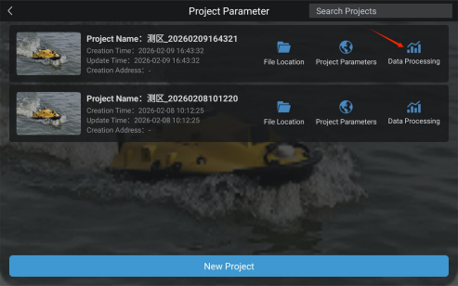
Figure 6.11.10 Project List
11. Select the survey line to be processed from the survey line list on the left. Tap Previous Survey Line or Next Survey Line to quickly switch between survey lines for processing.

177
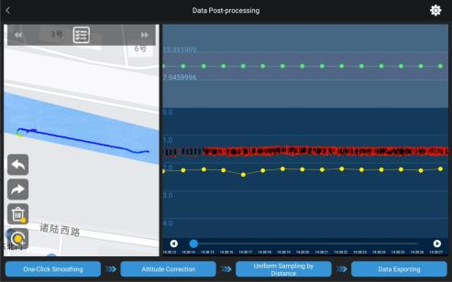
Figure 6.11.11 Bathymetric Data Sampling Window
12. In the bathymetric data processing view, depth points can be manually adjusted by dragging
them to the correct position, or removed using the Delete function to eliminate outliers and noise points. Tap the Shift Left or Shift Right button at the bottom of the interface to adjust the
bathymetric data horizontally.
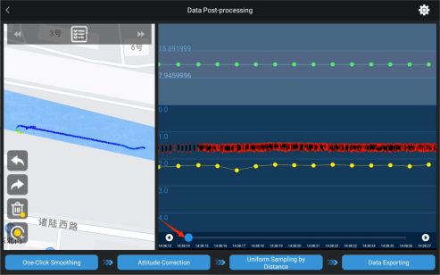

178
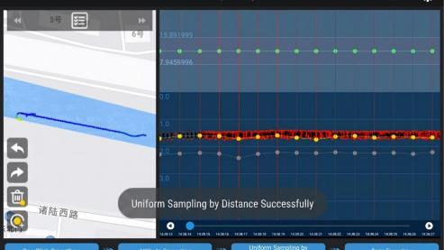
Figure 6.11.12 Survey Line Scrolling
13. After removing all noise points from the survey lines, tap One-Click Smoothing, and then tap Attitude Correction.
14. Tap Data Settings in the upper-right corner and open Sampling Settings. Set the Sampling
Interval as required, then tap Uniform Sampling by Distance in the lower-right corner to perform
data resampling.

Figure 6.11.13 Sampling Settings Interface
Figure 6.11.14 Uniform Sampling by Distance
15. After the sampling process is completed, corresponding red sampling lines will be displayed in

179
the bathymetric data view. After verifying the results, tap Data Export again.
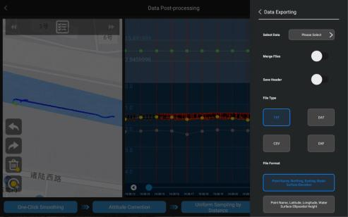
Figure 6.11.15 Data Export Interface
16. Select the survey line(s) to be exported. As required, enable the File Merge and Save Header options. After selecting the File Type and File Format, tap Confirm to export the data.
The exported output files are saved in a dedicated folder by default. Refer tothe on-screen prompt for the file location.

Figure 6.11.16 Data Exporting Options

180
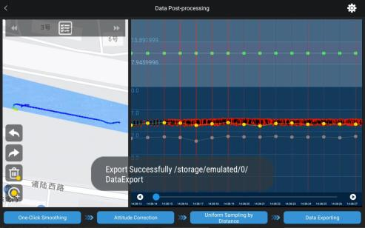
Figure 6.11.17 Data Export Successful

181

