1. We use msgpack-c. Its link is available from the official website

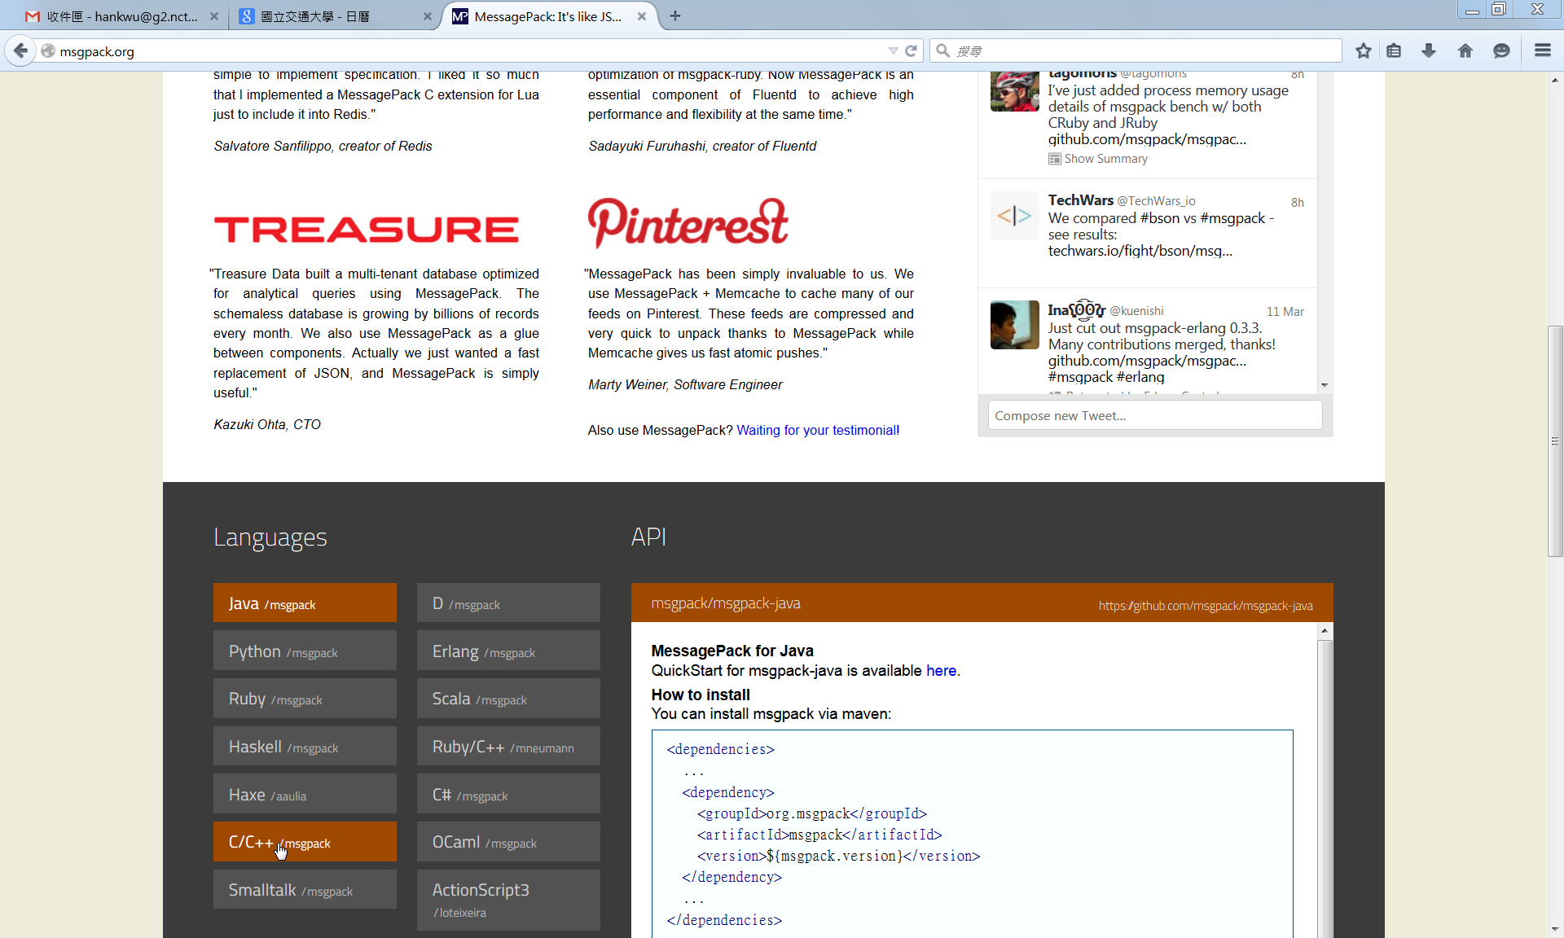

1. wget msgpack-c zip file

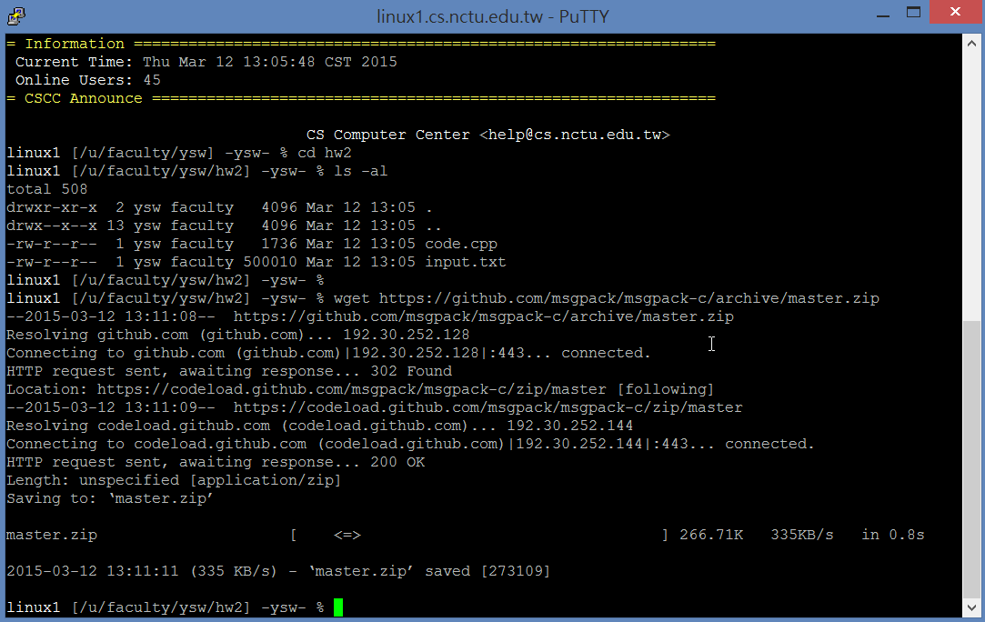

1. Unzip it

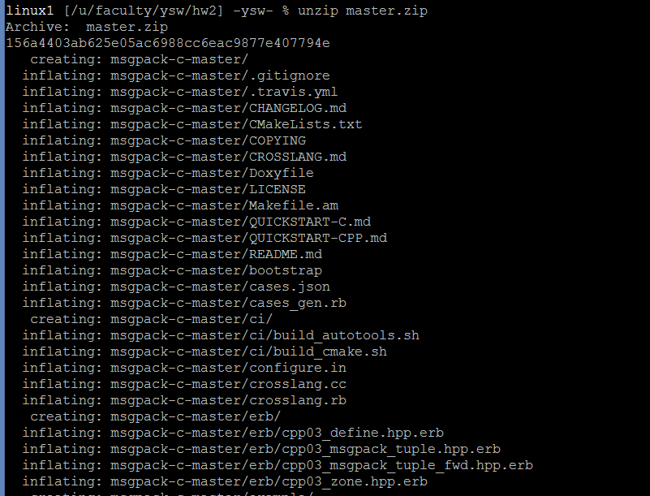

1. Compile your code

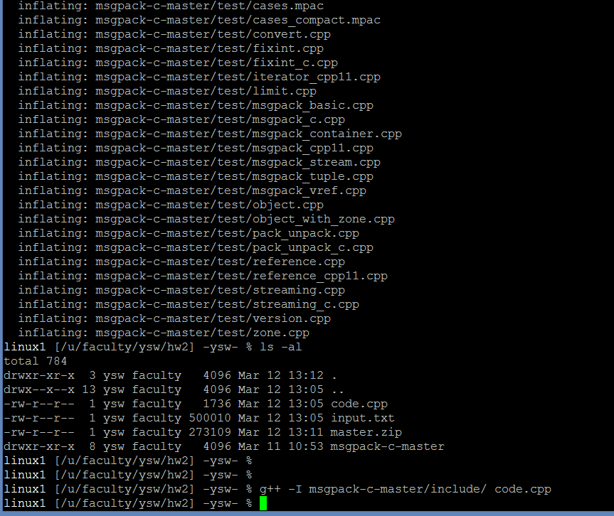

If you use MS Visual Studio on Windows, you may add the msgpack include path with the following steps

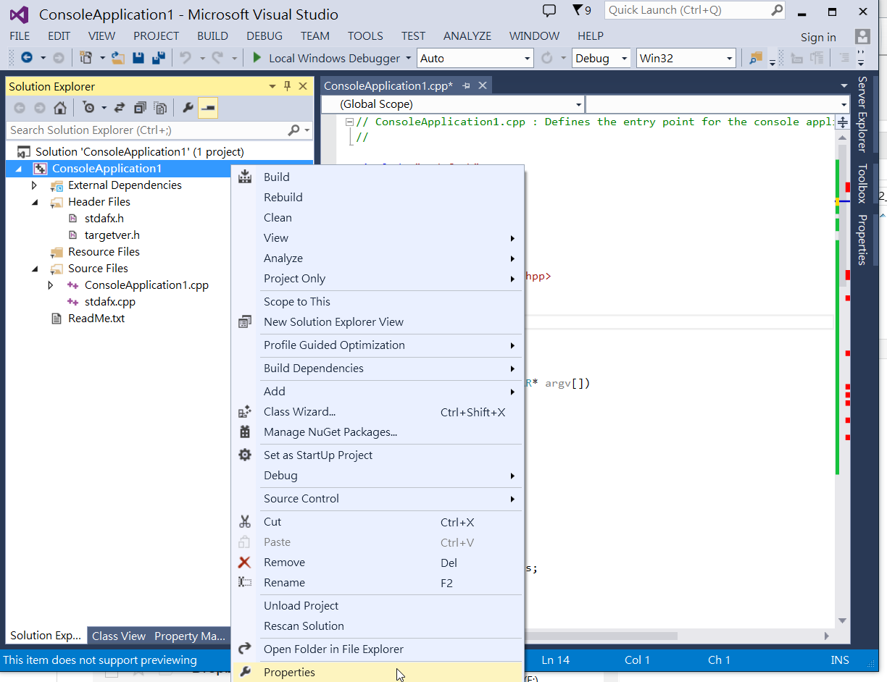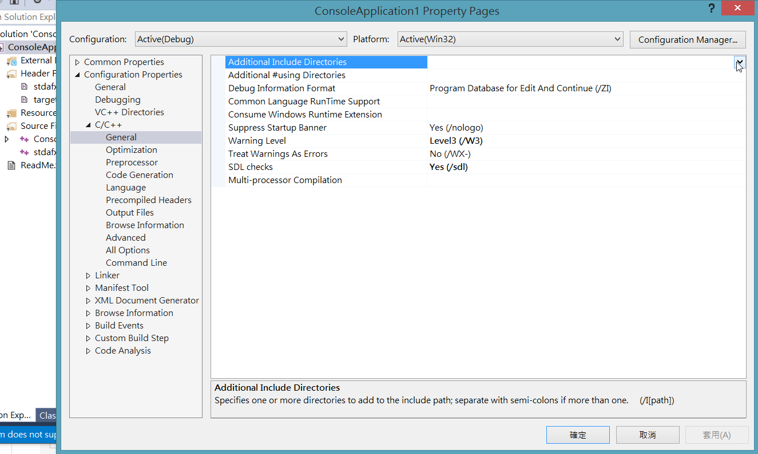

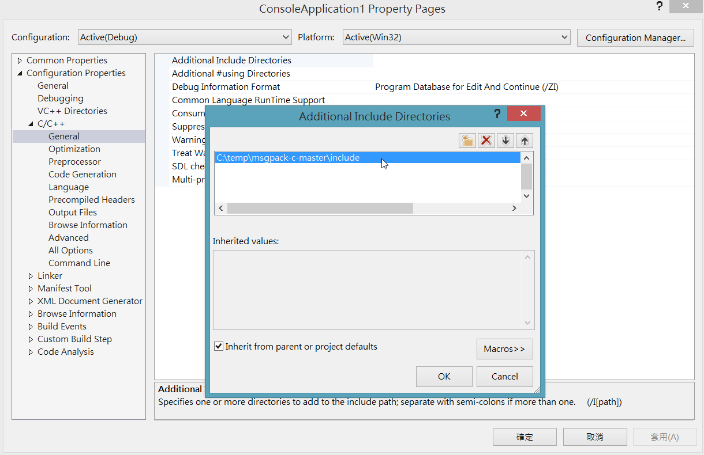

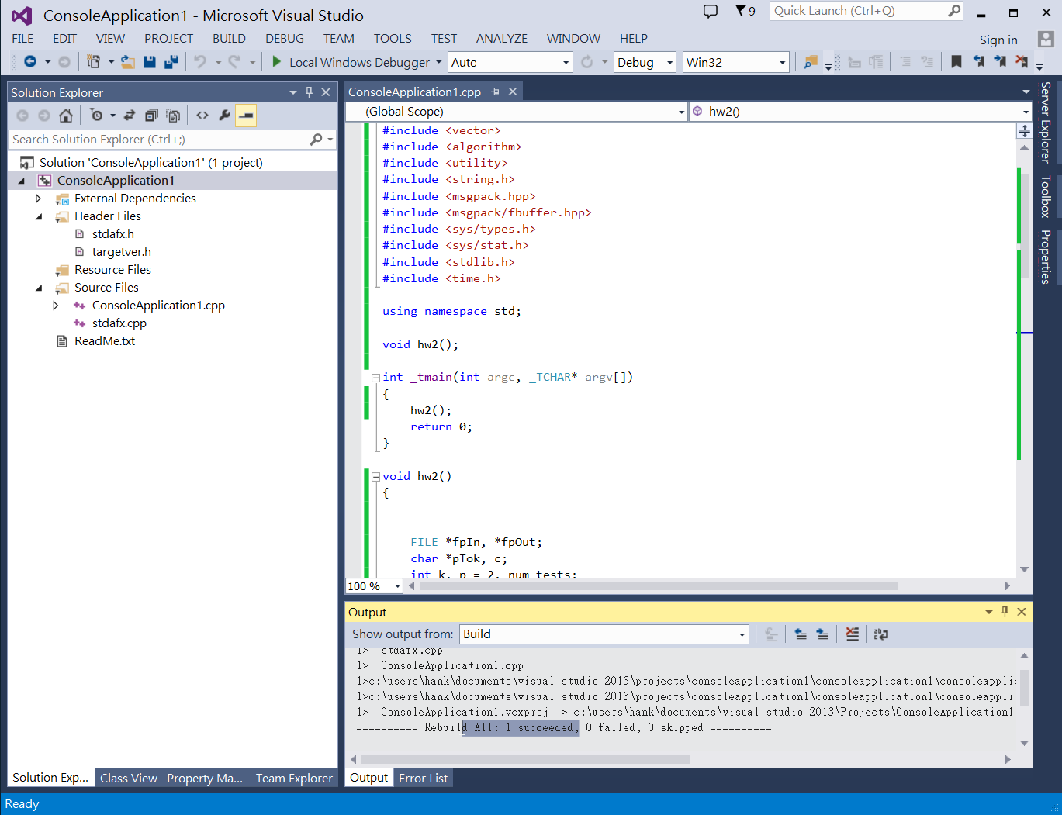

**References**

<https://github.com/msgpack/msgpack-c/wiki/cpp_packer>

<https://github.com/msgpack/msgpack-c/wiki/cpp_unpacker>

