1. Install sbt

http://www.scala-sbt.org/download.html

2. Unpack Java customized template

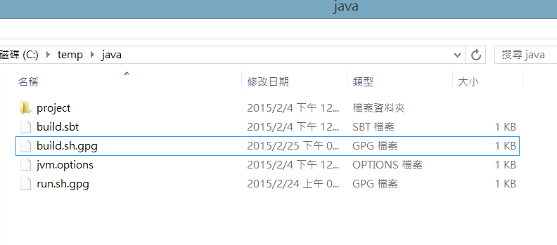

3. Put your code under src/main/java

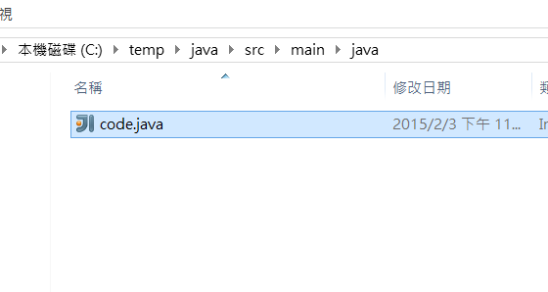

4. Compile your code with ‘sbt assembly’

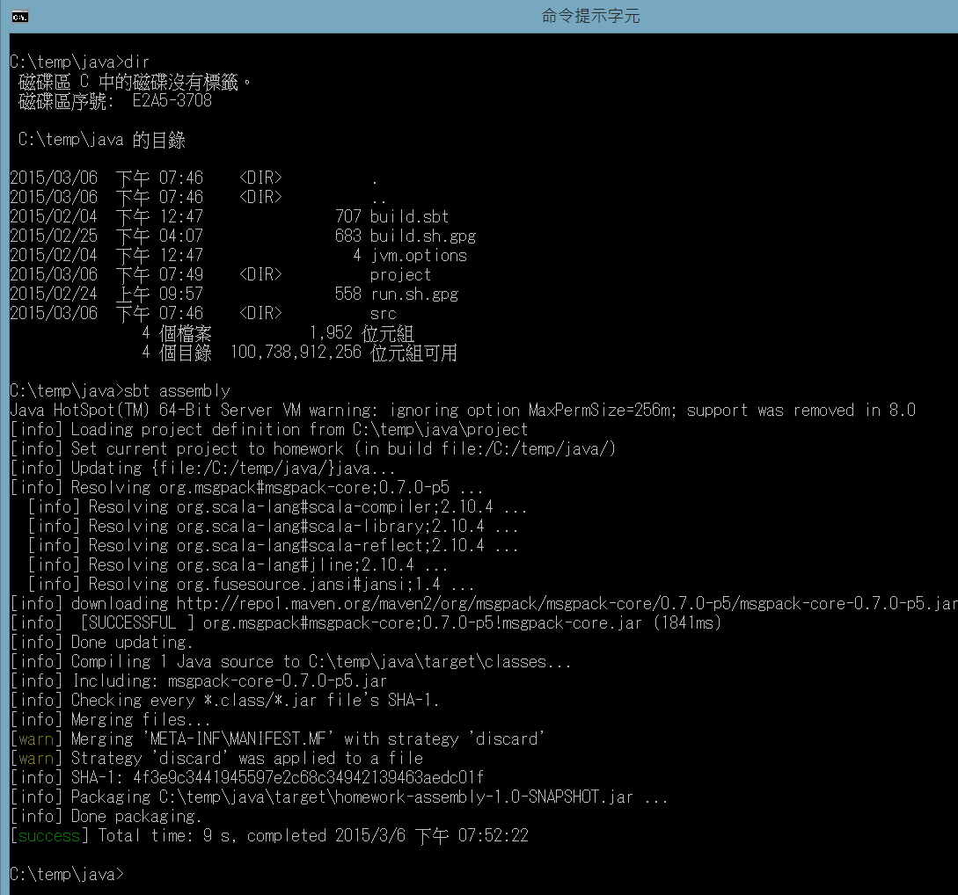

5. Put input.txt in place and run the jar file

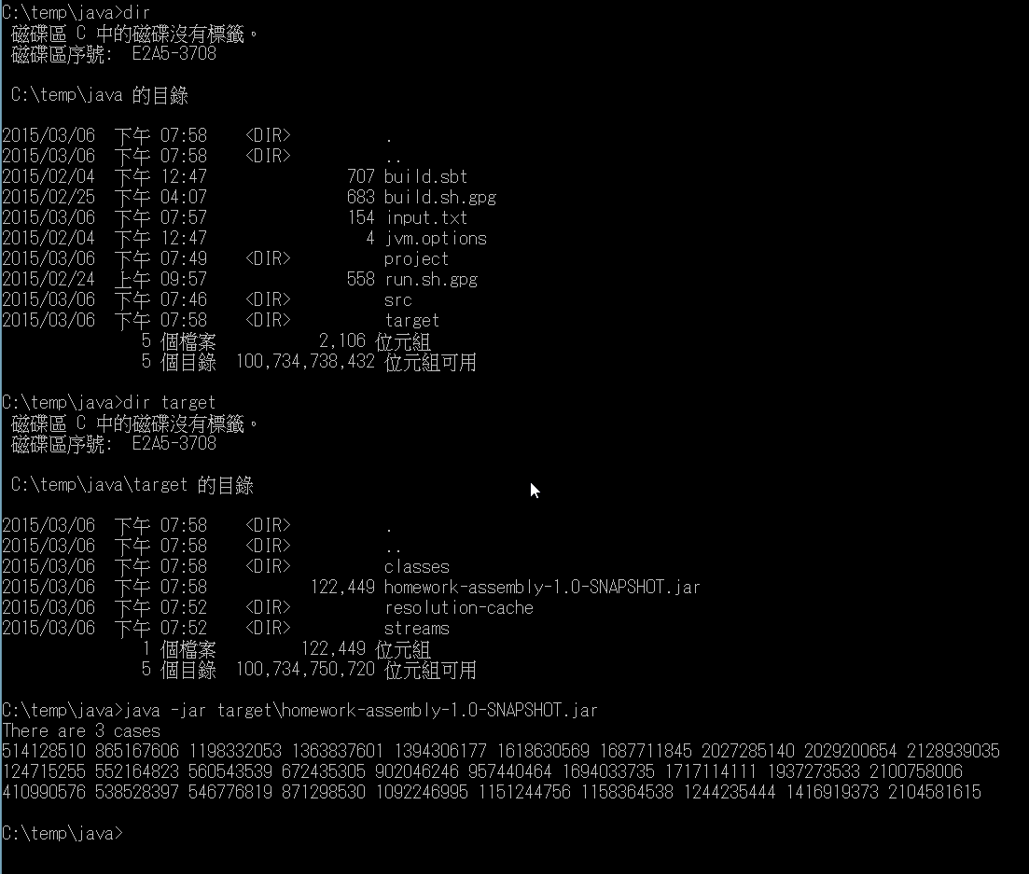

Under the hood, this is how to add msgpack to a sbt project

